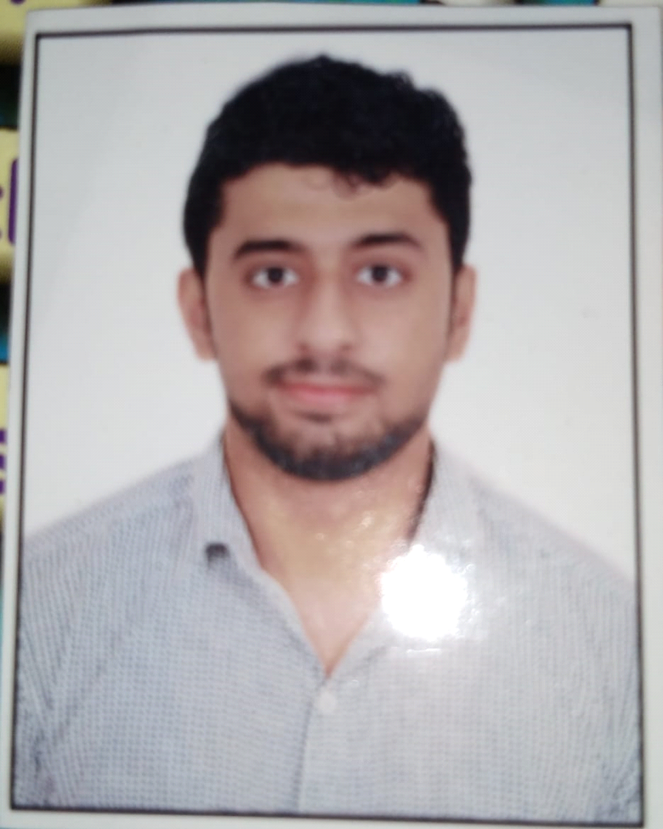

**SHIVAM SETHI**

**Area of Specialization: Finance & Marketing**

**Professional Experience**

**Company Name: Capline India Services Pvt ltd**

**Location: Noida**

**Job title: Business Analyst**

**Job Profile: Working in the Aging team of the Operations department handling the Claims Aging, Billing, Posting part, Also providing solutions after analyzing the Insurance claims data, Making all the important weekly & monthly reports. Interacting with clients solving their queries, Playing a crucial role in operations.**

**Educational Qualification:**

|  |  |  |  |  |
| --- | --- | --- | --- | --- |
| **Degree** | **College/School** | **Board/University** | **Year of passing** | **CGPA/Percentage** |
| **PGPM** | **IBS Gurgaon** | **ICFAI Business School, Gurgaon** | **2021** | **6.40 CGPA** |
| **BBA** | **Maharaja Surajmal Institute of Technology** | **Inderprastha university** | **2017** | **68.74%** |
| **XII** | **Happy Model School** | **CBSE** | **2014** | **62.4%** |
| **X** | **Happy Model School** | **CBSE** | **2012** | **6.2 GPA** |

**Summer Internship at IBS Gurgaon**

* **Company:** “**Sharekhan** India Ltd”
* **Project Title:** **COMPARATIVE STUDY ON SHAREKHAN LTD. WITH OTHER STOCK BROKING HOUSES**”.
* **Project Area:** Finance and Sales
* **Project Synopsis:** Learned most of the basic financial tools and basic investment rules and policies. To study, enhance and efficiently utilize different types of Technical Indicator and Oscillators and use them to interpret and predict the stock market indices of different stocks. Pitch sales to customers to open a Demat account for Sharekhan.

**Duration:** 14 weeks (Feb to May 2019**)**

**Additional Projects Undertaken:**

* **2018: Worked at Amazon for 6 months as a CSA(Customer Service Associate), Voice process dealt with clients from South America Handling their issues and solving their queries.**
* **2019: Worked at Delta Reservations as an executive for 5 months Selling tickets and helping clients with their previous bookings.**

**Certifications:**

* Software skills(c, C++) certificate issued by Computer professionals group.
* Microsoft Excel certifications from the academy.
* Working knowledge of SQL.
* Secure 12th rank in International English Olympiad.

**Professional Skills**

* Leadership, Global orientation, teamwork.
* Strong Presentation, communication, interpersonal skills.
* General business understanding.
* Keen eye to the detail

**Awards/Achievements:**

* Led the school Badminton team to interzonal.
* Secured 1st position in Debate on use of microwaves in inter-college competition

**Extra-Curricular Activities & Hobbies**

Captain of cricket team for Happy Model School matches in year 2013.

Exploring new places.

Strategic mind game.

Social involvement.

**Personal Details**

Date of Birth: **16/04/1996**

Gender: **Male**

Mobile Number: **7982314334**

Email ID: **shivamsethi96.ss@gmail.com**

Father’s name: **Sandeep Sethi**

Residential Contact Number: **7838644250**

Permanent Address: **Wz-188a Shiv nagar first floor street no 11 near, Janakpuri-**