**RESUME**

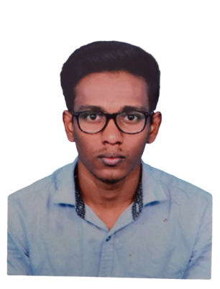

**PRASANTH. P**

**CONTACT:**9688022089

**E-mail:**[prasanth.iniyan@gmail.com](mailto:prasanth.iniyan@gmail.com)

# CAREEROBJECTIVE

* To become a dynamic, successful employee and to satisfy myself and make others satisfy and toworkin challengingenvironmentwhereIcan utilize and develop myskills.

# ACADAMICQUALIFICATION

* + Completed ELECTRICAL AND ELECTRONICS Engineering – B.E in Government College at Dharmapuri.
  + CompletedhighersecondaryeducationinSakthiVigneshwaraKalviNilayamatTirupur.
  + Completed secondary education in Sakthi Vigneshwara Kalvi Nilayam at Tirupur.

## CO-CURRICULARACTIVITIES

* + One of the participants in INDIA BIX and APTIPEDIA
  + Participated in university level cricket match in 2018.

# TECHNICALEXPOSURE

## Workshop

* Participantinworkshopbasedon**“PowerSystemOperationandControl”**atGCE-Dharmapuri.

# EEXPERIENCE

* **Organizations** - RND Softech Pvt Ltd, Coimbatore - Process Executive - AR

Access Healthcare, Chennai - Senior client partner - AR

* **Description** - Dealing with providers on a day-to-day basis on issue and resolving issues related to claims, ERA’s and other insurance related queries.
* **Responsibilities -** Working with insurance to fix various denial reason and claim verification so that we receive payments with the time limit for the provider also make sure client is satisfied with volume of work done and also good quality of working is done. Working on RCM cycle to for the closure of claim.
* Worked in Brightree client to follow the AR work flow and have to fix the denials getting the payments also specialized in DME equipmemts and documentations.

# STRENGTH

* + Positiveattitudes.
  + Abilitytowork inateam.
  + Abilityto deal with people diplomatically.
  + Goodcommunicationskills.
  + Quicklearnerandjovial.
  + Leadership skills

# PERSONALDATA

**Dateof Birth:**30-03-1998

**Age:**23

**Languages:**Tamil,English(Read,Write,Speak)

**DECLARATION**

Iherebydeclarethat allaboveinformationfurnished above is trueto bestof myknowledge

## Yourssincerely

**(PRASANTH.P)**