## Resume

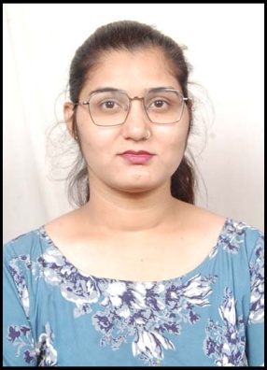

**PALAK RATHORE**

**Mobile No- 6262881550/6264452733**

**Email. Id :-** [**palakrathore51@gmail.com**](mailto:palakrathore51@gmail.com)

**Add:- Narendra Nagar,Railway Station Road, Sehore(M.P.)- 466001**

## CAREER OBJECTIVE:

Self motivate, hardworking person who like to meet new challenges & I would like to work in an organization where I can use my knowledge in best way.

## EDUCATIONAL QUALIFICATIONS:

|  |  |  |
| --- | --- | --- |
| B.Com | B.U. University | 79% |
| 12th | M.P. Board | 83% |
| 10th | M.P. Board | 81% |

## SKILLS:

* Excellent soft skills.
* Basic knowledge of computer .
* Ms Excel, Ms Office, Power Point
* Excellent communication skills.
* Hindi & English Typing .

**PERSONAL DETAILS:**

**Father’s Name : Mr. HUKUM SINGH RATHORE**

Date of Birth : 13 JUNE 1999

Marital Status : Unmarried

Language Known : Hindi, English

## STRENGTH:

* Smart Working, Sincere & Adaptive.
* Team Player.
* Leadership Qualities.

**DECLARATION:**

I hereby declare that all the statements in the document are true, complete and correct to the best of my knowledge and belief.

**Date……….. Palak Rathore**

**Place………..**