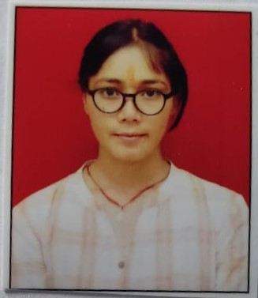**CURRICULUM VITAE**

**SEEMA NEGI**

CONTECT INFO:-

E.MAIL:Seemunegi800@gmail.com

MOBILE: 7088348337

ADDRESS: H.NO. 77B, BHAGWATI GARDEN EXT.

DWARKA MOR, NEW DELHI-110059

* **Objective**:

Seeking a challenging position in a reputed organization, Where I can learn new skills, expand my knowledge and leverage my learning’s.

* **Skills** :

1. Good communication skills.
2. Anatomy, ICD -10CM, CPT
3. Computer skill MS excel, MS office

* **Additional Certification :-**
* **CPC -A ( ID 01990707)**
* **EDUCATION DETAILS**

1. Completed Master`s in life sciences from Kumaon University, Nainital (Uttarakhand) in 2020
2. Completed Bachelors in Science from Kumaon University, Nainital (Uttarakhand) in 2018
3. Completed 12th from Uttarakhan Board, Nainital (Uttarakhand) in 2015
4. Completed 10th from Uttarakhan Board, Nainital (Uttarakhand) in 2013

* **PERSONAL DETAILS:**

Name : Seema Negi

Fathers name : Mr. Jaman Singh Negi

Date of birth : 7th Sep 1997

Gender : Female

Nationality : Indian

Marital status : Single

* **LANGUAGES KNOWN:**

1. English
2. Hindi

* **DECLARATION**

I hereby declare that all the details mentioned above are in accordance with the truth and fact as per my knowledge and I hold the responsibility for the correctness of the above mentioned particulars.

(SeemaNegi)i