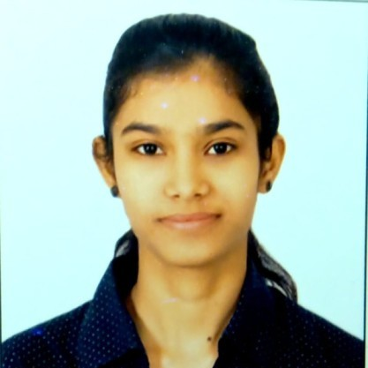87 MMIG INDRAPURAM SHAMSHABAD ROAD RAJPUR

CHUNGI, AGRA, UTTAR PRADESH 282001

89792 29619 | [shr](mailto:shraddhagupta1821@gmail.com)[addhagupta1821@gmail.com](mailto:addhagupta1821@gmail.com)

OBJECTIVE

Seeking for a challenging position in your organization where i can learn new skills, expand my knowledge, and leverage my learnings. To get an opportunity where I can make the best of my potential and contribute to the organization's growth.

EDUCATION



St. Mary's convent school

2015

X CBSE 72%



John Milton Public School

2017

XII CBSE 65%



Dr. MPS Group of Institute

2021

Bsc biotechnology 69.47%

PROJECTS



Isolation and identiﬁcation of microbial ﬂora from different beverage

Under the project we learned about what kind of micrograms are present in different kind of beverages. For which we learned how to prepare media for plating. Acknowledge about the bacteria, fungi is present. Learned about 2 different variety of bacteria whether the bacteria is gram positive or gram negative and prepared some slides for them.

INDUSTRIAL VISIT

Industrial visit at ICAR- directorate of Rapeseed Mustard research, Bharatpur Industrial visit at YAKULT DADONE pvt. Ltd. Sonipat, Haryana

SKILLS & CERTIFICATE

Microbial testing Total plate count

Handling of instrument **CPC(2022)-AAPC**

WORKSHOPS

Attended 4th inter college annual BIOCHROME in 2018, entitled "DRUG DELIVERY".

Attended National Conference on resilience and resource management including ICT for sustainable agriculture and biotechnology.

INTERESTS

Microbiology Quality testing

Product development

LANGUAGES

English Hindi