**PetrolPump-Management-Python**

**Aim :**

To create a Software that can manage and record the working of a Petrol Pump using Python.

**Overview of the Project :**

Petrol Pump Management System is a computer-based software solution that aims to simplify and automate the operations of a petrol pump. This project is developed using Python programming language and uses a graphical user interface (GUI) to facilitate the user's interaction with the system.

The software provides a range of features to manage the daily operations of a petrol pump, including:

1. **Pump management :** The system allows the user to manage the pumps at the petrol station, enabling them to monitor the status of each pump and track fuel sales for each pump.
2. **Inventory management :** The software helps the user keep track of fuel inventory, including the fuel type, quantity, and price. It provides alerts for low inventory levels, allowing the user to order new stock in advance.
3. **Sales management :** The system allows the user to record fuel sales and generate transaction history.

Overall, the Petrol Pump Management System developed using Python is a user-friendly, feature-rich software solution that simplifies and automates the daily operations of a petrol pump. It helps the user to streamline their operations, save time and effort, and make informed decisions based on accurate data.

**Required Modules :**

* tkinter
* customtkinter
* PIL
* uuid
* pickle
* csv
* time

**Code implementation :**

**Splash Screen**

This function is used to show the splash screen of the application. It will show the application name and a loading message.

class splashScreen:

    def __init__(self):

        root=Tk()

        width_of_window = 450

        height_of_window = 260

        screen_width = root.winfo_screenwidth()

        screen_height = root.winfo_screenheight()

        x_coordinate = (screen_width/2)-(width_of_window/2)

        y_coordinate = (screen_height/2)-(height_of_window/2)

        root.geometry("%dx%d+%d+%d" %(screen_width,screen_height,x_coordinate,y_coordinate))

        root.overrideredirect(1)

        Frame(root, width=570, height=250, bg='#272727').place(x=0,y=0)

        label1=Label(root, text='PETROL PUMP MANAGEMENT', fg='white', bg='#272727')

        label1.configure(font=("Berlin Sans FB Demi", 22))

        label1.place(x=50,y=90)

        label2=Label(root, text='Loading...', fg='white', bg='#272727')

        label2.configure(font=("Calibri", 14, 'bold'))

        label2.place(x=10,y=215)

        image_a=ImageTk.PhotoImage(file='assets/c2.png')

        image_b=ImageTk.PhotoImage(file='assets/c1.png')

        for i in range(3):

            l1=Label(root, image=image_a, border=0, relief=SUNKEN).place(x=240, y=145)

            l2=Label(root, image=image_b, border=0, relief=SUNKEN).place(x=260, y=145)

            l3=Label(root, image=image_b, border=0, relief=SUNKEN).place(x=280, y=145)

            l4=Label(root, image=image_b, border=0, relief=SUNKEN).place(x=300, y=145)

            root.update_idletasks()

            time.sleep(0.2)

            l1=Label(root, image=image_b, border=0, relief=SUNKEN).place(x=240, y=145)

            l2=Label(root, image=image_a, border=0, relief=SUNKEN).place(x=260, y=145)

            l3=Label(root, image=image_b, border=0, relief=SUNKEN).place(x=280, y=145)

            l4=Label(root, image=image_b, border=0, relief=SUNKEN).place(x=300, y=145)

            root.update_idletasks()

            time.sleep(0.2)

            l1=Label(root, image=image_b, border=0, relief=SUNKEN).place(x=240, y=145)

            l2=Label(root, image=image_b, border=0, relief=SUNKEN).place(x=260, y=145)

            l3=Label(root, image=image_a, border=0, relief=SUNKEN).place(x=280, y=145)

            l4=Label(root, image=image_b, border=0, relief=SUNKEN).place(x=300, y=145)

            root.update_idletasks()

            time.sleep(0.2)

            l1=Label(root, image=image_b, border=0, relief=SUNKEN).place(x=240, y=145)

            l2=Label(root, image=image_b, border=0, relief=SUNKEN).place(x=260, y=145)

            l3=Label(root, image=image_b, border=0, relief=SUNKEN).place(x=280, y=145)

            l4=Label(root, image=image_a, border=0, relief=SUNKEN).place(x=300, y=145)

            root.update_idletasks()

            time.sleep(0.2)

        root.destroy()

        LoginPage()

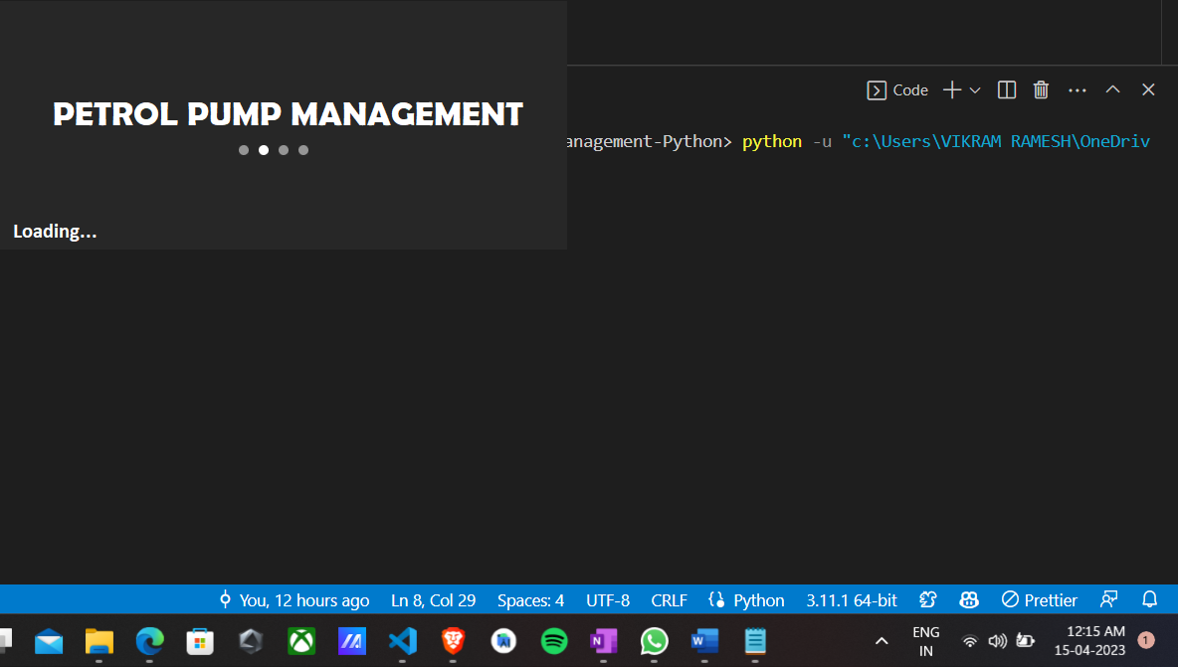        root.mainloop()

**Login Screen**

This function is used to create the login page of the application. Will show the username and password entry boxes. It will also show the login button.

def LoginPage():

    root1 = Tk()

    root1.withdraw()

    root = CTkToplevel()

    root.resizable(width= False, height= False)

    WW = 732

    WH = 450

    SW = root.winfo_screenwidth()

    SH = root.winfo_screenheight()

    x = SW/2 - WW/2

    y = SH/2 - WH/2

    root.geometry('%dx%d+%d+%d' %(WW, WH, x, y))

    root.title('Petrol Pump Management')

    bg = ImageTk.PhotoImage(file='assets/background2_small.jpeg')

    label1 = Label(root, image = bg)

    label1.place(x = 0, y = 0)

    frame = CTkFrame(master = root, height=200, width=6000)

    frame.pack(pady=60, padx=60, expand=True)

    label = CTkLabel(master=frame, text='User Login', font=('Impact', 35,

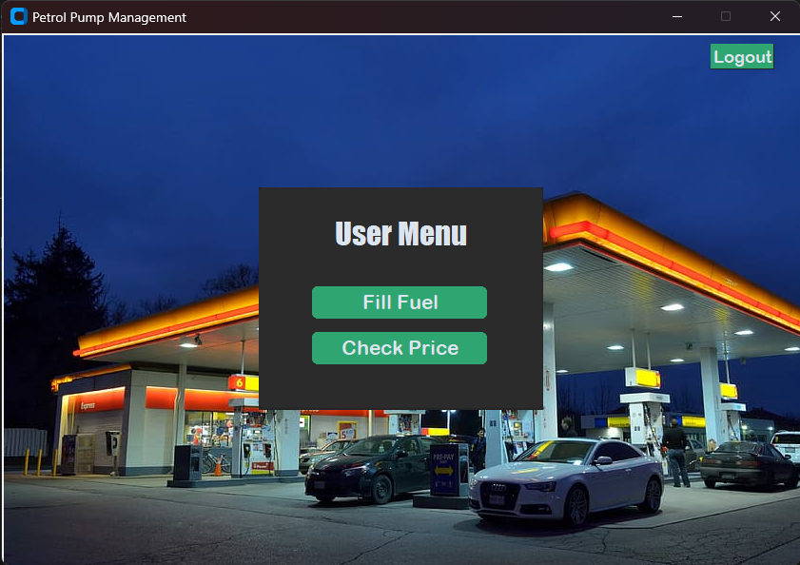

**Admin Home Screen**

This function is used to show the admin menu. It will show the admin menu and the buttons to go to the other pages. It will also have a logout button to go back to the login page.

def admin():

    try:

        adminWindow = CTkToplevel()

        adminWindow.resizable(width= False, height= False)

        WW = 732

        WH = 450

        SW = adminWindow.winfo_screenwidth()

        SH = adminWindow.winfo_screenheight()

        x = SW/2 - WW/2

        y = SH/2 - WH/2

        adminWindow.geometry('%dx%d+%d+%d' %(WW, WH, x, y))

        adminWindow.title('Petrol Pump Management')

        bg = ImageTk.PhotoImage(file='assets/background.jpg')

        label1 = Label(adminWindow, image = bg)

        label1.place(x = 0, y = 0)

        frame = CTkFrame(master = adminWindow, height=200, width=6000)

        frame.pack(pady=60, padx=60, expand=True)

        label = CTkLabel(master=frame, text='Admin Menu', font=('Impact', 28))

        label.pack(pady=25, padx=70)

        filling = CTkButton(master=frame, text='Update  Price', font=('Arial Rounded MT Bold', 18), width=162, height=30, command= lambda: updatePrice(adminWindow))

        filling.pack(pady=6, padx=10)

        filling = CTkButton(master=frame, text='Update  Quantity', font=('Arial Rounded MT Bold', 18), width=162, height=30, command= lambda: updateQty(adminWindow))

        filling.pack(pady=6, padx=10)

        checkPrice = CTkButton(master=frame, text='Transactions', font=('Arial Rounded MT Bold', 18), width=162, height=30, command= lambda: transactions(adminWindow))

        checkPrice.pack(pady=6, padx=10)

        label = CTkLabel(master=frame, text='', font=('Impact', 26))

        label.pack(pady=2, padx=40)

        logoutButton = CTkButton(master=adminWindow, text='Logout', font=('Arial Rounded MT Bold', 16), width=18, height=2, command= lambda: goBack(adminWindow))

        logoutButton.place(x= 650, y=10)

        adminWindow.mainloop()

    except Exception as e:

        messagebox.showerror(f'Python Error', 'Error: {e}')

**Customer Fuel Filling Page**

This class is used to create the fill page. It will show the fuel type options. It will also have a back button to go back to the homepage page.

def fillPage():

    fillWindow = CTkToplevel()

    fillWindow.resizable(width= False, height= False)

    WW = 732

    WH = 488

    SW = fillWindow.winfo_screenwidth()

    SH = fillWindow.winfo_screenheight()

    x = SW/2 - WW/2

    y = SH/2 - WH/2

    fillWindow.geometry('%dx%d+%d+%d' %(WW, WH, x, y))

    fillWindow.title('Petrol Pump Management')

    bg = ImageTk.PhotoImage(file='assets/background.jpg')

    label1 = Label(fillWindow, image = bg)

    label1.place(x = 0, y = 0)

    frame = CTkFrame(master = fillWindow, height=200, width=600)

    frame.pack(pady=60, padx=60, expand=True)

    label = CTkLabel(master=frame, text='Choose Fuel Type', font=('Impact', 28))

    label.pack(pady=25, padx=70)

    Petrol = CTkButton(master=frame, text='Petrol', font=('Arial Rounded MT Bold', 18), width=162, height=30, command= lambda: petrol(fillWindow))

    Petrol.pack(pady=20, padx=30, side= LEFT)

    Diesel = CTkButton(master=frame, text='Diesel', font=('Arial Rounded MT Bold', 18), width=162, height=30, command= lambda: diesel(fillWindow))

    Diesel.pack(pady=20, padx=30, side= RIGHT)

    backButton = CTkButton(master=fillWindow, text='<- Back', font=('Arial Rounded MT Bold', 16), width=18, height=2, command= lambda: goBack(fillWindow))

    backButton.place(x= 5, y=5)

    fillWindow.mainloop()

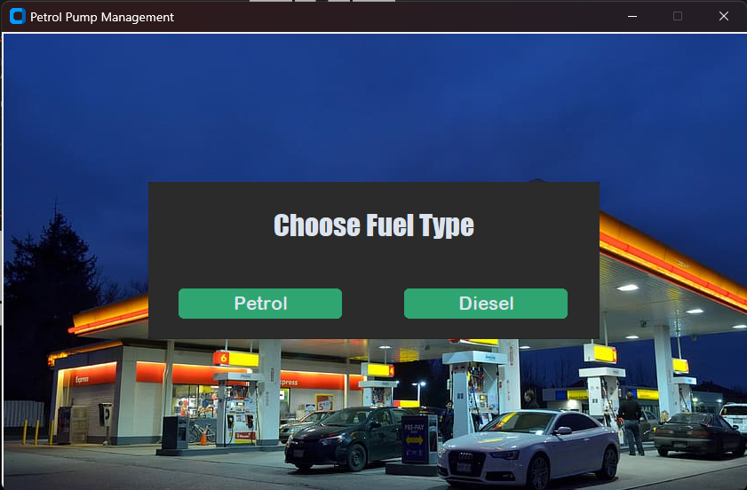

**Customer Fuel Price Checking Page**

This function is used to show the current price of petrol and diesel. It will show the current price of petrol and diesel. It will also have a back button to go back to the home page. It will also have a button to update the price of petrol and diesel. It will also have a entry to enter the new price of petrol and diesel. It will also have a button to confirm the update. It will destroy the current window and open the update rate page.

def CheckPrice():

    try:

        fillWindow = CTkToplevel()

        fillWindow.resizable(width= False, height= False)

        WW = 732

        WH = 450

        SW = fillWindow.winfo_screenwidth()

        SH = fillWindow.winfo_screenheight()

        x = SW/2 - WW/2

        y = SH/2 - WH/2

        fillWindow.geometry('%dx%d+%d+%d' %(WW, WH, x, y))

        fillWindow.title('Petrol Pump Management')

        ic = Image.open('assets/background3.jpg')

        res_img = ic.resize((910,605))

        bg = ImageTk.PhotoImage(res_img)

        label1 = Label(fillWindow, image = bg)

        label1.place(x = 0, y = 0)

        frame = CTkFrame(master = fillWindow, height=200, width=6000)

        frame.pack(pady=60, padx=60, expand=True)

        currentPetrolPrice = dataHandling.getData(r'data\petrolPrice.pkl')

        currentDieselPrice = dataHandling.getData(r'data\dieselPrice.pkl')

        label1 = CTkLabel(master=frame, text='Current Price Details', font=('Arial Rounded MT Bold', 24), width=162, height=30)

        label1.pack(pady=8, padx=70)

        label2 = CTkLabel(master=frame, text=f'Petrol : {currentPetrolPrice}', font=('Arial Rounded MT Bold', 18), width=162, height=30)

        label2.pack(pady=5, padx=70)

        label3 = CTkLabel(master=frame, text=f'Diesel : {currentDieselPrice}', font=('Arial Rounded MT Bold', 18), width=162, height=30)

        label3.pack(pady=5, padx=70)

        sizeBox = CTkLabel(master=frame, text=f' ', font=('Arial Rounded MT Bold', 2), width=162, height=10)

        sizeBox.pack(pady=20, padx=10)

        backButton = CTkButton(master=fillWindow, text='<- Back', font=('Arial Rounded MT Bold', 16), width=18, height=2, command= lambda: goBack(fillWindow))

        backButton.place(x= 5, y=5)

        fillWindow.mainloop()

    except Exception as e:

        messagebox.showerror(f'Python Error', 'Error: {e}')

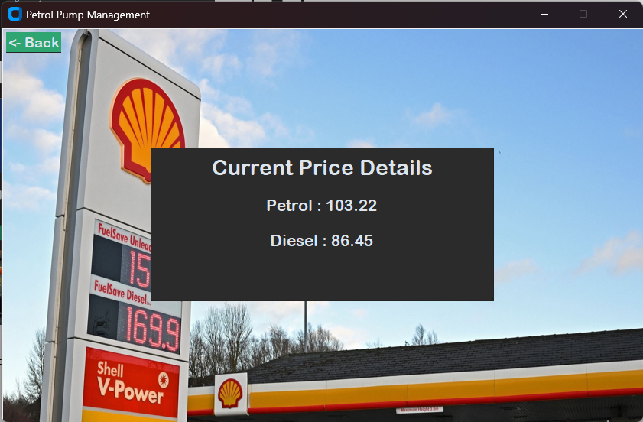

**Admin Fuel Price updating Page**

This function is used to create the update rate page. It will show the current price of petrol and diesel. It will also have a back button to go back to the admin page. It will also have a button to update the price of petrol and diesel. It will also have a entry to enter the new price of petrol and diesel. It will also have a button to confirm the update. It will destroy the current window and open the update rate page.

def updateRate():

    try:

        costWindow = CTkToplevel()

        costWindow.resizable(width= False, height= False)

        WW = 732

        WH = 450

        SW = costWindow.winfo_screenwidth()

        SH = costWindow.winfo_screenheight()

        x = SW/2 - WW/2

        y = SH/2 - WH/2

        costWindow.geometry('%dx%d+%d+%d' %(WW, WH, x, y))

        costWindow.title('Petrol Pump Management')

        ic = Image.open('assets/background3.jpg')

        res_img = ic.resize((910,605))

        bg = ImageTk.PhotoImage(res_img)

        label1 = Label(costWindow, image = bg)

        label1.place(x = 0, y = 0)

        frame = CTkFrame(master = costWindow, height=500, width=60)

        frame.pack(pady=60, padx=60, expand=True)

        currentPetrolPrice = dataHandling.getData(r'data\petrolPrice.pkl')

        currentDieselPrice = dataHandling.getData(r'data\dieselPrice.pkl')

        label1 = CTkLabel(master=frame, text='Current Price Details', font=('Arial Rounded MT Bold', 24), width=162, height=30)

        label1.pack(pady=8, padx=70)

        label2 = CTkLabel(master=frame, text=f'Petrol : {currentPetrolPrice}', font=('Arial Rounded MT Bold', 18), width=162, height=30)

        label2.pack(pady=5, padx=70)

        label3 = CTkLabel(master=frame, text=f'Diesel : {currentDieselPrice}', font=('Arial Rounded MT Bold', 18), width=162, height=30)

        label3.pack(pady=5, padx=70)

        sizeBox = CTkLabel(master=frame, text=f' ', font=('Arial Rounded MT Bold', 50), width=162, height=30)

        sizeBox.pack(pady=20, padx=10)

        label4 = CTkLabel(master=frame, text=f'Enter New Petrol Rate', font=('Arial Rounded MT Bold', 15), width=100, height=30)

        label4.place(x=20, y=160)

        entry1 = CTkEntry(master=frame, placeholder_text='Update Petrol Price')

        entry1.place(x=216, y=160)

        label5 = CTkLabel(master=frame, text=f'Enter New Diesel Rate', font=('Arial Rounded MT Bold', 15), width=162, height=30)

        label5.place(x=20, y=200)

        entry2 = CTkEntry(master=frame, placeholder_text='Update Diesel Price')

        entry2.place(x=216, y=200)

        button = CTkButton(master=frame, text='Update Price', command= lambda: updatePrice(entry1, entry2, costWindow))

        button.pack(pady=25, padx=10)

        backButton = CTkButton(master=costWindow, text='<- Back', font=('Arial Rounded MT Bold', 16), width=18, height=2, command= lambda: goBack(costWindow))

        backButton.place(x= 5, y=5)

        costWindow.mainloop()

    except Exception as e:

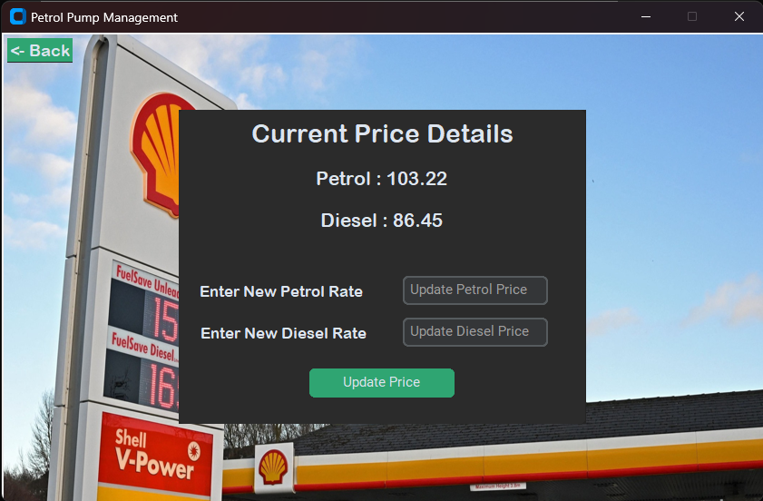        messagebox.showerror(f'Python Error', 'Error: {e}')

**Transaction History Page**

This function is used to show the transaction page. It will show the transaction page and the buttons to go to the other pages.

def transactionPage():

    transactionWindow = CTkToplevel()

    transactionWindow.resizable(width= False, height= False)

    WW = 732

    WH = 450

    SW = transactionWindow.winfo_screenwidth()

    SH = transactionWindow.winfo_screenheight()

    x = SW/2 - WW/2

    y = SH/2 - WH/2

    transactionWindow.geometry('%dx%d+%d+%d' %(WW, WH, x, y))

    transactionWindow.title('Petrol Pump Management')

    bg = ImageTk.PhotoImage(file='assets/background2_small.jpeg')

    label1 = Label(transactionWindow, image = bg)

    label1.place(x = 0, y = 0)

    mainFrame = Frame(transactionWindow, bg='darkgray')

    mainFrame.pack(side=LEFT, padx=20)

    label = CTkLabel(master=mainFrame, text='Transaction History', font=('Impact', 35, 'bold'))

    label.pack(pady=10, padx=40)

    frm = Frame(mainFrame)

    frm.pack(side=LEFT, padx=20, pady=10)

    tv = ttk.Treeview(frm, columns=(1, 2, 3, 4), show='headings', height='20')

    tv.pack()

    backButton = CTkButton(master=transactionWindow, text='<- Back', font=('Arial Rounded MT Bold', 16), width=18, height=2, command= lambda: goBack(transactionWindow))

    backButton.place(x= 5, y=5)

    file = open(r'data\transactions.csv')

    csvreader = csv.reader(file)

    r_set = [row for row in csvreader]

    tv.heading(1, text='ID', anchor=CENTER)

    tv.heading(2, text='Transaction Detail', anchor=W)

    tv.heading(3, text='Debit')

    tv.heading(4, text='Credit')

    for dat in r_set:

        v = [r for r in dat]

        tv.insert('', 'end', iid=v[0], values=v)

    transactionWindow.mainloop()

**Fuel Filling Page :**

This class is used to create the petrol page. It will show the current price and quantity of petrol. It will also have a back button to go back to the homepage page. It will also have a button to fill the petrol. It will also have a entry to enter the quantity of petrol to be filled.

def PetrolPage():

    crPrice = dataHandling.getData(r'data\petrolPrice.pkl')

    crQty = dataHandling.getData(r'data\petrolQty.pkl')

    # print(availPetrol)

    petrolWindow = CTkToplevel()

    petrolWindow.resizable(width= False, height= False)

    WW = 732

    WH = 450

    SW = petrolWindow.winfo_screenwidth()

    SH = petrolWindow.winfo_screenheight()

    x = SW/2 - WW/2

    y = SH/2 - WH/2

    petrolWindow.geometry('%dx%d+%d+%d' %(WW, WH, x, y))

    petrolWindow.title('Petrol Pump Management')

    bg = ImageTk.PhotoImage(file='assets/background.jpg')

    label1 = Label(petrolWindow, image = bg)

    label1.place(x = 0, y = 0)

    frame = CTkFrame(master = petrolWindow, height=200, width=600)

    frame.pack(pady=60, padx=60, expand=True)

    label = CTkLabel(master=frame, text='Petrol', font=('Impact', 28))

    label.pack(pady=9, padx=70)

    label = CTkLabel(master=frame, text=f'Current Petrol Price : {crPrice}', font=('Impact', 16))

    label.pack(pady=5, padx=70)

    label = CTkLabel(master=frame, text=f'Petrol Quantity : {crQty}', font=('Impact', 16))

    label.pack(pady=5, padx=70)

    entry1 = CTkEntry(master=frame, placeholder_text='Enter Quantity')

    entry1.pack(pady=8, padx=10)

    filling = CTkButton(master=frame, text='Fill', font=('Arial Rounded MT Bold', 18), width=162, height=30, command= lambda: fillLitreFunction(entry1, petrolWindow))

    filling.pack(pady=15, padx=30)

    petrolWindow.mainloop()

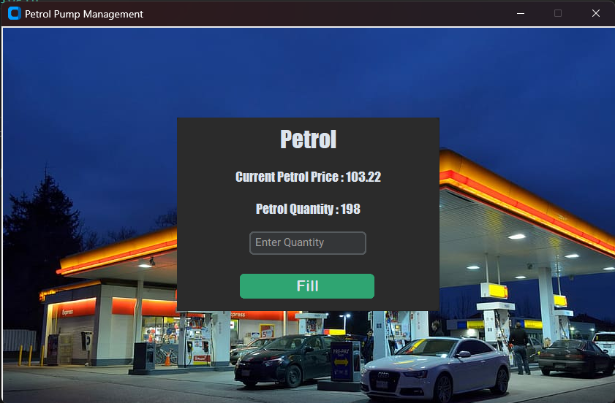

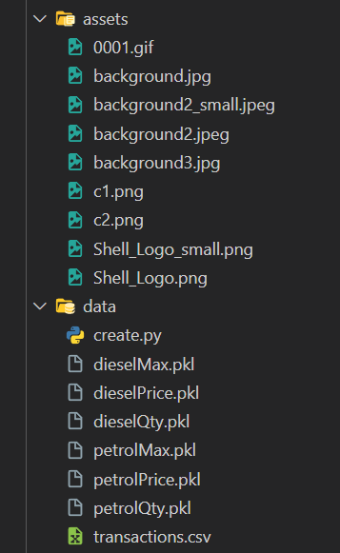**Data Storage and Assets :**

**Done By :**

K R VIKRAM

CS21B1020

NIT, PUDUCHERRY