**Project Report**

**Autolisp Programming**

**Submitted By :**

**13101 - Rajat**

**13105 - Naman Nishant Rana**

**13108 - Vikram Singh Chandel**

**Auto lisp : Introduction**

Auto LISP can be used simply to automate repetitive tasks or to build complex programs that extend AutoCAD and make it more productive. For example, you could write a program that calculates the total length of polylines on a particular layer.

People may tell you that Auto LISP is too limited and not powerful enough and that the higher-end languages are the way to go with AutoCAD customization. That may be true if you're a serious developer of 3rd party applications but if you're just a regular AutoCAD user who wants to make their life easier, Auto LISP is just the thing.

**AutoLISP commands used :**

**defun :** Defines a new function.

**setq** : Sets a value to a variable.

**polar** : Gets a point at a specific distance and angle from given point .

**list** : Creates a list with given elements .

**command**: Executes a auto cad command.

**car** : The primary command for taking a list apart, (car) gives you the first element of a list

**cadr** : This always produces the second element of a list.

**getpoint** : Needs you to pick a point on the screen.

**getstring** : Needs a string of text.

**getdist** : Needs a value either by picking on the screen or a number from the keyboard

**getvar** : Gets value from a variable

**setvar** : Sets a value to a variable

**Aim of our project:**

**To make a function to draw the following beam as per user specified parameters.**

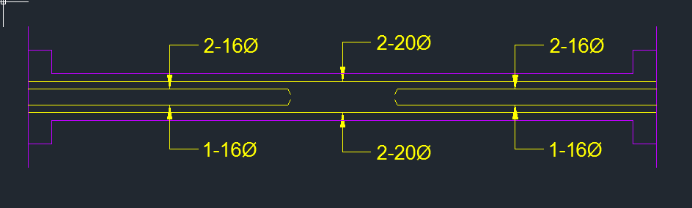

**Prerequisites of program**

**Define layers**:

User is required to create following layers as per colours preferred:

1. bars (yellow in our case)
2. concrete cover (pink in our case)

**Functions created in our program:**

1. **dtr**(angle) :

Converts from degree to radian

1. **beam** (p1 lb lr label1 label2 label3 label4 label5 label6 s1 s2 s3 hcolw)

This is the function which draws the beam using beam parameters. The inputs are explained below.

1. **main** ()

This function uses beam function and input from user to draw the beam required.

**Inputs for our program:**

* **Centre point (p1)**
* **Labels (label1, label2 … label6)**
* **Beam length (lb)**
* **Inner r/f bar length (lr)**
* **Distance from centre of beam to inner bars (s1)**
* **Distance from centre of beam to outer bars (s2)**
* **Half beam depth (s3)**
* **Half column width (hcolw)**

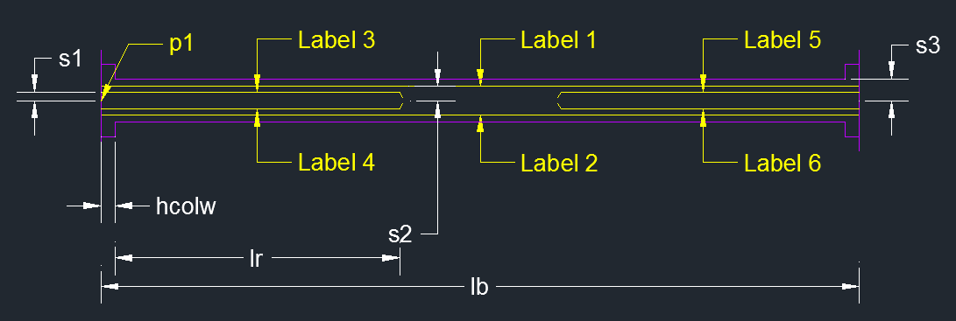

**Procedure** **:**

1. Place “beam.lsp” in the same directory as your AutoCAD file.
2. Open your AutoCAD file and type in command :

(load “beam”)

1. Now execute main function as below :

main

1. Enter the inputs as explained above.
2. Your beam will be created according to your dimensions.

**Conclusion:**

Auto LISP is a very powerful tool to perform repetitive operation on AutoCAD and hence save a lot of time.