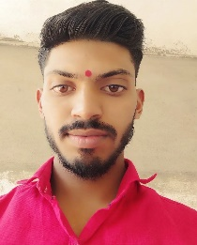RESUME

**Mr.** **VIKRAM GOLAIT**

Contact: +91 7887589262

Email Id: [vikramgolait1660@gmail.com](mailto:vikramgolait1660@gmail.com)

Address: At Post Kalimath Upla, Tq-Kannad, Dist-Sambhajinagar, Pin-431103.

**OBJECTIVE**

To obtain a challenging position at a recognized firm where I may grow my knowledge, abilities, and learnings. Find a responsible job opportunity where I can put my learning and skills to good use while contributing to the company's success

**EDUCATIONAL QUALIFICATION**

* Passed out BSC Graduation Complete In 2023

Marks 60%

* Passed out 12 th HSC Maharashtra State Board Complete In 2019

Marks 56%

* Passed out 10 th SSC Maharashtra State Board Complete In 2017

Marks 62%

**TECHNICAL SKILLS**

* HTML, CSS.
* JAVASCRIPT.
* JQUERY.
* ANGULAR
* BOOSTRAP.
* Installation and configuration of various operating systems ie, Windows 7, Windows Vista, Windows 8.1, Windows 10, Windows11.
* Provide support to MS Office 365, Outlook MS Office & Antivirus.
* Laptop Parts Exchange & Repair
* Diagnose hardware and raised ticket with vendor for hardware replacement
* Installation & troubleshooting of Hardware, Replacement of parts of Desktop And

Laptops

**WORK EXPERIENCE**

* FRESHER

**STRENGTH & HOBBIES**

* Hard & Smart Working
* Tim work
* Honest & Punctual
* Time Management
* Arts , Drawing , Cricket

**PERSONAL DETAILS**

Date Of Birth : 09-06-2002

Age : 23

Marital Status : Single

Father’s Name : Raju Golait