Create a spring microservice which will use AWS DynamoDB as the backend datastore. Deploy the microservice to the AWS Elastic Beanstalk and perform the crud operations using Postman. For simplicity sake avoid creating the service layer. Create only Repository class, Controller, model and any supporting classes.

1. Create a DynamoDB table in AWS
   1. Search for DynamoDB from AWS services.

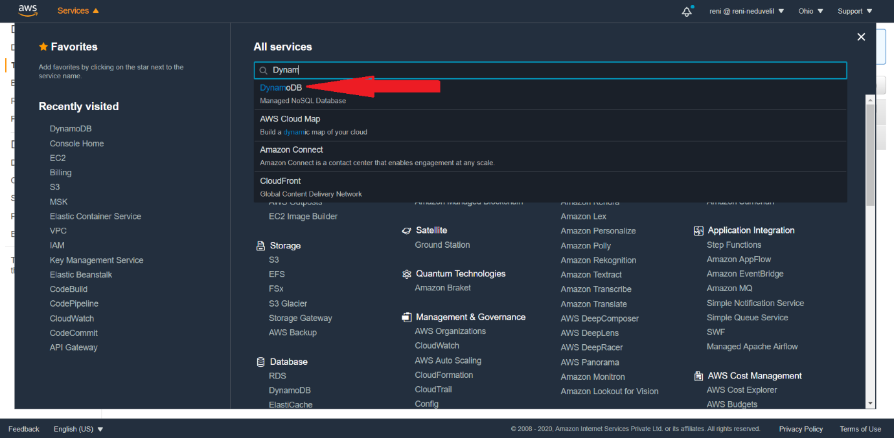

* 1. Create the table by clicking on the “Create table” button in the Amazon DynamoDB screen as shown in the screen below

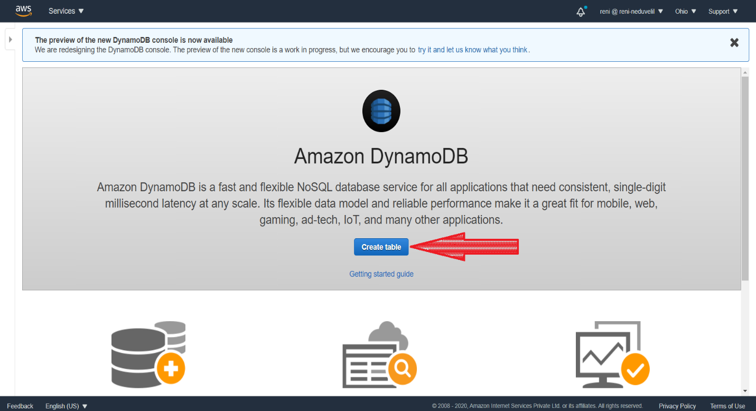

* 1. Provide the table name and the Partition key (Primary key) and click on the “Create” button

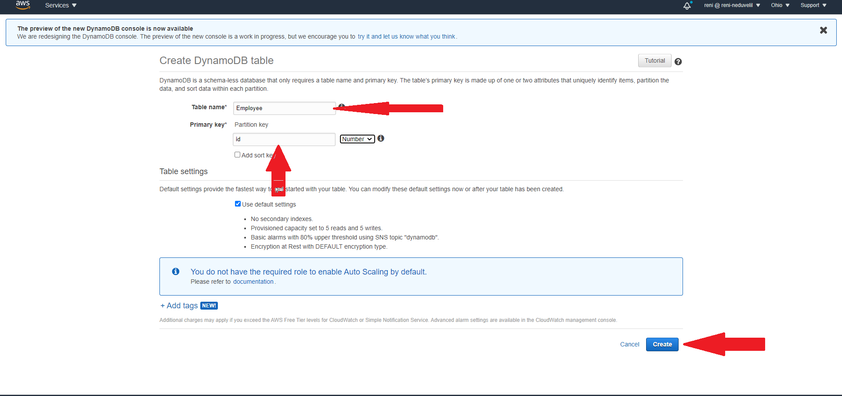

* 1. Click on the items tab and you can see that there are no items in the table.

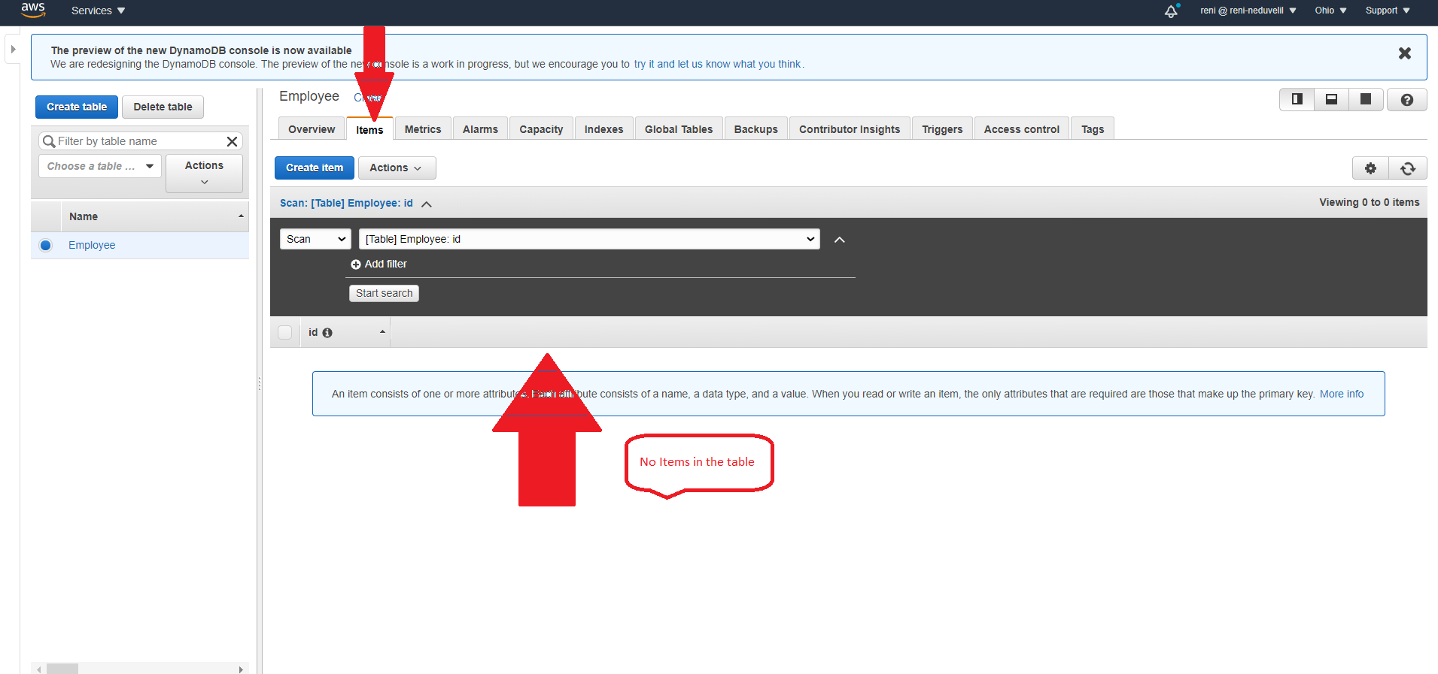

1. Create a spring boot REST application with the required dependency

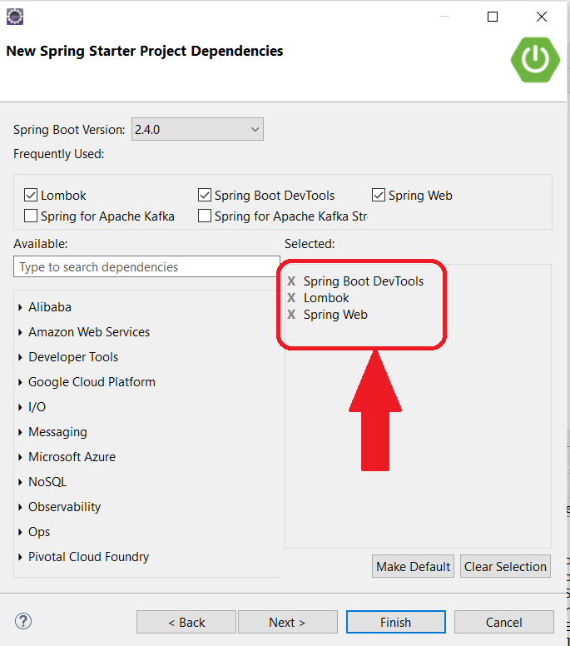

1. Include amazon DynamoDB Java SDK dependency as shown below.

<dependency>

<groupId>com.amazonaws</groupId>

<artifactId>aws-java-sdk-dynamodb</artifactId>

<version>1.11.904</version>

</dependency>

1. Create a model class “Employee” as shown in the below screen.

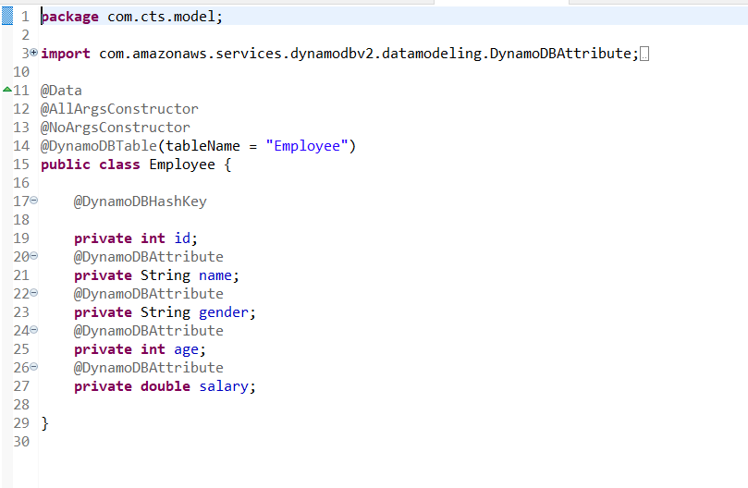

1. Create a DynamoDbConfig Class shown below.

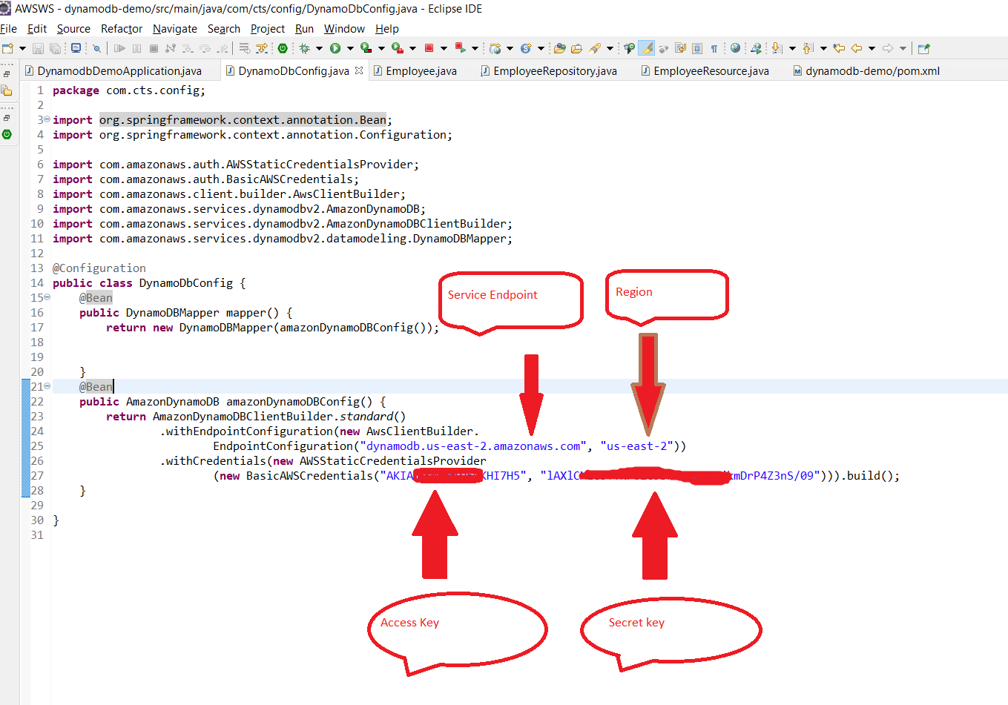

1. Create a EmployeeRepository class as shown below.

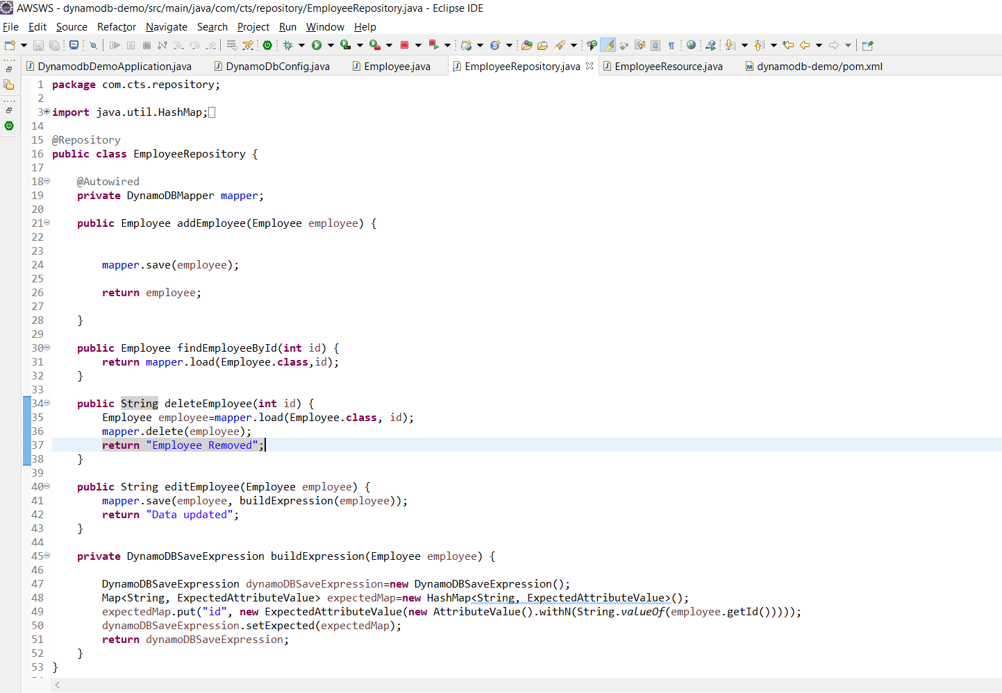

1. Create an EmployeeController class as shown below.

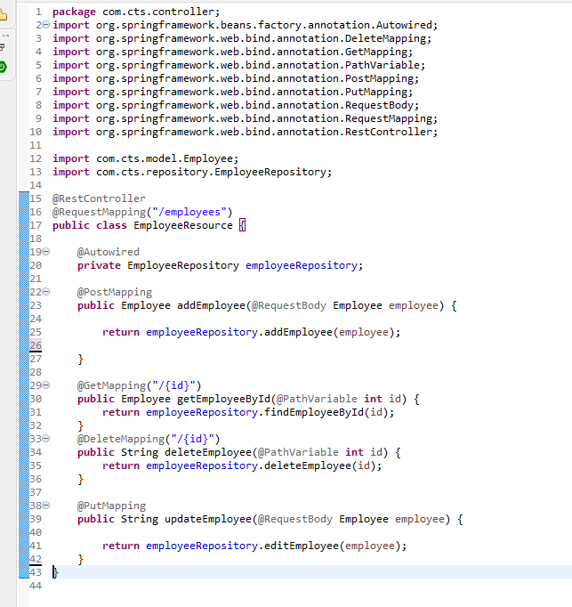

1. Make sure that you application is running in PORT Number 5000.
2. Compile and package your application.
3. Deploy the application to AWS Elastic Beanstalk.

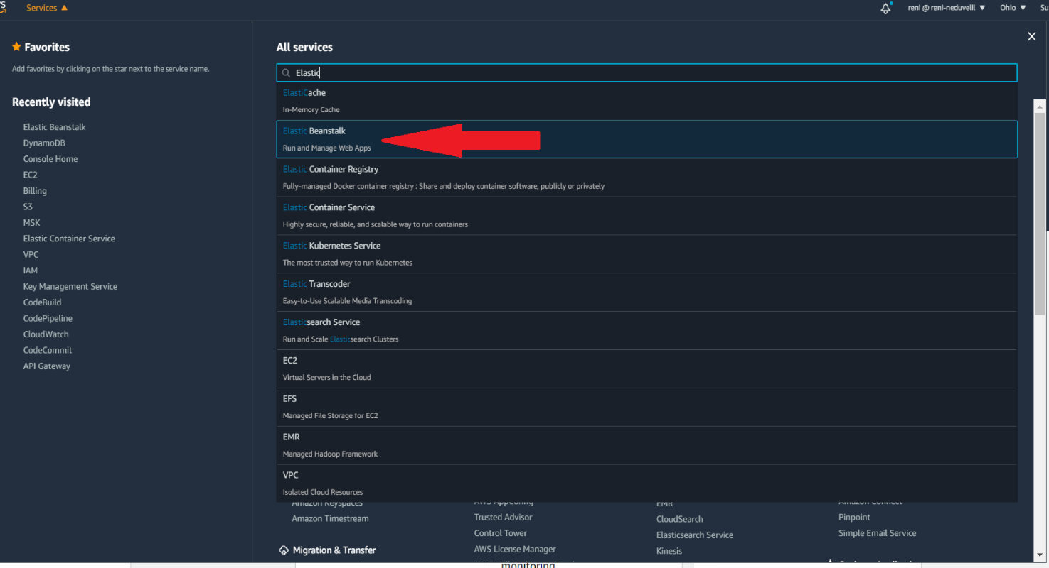

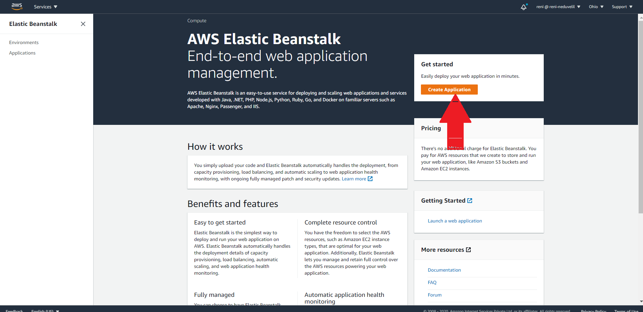

1. Give a name for the application, select platform and upload your “.jar” file.

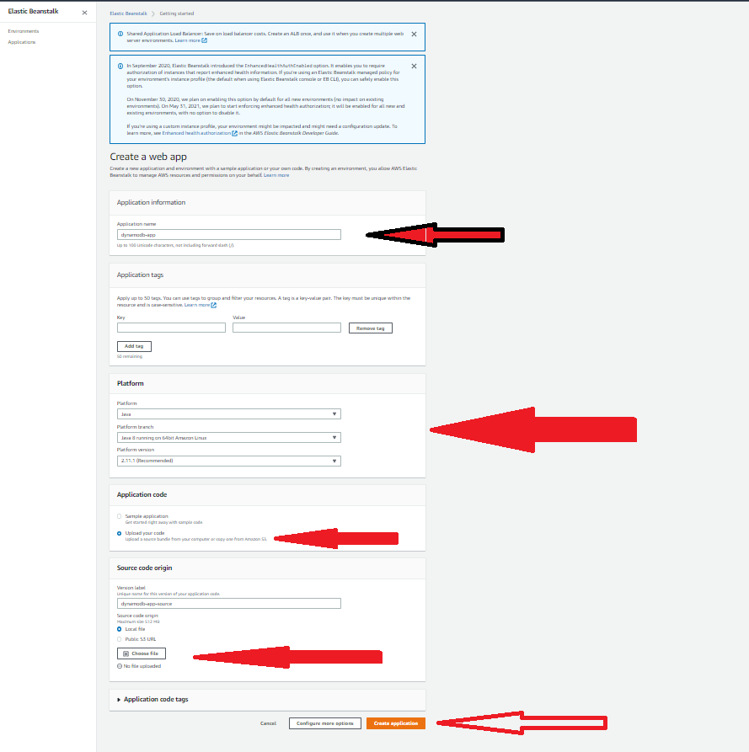

1. Once your application is deployed to the Elastic Beanstalk, copy the url of the application.

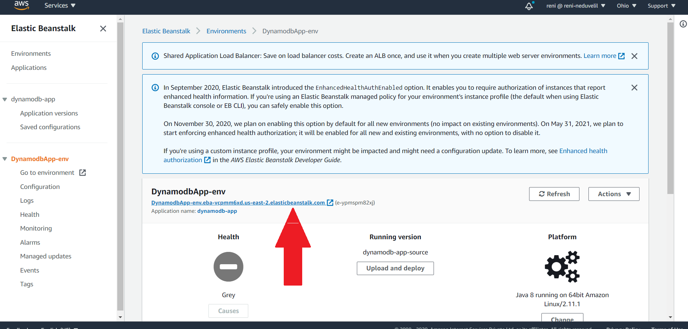

1. Paste it in the url bar of the Postman as shown below. Append /employees and send a POST request.
2. You can see that the added item is returned.

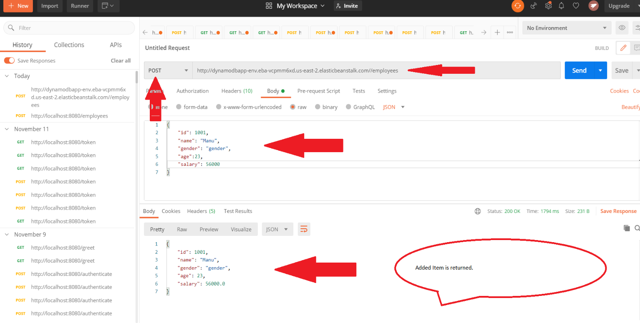

1. Go and check the DynamoDB table to see whether the Item has been added.
2. You can see that the Item has been added.

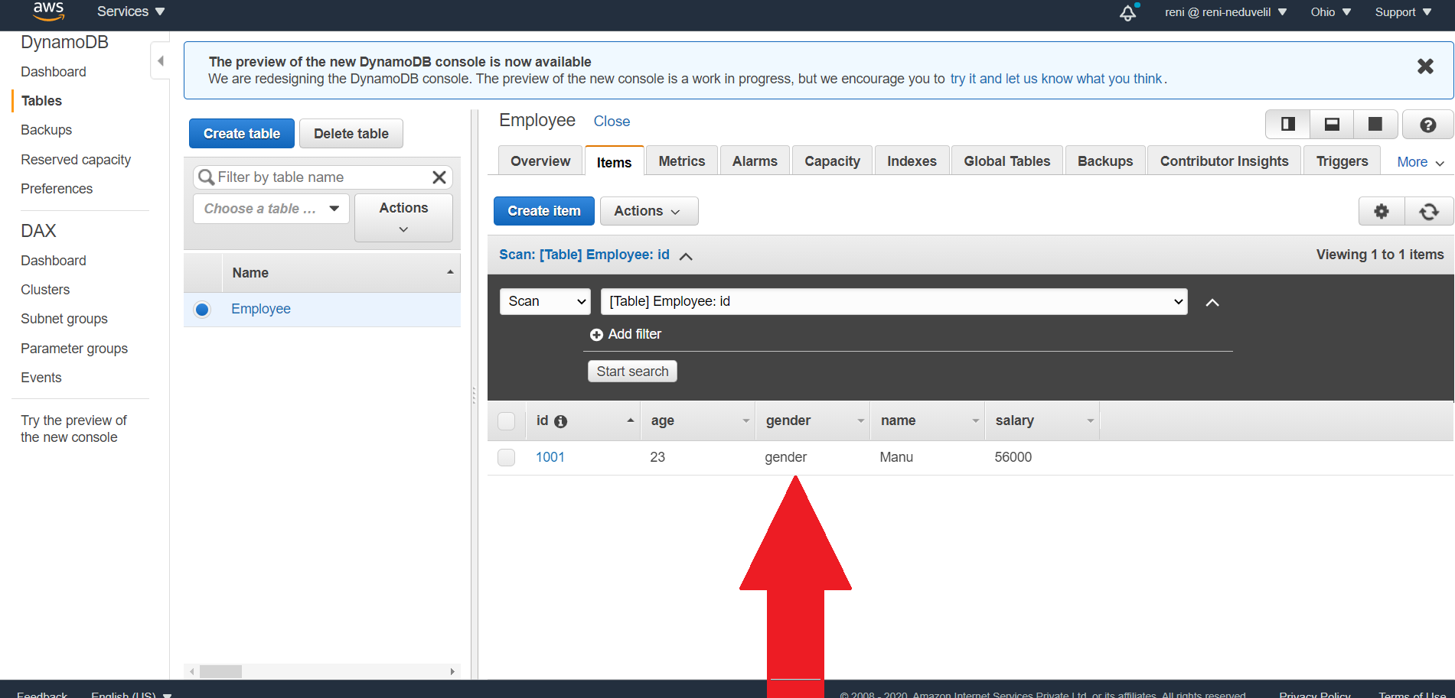

1. You can issue a GET request from the Postman or from the browser and check whether the added item is retrieved.

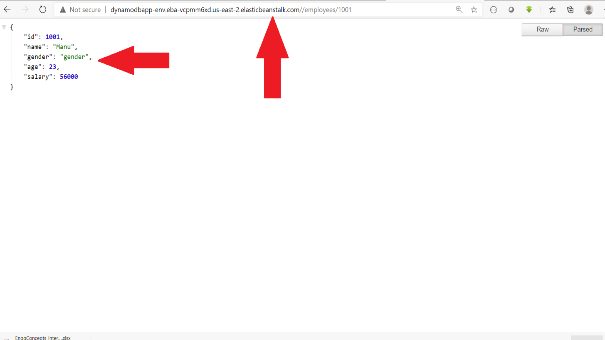

1. Once you are done with the hands-on, make sure that you delete the Elastic Beanstalk application and the DynamoDB table to avoid any additional cost.