Make use of Swagger to create documentation for RESTful/microservices

1. Create a simple RESTful service using Spring BOOT
2. Include the Swagger dependencies

<dependency>

<groupId>io.springfox</groupId>

<artifactId>springfox-swagger-ui</artifactId>

<version>3.0.0</version>

</dependency>

<dependency>

<groupId>io.springfox</groupId>

<artifactId>springfox-swagger2</artifactId>

<version>3.0.0</version>

</dependency>

1. Create a Swagger configuration class as shown below.

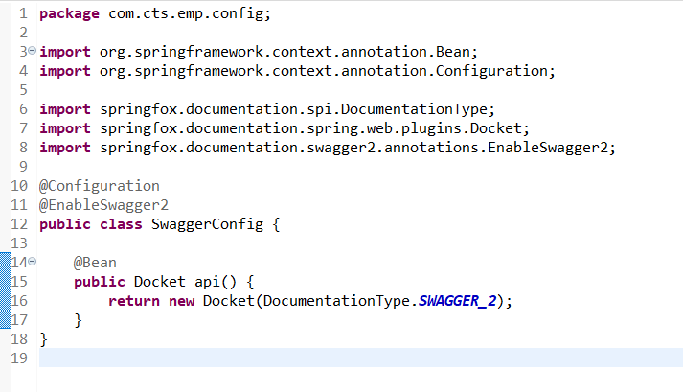

1. Visit the api endpoint “[localhost:8080/v2/api-docs](http://localhost:8080/v2/api-docs)” and you can see the complete API documentation of your service.

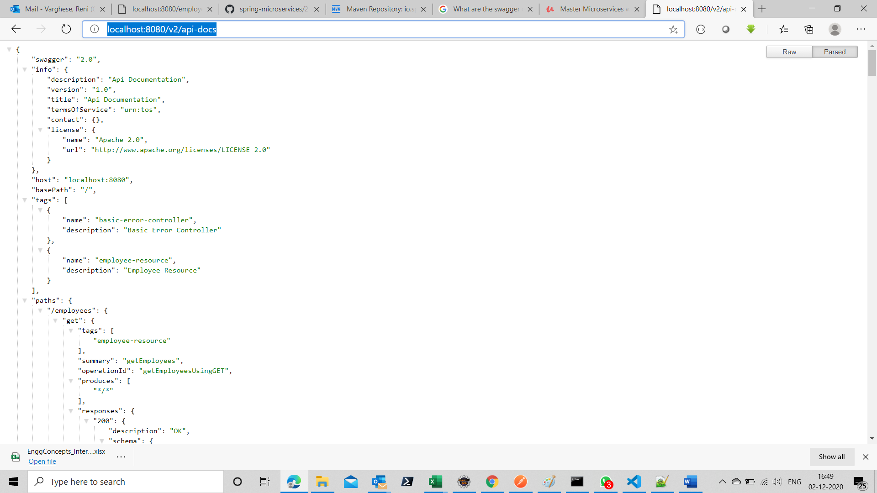

1. We can use Swagger specific annotations to customize the descriptions of model class and the properties.

