**APACHE KAFKA IMPLEMENTATION:**

**1.Kafka_Producer_from_java:**

Producing message with key and value serializer

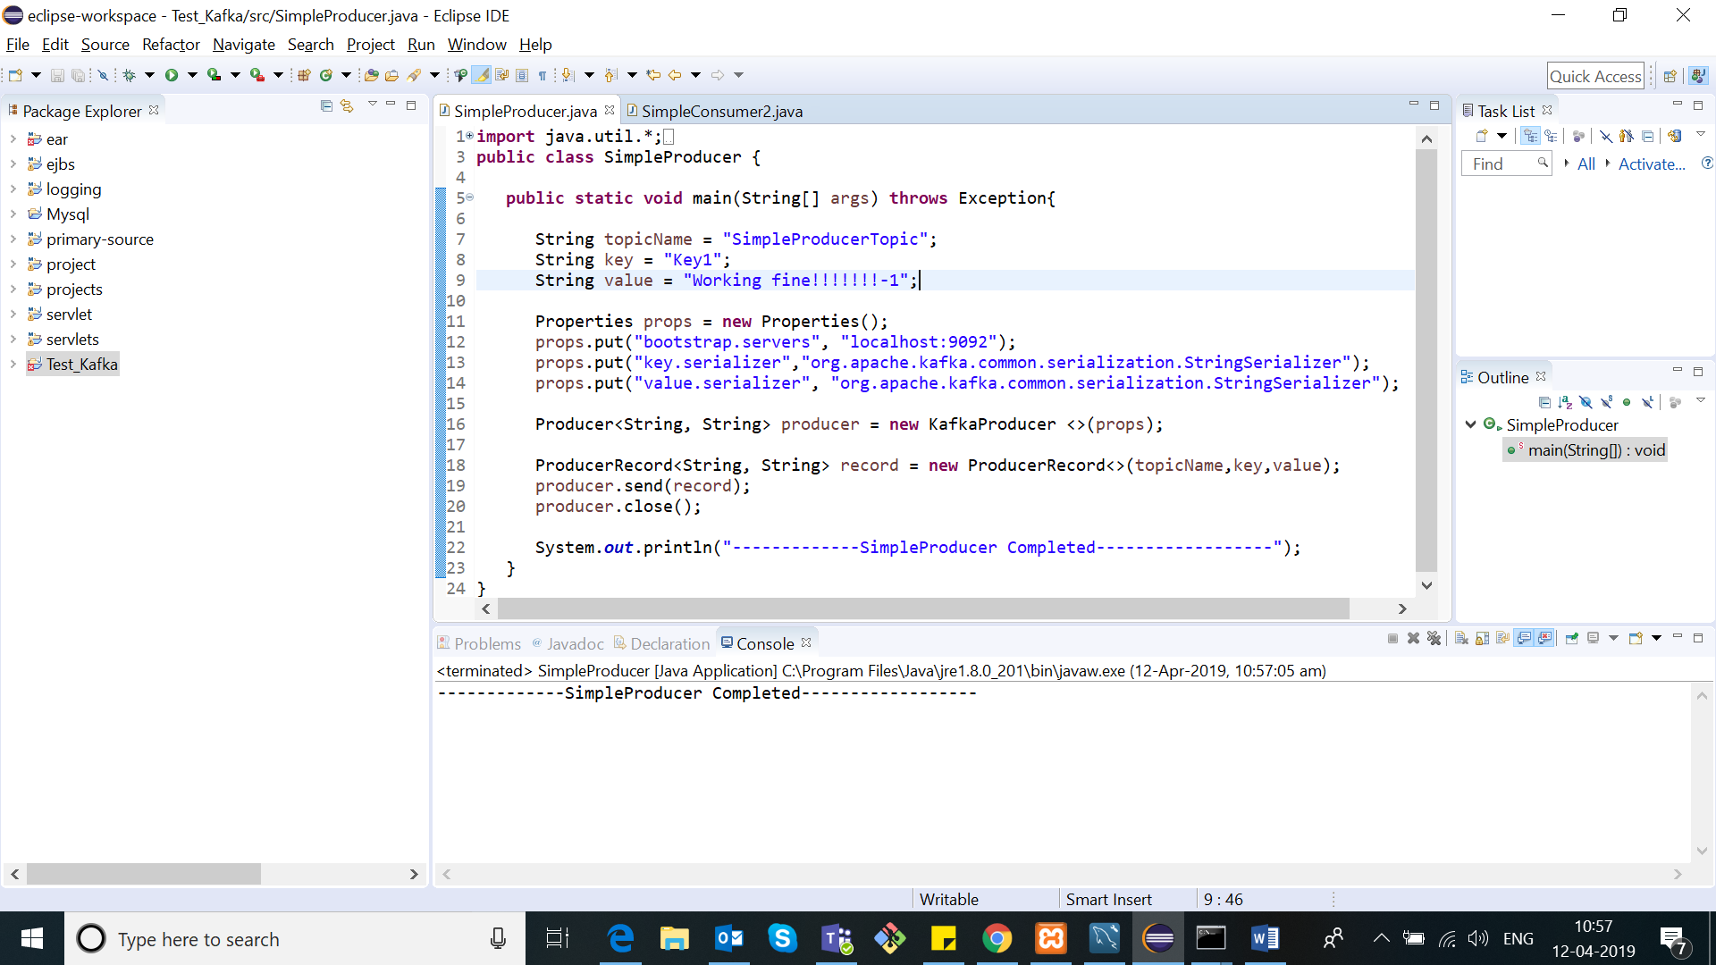

**2.Kafka_Consumer_from_java:**

Consumes message with deserialized key/value and offset value

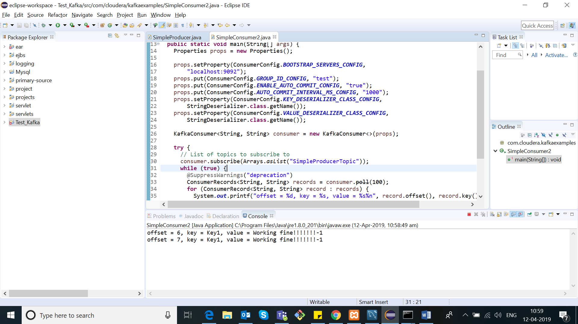

**3.Apache kafka :**

Setup and workflow with kafka-producer-console.bat and kafka-console-consumer.bat

