 

**INSTITUTE FOR ADVANCED COMPUTING AND SOFTWARE DEVELOPMENT**

**(IACSD), AKURDI, PUNE**

**Documentation On**

**‌Pariskha**

**(Exam Portal)**

(**PG-DAC Sept 2023)**

**Submitted By:**

**Group No:115**

**Rollno : Name:**

239112 Vikram singh

239004 Akash Pawar

Mr.Narandra pawar Mr. Rohit Puranik

**Project Guide**  **Centre Coordinator**



**ABSTRACT**

Pariksha ExamPortal is an effort to built an web Application for daily Quiz.The project will focus on Creating website were we can give students a better for enhancing the Knowledge with Quiz test,The project is an Complete Exam Portal using Spring Boot and Angular step by step. In this project will build backend of the exam portal using spring boot technology and front-end using angular and Database using MySql and workbench, the project covers the functionalities such as Register student and login for both user and Admin and how many students have attempt Quiz and their Details and results date and time.

This project assesses students by conducting online objective tests. The tests would be Highly customizable. This project will enable educational institutes to conduct test and Have automated checking of answers based on the response by the candidates. The projects allow faculties to create their own tests. It would enable educational Institutes to perform tests, quizzes and create feedback forms. It asks the faculty to create The set of questions The faculty then creates groups and adds related students to the Roups. Further Furthermore, the tests are associated with specific groups so that only associated Students can appear for the test. The result of the response would be available to the The faculty of the question set. Further Furthermore, the result will also be mailed to the student. This Project would be helpful for creating practice tests, say for educational institutes and Students have a feedback form.



**ACKNOWLEDGEMENT**

I take this occasion to thank God, almighty for blessing us with his grace and taking our endeavor to a successful culmination. I extend my sincere and heartfelt thanks to our esteemed guide, Mr. Narandara pawar for providing us with the right guidance and advice at the crucial junctures and for showing me the right way. I extend my sincere thanks to our respected Centre Co-Ordinator Mr. Rohit Puranik, for allowing us to use the facilities available. I would like to thank the other faculty members also, at this occasion. Last but not the least, I would like to thank my friends and family for the support and encouragement they have given me during the course of our work.

**Vikram singh(230941220211)**

**Akash Pawar (230941220010)**



**INDEX**

| **Sr. No.** | **Title** | **Pg. No.** |
| --- | --- | --- |
| 1 | INTRODUCTION | 5 |
| 1.1 | PURPOSE | 6 |
| 1.2 | SCOPE | 6 |
| 1.3 | OBJECTIVE OF PROJECT ON Prakisha | 6 |
| 1.4 | FUNCTIONALITIES PROVIDED BY Pariksha ARE AS FOLLOWS | 6 |
| 2 | REQUIREMENT | 8 |
| 3 | UML DIAGRAM | 11 |
| 4 | DATABASE DESIGN | 14 |
| 5 | SNAPSHOTS | 21 |
| 6 | REFERENCES | 28 |

Software Requirement Specification(SRS) for

Pariksha-Examportal.

# Introduction

### 1.1 Purpose:

Pariksha ExamPortal is an endeavor aimed at developing a web application for daily quizzes. The project focuses on creating a website where students can enhance their knowledge through quiz tests. The project involves building a complete exam portal using Spring Boot for the backend, Angular for the frontend, and MySQL and MySQL Workbench for the database. The functionalities covered in this project include:

* User Registration: Students can register themselves on the platform.
* User Login: Both users and administrators can log in to their respective accounts.
* Quiz Attempt Tracking: The portal keeps track of how many students have attempted quizzes.
* Student Details: Details of students who have registered and attempted quizzes are stored.
* Results Date and Time: The portal displays the date and time of quiz results.

Throughout the project, a step-by-step approach will be followed to develop the backend using Spring Boot, frontend using Angular, and integrating MySQL as the database. The primary goal is to provide a user-friendly interface for students to engage in quiz tests, track their progress, and view their results efficiently.

### 

### 1.2 Scope:

### This project would be very useful for educational institutes where regular evaluation of students' is required. Further it can also be useful for anyone who requires feedback based on objective type responses.

### 1.3 Definitions:

SRS- Software Requirement Specification

GUI- Graphical User Interface

DFD - Data Flow Diagram

UML - Unified modelling Language

**1.4 Overview:**

* Pariksha ExamPortal is a project aiming to develop a web application for daily quizzes.
* The primary goal is to create a website where students can enhance their knowledge through quiz tests.
* Technologies employed:

Backend: Spring Boot

Frontend: Angular

Database: MySQL with Workbench

* The project is structured as a complete exam portal developed step by step.
* Development includes building the backend using Spring Boot and the frontend using Angular.
* Key functionalities encompass:

 Student registration

User and admin login

Tracking quiz attempts

Displaying detailed results including date and time.

**2.Overall Description**:

This project assesses students by conducting online objective tests. The tests would be Highly customizable. This project will enable educational institutes to conduct test and Have automated checking of answers based on the response by the candidates. The projects allow faculties to create their own tests. It would enable educational Institutes to perform tests, quizzes and create feedback forms. It asks the faculty to create The set of questions The faculty then creates groups and adds related students to the Roups. Further Furthermore, the tests are associated with specific groups so that only associated Students can appear for the test. The result of the response would be available to the The aculty of the question set. Further Furthermore, the result will also be mailed to the student. This Project would be helpful for creating practice tests, say for educational institutes and Students have a feedback form.

**2.1 Product Perspective**:

This product aimed toward a person who want to Enhance Knowledge

**2.2 Product Functions**:

Pariksha ExamPortal should support the following use case:

**Use Case Diagrams:**

A use case is a depiction of a sequence of actions. Graphically, it is represented as an ellipse with a solid line including only its name. A use case diagram is a behavioral diagram illustrating a set of use cases, actors, and their relationships. The diagram showcases associations between use cases and actors, with actors representing real-world entities. In this context, the primary actor is the "User," encompassing both students and administrators, while the secondary actor is the "System" or the ExamPortal itself, facilitating seamless interactions between users and the application.

.

**Use case diagram for user**

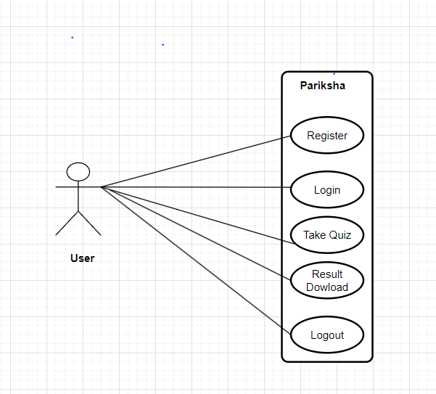



**2.3 User Characeristics**:

User should be familiar with the terms like login, register and take Quiz etc.

**Use case diagram for Admin**

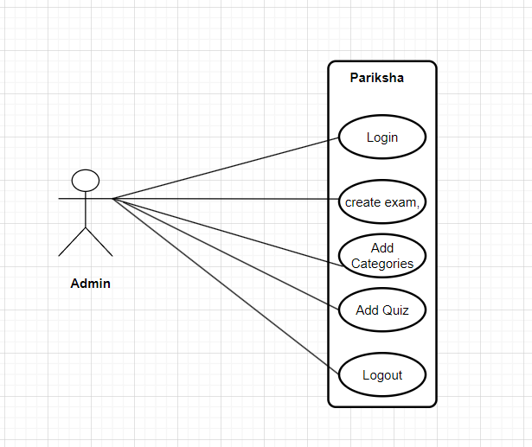

**3 Technical Issues**:

This system will work on client-server architecture. It will require an internet server and which will be able to run web application. The system should support some commonly used browser such as IE, mozzila firefox, chrome etc.

**HARDWARE REQUIREMENT**

Hardware requirements for insurance on internet

will be same for both parties which are as follows:

| **RAM** | 2 GB |
| --- | --- |
| **Hard disk** | 320 GB |
| **Processor** | Dual Core |

**Software Requirements**

**Client side:**

| **Web Browser** | Google Chrome or any  compatible browser |
| --- | --- |
| **Operating System** | Windows or any equivalent OS |

**Server side:**

| **Web Server** | TOMCAT |
| --- | --- |
| **Server side Language** | JAVA |
| **Database Server** | MYSQL |
| **Web Browser** | Google Chrome or any  compatible browser |
| **Operating System** | Windows or any equivalent OS |



**Other Requirements:**

**Hardware and Network Interfaces:**

Back-end Server Configuration:

* Intel Pentium-IV Processor
* 128 MB RAM
* 1 Raid Controller Card
* 32-bit Ethernet Controller (100 Base-T)
* 8 x 2.0 GB Fast SCSI/2 with Raid Support
* 2.88 MB FDD
* 48x CD ROM Drive
* SVGA Colour Monitor on PCI with 1MB RAM
* 101 Keys Keyboard
* 1 Microsoft Mouse with pad
* 4/8 GB DAT
* One Serial & Two Parallel Ports
* Internet Information Server (IIS)
* Microsoft Transaction Server (MTS)

Front-end Client Configuration:

* Intel Pentium-III @ 650 MHz Processor
* 128 MB SDRAM
* 10 GB Hard Disk Drive
* 1.44 MB Floppy Disk Drive
* 15” SVGA Digital Color Monitor
* One Serial, One Parallel port, and One USB port
* 104 Keys Keyboard
* PS2 Mouse with pad
* 32-bit PCI Ethernet Card
* 48X CD Drive

**Communication Interfaces**:

The two parties should be connected by LAN or WAN for the communication purpose.  
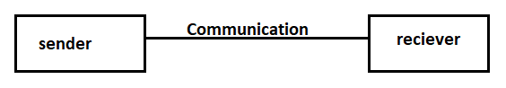







**5.System Design Specification:**

**System Flow Chart**

**ER DIAGRAM**

The Entity-Relationship (ER) model was originally proposed by Peter in 1976 [Chen76] as a way to unify the network and relational database views. Simply stated the ER model is a conceptual data model that views the real world as entities and

relationships. A basic component of the model is the Entity-Relationship diagram which is used to visually represent data objects. Since Chen wrote his paper the model has been extended and today it is commonly used for database design for the database designer, the utility of the ER model is:

* It maps well to the relational model. The constructs used in the ER model can easily be transformed into relational tables.
* It is simple and easy to understand with a minimum of training. Therefore, the model can be used by the database designer to communicate the design to the end user.
* In addition, the model can be used as a design plan by the database developer to implement a data model in specific database management software.

.

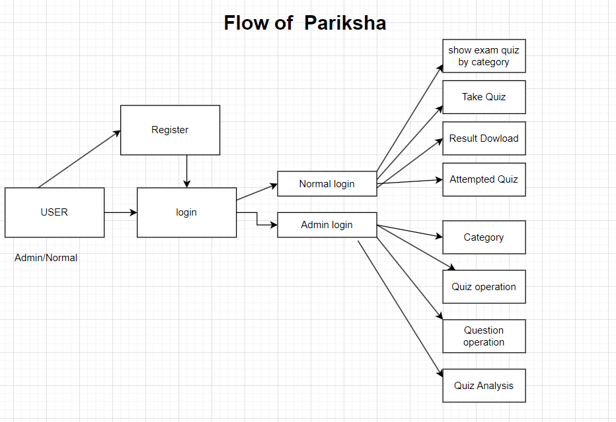

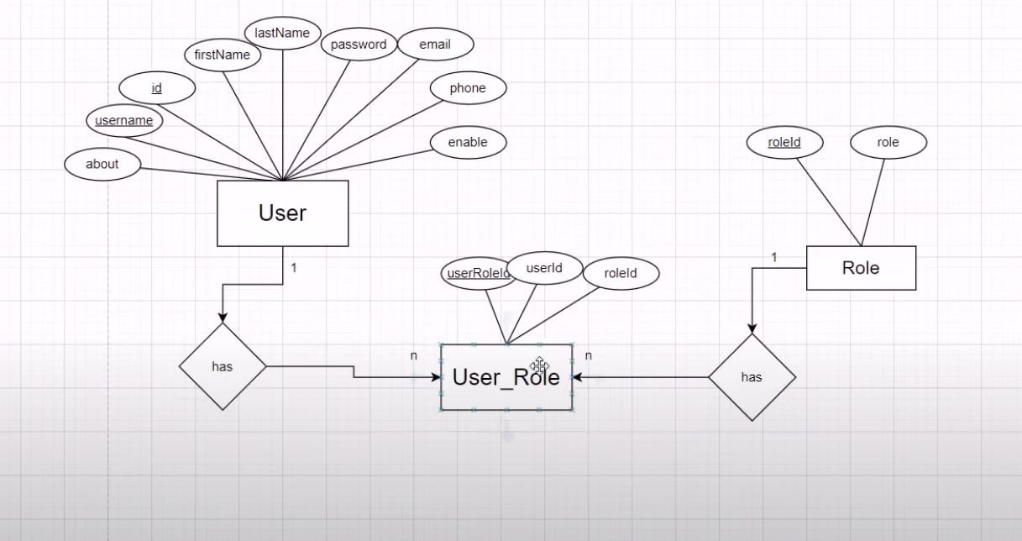

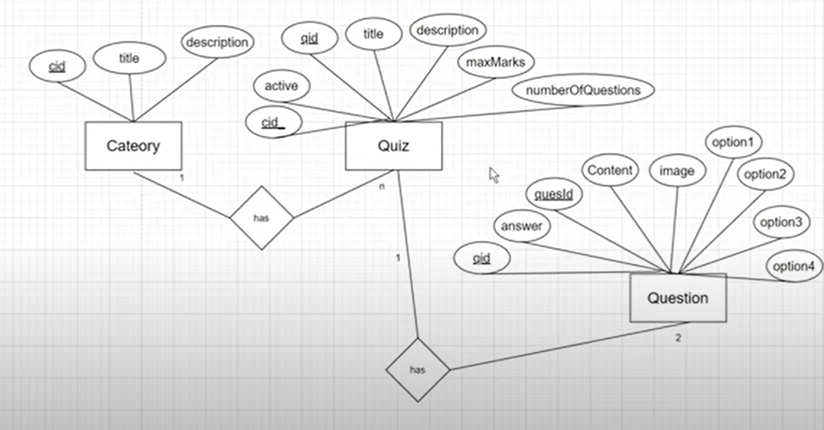



**DATABASE DESIGN**

The data in the system has to be stored and retrieved from database. Designing the database is part of system design. Data elements and data structures to be stored have been identified at analysis stage. They are structured and put together to design the data storage and retrieval system.

A database is a collection of interrelated data stored with minimum redundancy to serve many users quickly and efficiently. The general objective is to make database access easy, quick, inexpensive and flexible for the user. Relationships are established between the data items and unnecessary data items are removed. Normalization is done to get an internal consistency of data and to have minimum redundancy and maximum stability. This ensures minimizing data storage required, minimizing chances of data inconsistencies and optimizing for updates. The MS Access database has been chosen for developing the relevant databases.

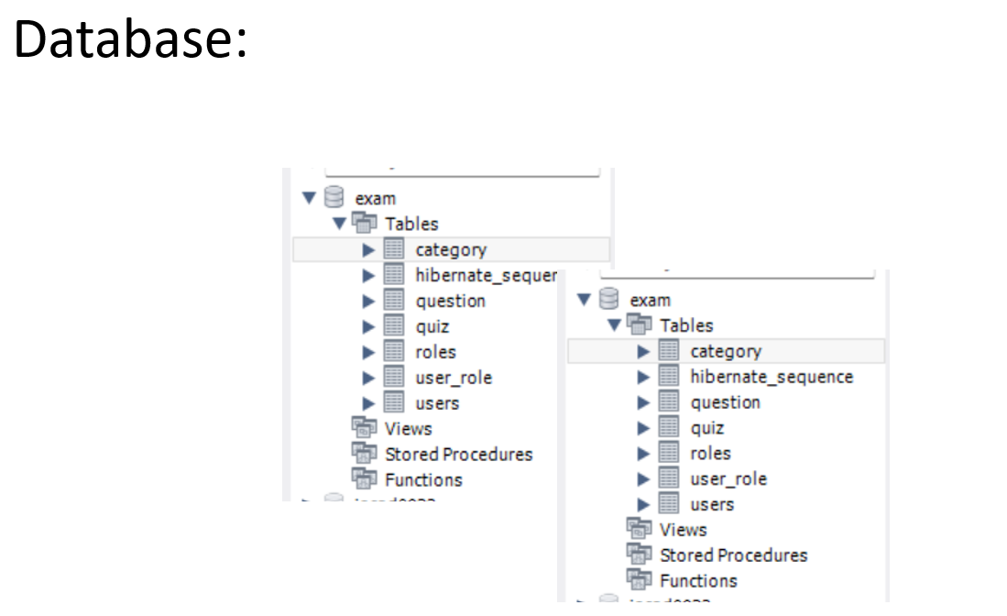



**Tables:**

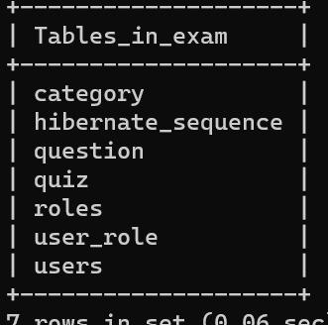

**users:**

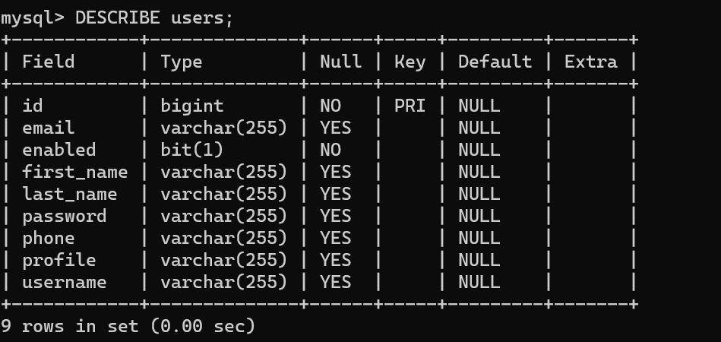

**Category:**

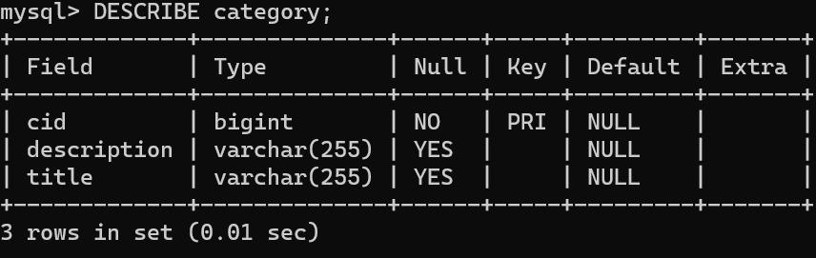

**question:**

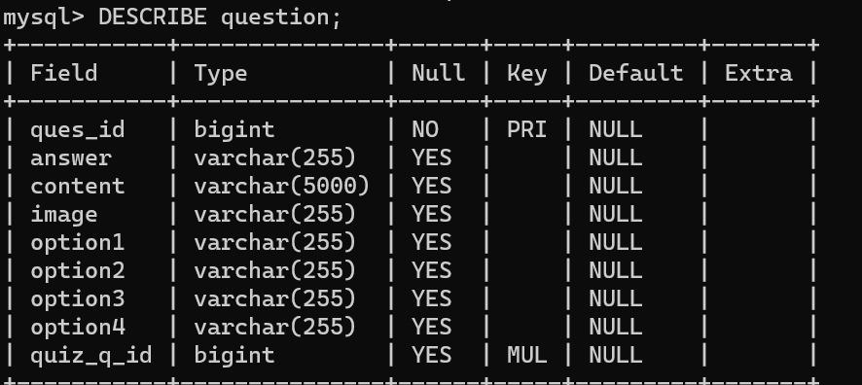

**quiz:**

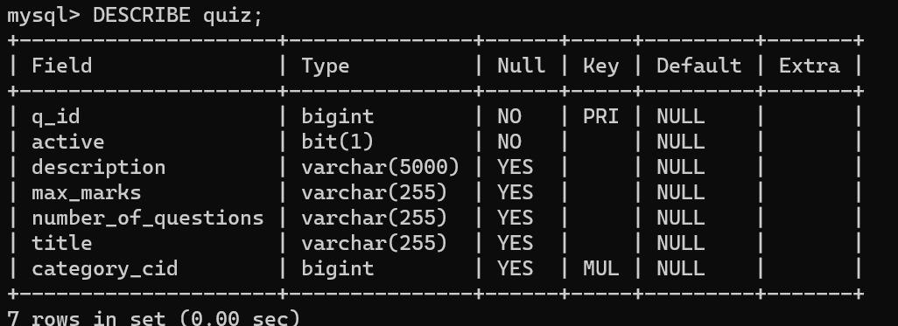

**Roles:**

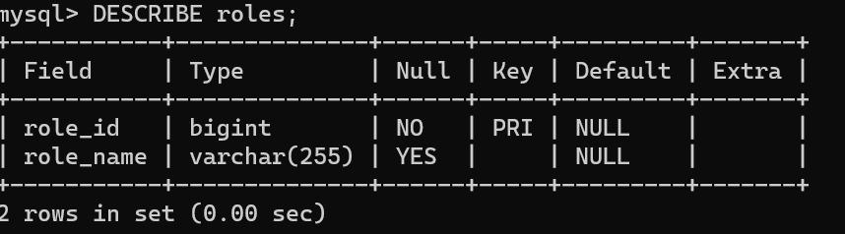



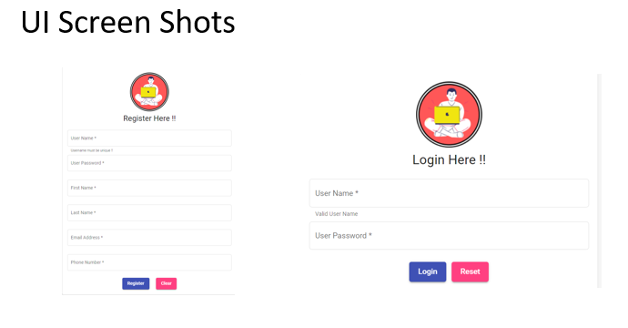

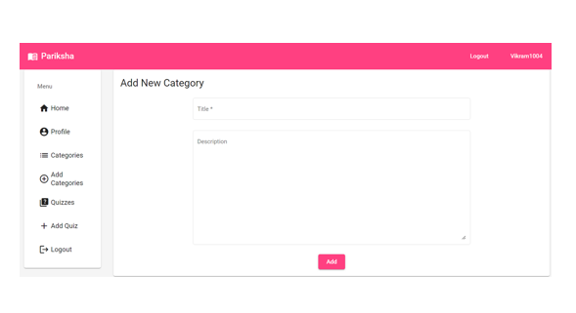





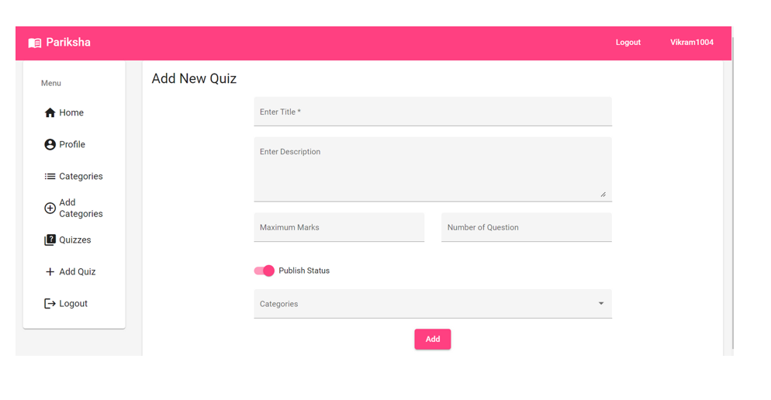

**Admin:**



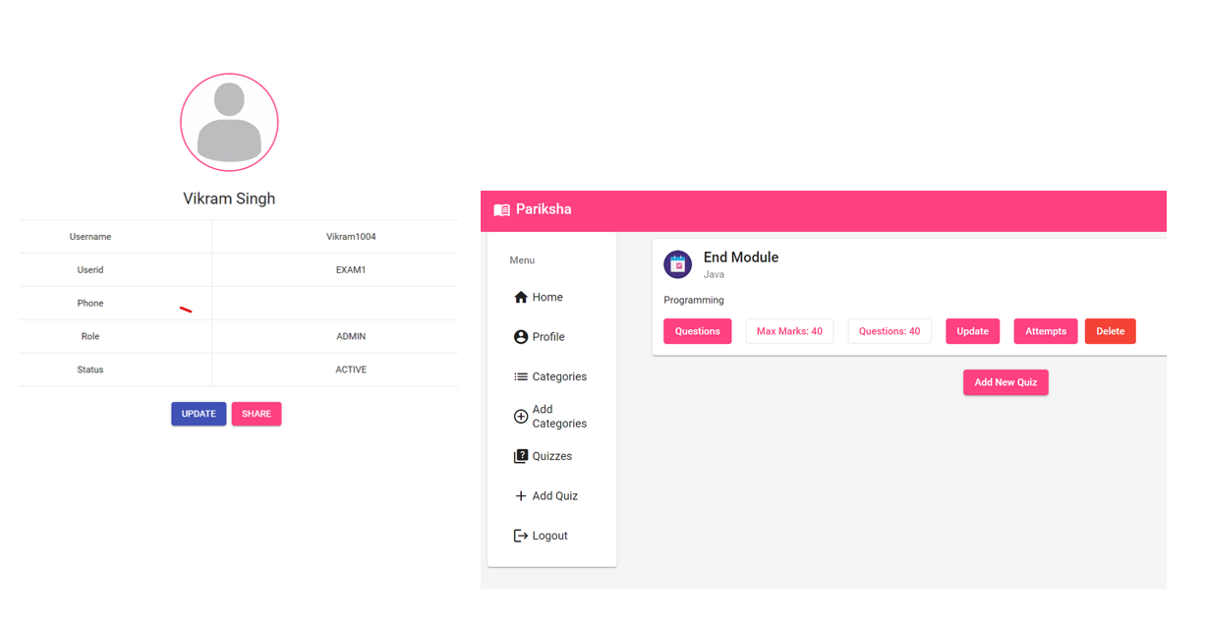



**REFERENCE**

http://www.google.com

http://www.javatpoint.com/java- tutorial

http://www.w3.org

http://www.wikipedia.org

https://www.tutorialspoint.com/java