9.1 Entering, approaching (9)
1. (3P) You want to pull out of a row of parked vehicles into the stream of moving traffic. Behind you is a parked truck and trailer. How do you assess this situation?
- Because of your restricted view, you cannot see approaching vehicles until they are very close
- Because of their restricted view, vehicles approaching from behind cannot see your vehicle until very late
- It is safe to pull out here because you are protected by the truck and trailer behind you
2. (4P) You want to turn out of a road with a sunken kerbstone into another road. A car is coming from the left. What applies here?
- Whoever turns into a road over a sunken kerbstone must wait
- The sunken kerbstone is of no relevance for the obligence to wait
- The rule „right before left“
3. (4P) What must you do when leaving the edge of the roadway?
- Check for traffic from behind
- Switch on your direction indicator
- A look into the rear view mirror is sufficient
4. (4P) You want to leave a traffic calming zone and begin driving along a road. What should you do? I have to
- Indicate the direction of movement prior to taking the turn
- Allow pedestrians on the footpath to walk past
- Observe the „right before left“ rule
5. (4P) You want to leave a traffic-calming zone and begin driving along a road. Cyclists are approaching from the left. Who is required to wait?
- Everyone is required to stop and then agree among one another who should proceed first
- I have to wait
- The cyclists have to wait
6. (4P) You want to leave a property lot and turn right into a road. Cyclists are approaching from the left. Who is required to wait?
- I have to wait
- The cyclists have to wait
- Everyone is required to stop and then agree among one another who should proceed first
7. (4P) You want to leave a property lot and turn into road while passing over footpath. What must you look out for?
- You should be directed by another person if necessary
- Pedestrians on the footpath may not be endangered
- First take note of the flowing traffic on the road
8. (2P) You want to exit a parking space and move into the moving traffic. What should you do?
- I have to take note of the traffic behind me
- I have to indicate before moving off
- I may not endanger the moving traffic
9. (4P) You want to exit the property lot. What is the right thing to do?
- I may drive on if the pedestrians waive their right of way
- I have to wait until the pedestrians have crossed over the exit
- I sound my horn briefly so that the pedestrians will allow me to exit
------------------------------------------------------------------------------------------------------------------------------------------------------
9.2 Driving alongside (16)
1. (4P) What must you remember when you want to change lanes?
- You must signal your intention to change lanes in time
- You must pay attention to the traffic following behind
- You must always brake heavily before changing lanes
2. (3P) On a road with several lanes in one direction, one of the lanes ends ahead. You are driving on the lane which is coming to an end. What should you do?
- Only move over just before the road starts to narrow by following the zipper feed-in method
- Move into the through lane immediately after you see the first sign indicating that the road will narrow
- Always be the first to move over into the through lane
3. (3P) In what situations is the alternate merging procedure to be used?
- If lanes are not continuously free to traffic due to an obstacle
- When lanes come to an end
- Where merging lanes join
4. (3P) A lane terminates on a road with several lanes heading in the same direction. What should you do when driving on the through lane? I have to
- Allow traffic on the terminating lane to merge in accordance with the alternate merging procedure
- Drive past the vehicles on the terminating lane
- Make eye-contact and then decide according to the situation
5. (4P) What should you know about using the rear-view mirror?
- I am unable to see vehicles and pedestrians in the blind spot
- Rear-view mirrors must be adjusted to the particular driver
- The interior mirror has no blind spot to the right side
6. (4P) You want to continue driving straight ahead. What is the right course of action? [Insert Picture]
7. (5P) Video Question . What is the right course of action ?
- I slow down
- I accelerate
- I continue driving as before
8. (5P) Video Question . What is the right course of action ?
- I remain behind the bus for the moment
- I overtake the bus at a moderate speed
- I switch lane without overtaking immediately
9. (4P) Video Question . What should you do?
- Reduce speed, be ready to brake
- Move to the left-hand lane
- Continue driving, flash lights to signal
10. (4P) Video Question – What is the right course of action?
- I wait before the obstruction
- I continue slowing down
- I switch to the left-hand lane

11. (4P) For what reason do you have to switch to the right hand lane now?
- Because of the rule on using the right hand lane unless overtaking etc
- Because of the red car
- Because of the tractor
12. (4P) Video Question : Why do you have to slow down here?
- Because of the truck
- Because of the white car
- Because of the speed limit
13. (4P) Video Question : What should you do now?
- I let the blue car to merge in front of me
- I immediately change from the left lane to the central lane
- I accelerate
14. (4P) Video Question : You want to continue straight ahead. What should you do?
- I change lanes just before the narrowing of the road
- I move into the right-hand lane now
15. (3P) What do you do if you want to drive straight on?
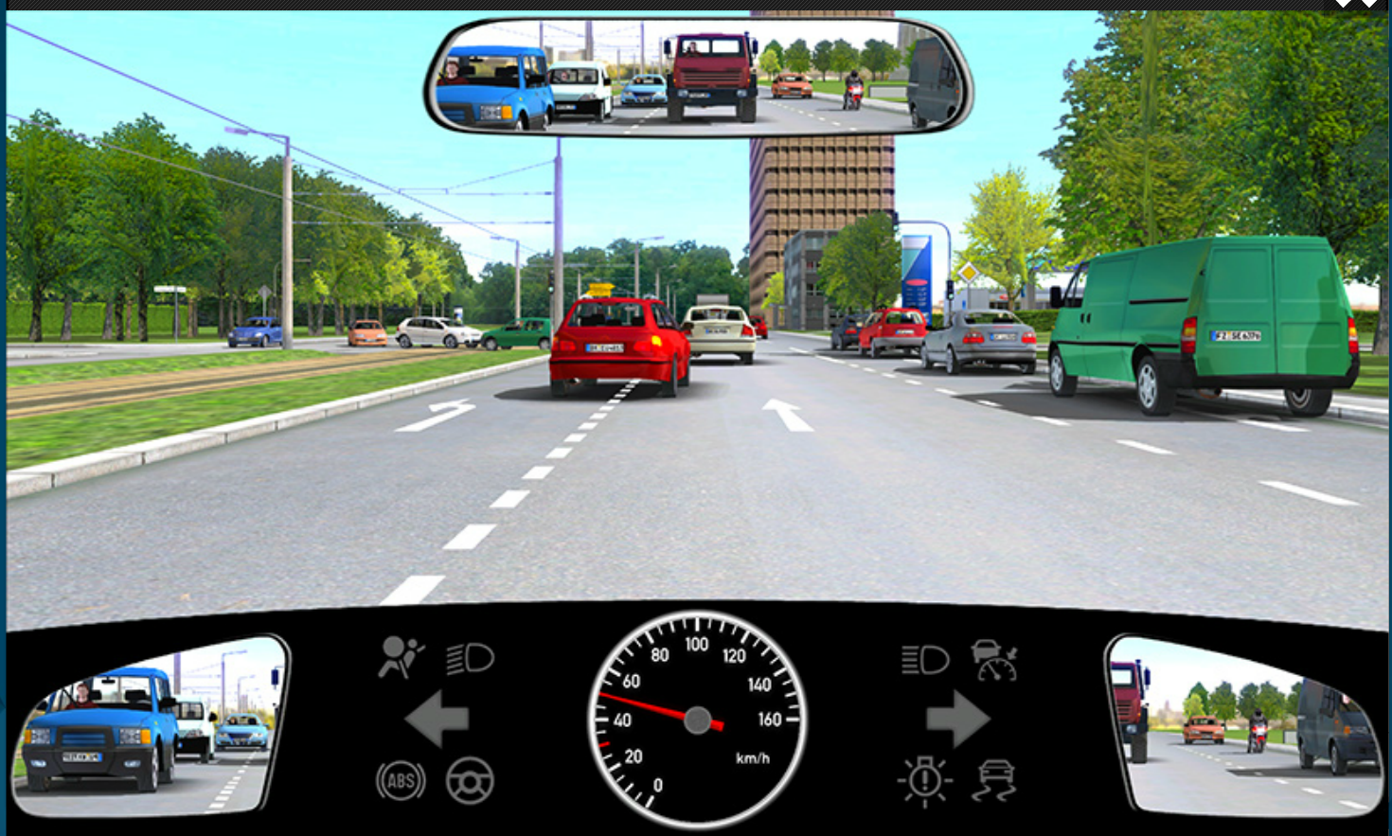
- Brake so that the driver in front can change lanes
- Overtake the other vehicle in the left-hand line since the traffic light is green
- Sound your horn to indicate to the driver in front that he may not change lanes so close to the crossroads
16. (4P) What must you reckon with here?
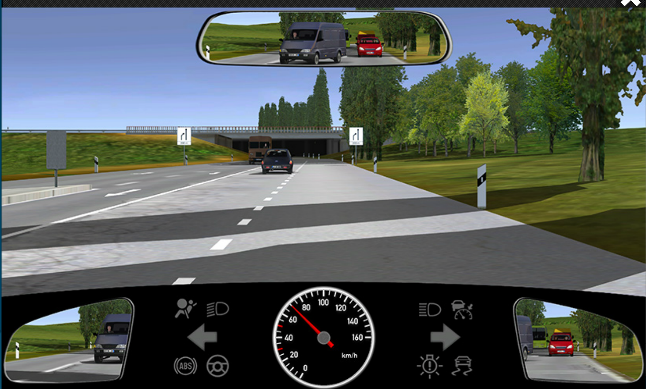
- The vehicle in front changing lanes
- Denser traffic beyond the underpass
- The right hand lane coming to an end
------------------------------------------------------------------------------------------------------------------------------------------------------

9.3 Passing (17)
1. ()
2. ()
3. ()
4. ()
5. ()
6. ()
7. ()
8. ()
9. ()
10. ()
11. ()
12. ()
13. ()
14. ()
15. ()
16. ()
17. ()
------------------------------------------------------------------------------------------------------------------------------------------------------
9.4 Overtaking (66)
------------------------------------------------------------------------------------------------------------------------------------------------------
9.5 Turning (33)
------------------------------------------------------------------------------------------------------------------------------------------------------

9.6 Driving in Reverse (3)
1. (3P) What is the right course of action when reversing? I look behind me and
- Drive slowly and attentively
- Make sure that no-one is located in my blind spot
- Ensure the road area is safe by additionally looking all around me
2. (3P) Ahead of the motorbike a car is seeking to reverse on the road. What should you anticipate?
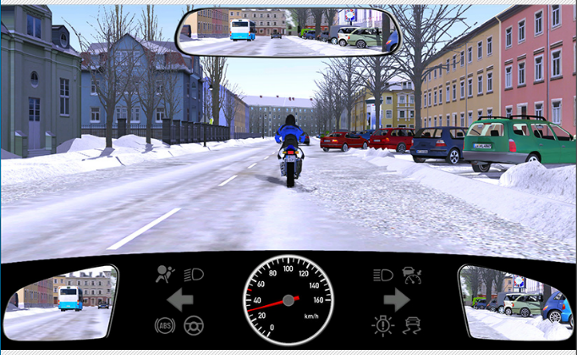
- That the car continues to reverse
- That the motorbike will suddenly brake
- That my braking distance will be longer than normal
3. (5P) Video Question : What should you do now?
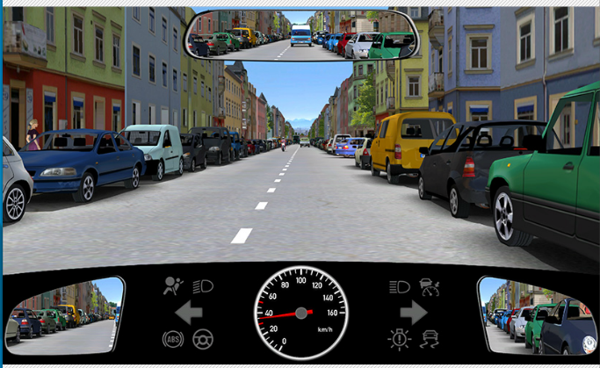
- Slow down and be ready to brake
- Continue driving as before
- Swerve to the left
------------------------------------------------------------------------------------------------------------------------------------------------------
9.7 Swerving (1)
1. (5P) Video Question: What must you do in this situation?
- I immediately brake sharply
- I do not swerve
- I steer to the left
------------------------------------------------------------------------------------------------------------------------------------------------------

