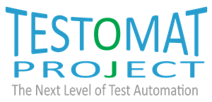

Contribution to final report

For EKS InTec

2020-06-05 2020
Version 0.3

Edited by:
Thorsten Schmitz
9

Revision history
Date | Version | Comments
2020-05-14 | 0.1 | Initial document - Template mode
2020-05-27 | 0.2 | Updates after first review!
2020-06-05 | 0.3 | Updated - and added what is public, and what is in report (for itea) called Visibility
2020-06-11 | 0.4 | Updated. It is not only ONE challenge. Added text

Contents
Revision history 2
Contents 3
Introduction 4
Why is TESTOMAT Project a Success for us: 5
1. Catch-phrase: 5
2. Text: A bit longer -3-5 rows (for a press-release) and web 5
Who were are Collaborators (of this success- give kudos) 5
Main Challenge and Innovation 5
Unique Selling point 5
Innovations Realized 6
Technical Achievements 6

Introduction
EKS InTec GmbH
EKS InTec GmbH provides services for planning, development, simulation and commissioning of production facilities and special purpose machines ranging from simple to complex. Our primary customer is the automotive industry. EKS-InTec covers the entire digital development process, including process planning, the design of stations and complete manufacturing systems for the car body production as well as the simulation and optimization of manufacturing processes during virtual and real commissioning.
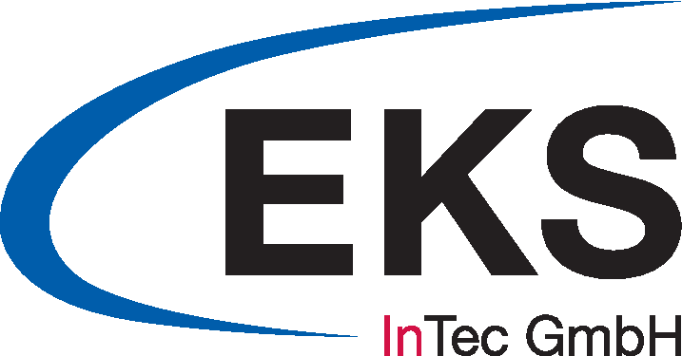

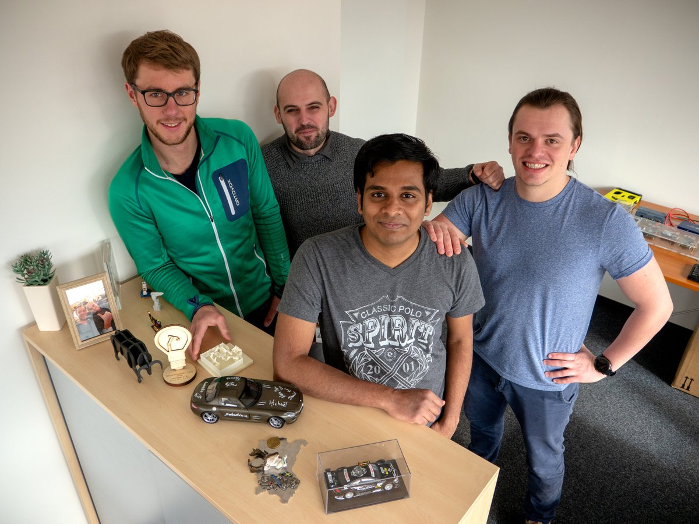
Dr. Anton Strahilov, Head of Research
Thorsten Schmitz, Project Coordinator Research
Dimitri Penner, Project Coordinator Research
Thiruvikraman Sourirajalu, Software developer

Why is TESTOMAT Project a Success for us:
(Visibility: Definitely public) Testimonial to be linked to the web per partner 1-3)

Catch-phrase:
We can now offer a time-saving service that can automatically test a robot program for the movement and reachability of points and perform detailed logic test of PLC programs.

Text: A bit longer -3-5 rows (for a press-release) and web
A prototype of a robot program test tool was developed as part of the TESTOMAT project. This tool helps to save time during the robot program test process. Therefore the time saved can be used for other important tests that have not yet been performed. This leads to a better software quality of the tested production cell. In addition, EKS has developed a prototype PLC program test tool as part of TESTOMATproject that increases the test coverage of the PLC logic. Such PLC program tests were previously performed manually and the test coverage was insufficient.

Who were are Collaborators (of this success- give kudos)
We have mainly worked with the FFT on the above mentioned success story. We also worked together with ifak and Fokus on many of the common goals of the project, e.g. on the brochures, the book etc. with the respective work package leaders. Furthermore the cooperation with ifak has to be mentioned and emphasized.

Main Challenge and Innovation
The main challenge for EKS was to find out how a system manufacturer could improve the quality of its PLC as well as robot programs and avoid failures.
As a result, EKS has to meet the challenge of packaging the needs of system manufacturers into usable and effective tools.
Thus EKS was able to realize two innovations in the form of prototypes that enable the quality of robot programs and PLC programs to be increased by making it easier and more systematic to detect errors.

Unique Selling point

With this result, EKS can offer a new tool and use it itself for semi-automated testing of robot programs and checking of PLC program logic. All movement commands as well as step into a step chain are automatically checked for accessibility and uniqueness. This saves a lot of time when preparing a virtual commissioning but also when performing the real commissioning. With the help of this time saving, regression tests can be carried out after adjustments have been made during execution.
Virtual Commissioners can use both tool to test robot programs from the point of view of accessibility of robot programming as well as to cover the uniqueness of the PLC program without having any knowledge.

Innovations Realized
A prototypical robot program test tool and PLC program test tool. These two tools include the use of the ABB SDK and parts of the Siemens SDK. Also the feasibility of automated test execution for robot program tests proven respective PLC programs has been partially proven. An extension for other robot manufacturers such as Fanuc or Kuka is possible but not planned within TESTOMAT. With regard to the PLC programs, the prototype can also be extended to other PLC hardware and languages but is not addressed into TESTOMAT.

Technical Achievements
- Basis-model realized as C# classes which can be used for different robot types and PLC languages.
- User Interface for both test tools are realized in such a way that they can be used independently.
- First running test tool as prototype for robot programs and PLC programs

