Collections in Java
Collections in java is a framework that provides an architecture to store and manipulate the group of objects.
All the operations that you perform on a data such as searching, sorting, insertion, manipulation, deletion etc. can be performed by Java Collections.

What is Collection framework
Collection framework represents a unified architecture for storing and manipulating group of objects. It has:
- Interfaces and its implementations i.e. classes
- Algorithm

Hierarchy of Collection Framework
Let us see the hierarchy of collection framework.The java.util package contains all the classes and interfaces for Collection framework.



Iterator interface
Iterator interface provides the facility of iterating the elements in forward direction only.

Java Non-generic Vs Generic Collection
Java collection framework was non-generic before JDK 1.5. Since 1.5, it is generic.
Java new generic collection allows you to have only one type of object in collection. Now it is type safe so typecasting is not required at run time.
Let's see the old non-generic example of creating java collection.
- ArrayList al=new ArrayList();//creating old non-generic arraylist
Let's see the new generic example of creating java collection.
- ArrayList<String> al=new ArrayList<String>();//creating new generic arraylist
In generic collection, we specify the type in angular braces. Now ArrayList is forced to have only specified type of objects in it. If you try to add another type of object, it gives compile time error.

Java ArrayList class

Java ArrayList class uses a dynamic array for storing the elements. It inherits AbstractList class and implements List interface
he important points about Java ArrayList class are:
- Java ArrayList class can contain duplicate elements.
- Java ArrayList class maintains insertion order.
- Java ArrayList class is non synchronized.
- Java ArrayList allows random access because array works at the index basis.
- In Java ArrayList class, manipulation is slow because a lot of shifting needs to be occurred if any element is removed from the array list

- List<String> data=new ArrayList<String>();
- data.add("zzaaa");
- data.add("ppp");
- data.add("qqqq");
- System.out.println(data);

- Iterator<String> itr= data.iterator();
- while(itr.hasNext())
- {
- System.out.println(itr.next());

- }

[zzaaa, ppp, qqqq]
zzaaa
ppp
qqqq
Diff between lsy and arraylist reference
List reference
You can only call methods defined in the List interface, e.g., add(), get(), remove(), size(), etc.
ArrayList reference
You can call all List methods plus any extra methods specific to ArrayList, like trimToSize() or ensureCapacity().

Java LinkedList class

Java LinkedList class uses doubly linked list to store the elements. It provides a linked-list data structure. It inherits the AbstractList class and implements List and Deque interfaces

The important points about Java LinkedList are:
- Java LinkedList class can contain duplicate elements.
- Java LinkedList class maintains insertion order.
- Java LinkedList class is non synchronized.
- In Java LinkedList class, manipulation is fast because no shifting needs to be occurred.
- Java LinkedList class can be used as list, stack or queue

Doubly Linked List.

This is a Java Program to implement a Doubly Linked List. A linked list is a data structure consisting of a group of nodes which together represent a sequence. Under the simplest form, each node is composed of a data and a reference (in other words, a link) to the next node in the sequence

A Doubly Linked List (DLL) contains an extra pointer, typically called previous pointer, together with next pointer and data which are there in singly linked list.

Advantage over singly linked list
1) A DLL can be traversed in both forward and backward direction.
2) The delete operation in DLL is more efficient if pointer to the node to be deleted is given.
In singly linked list, to delete a node, pointer to the previous node is needed. To get this previous node, sometimes the list is traversed. In DLL, we can get the previous node using previous pointer.
Disadvantages over singly linked list
1) Every node of DLL Require extra space for an previous pointer. It is possible to implement DLL with single pointer though (See this and this).
2) All operations require an extra pointer previous to be maintained. For example, in insertion, we need to modify previous pointers together with next pointers. For example in following functions for insertions at different positions, we need 1 or 2 extra steps to set previous pointer.

Difference between ArrayList and LinkedList
ArrayList and LinkedList both implements List interface and maintains insertion order. Both are non synchronized classes.
But there are many differences between ArrayList and LinkedList classes that are given below.
ArrayList LinkedList
- ArrayList internally uses dynamic array to store the elements.
LinkedList internally uses doubly linked list to store the elements

- Manipulation with ArrayList is slow because it internally uses array. If any element is removed from the array, all the bits are shifted in memory.
Manipulation with LinkedList is faster than ArrayList because it uses doubly linked list so no bit shifting is required in memory.
- ArrayList class can act as a list only because it implements List only
.LinkedList class can act as a list and queue both because it implements List and Deque interfaces.
- ArrayList is better for storing and accessing data.
LinkedList is better for manipulating data.

hashing
Hashing is the transformation of a string of characters into a usually shorter fixed-length value or key that represents the original string. Hashing is used to index and retrieve items in a database because it is faster to find the item using the shorter hashed key than to find it using the original value. It is also used in many encryption algorithms

In computing, a hash table (hash map) is a data structure which implements an associative array abstract data type, a structure that can map keys to values. A hash table uses a hash function to compute an index into an array of buckets or slots, from which the desired value can be found.

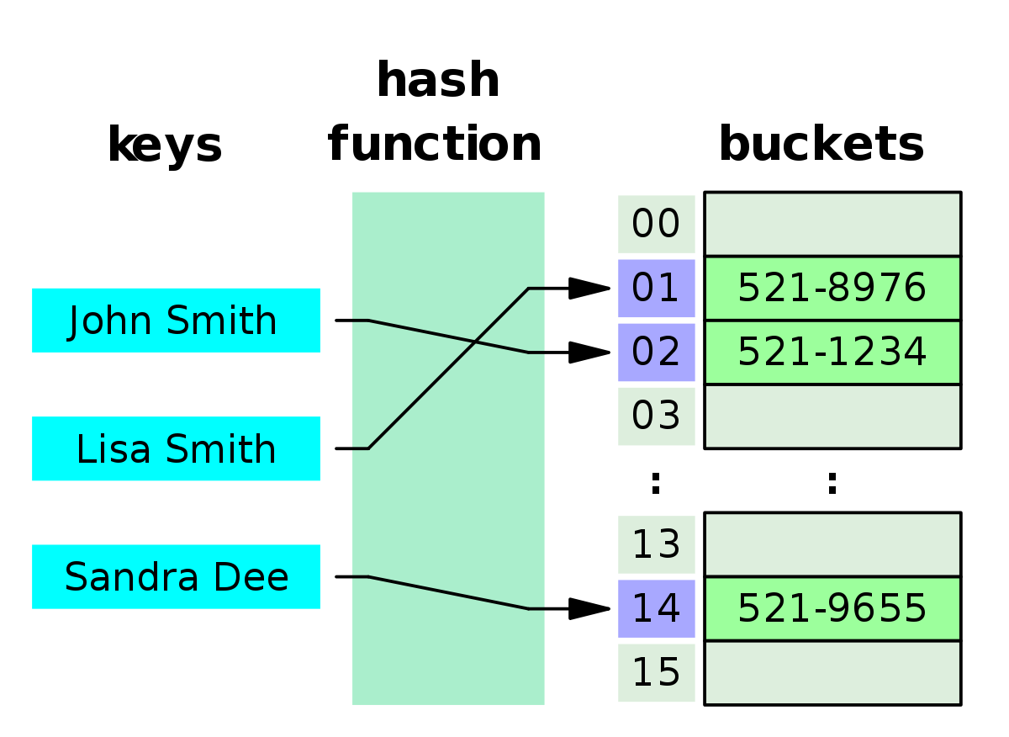

Java HashSet class

Java HashSet class is used to create a collection that uses a hash table for storage. It inherits the AbstractSet class and implements Set interface.
The important points about Java HashSet class are:
- HashSet stores the elements by using a mechanism called hashing.
- HashSet contains unique elements only.

Difference between List and Set
List can contain duplicate elements whereas Set contains unique elements only

HashSet<String> set=new HashSet<String>();
set.add("Ravi");
set.add("Vijay");
set.add("Ravi");
set.add("Ajay"); //Traversing elements
Iterator<String> itr=set.iterator();
while(itr.hasNext()){
System.out.println(itr.next());

Java LinkedHashSet class
Java LinkedHashSet class is a Hash table and Linked list implementation of the set interface. It inherits HashSet class and implements Set interface

The important points about Java LinkedHashSet class are:
- Contains unique elements only like HashSet.
- Provides all optional set operations, and permits null elements.
- Maintains insertion order.

LinkedHashSet<String> al=new LinkedHashSet<String>();
al.add("Ravi");
al.add("Vijay");
al.add("Ravi");
al.add("Ajay");
Iterator<String> itr=al.iterator();
while(itr.hasNext()){
System.out.println(itr.next());

Java Deque Interface
Java Deque Interface is a linear collection that supports element insertion and removal at both ends. Deque is an acronym for "double ended queue".
ss are:
- Contains unique elements only like HashSet.
- Provides all optional set operations, and permits null elements.
- Maintains insertion order.

Java Queue Interface
Java Queue interface orders the element in FIFO(First In First Out) manner. In FIFO, first element is removed first and last element is removed at last

Java Map Interface

A map contains values on the basis of key i.e. key and value pair. Each key and value pair is known as an entry. Map contains only unique keys.
Map is useful if you have to search, update or delete elements on the basis of key.

Map<Integer,String> map=new HashMap<Integer,String>();
map.put(100,"Amit");
map.put(101,"Vijay");
map.put(102,"Rahul");
for(Map.Entry m:map.entrySet()){
System.out.println(m.getKey()+" "+m.getValue());

HashMap class

Java HashMap class implements the map interface by using a hashtable. It inherits AbstractMap class and implements Map interface.
The important points about Java HashMap class are:
- A HashMap contains values based on the key.
- It contains only unique elements.
- It may have one null key and multiple null values.
- It maintains no order.

HashMap<Integer,String> hm=new HashMap<Integer,String>();
hm.put(100,"Amit");
hm.put(101,"Vijay");
hm.put(102,"Rahul");
for(Map.Entry m:hm.entrySet()){
System.out.println(m.getKey()+" "+m.getValue());

Java LinkedHashMap class

Java LinkedHashMap class is Hash table and Linked list implementation of the Map interface, with predictable iteration order. It inherits HashMap class and implements the Map interface

The important points about Java LinkedHashMap class are:
- A LinkedHashMap contains values based on the key.
- It contains only unique elements.
- It may have one null key and multiple null values.
- It is same as HashMap instead maintains insertion order.

LinkedHashMap<Integer,String> hm=new LinkedHashMap<Integer,String>()
hm.put(100,"Amit");
hm.put(101,"Vijay");
hm.put(102,"Rahul");
for(Map.Entry m:hm.entrySet()){
System.out.println(m.getKey()+" "+m.getValue());
}

Java TreeMap class

Java TreeMap class implements the Map interface by using a tree. It provides an efficient means of storing key/value pairs in sorted order.
The important points about Java TreeMap class are:
- A TreeMap contains values based on the key. It implements the NavigableMap interface and extends AbstractMap class.
- It contains only unique elements.
- It cannot have null key but can have multiple null values.
- It is same as HashMap instead maintains ascending orde

- lass TestCollection15{
- public static void main(String args[]){
- TreeMap<Integer,String> hm=new TreeMap<Integer,String>();
- hm.put(100,"Amit");
- hm.put(102,"Ravi");
- hm.put(101,"Vijay");
- hm.put(103,"Rahul");
- for(Map.Entry m:hm.entrySet()){
- System.out.println(m.getKey()+" "+m.getValue());
- }
- }

Java Hashtable class
Java Hashtable class implements a hashtable, which maps keys to values. It inherits Dictionary class and implements the Map interface.
The important points about Java Hashtable class are:
- A Hashtable is an array of list. Each list is known as a bucket. The position of bucket is identified by calling the hashcode() method. A Hashtable contains values based on the key.
- It contains only unique elements.
- It may have not have any null key or value.
- It is synchronized
- public static void main(String args[]){
- Hashtable<Integer,String> hm=new Hashtable<Integer,String>();

- hm.put(100,"Amit");
- hm.put(102,"Ravi");
- hm.put(101,"Vijay");
- hm.put(103,"Rahul");

- for(Map.Entry m:hm.entrySet()){
- System.out.println(m.getKey()+" "+m.getValue());
- }

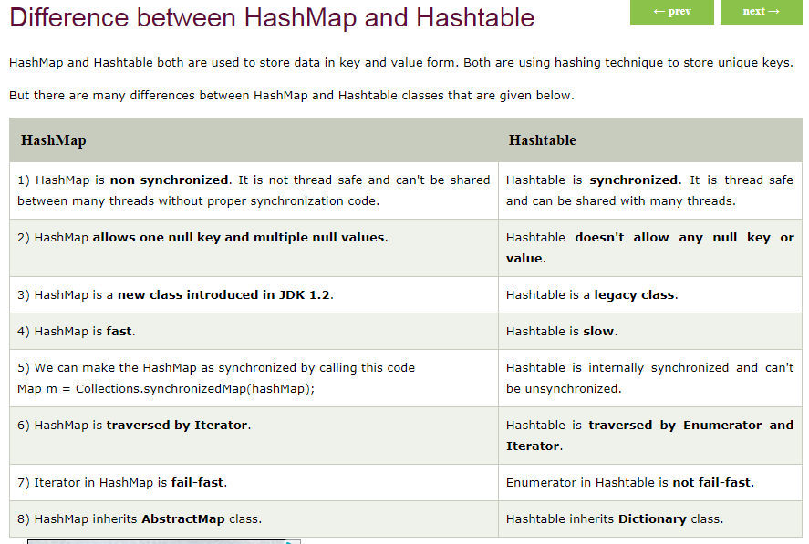

Every collection type is suitable for a particular scenario. There is no fastest or best collection.
- If you need fast access to elements using index, ArrayList is your answer.
- If you need fast access to elements using a key, use HashMap.
- If you need fast add and removal of elements, use LinkedList (but it has a very poor index access performance

Java Queue Interface
Java Queue interface orders the element in FIFO(First In First Out) manner. In FIFO, first element is removed first and last element is removed at last.

Queue Interface declaration
- public interface Queue<E> extends Collection<E>

Methods of Java Queue Interface
Method | Description
boolean add(object) | It is used to insert the specified element into this queue and return true upon success.
boolean offer(object) | It is used to insert the specified element into this queue.
Object remove() | It is used to retrieves and removes the head of this queue.
Object poll() | It is used to retrieves and removes the head of this queue, or returns null if this queue is empty.
Object element() | It is used to retrieves, but does not remove, the head of this queue.
Object peek() | It is used to retrieves, but does not remove, the head of this queue, or returns null if this queue is empty.

PriorityQueue class
The PriorityQueue class provides the facility of using queue. But it does not orders the elements in FIFO manner. It inherits AbstractQueue class.

- public static void main(String args[]){
- PriorityQueue<String> queue=new PriorityQueue<String>();
- queue.add("Amit");
- queue.add("Vijay");
- queue.add("Karan");
- queue.add("Jai");
- queue.add("Rahul");
- System.out.println("head:"+queue.element());
- System.out.println("head:"+queue.peek());
- System.out.println("iterating the queue elements:");
- Iterator itr=queue.iterator();
- while(itr.hasNext()){
- System.out.println(itr.next());
- }
- queue.remove();
- queue.poll();
- System.out.println("after removing two elements:");
- Iterator<String> itr2=queue.iterator();
- while(itr2.hasNext()){
- System.out.println(itr2.next());
- }
- }

Java EnumSet class
Java EnumSet class is the specialized Set implementation for use with enum types. It inherits AbstractSet class and implements the Set interface.
- enum days {
- SUNDAY, MONDAY, TUESDAY, WEDNESDAY, THURSDAY, FRIDAY, SATURDAY
- }
- public class EnumSetExample {
- public static void main(String[] args) {
- Set<days> set = EnumSet.of(days.TUESDAY, days.WEDNESDAY);
- // Traversing elements
- Iterator<days> iter = set.iterator();
- while (iter.hasNext())
- System.out.println(iter.next());
- }

Collections class provides static methods for sorting the elements of collection.If collection elements are of Set type, we can use TreeSet.But We cannot sort the elements of List.Collections class provides methods for sorting the elements of List type elements.

Array and ArrayList
1 Array: Simple fixed sized arrays that we create in Java, like below and Dynamic sized arrays in Java that implement List interface.

2 An array is basic functionality provided by Java. ArrayList is part of collection framework in Java. Therefore array members are accessed using [], while ArrayList has a set of methods to access elements and modify them
3 Array can contain both primitive data types as well as objects of a class depending on the definition of the array. However, ArrayList only supports object entries, not the primitive data types.
Note: When we do arraylist.add(1); : it converts the primitive int data type into an Integer object. Sample Code
4 Since ArrayList can’t be created for primitive data types, members of ArrayList are always references to objects at different memory locations (See this for details). Therefore in ArrayList, the actual objects are never stored at contiguous locations. References of the actual objects are stored at contiguous locations.
In array, it depends whether the arrays is of primitive type or object type. In case of primitive types, actual values are contiguous locations, but in case of objects, allocation is similar to ArrayList.

Key Differences Between List and ArrayList
- One of the most important differences between List and ArrayList is that list is an interface and ArrayList is a standard Collection class.
- List interface extends the Collection framework whereas, the ArrayList extends AbstractList Class and it implements Listinterfaces.
- The namespace for List interface is System.Collection.Genericwhereas, the namespace for ArrayList is System.Collection.
- List interface creates a collection of elements that is stored in a sequence and are identified or accessed by their index number. On the other hand, ArrayList creates an array of objects where the array can dynamically grow when required.

Exception Handling in Java
The exception handling in java is one of the powerful mechanism to handle the runtime errors so that normal flow of the application can be maintained

The core advantage of exception handling is to maintain the normal flow of the application. Exception normally disrupts the normal flow of the application that is why we use exception handling. Let's take a scenario

Difference between checked and unchecked exceptions

1) Checked Exception
The classes that extend Throwable class except RuntimeException and Error are known as checked exceptions e.g.IOException, SQLException etc. Checked exceptions are checked at compile-time.

2) Unchecked Exception
The classes that extend RuntimeException are known as unchecked exceptions e.g. ArithmeticException, NullPointerException, ArrayIndexOutOfBoundsException etc. Unchecked exceptions are not checked at compile-time rather they are checked at runtime.

3) Error
Error is irrecoverable e.g. OutOfMemoryError, VirtualMachineError, AssertionError etc

Java Exception Handling Keywords
There are 5 keywords used in java exception handling.
- try
- catch
- finally
- throw
- throws

Java try block
Java try block is used to enclose the code that might throw an exception. It must be used within the method.
Java try block must be followed by either catch or finally block.

Syntax of java try-catch
- try{
- //code that may throw exception
- }catch(Exception_class_Name ref){}

Java catch block
Java catch block is used to handle the Exception. It must be used after the try block only.
You can use multiple catch block with a single try.
- public class Testtrycatch2{
- public static void main(String args[]){
- try{
- int data=50/0;
- }catch(ArithmeticException e){System.out.println(e);}
- System.out.println("rest of the code...");
- }
- }

Java Multi catch block
If you have to perform different tasks at the occurrence of different Exceptions, use java multi catch block.

Rule: All catch blocks must be ordered from most specific to most general i.e. catch for ArithmeticException must come before catch for Exception
- public class TestMultipleCatchBlock{
- public static void main(String args[]){
- try{
- int a[]=new int[5];
- a[5]=30/0;
- }
- catch(ArithmeticException e){System.out.println("task1 is completed");}
- catch(ArrayIndexOutOfBoundsException e){System.out.println("task 2 completed");}
- catch(Exception e){System.out.println("common task completed");}

- System.out.println("rest of the code...");
- }
- }

Java Nested try block
The try block within a try block is known as nested try block in java.

Why use nested try block
Sometimes a situation may arise where a part of a block may cause one error and the entire block itself may cause another error. In such cases, exception handlers have to be nested

Syntax:
- ....
- try
- {
- statement 1;
- statement 2;
- try
- {
- statement 1;
- statement 2;
- }
- catch(Exception e)
- {
- }
- }
- catch(Exception e)
- {
- }

- class Excep6{
- public static void main(String args[]){
- try{
- try{
- System.out.println("going to divide");
- int b =39/0;
- }catch(ArithmeticException e){System.out.println(e);}

- try{
- int a[]=new int[5];
- a[5]=4;
- }catch(ArrayIndexOutOfBoundsException e){System.out.println(e);}

- System.out.println("other statement);
- }catch(Exception e){System.out.println("handeled");}

- System.out.println("normal flow..");
- }
- }

Java finally block
Java finally block is a block that is used to execute important code such as closing connection, stream etc.
Java finally block is always executed whether exception is handled or not.
Java finally block follows try or catch bloc
- public class TestFinallyBlock2{
- public static void main(String args[]){
- try{
- int data=25/0;
- System.out.println(data);
- }
- catch(ArithmeticException e){System.out.println(e);}
- finally{System.out.println("finally block is always executed");}
- System.out.println("rest of the code...");
- }
- }

Output:Exception in thread main java.lang.ArithmeticException:/ by zero
finally block is always executed
rest of the code...

Rule: For each try block there can be zero or more catch blocks, but only one finally block.

Note: The finally block will not be executed if program exits(either by calling System.exit() or by causing a fatal error that causes the process to abort).

Java throw exception

Java throw keyword
The Java throw keyword is used to explicitly throw an exception.
We can throw either checked or uncheked exception in java by throw keyword. The throw keyword is mainly used to throw custom exception. We will see custom exceptions later.
The syntax of java throw keyword is given below.
- throw exception;
- throw new IOException("sorry device error);

java throw keyword example
In this example, we have created the validate method that takes integer value as a parameter. If the age is less than 18, we are throwing the ArithmeticException otherwise print a message welcome to vote.
- public class TestThrow1{
- static void validate(int age){
- if(age<18)
- throw new ArithmeticException("not valid");
- else
- System.out.println("welcome to vote");
- }
- public static void main(String args[]){
- validate(13);
- System.out.println("rest of the code...");
- }
- }

Output:
Exception in thread main java.lang.ArithmeticException:not valid

Java throws keyword
The Java throws keyword is used to declare an exception. It gives an information to the programmer that there may occur an exception so it is better for the programmer to provide the exception handling code so that normal flow can be maintained.

Which exception should be declared
Ans) checked exception only, because:
- unchecked Exception: under your control so correct your code.
- error: beyond your control e.g. you are unable to do anything if there occurs VirtualMachineError or StackOverflowError.

Java throws example
Let's see the example of java throws clause which describes that checked exceptions can be propagated by throws keyword.
- import java.io.IOException;
- class Testthrows1{
- void m()throws IOException{
- throw new IOException("device error");//checked exception
- }
- void n()throws IOException{
- m();
- }
- void p(){
- try{
- n();
- }catch(Exception e){System.out.println("exception handled");}
- }
- public static void main(String args[]){
- Testthrows1 obj=new Testthrows1();
- obj.p();
- System.out.println("normal flow...");
- }
- }

Output:
exception handled
normal flow...

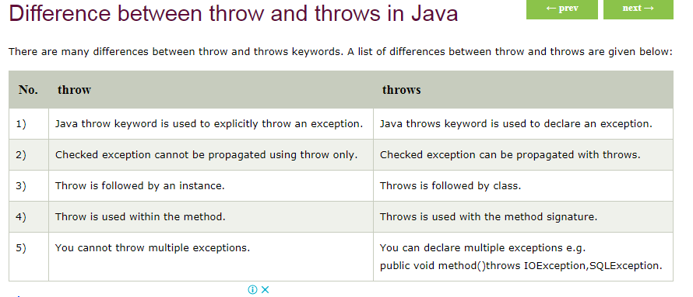

Java throw example
- void m(){
- throw new ArithmeticException("sorry");
- }

Java throws example
- void m()throws ArithmeticException{
- //method code
- }

Java throw and throws example
- void m()throws ArithmeticException{
- throw new ArithmeticException("sorry");
- }

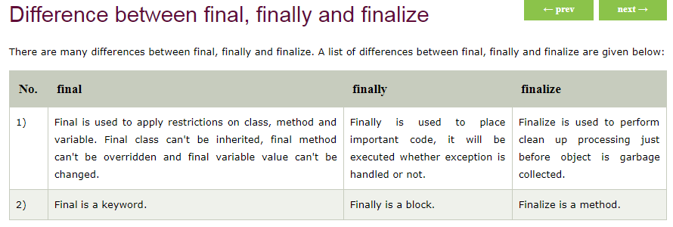

ExceptionHandling with MethodOverriding in Java
There are many rules if we talk about methodoverriding with exception handling. The Rules are as follows:
- If the superclass method does not declare an exception
  - If the superclass method does not declare an exception, subclass overridden method cannot declare the checked exception but it can declare unchecked exception.
- If the superclass method declares an exception
  - If the superclass method declares an exception, subclass overridden method can declare same, subclass exception or no exception but cannot declare parent exception.

Wrapper class in Java
Wrapper class in java provides the mechanism to convert primitive into object and object into primitive
autoboxing and unboxing feature converts primitive into object and object into primitive automatically. The automatic conversion of primitive into object is known as autoboxing and vice-versa unboxing

For example: While working with collections in Java, we use generics for type safety like this: ArrayList<Integer> instead of this ArrayList<int>. The Integer is a wrapper class of int primitive type. We use wrapper class in this case because generics needs objects not primitives. There are several other reasons you would prefer a wrapper class instead of primitive type, we will discuss them as well in this article.

The primitive data types are not objects so they do not belong to any class. While storing in data structures which support only objects, it is required to convert the primitive type to object first which we can do by using wrapper classes

Wrapper class Example: Primitive to Wrapper
- public class WrapperExample1{
- public static void main(String args[]){
- //Converting int into Integer
- int a=20;
- Integer i=Integer.valueOf(a);//converting int into Integer
- Integer j=a;//autoboxing, now compiler will write Integer.valueOf(a) internally

- System.out.println(a+" "+i+" "+j);
- }}

Wrapper class Example: Wrapper to Primitive
- public class WrapperExample2{

- public static void main(String args[]){
- //Converting Integer to int
- Integer a=new Integer(3);
- int i=a.intValue();//converting Integer to int
- int j=a;//unboxing, now compiler will write a.intValue() internally

- System.out.println(a+" "+i+" "+j);
- }

Abstraction in Java
Abstraction is a process of hiding the implementation details and showing only functionality to the user.
Another way, it shows only important things to the user and hides the internal details for example sending sms, you just type the text and send the message. You don't know the internal processing about the message delivery.

Abstract class in Java
A class that is declared with abstract keyword, is known as abstract class in java. It can have abstract and non-abstract methods (method with body).

Abstract class in Java
A class that is declared as abstract is known as abstract class. It needs to be extended and its method implemented. It cannot be instantiated.

Example abstract class
- abstract class A{}

abstract method
A method that is declared as abstract and does not have implementation is known as abstract method.

Example abstract method
- abstract void printStatus();//no body and abstract

- abstract class Shape{
- abstract void draw();
- }
- //In real scenario, implementation is provided by others i.e. unknown by end user
- class Rectangle extends Shape{
- void draw(){System.out.println("drawing rectangle");}
- }
- class Circle1 extends Shape{
- void draw(){System.out.println("drawing circle");}
- }
- //In real scenario, method is called by programmer or user
- class TestAbstraction1{
- public static void main(String args[]){
- Shape s=new Circle1();//In real scenario, object is provided through method e.g. getShape() method
- s.draw();
- }
- }
drawing circle

Abstract class having constructor, data member, methods etc.
An abstract class can have data member, abstract method, method body, constructor and even main() method

- //example of abstract class that have method body
- abstract class Bike{
- Bike(){System.out.println("bike is created");}
- abstract void run();
- void changeGear(){System.out.println("gear changed");}
- }

- class Honda extends Bike{
- void run(){System.out.println("running safely..");}
- }
- class TestAbstraction2{
- public static void main(String args[]){
- Bike obj = new Honda();
- obj.run();
- obj.changeGear();
- }
- }
Test it Now
bike is created
running safely..
gear changed

Rule: If there is any abstract method in a class, that class must be abstract.
- class Bike12{
- abstract void run();
- }
Test it Now
compile time error

Rule: If you are extending any abstract class that have abstract method, you must either provide the implementation of the method or make this class abstract.

Static blocks in Java
Unlike C++, Java supports a special block, called static block (also called static clause) which can be used for static initializations of a class. This code inside static block is executed only once: the first time you make an object of that class or the first time you access a static member of that class (even if you never make an object of that class). For example, check output of following Java program.
// filename: Main.java
class Test {
static int i;
int j;

// start of static block
static {
i = 10;
System.out.println("static block called ");
}
// end of static block
}

class Main {
public static void main(String args[]) {

// Although we don't have an object of Test, static block is
// called because i is being accessed in following statement.
System.out.println(Test.i);
}
}

Reverse String
class ReverseString
{
public static void main(String[] args)
{
String input = "GeeksForGeeks";

// convert String to character array
// by using toCharArray
char[] try1 = input.toCharArray();

for (int i = try1.length-1; i>=0; i--)
System.out.print(try1[i]);
}
}

How to create Immutable class in Java?
Immutable class means that once an object is created, we cannot change its content. In Java, all the wrapper classes (like String, Boolean, Byte, Short) and String class is immutable. We can create our own immutable class as well.
Following are the requirements:
• Class must be declared as final (So that child classes can’t be created)
• Data members in the class must be declared as final (So that we can’t change the value of it after object creation)
• A parameterized constructor
• Getter method for all the variables in it
• No setters(To not have option to change the value of the instance variable)
Example to create Immutable class
// An immutable class
public final class Student
{
final String name;
final int regNo;

public Student(String name, int regNo)
{
this.name = name;
this.regNo = regNo;
}
public String getName()
{
return name;
}
public int getRegNo()
{
return regNo;
}
}

// Driver class
class Test
{
public static void main(String args[])
{
Student s = new Student("ABC", 101);
System.out.println(s.name);
System.out.println(s.regNo);

// Uncommenting below line causes error
// s.regNo = 102;
}
}

Synchronization in Java
Synchronization in java is the capability to control the access of multiple threads to any shared resource.
Java Synchronization is better option where we want to allow only one thread to access the shared resource.

Why use Synchronization
The synchronization is mainly used to
- To prevent thread interference.
- To prevent consistency problem.

Types of Synchronization
There are two types of synchronization
- Process Synchronization
- Thread Synchronization

synchronized
A synchronized block in Java is synchronized on some object. All synchronizedblocks synchronized on the same object can only have one thread executing inside them at a time. All other threads attempting to enter the synchronized block are blocked until the thread inside the synchronized block exits the block.

In java System.out.println(); System and out represnts what ?
- System → Class
- out → Static object of type PrintStream
- println() → Method of PrintStream used to print a line to the console
Wht java not support multiple inherientence

Main Reason: Diamond Problem 💎
If Java allowed multiple inheritance, a situation like this could happen:
class A {
void show() {
System.out.println("Hello from A");
}
}

class B extends A { }

class C extends A { }

class D extends B, C { } // ❌ Not allowed in Java
Here, class D would inherit show() from both B and C.
If both override show(), Java would not know which version D should use.
This confusion is called the Diamond Problem.

Other Reasons
- Code complexity – Multiple inheritance makes code harder to understand and maintain.
- Ambiguity in constructors – It becomes unclear which parent constructor should run.
- Maintenance issues – Changes in one parent class could affect behavior unexpectedly.

Why method overloading is not recognized by return type in java
In Java, method overloading is not recognized by return type alone because the compiler decides which method to call based only on the method name and parameter list, not the return type.

🔹 What Java Uses to Identify a Method
A method signature in Java consists of:
- Method name
- Parameter types (number, type, and order)
Return type is NOT part of the method signature.

❌ Example (Not Allowed)
class Test {
int add(int a, int b) {
return a + b;
}

double add(int a, int b) { // ❌ Compile-time error
return a + b;
}
}
Even though the return types are different (int and double), this causes a compile-time error because the parameter list is the same.

🔹 Why Java Does This
When you call:
add(5, 10);
The compiler must decide which method to execute.
But at the time of method call, Java does not look at the return type to determine the method — only the parameters.
Imagine:
System.out.println(add(5, 10));
The compiler would not know whether to call the int version or the double version just based on return type. That would create ambiguity.

✅ Correct Way to Overload
Change the parameter list:
int add(int a, int b) {
return a + b;
}

double add(double a, double b) {
return a + b;
}
Now the compiler can clearly differentiate between the methods.

🔹 Summary
- ✔ Method overloading depends on method name + parameters
- ❌ Return type alone cannot differentiate methods
- Reason: To avoid ambiguity during compile-time method resolution
If you want, I can also explain how method overriding is different from overloading.

