GetDP

SN SINGH

17-6-2026

Keywords

Electromagnetic modelling
Coupling
Parametric modelling
Meshing
Postprocessing
Otimization

gmsh, getdp, onelab, Fiqus, paraview
POISSON, Opera3D, Radia, Ansys
Python, Comi, .geo,
GUI / scripting (advantage /disadvantage)
AI

2D, 3D
DC, ac harmonic, transient

Weak form
Formulation

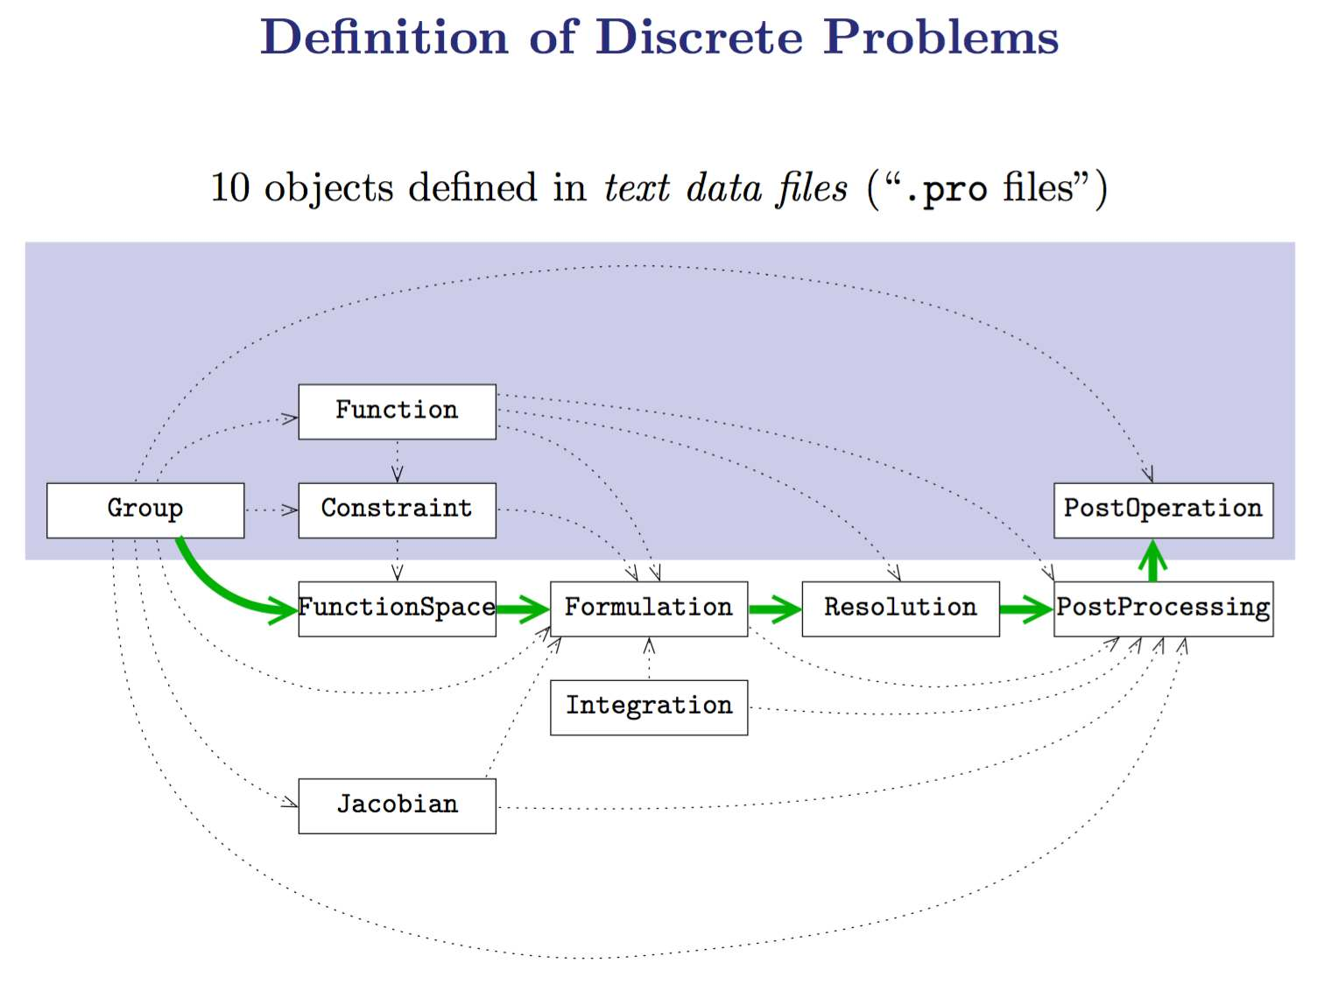

Gmsh + GetDP ==> Onelab

Gmsh : pre-processing
+ model creation
+ meshing
+ post-processing

GetDP : FEM solver

GetDP ==> CernGetDP ==> Fiqus

ONELAB Guiding Principles
- Don’t reimplement, interface
- Make it easy to provide templates, with interactive parameter modification

A brief survey of main disadvantages
of applications used by AMTD

POISSON Advantages

a historic benchmark for 2D magnetostatic design.

Its multipole calculations are deeply trusted, historically verified, and tailored precisely for particle beamline requirements.

POISSON Disadvantages

0) POISSON is strictly limited to 2D static fields (DC).

1) difficult to perform local mesh refinement

2) Inability to handle arbitrary geometries & curves -- modeling complex geometries in POISSON is famously tedious and error-prone.

3) two solvers – poisson and pandira. Combining strong permanent magnets with dynamic coils can become cumbersome to formulate.

4) Post-processing requires separate, independent modules like TEKPLOT.

Radia advatage – No meshing of air till ‘infinity’

Radia disadvantages

1) Input geometry, special meshing (structured)

2) Solves only 3D magnetostatic problems. No ac, no multiphysics coupling, no true 2D.

Opera3D Advantages

1) For decades, it was the gold standard for designing dipoles, quadrupoles, and superconducting magnets because of its highly precise finite element formulations (like the TOSCA solver).

Opera3D Disadvantages

0) All the disadvantages of a closed code application

1) It carries significant legacy baggage.

2) disadvantages of (A,ψ,ϕ) agains A-V

3) COMI syntax is archaic, difficult to debug, and completely disconnected from modern software engineering standards.

4) seperate modeller, solver, postprocessor

5) Because Opera is a niche, highly specialized tool for high-end magnetics (unlike Ansys or COMSOL which cover broad engineering sectors), its user base is relatively small.

Ansys Advantages: multiphysics coupling ?

Ansys disadvantages:

0) All the disadvantages of a closed code application

1) Ansys is designed natively for Windows environments

2) Heavy Graphical User Interface (GUI) Dependency

3) Ansys Maxwell is incredibly expensive. Ansys charges additional, expensive licensing fees per CPU core.

(With open-source tools, you can spin up a cluster of 128 or 256 cores on Linux to parallelize a sensitivity analysis completely for free.)

4) Because of the proprietary file formats and strict licensing, you cannot easily share your complete simulation models

Components of a good tool-chain for design of Accelerator Magnets

- Preprocessor -- powerful script for parametric modelling, able to import/export in other file formats, good and flexible meshing capability

- Solver -- parallel, nonlinear, adaptive time, fast, rugged

- Postprocessor -- shaould have a minimal beam dynamics calculator in it

- Optimizer

- 'App developer' -- applictin deployment

Other required characteristics
- easy to learn and use
- available on multiple plateforms (Linux, windows, Mac etc..)
- free / open source ,
- with good GUI, good API and good control through scripts
- input and output file formats should be open and standard,
- should have good materials library,
- easy and flexible boundary conditions
- easy and flexible sources specification (linear & nonlinear materials, anisotropic materials, ..)
- should be easy to configure,
- should be able to do multiphysics (at least electromagnetics, thermal, structural)
- should be able to do 1D, 2D and 3D simulation,
- should be able to do steady state, harmonic or time analysys,
- should have facilities, such as library of in-built coils
- well validated and discussed (should not be very new)
- sufficiently big user base
- active discussion group
- good documentation

Features of Gmsh
Geometry Modeling: Construct and edit complex 3D geometries with powerful tools.
Mesh Generation: Automatically generate meshes of various shapes with ease.
Advanced Visualization: Visualize meshes in 3D with advanced rendering techniques.
Advanced Solvers: Solve equations with advanced numerical solvers.

Others
CAD Integration: Import and export CAD models from a variety of sources.
Parametric Modeling: Create parametric models with a few clicks.
HPC Support: Support for high performance computing clusters.

Mesh Morphing: Morph meshes between different geometries.
Mesh Optimization: Optimize meshes for high performance computing.
Mesh Refinement: Smoothly refine and improve mesh quality.
Multi-platform: Compatible with Windows, Linux, Mac and more.

Run on low end machines and/or machines with no graphical interface.

Physical Groups: Group and organize entities into physical groups.
Post-processing : Visualize, analyze and compare results with ease.
==> visualize and export computational results in a great variety of ways. Gmsh can display scalar, vector and tensor datasets, perform various operations on the resulting post-processing views (see Post-processing module), can export plots in many different formats (see General options list), and can generate complex animations (see General tools, and t8.geo).
built-in plug-ins ===> such as applying cuts, clips, and thresholding
Scripting: Create powerful scripts with the built-in scripting language.
Parallel computing of mesh ??? ===> From 2019, Multi-Threaded 3D meshing (fine-grained), STL remeshing.
Create repeatative geometries.

Why use GetDP
- It is Free and Open Source.
- It is capable of solving Single or Multiphysics with various couplings
- Flexibility to define application specific physics
- Modern scripting langue allowing repeatable analysis
- Graphical user interface provided via Gmsh, through ONELAB interface
- available on Linux, Windows and Mac
- It is light and fast.
- It is able to solve 1D, 2D, 3D problems
- DC analysis (or steady state analysis), time harmonic and time domain analysis
- It provides for creating custom menus and parametric analysis (using GMSH)
- It is used in CERN for superconducting magnet design (FiQuS)
- It can be used for parallel computing using GetDDM.
- It can easily be used with optimization programs ( such as CONVEKS )
- stranded & massive conductor simulation --> good performance even where ROXIE does not perform well, for example in HTS conductors.
- It is designed for EM in mind, great for eddy-current problems
- It can be used to solve problems NOT SOLVABLE by other software. (BUT adding a new functionality in Elmer requires knowledge in FEM and Fortran)

Some shortcomings of GetDP
- Steep learning curve because it is more dependent on programming. (It can be assumed its strength too.)
- GetDP requires users to define almost everything from scratch. (But once created, it becomes re-usable.)

GetDP is an environment open to various couplings. Any coupling between--
• Physical problems (electromagnetic, thermal, mechanical, ...)
• Numerical methods (finite element methods, integral methods, ...)
• Geometries (1D, 2D, 3D)
• Time states (static, harmonic, transient, eigen values)
How?
• Clear mathematical definitions/structure
• Directly transcribed into 10 interdependent objects

steam-FiQuS
https://gitlab.cern.ch/steam/fiqus
FiQuS is based solely on open-source software and uses Python to generate geometries and meshes with Gmsh and compute solutions with GetDP.
FiQuS scripts have a modular structure to accommodate a broad range of geometries and simulation requirements, focusing mainly on superconducting accelerator magnets. FiQuS is organized into multiple Python scripts. The code is constituted by a mix of built-in functions, third-party libraries, and Gmsh API commands and command-line interface (CLI) calls to GetDP. Its structure is modular.
Three specific capabilities of FiQuS that represent the basis upon which the future modules will be built, mainly:
(1) enabling cooperative simulations and the Single Source Of Truth (SSOT) practice;
(2) seamlessly integrating magnet design details around a set of input files;
(3) enabling parametric analysis and multi-objective optimization with Dakota software developed by Sandia National Laboratories.

