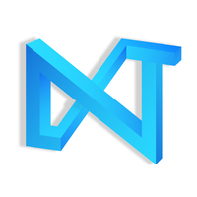

Associate   
Next Tech Lab

October 2020 – Present   
Chennai, Tamil Nadu, India