AIM  
To create a self watering plant system using a soil sensor, water pump and nodeMCU 8266

Components Used:

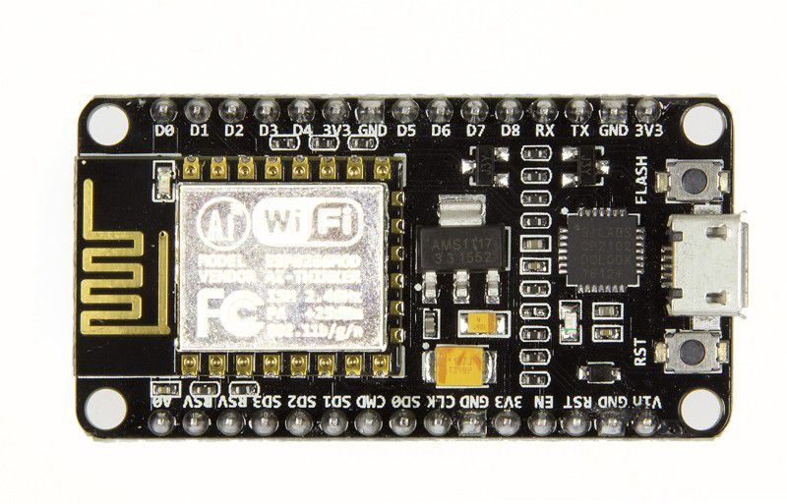1. nodemcu8266 2. Water pump(3-6v)

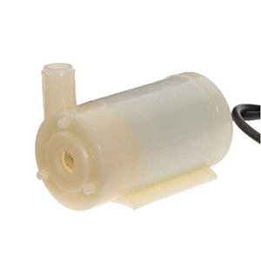

3. Soil sensor 4. 2 channel Relay module

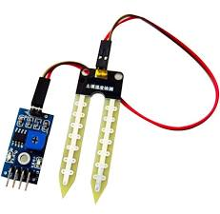

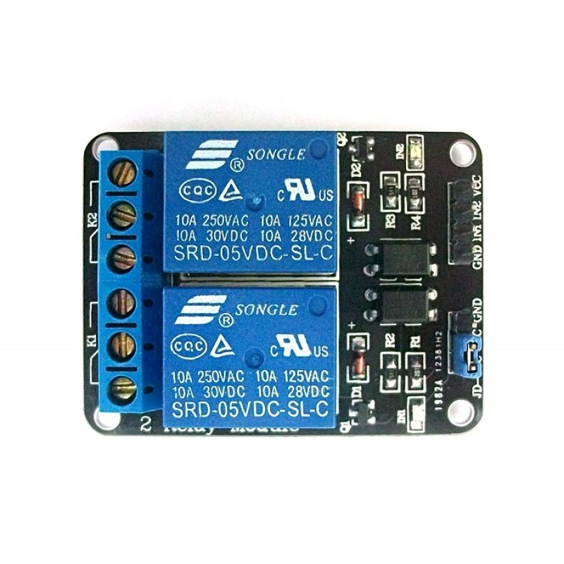

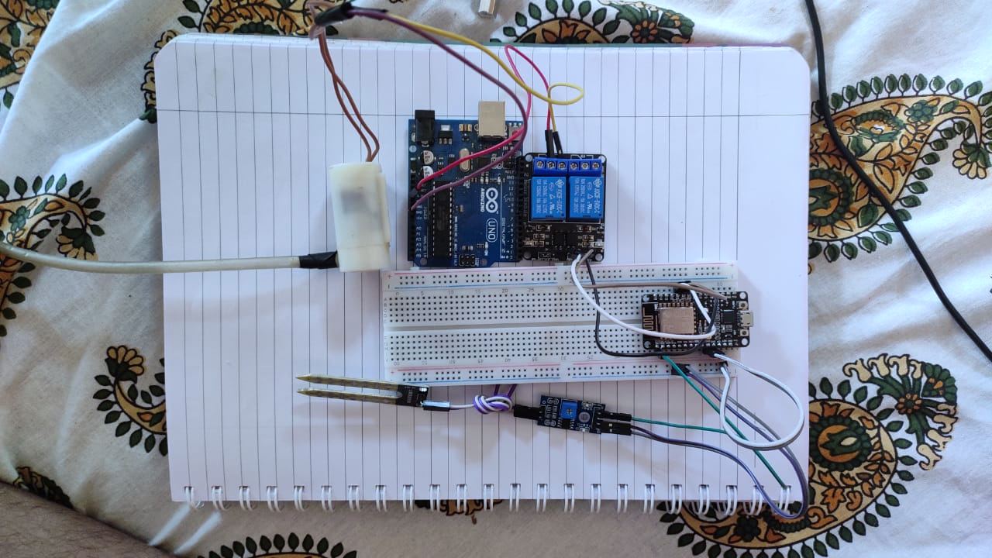

Soil sensor module has the following pins:

The sensor itself has 2 pins to transmit data to the LM393 module which has 4 pins:

* VCC:- It supplies power for the module. It is around 205 to 3.3 volts.
* A0: analog output
* D0:Digital Output
* . GND:- It is the Ground Pin and needs to be connected to the GND pin on the NodeMCU.

### Relay module has: Control Pins:

VCC pin supplies power to the built-in optocoupler and optionally to the electromagnet of the relay (if you keep the jumper in place)

GND is the common Ground connection.

IN1 & IN2 pins are used to control the relay. These are active low pins, meaning the relay will be activated when you pull the pin LOW and it will become inactive when you pull the pin HIGH.

Power Supply Selection Pins:

JD-VCC supplies power to the electromagnet of the relay. When the jumper is in place, it takes power from the Arduino’s 5V line. Without the jumper cap, you have to connect it to an independent power source.

VCC With the jumper cap on, this pin is shorted to the JD-VCC pin. If you remove the jumper, keep this pin unconnected.

GND is the common Ground connection.

Output Terminals:

COM pin is connected to the signal you are planning to switch.

NC pin is connected to the COM pin by default, unless you send a signal from the Arduino to the relay module to break the connection.

NO pin is open by default, unless you send a signal from the Arduino to the relay module to make the connection.

The connections to nodemcu are as follows:

IN1 pin Is connected to D4 pin in nodeMCU

GND pin is connected to GND pin in nodeMCU

Vcc pin is connected to 3v3 pin in nodeMCU

COM pin is connected to a 3.3v output

NO pin is connected to anode of water pump

COM pin is connected to cathode of the water pump

A0 pin is connected to the A0 pin in nodeMCU

GND pin is connected to GND pin in nodeMCU

Vcc pin is connected to 3v3 pin in nodeMCU

Soil sensor pins are connected to the LM393 pins

Project

Step 1: obtaining the soil moisture levels from the soil sensor