Customer_Shopping_Behavior_Report:
Business Problem & Flow Chart:
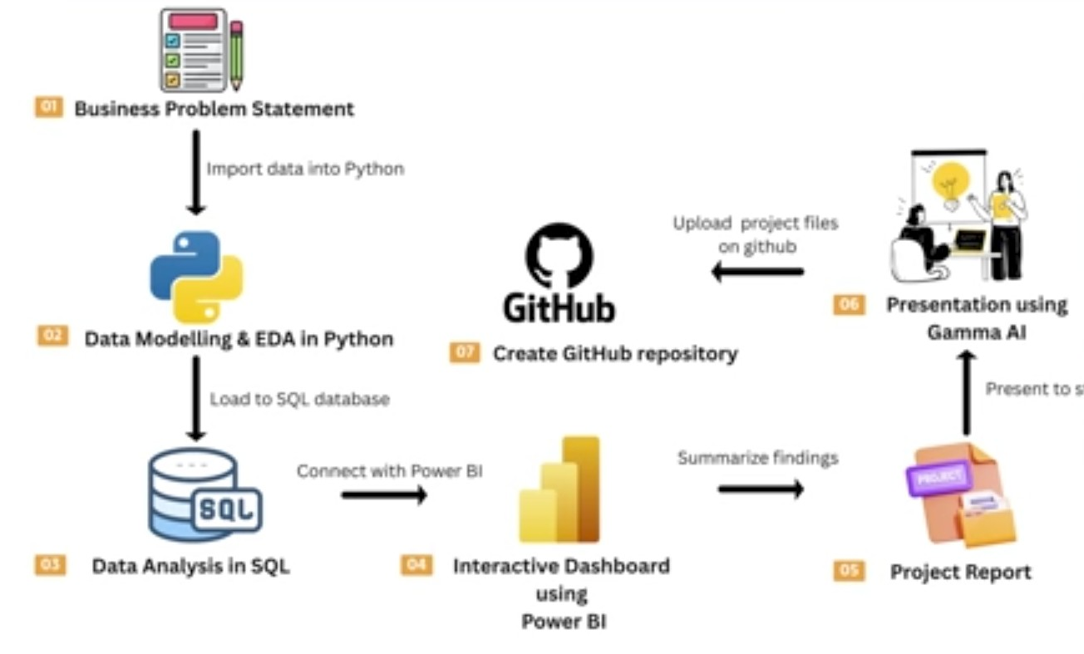
Firstly, I have collected the customer data from online source in the form of excel ‘csv’ file
Eg: customer_shopping_behavior.csv
secondly, I uploaded that data into jupyter notebook file
and then created new file with the extension ‘ipynb’
Eg: customer_shopping_behavior_analysis.ipynb
>>Then I used pandas library for data reading,cleaning,removing duplicates and handling errors.
Eg: Import pandas as pd
>>I created a (data frame) object with the short name = ‘df’

Below code is used to read the entire data from customer_shopping_behavior.csv for data cleaning and handling errors.
Eg: df=pd.read_csv(‘customer_shopping_behavior.csv’)
df.head()-code is used to show table data.

df.info()-code is used to show info of table which has data types and columns
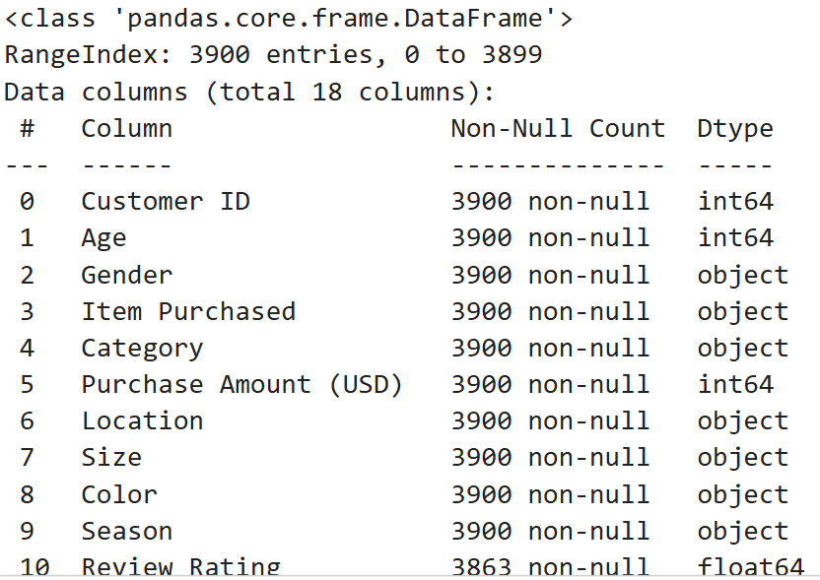

df.describe()-code is used to show columns with integer type as statistical analysis.
Eg: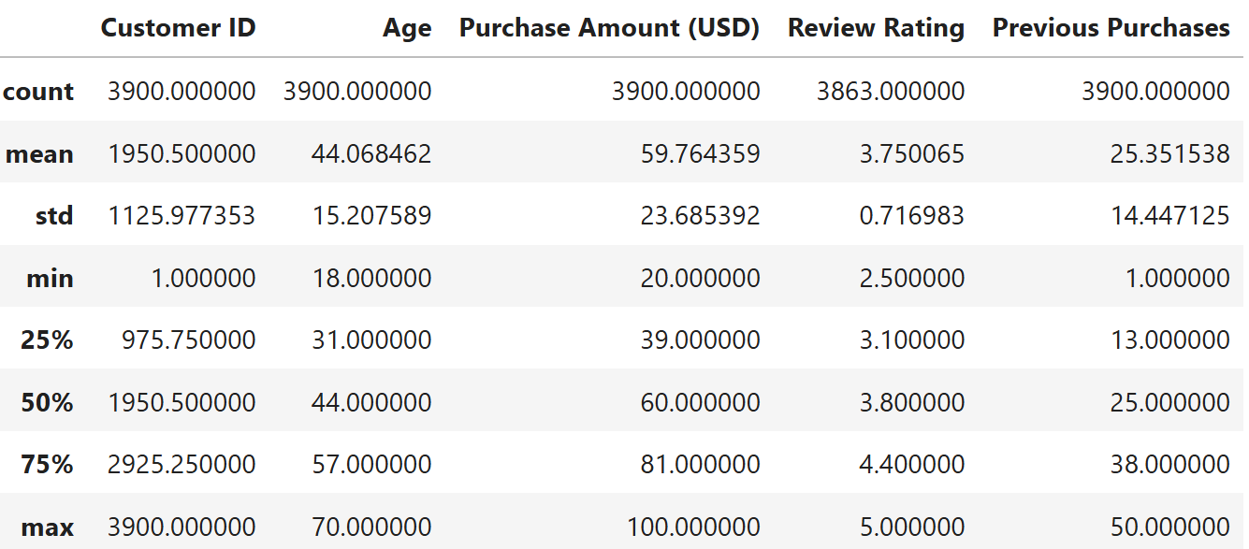

Cleaning the data:
--------------------------
#checking the null values in a table

Code: df.isnull().sum()
>> If there is any null values available in the table(columns) handle them with some tansform(), median(),mean() functions and fill them with fillna()-function.

Data organizing: handling inconsistency in columns.
----------------------
Making the columns string words into lower case()-to showcase in an organized format.
Eg:
Code: df.columns=df.columns.str.lower()
Replacing the spaces with underscore so it looks well organized
Eg:
Code: df.columns= df.columns.str.replace(' ','_')
Renaming the inconsistency columns with proper format
Eg:
Code: df=df.rename(columns={'purchase_amount_(usd)':'purchase_amount'})

showing organized table data:
----------------------------------------
Index(['customer_id', 'age', 'gender', 'item_purchased', 'category',
'purchase_amount', 'location', 'size', 'color', 'season',
'review_rating', 'subscription_status', 'shipping_type',
'discount_applied', 'promo_code_used', 'previous_purchases',
'payment_method', 'frequency_of_purchases'],
dtype='object')
Installing psycopg2.binary:
----------------------------------
-most popular postgresql database adapter for python.
-To bridge the gap between python application and postgresql database.
-It enables us to execute sql queries,manage database transactions and manipulate records directly from python code.
Sqlalchemy:
---------------
-powerful python database toolkit used primarily it allows us to write sql queries.
Python code: pip install psycopg2.binary sqlalchemy

Connecting python to posgtgresql:
-----------------------------------------------

from sqlalchemy import create_engine

# PostgreSQL connection details
username ='postgres'
password = 'anand123'
host = 'localhost'
port = '5432'
database = 'customer_behavio'

# Create connection
engine =create_engine(f"postgresql+psycopg2://{username}:{password}@{host}:{port}/{databse}")
#data transporting to sql
table_name = "customer"
df.to_sql(table_name,engine, if_exists="replace",index=False)
print(f"Data successfully loaded into table '{table_name}' in database '{database}'.")

output: Data successfully loaded into table 'customer' in database 'customer_behavior'.
Business problem and solutions using sql queries:
------------------------------------------------------------------
--1.what is the total revenue generated by male vs female customers?
Query: select gender, sum(purchase_amount) as total_revenue
from customer
group by gender;
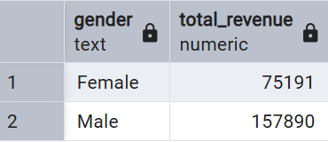
Business solution: Increase focus on male customers as they are frequently involving buying products more than females.

--2.which customers used a discount but still spent more than the average purchase amount
Query:select customer_id,purchase_amount
from customer
WHERE discount_applied='Yes' AND purchase_amount >= (select AVG(purchase_amount) from customer)
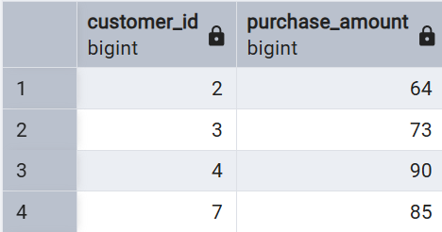

--3.which are the top 5 products with highest average review rating?
Query:select item_purchased,ROUND(AVG(review_rating::numeric),2) AS "average review rating products"
from customer
group by item_purchased
order by AVG(review_rating) desc
limit 5;
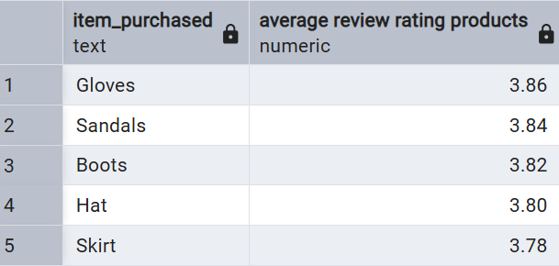
Business solution: increase the availability of the above products in warehouses like:gloves,sandals,boots,hats,skirts as they are very highly purchasing by customers.

--4.compare the average purchase amount between standard and express
Query:select shipping_type,ROUND(AVG(purchase_amount),2)
from customer
where shipping_type in ('Standard','Express')
group by shipping_type
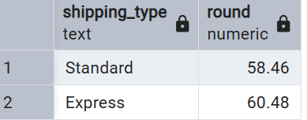
Business solution: select these top most shipping types for better deliverable of products like we get express and standard shipping types .

--5.do subscribed customers spend more? compare average spend and total revenue
--between subscribers and non-subscribers
Query:select subscription_status,
COUNT(customer_id) as total_customers,
ROUND(AVG(purchase_amount),2) as avg_spend,
SUM(purchase_amount) as total_revenue
from customer
group by subscription_status
order by avg_spend,total_revenue desc;
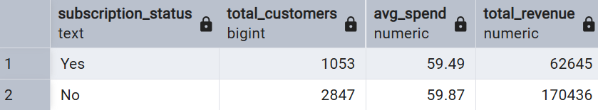
Business solution: Increase more focus on subscription based user to make them engage every day to buy products on the other side no-subscribers are even purchasing more than subscribed customers.

--6.which 5 products have the highest percentage of purchases with discount applied and without discount_applied?
Query:select item_purchased,
ROUND(100*SUM(CASE WHEN discount_applied = 'Yes' THEN 1 ELSE 0 END)/COUNT(*),2) as discount_rate_yes,
ROUND(100*SUM(CASE WHEN discount_applied = 'No' THEN 1 ELSE 0 END)/COUNT(*),2) as discount_rate_no
from customer
group by item_purchased
order by discount_rate_yes,discount_rate_no desc
limit 5;
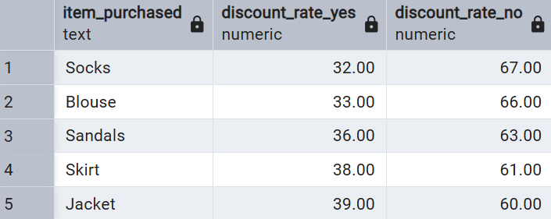
Business solution: from the above table we can figure out that above products are selling most because there is high discount_rate given on the products so customers are willing to buy products with more discount_rate

--7.segment customer into new,returning, and loyal based on their total
--number of previous_purchases,and show the count of each segment.
Query:SELECT COUNT(customer_id) as customer_count,
CASE
WHEN previous_purchases = 1 THEN 'New'
WHEN previous_purchases BETWEEN 2 AND 10 THEN 'Returning'
ELSE 'Loyal'
END AS customer_segment
FROM customer
GROUP BY customer_segment
ORDER BY customer_count DESC;
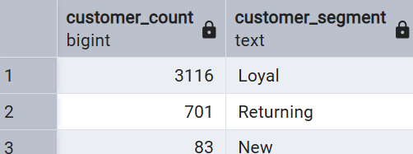
Business solution: Here we can assume that loyal customers are more compared to returning and new customer so our main focus is to giving retaining the loyal customer by providing some extra benefits to the loyal customers like in the form of dicounts,bonuses etc..

--8.what are the top 3 most purchased products within each category?
Query:WITH product_purchases AS (SELECT category, item_purchased,
COUNT(*) AS total_purchase FROM customer
GROUP BY category, item_purchased),
ranked_products AS ( SELECT category,item_purchased,total_purchases,
ROW_NUMBER() OVER ( PARTITION BY category
ORDER BY total_purchases DESC) AS rank_num
FROM product_purchases)
SELECT category,item_purchased,total_purchases,rank_num
FROM ranked_products
WHERE rank_num <= 3
ORDER BY category, rank_num;
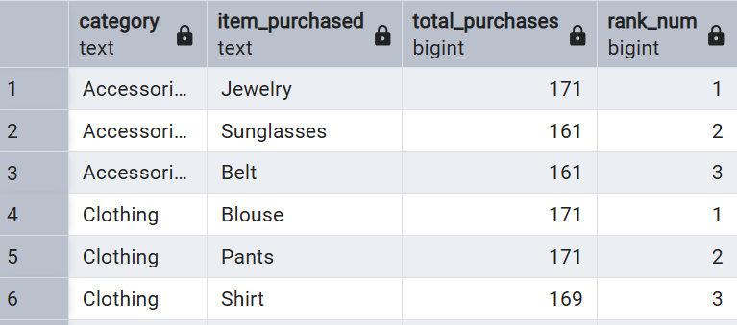
Business solution: From the above table we can get insights in the form that in accessories category the most purchased item is jewelry thus we need to increase the jewelry production and availability,
On the other side in clothing category products like blouses and pants has huge demand compared to other products so try to increase the availability of blouses,pants,shirts which are likely to purchased by many customers in this regar.

--9.Are customers who are repeat buyers(more than 5 previous purchases) also likely
--to subscribe?
Query:WITH customer_segments AS (SELECT customer_id,
CASE
WHEN previous_purchases > 5 THEN 'Repeat Buyer'
ELSE 'Non-Repeat Buyer'
END AS customer_type,
subscription_status
FROM customer)
SELECT customer_type,
COUNT(*) AS total_customers,
SUM(CASE WHEN subscription_status = 'Yes' THEN 1 ELSE 0 END) AS subscribers
FROM customer_segments
GROUP BY customer_type;
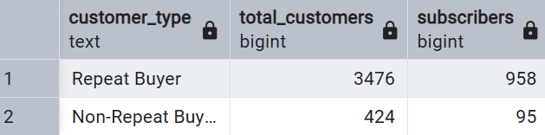

--10.find the revenue contribution of each age group?
Query:select age_group,SUM(purchase_amount) as revenue_contribution
from customer
group by age_group
order by revenue_contribution desc;
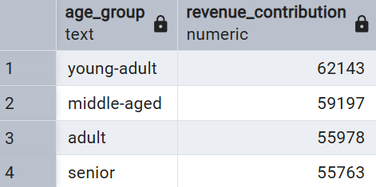

Importing table data from postgresql to power bi:
---------------------------------------------------------------------------------------
-Establish a connection between postgresql and powerbi
-server : localhost:5432
-database : customer_behavior
-Import and transform data into power bi after multiple steps .

DASHBOARD CREATION:
---------------------------------
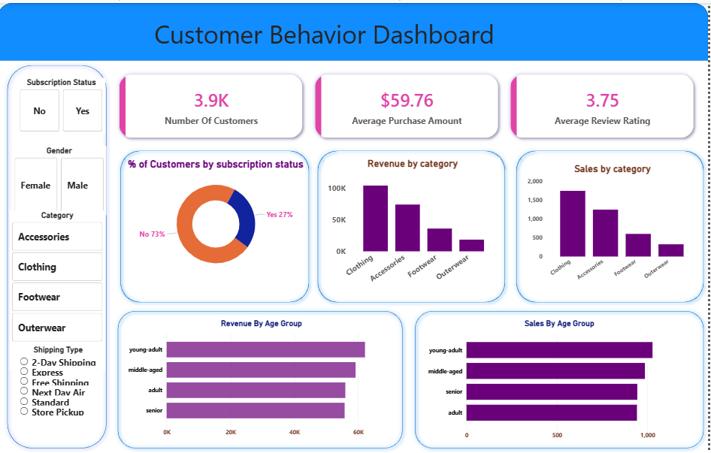
Business Solutions: From the dashboard we can get various insights to improve company sales
--customers subscription must be improve to enhance sales and product purchases even the non subscribed customers are purchasing more products compared to subscribed customers
--most of the revenue coming from clothing category as most of the customers buying clothing products so company needs to enhance and availability of clothing products even most of the sales are from clothing and accessories
--Revenue and sales by age group,where most of customers are from young adults so try to focus on young adults related required products
--coming to review rating ,it is quite moderate at 3.75 rating so company needs to enhance quality of the products
--coming to gender analysis -most of the customers are purchasing from male category try to also incorporate female required items in the market and more importantly enhance the male required products to attract even more male customers
--coming to category enhance the clothing and try to focus more on other categories like accessories and footwear so company may gets full profits.
--finally,crucial part the product needs to reach the customer without any damage so incase of that situation the shipping type needs to be focused here we get express shipping plays crucial role in shipping most of the products reaching efficiently to the customers so it needs to leveraged,after express ,standard is also doing good in shipping.

