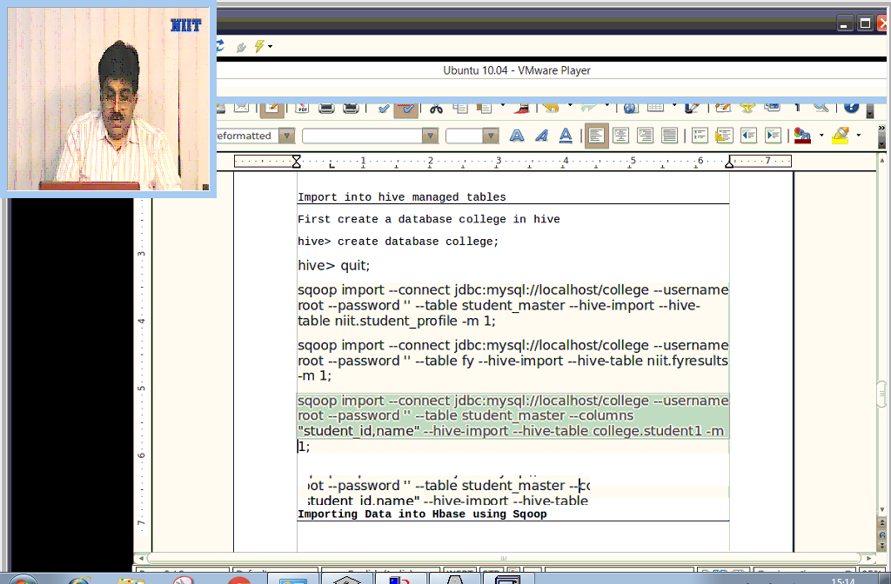

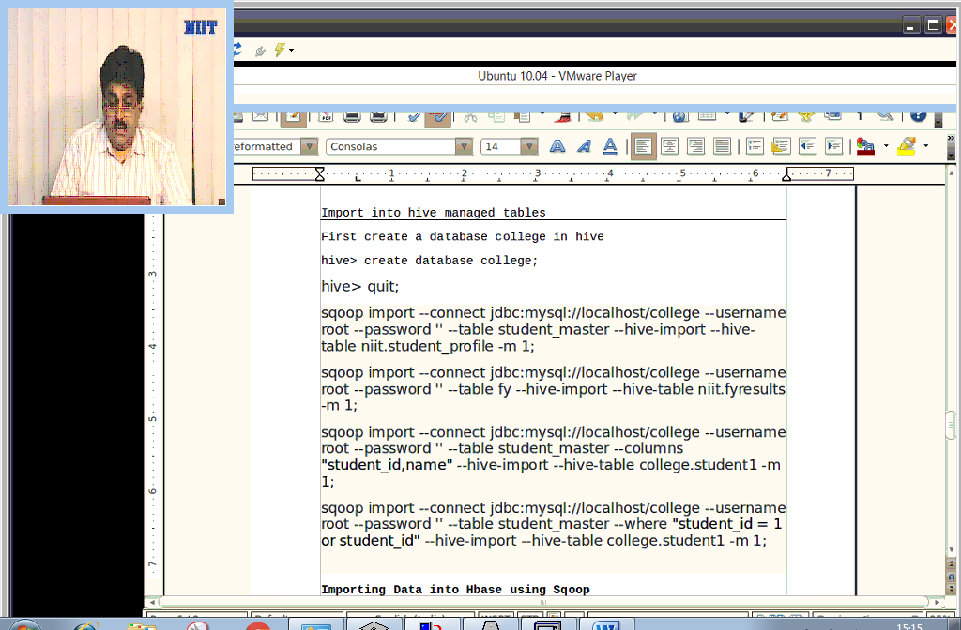

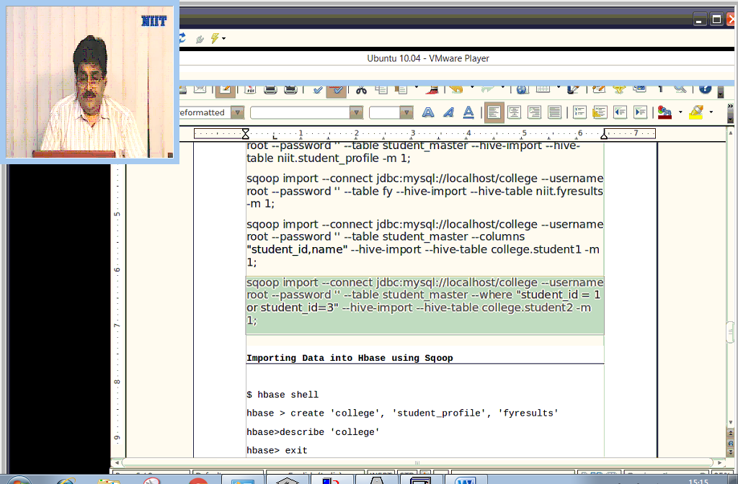

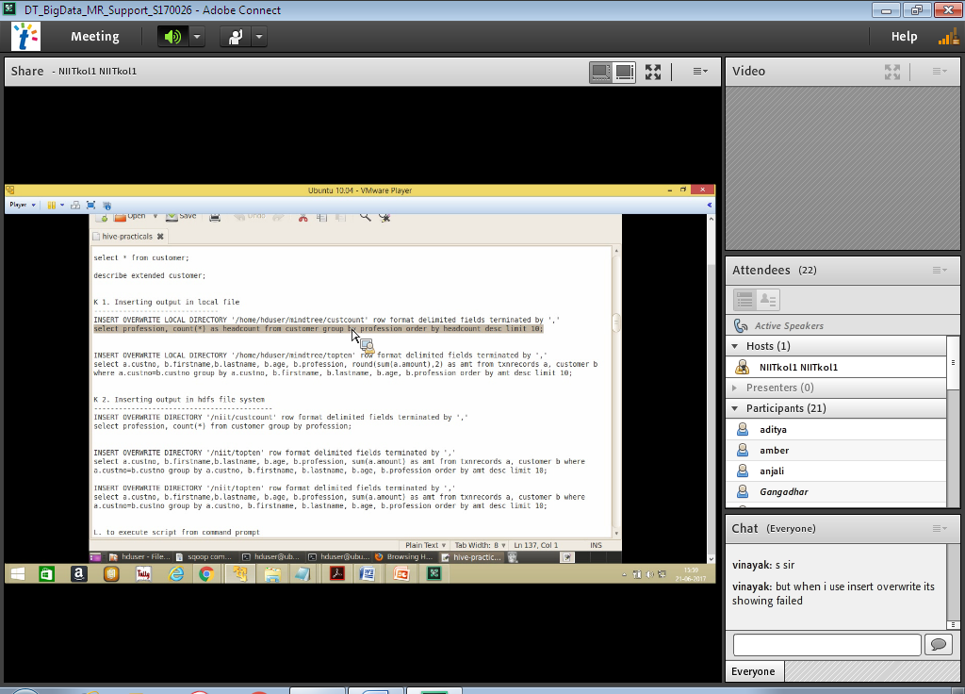

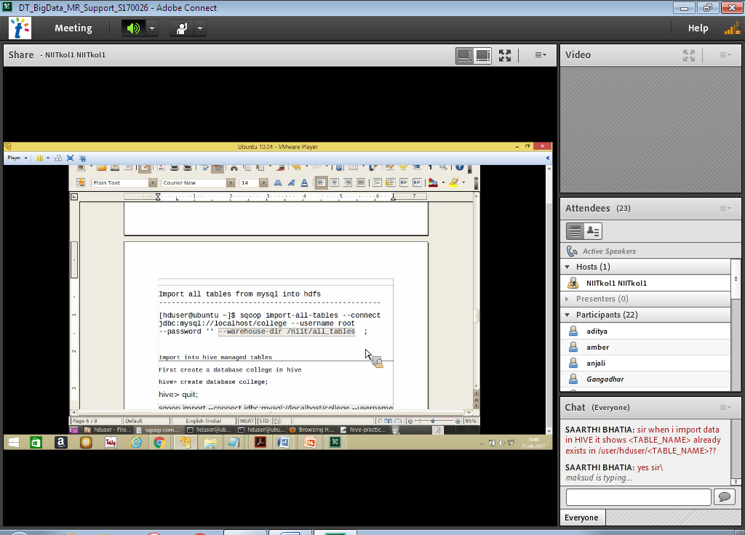

Share with Friends

[Java Developers & Testing Engineers](http://www.hyderabadwalkins.in/120-it-walkins/5602-java-developers-testing-engineers)

***Walkin on 19th Jun ti 7th Jul***

Company Name

NXTVISION Software Technologies (p) limited

Qualification

Graduate

Experience

Freshers

Salary

1,25,000 P.A.

No of Openings

15

Work Location

Hyderabad

Job Description

* + We are looking for freshers to work on domestic projects who would be trained by us.
  + They have to undergo with [JAVA, TESTING] Projects offered by our clients.
  + This is a salary based job program for people interested in making their career in IT.
  + NXTVISION will provide 4 months of training and thereafter 3/6/9/12 months of job experience on ongoing projects. Fee will be charged for Training.

Address

* **Walkin Time:**From 11am
* **Venue:**NXTVISION Software Technologies (p) Ltd #No:11, Vision Arcade, Jaihind Enclave Road, Near Best Western Ashoka Hotel, Madhapur, Hyderabad

Contact

﻿

* **Posted By:**Krishna
* **Telephone:**91-40-65541122
* **Website:**[View company website](http://www.nxtvisionsofttech.com/)