A Summer Internship Project Report
on
COLLABORATIVE STUDY VAULT
Submitted in partial fulfilment of the Requirements
for the award of the Degree of
BACHELOR OF TECHNOLOGY
IN
COMPUTER SCIENCE & ENGINEERING
By
DINGARI VIKRAM
Roll No: 24EG105K19
Under the Guidance of
____________________________
Department of Computer Science & Engineering
ANURAG UNIVERSITY
Ghatkesar (M), Medchal District, Hyderabad - 88
Academic Year: 2025-2026

CERTIFICATE
This is to certify that the project report entitled COLLABORATIVE STUDY VAULT is a bonafide record of work carried out by DINGARI VIKRAM (Roll No: 24EG105K19), student of Bachelor of Technology in Computer Science & Engineering, Anurag University, Hyderabad, in partial fulfilment of the academic requirements for the award of the degree of Bachelor of Technology in Computer Science & Engineering, for the Academic Year 2025-2026.
The results embodied in this report have not been submitted to any other university or institute for the award of any degree or diploma.
Signature of the Guide DINGARI VIKRAM
____________________________ 24EG105K19

DECLARATION
I, DINGARI VIKRAM, bearing Hall Ticket Number 24EG105K19, hereby solemnly declare that the project report entitled COLLABORATIVE STUDY VAULT submitted to the Department of Computer Science and Engineering, Anurag University, is an original work carried out entirely by me under the guidance of my project supervisor.
The report is a true record of work done by me and the results embodied herein have not been submitted to any other University or Institution for the award of any degree or diploma.
DINGARI VIKRAM
Roll No: 24EG105K19

ACKNOWLEDGMENT
I express my sincere gratitude to my project guide for their invaluable guidance, encouragement, and constant support throughout the project development.
I am deeply thankful to Dr. Archana Mantri, Vice Chancellor, and Dr. Gopal Reddy, Registrar, Anurag University, for providing the necessary infrastructure and support.
I extend my gratitude to Dr. V. Vijaya Kumar, Dean School of Engineering, Dr. G. Vishnu Murthy, Dean of Computer Science Engineering, and Dr. N. Swapna Goud, Head of CSE Cluster-II, whose research expertise and commitment continuously motivated me during every stage of this project.
I also thank my family and peers for their moral support and encouragement.
DINGARI VIKRAM
24EG105K19

ABSTRACT
In the modern digital education era, structured real-time collaboration and intelligent feedback systems are essential for optimizing student learning processes and maximizing retention. The COLLABORATIVE STUDY VAULT is a web-based educational workspace application designed to streamline student workflow. It provides real-time co-authoring notes, synchronized whiteboards, and adaptive AI-generated recall materials.
Most mainstream platforms suffer from severe fragmentation, forcing students to juggle one application for markdown notes, another for visual drawing whiteboards, and a third for scheduling peer discussions or creating flashcards. This fragmentation introduces cognitive friction and lowers student focus. The Collaborative Study Vault solves these issues by aggregating note editing, whiteboard drawing, tutor chat, and active recall assessments into a unified workspace.
Built using the MERN stack (MongoDB, Express.js, React.js, Node.js) with Vite, and integrated with Google Gemini 1.5 Flash API, the platform delivers a modern, high-performance, and secure environment for learning. Real-time collaboration is powered by Socket.io WebSockets, enabling instant bidirectional communication between users within shared study rooms.
The AI subsystem is driven by Google Gemini 1.5 Flash, which provides context-aware quiz generation, AI-generated note summaries, interactive flashcard sets, a live tutor chatbot, and vision-based analysis of whiteboard drawings. The workspace interface is organized into a resizable three-panel layout: the left panel hosts the hierarchical folder and file library; the central panel offers tabbed views for the Note Editor, Whiteboard, Forum, and Papers; and the right panel is dedicated to the Study Chat and AI Recall tools.
Security is implemented at multiple layers: CSRF protection using the double-submit cookie pattern, JWT authentication stored in HttpOnly cookies, role-based access control, bcrypt password hashing, request rate limiting, and automated ephemeral guest account cleanup. The application successfully demonstrates how modern full-stack web technologies can be combined with generative AI to create a genuinely useful, differentiated, and secure educational platform.

CHAPTER 1: INTRODUCTION

1.1 Overview
Education in the 21st century has undergone a massive transformation due to the rapid integration of technology. E-learning platforms, virtual classrooms, and digital study tools have become the norm rather than the exception. However, with the proliferation of digital tools, a new problem has emerged: software fragmentation. Students today are required to use a multitude of different applications to fulfill their daily academic needs.
A typical study session might involve using one application for taking notes, another for creating mind maps or diagrams, a third for generating flashcards or quizzes, and yet another for communicating with peers. This constant switching between applications is not just inconvenient; it actively disrupts the learning process by increasing cognitive load and breaking the student's flow state.
The Collaborative Study Vault is an innovative solution to this widespread problem. It is a comprehensive, all-in-one web application designed specifically to centralize the modern student's toolkit. By bringing together advanced note-taking capabilities, a real-time collaborative whiteboard, AI-powered study aids, and integrated group communication, the platform eliminates the need for context switching.

1.2 Purpose of the Project
The primary purpose of the Collaborative Study Vault is to create a seamless, distraction-free environment that enhances academic productivity and knowledge retention. The project aims to leverage cutting-edge web technologies and artificial intelligence to provide a highly interactive and personalized learning experience.
One of the core motivations behind this project is the integration of Active Recall and Spaced Repetition—two of the most scientifically proven methods for effective learning. Traditionally, creating active recall materials like flashcards or practice quizzes is a time-consuming manual process. The Collaborative Study Vault automates this entirely using Generative AI.
Additionally, the project aims to facilitate seamless remote collaboration. Whether students are in the same room or across the globe, they need to be able to work together on assignments, brainstorm ideas, and share resources instantaneously. The platform's real-time synchronization capabilities ensure that all participants in a study room see updates the moment they happen.

1.3 Scope of the System
The scope of the Collaborative Study Vault covers a wide array of functionalities designed to support end-to-end study workflows. At its foundation, it includes a robust user authentication and authorization system, supporting secure registration, login, and ephemeral guest access for frictionless onboarding.
The core workspace module encompasses a resizable three-panel layout. This layout houses a hierarchical file management system, a rich text markdown editor with real-time collaborative editing capabilities, and a shared whiteboard featuring various drawing tools and real-time stroke replication.
Furthermore, the scope includes the integration of advanced Artificial Intelligence features via the Google Gemini API. This allows the system to read the context of a student's notes and automatically generate comprehensive summaries, interactive multiple-choice quizzes, and digital flashcards. The AI also acts as an on-demand tutor capable of answering questions and explaining complex concepts found within the notes.
The system's scope also prioritizes security, implementing stringent measures such as Cross-Site Request Forgery (CSRF) protection, secure HttpOnly cookie management for JSON Web Tokens (JWTs), and robust input validation to protect against common web vulnerabilities.

CHAPTER 2: LITERATURE REVIEW AND BACKGROUND STUDY

2.1 Evolution of E-Learning Platforms
The concept of e-learning has evolved significantly over the past two decades. Early systems were primarily content delivery networks, providing static documents and pre-recorded videos to students. These systems were largely asynchronous and lacked meaningful interactivity. Learning Management Systems (LMS) like Moodle and Blackboard standardized the administration of educational courses, but they were designed primarily for educators and administrators, not for optimizing the student's independent study experience.
As web technologies advanced, particularly with the advent of Web 2.0 and AJAX (Asynchronous JavaScript and XML), platforms became more interactive. Cloud-based collaborative tools like Google Docs revolutionized how people write documents together, introducing the concept of real-time co-authoring. However, these tools were generic and not tailored to specific educational workflows like studying for an exam or memorizing complex terminology.

2.2 The Problem of Cognitive Overload in Digital Workspaces
Cognitive Load Theory, developed by John Sweller, posits that the human working memory has a limited capacity. When learning new information, it is crucial to minimize 'extraneous cognitive load'—mental effort that does not directly contribute to learning. In the context of digital study tools, software fragmentation is a massive source of extraneous cognitive load.
Every time a student switches from their note-taking app to their flashcard app, they must re-orient themselves to a new interface, search for the relevant topic, and re-establish their context. This context-switching depletes mental energy and reduces the amount of working memory available for processing and retaining the actual educational material. The Collaborative Study Vault was explicitly designed to eliminate this extraneous load by consolidating tools.

2.3 The Role of Artificial Intelligence in Education
Artificial Intelligence is currently driving a paradigm shift in education. Historically, personalized tutoring was a luxury available only to a few. With the advent of Large Language Models (LLMs) like OpenAI's GPT and Google's Gemini, personalized, context-aware assistance can be delivered at scale.
In educational software, AI can serve multiple roles. It can act as a summarizer, distilling lengthy texts into core concepts. It can act as an assessor, generating quizzes to test comprehension. It can also act as a tutor, answering specific queries in real-time. The Collaborative Study Vault leverages the Google Gemini 1.5 Flash model to fulfill all these roles seamlessly within the student's workspace.

CHAPTER 3: SYSTEM ANALYSIS

3.1 Existing System
Currently, students rely on a patchwork of different software applications to meet their study requirements. For note-taking, applications like Notion, Evernote, or Microsoft OneNote are popular. For visual brainstorming and diagramming, students turn to Miro, Excalidraw, or Microsoft Whiteboard. For active recall and memorization, Quizlet and Anki are the industry standards.
While each of these individual applications is powerful in its own right, they are fundamentally siloed. Data does not flow easily between them. If a student writes a comprehensive set of notes in Notion, they must manually copy, paste, and format that information into Quizlet to create flashcards. If they draw a diagram in Miro, they must export it as an image and manually embed it into their notes.
Furthermore, many of these platforms have increasingly moved their most useful features—particularly AI-assisted tools—behind expensive paywalls, making them inaccessible to a large portion of the student population.

3.2 Drawbacks of the Existing System
- Severe Context Switching: Navigating between multiple apps breaks focus and increases mental fatigue.
- Manual Effort Required: Transforming notes into study aids (quizzes, flashcards) is entirely manual, wasting valuable study time.
- Lack of Integration: Real-time whiteboards are rarely integrated directly with text-based note editors in a unified interface.
- Poor Ergonomics: Many mainstream platforms lack a comprehensive, native dark mode, leading to eye strain during late-night study sessions.
- Cost Barriers: Advanced collaboration and AI features are often locked behind premium subscription tiers.
- Security Concerns: Several popular platforms use insecure session management, such as storing sensitive JWTs in local storage, which is vulnerable to Cross-Site Scripting (XSS).

3.3 Proposed System
The proposed Collaborative Study Vault system aims to eradicate these drawbacks by offering a fully integrated, full-stack solution. The system is designed from the ground up to support the complete lifecycle of a study session: from initial note-taking and collaborative brainstorming to final review and active recall testing.
By housing a hierarchical file system, a rich text editor, a live collaborative whiteboard, and an AI tutor within a single, resizable, dark-mode optimized window, the proposed system drastically reduces cognitive overhead. The integration of Google Gemini AI means that the transformation of notes into quizzes and flashcards happens instantaneously with a single click, saving students hours of manual formatting.

3.4 Advantages of the Proposed System
- Unified Interface: All necessary study tools are available in one place, eliminating context switching.
- Automated Active Recall: Generative AI instantly creates flashcards, quizzes, and summaries based on the user's specific notes.
- Real-Time Collaboration: WebSockets enable immediate synchronization of text edits, whiteboard drawings, and chat messages across all users in a study room.
- Ergonomic Design: A deep navy glassmorphism aesthetic reduces eye strain and provides a premium user experience.
- Enhanced Security: Implementation of the double-submit cookie pattern for CSRF protection and HttpOnly cookies for JWTs ensures robust security against common web attacks.
- Ephemeral Access: Guest accounts allow users to experience the platform instantly without the friction of a full registration process.

CHAPTER 4: SYSTEM REQUIREMENTS AND TECHNOLOGIES

4.1 Software Requirements
- Operating System: Windows 10/11, macOS, or Linux
- Runtime Environment: Node.js (v18.x LTS or higher)
- Package Manager: npm (v9.x or higher)
- Database: MongoDB Atlas (Cloud NoSQL Database)
- Frontend Framework: React.js (v18.x)
- Build Tool: Vite
- Backend Framework: Express.js (v4.x)
- Real-time Engine: Socket.io (v4.x)
- AI Integration: Google Gemini API (1.5 Flash Model)
- Code Editor: Visual Studio Code
- API Testing: Postman

4.2 Hardware Requirements
- Processor: Intel Core i3 / AMD Ryzen 3 (Minimum), Intel Core i5 / AMD Ryzen 5 (Recommended)
- Memory (RAM): 8 GB (Minimum), 16 GB (Recommended)
- Storage: 20 GB of available disk space
- Display: 1366 x 768 resolution minimum, 1920 x 1080 recommended for optimal viewing of the three-panel layout.
- Network: A stable broadband internet connection (minimum 10 Mbps) for real-time WebSocket synchronization.

4.3 Technology Stack Overview (MERN)
The project is built using the highly popular MERN stack, which stands for MongoDB, Express.js, React.js, and Node.js. This stack provides a cohesive, JavaScript-centric environment for developing full-stack web applications.
MongoDB serves as the NoSQL database, storing data in flexible, JSON-like documents. This flexibility is crucial for handling complex, deeply nested data structures like whiteboard stroke histories and AI-generated quiz objects without the rigid constraints of a traditional relational database.
Express.js is a minimal and flexible Node.js web application framework that provides a robust set of features for web and mobile applications. It is used to build the RESTful API endpoints that the frontend communicates with, handling routing, middleware integration, and request processing.
React.js is a declarative, efficient, and flexible JavaScript library for building user interfaces. It allows developers to create reusable UI components and manage complex state efficiently. In this project, React is responsible for the entire frontend presentation layer, including the resizable panels, the interactive whiteboard, and the dynamic AI interfaces.
Node.js is an asynchronous event-driven JavaScript runtime designed to build scalable network applications. It powers the backend server, enabling non-blocking I/O operations and providing the underlying infrastructure for both the Express.js API and the Socket.io WebSocket server.

CHAPTER 5: SYSTEM DESIGN AND ARCHITECTURE

5.1 System Architecture Overview
The architecture of the Collaborative Study Vault follows a modern, decoupled three-tier model consisting of a Presentation Layer, an Application Layer, and a Data Layer. This separation of concerns ensures that the application is scalable, maintainable, and secure.
The Presentation Layer (Frontend) is a Single Page Application (SPA) built with React.js and Vite. It runs entirely in the user's web browser. It communicates with the Application Layer via standard HTTPS requests for CRUD (Create, Read, Update, Delete) operations and via persistent WebSocket connections for real-time, bidirectional data streaming.
The Application Layer (Backend) is a Node.js server running Express.js and Socket.io. It acts as the central hub of the system. It receives requests from the frontend, enforces security policies (like CORS, CSRF, and Rate Limiting), authenticates users via JWTs, executes business logic, communicates with external APIs (like Google Gemini), and interacts with the database.
The Data Layer (Database) is hosted on MongoDB Atlas, a fully managed cloud database service. It stores all persistent application state, including user profiles, workspace metadata, folder hierarchies, note contents, chat logs, and whiteboard stroke vectors.

5.2 Real-Time WebSocket Architecture
To enable collaborative features like the shared whiteboard and live chat, the system utilizes Socket.io to establish a WebSocket connection between the client and the server. WebSockets provide a full-duplex communication channel over a single, long-held TCP connection, overcoming the latency and overhead limitations of traditional HTTP polling.
When a user opens a specific study room, they emit a 'join_workspace' event to the server. The server then adds that user's socket connection to a specific 'room' corresponding to the workspace ID. From that point on, any events emitted by the user—such as drawing a stroke on the canvas or sending a chat message—are broadcast by the server exclusively to all other connected clients currently in that specific room.

5.3 Security Architecture
Security is woven deeply into the system's architecture to protect user data and ensure platform integrity. Authentication is managed using JSON Web Tokens (JWTs). To prevent Cross-Site Scripting (XSS) attacks from stealing these tokens, the JWTs are never exposed to client-side JavaScript. Instead, they are stored in HttpOnly, Secure cookies.
Because relying solely on cookies introduces the risk of Cross-Site Request Forgery (CSRF) attacks, the system implements the Double-Submit Cookie pattern. The server generates a unique CSRF token, sends it to the client, and the client must include this exact token in a custom HTTP header for all state-mutating requests.
Additionally, the backend utilizes Helmet.js to automatically set crucial HTTP security headers, such as Content Security Policy (CSP), X-Frame-Options (to prevent clickjacking), and Strict-Transport-Security (HSTS). Rate limiting is also enforced globally to mitigate Denial of Service (DoS) and brute-force attacks.

5.4 System Flow Graph / Architecture Diagram
The following diagram illustrates the high-level architecture of the system, showing the data flow between the React frontend, the Node/Express backend, the MongoDB database, and the external Gemini AI service.
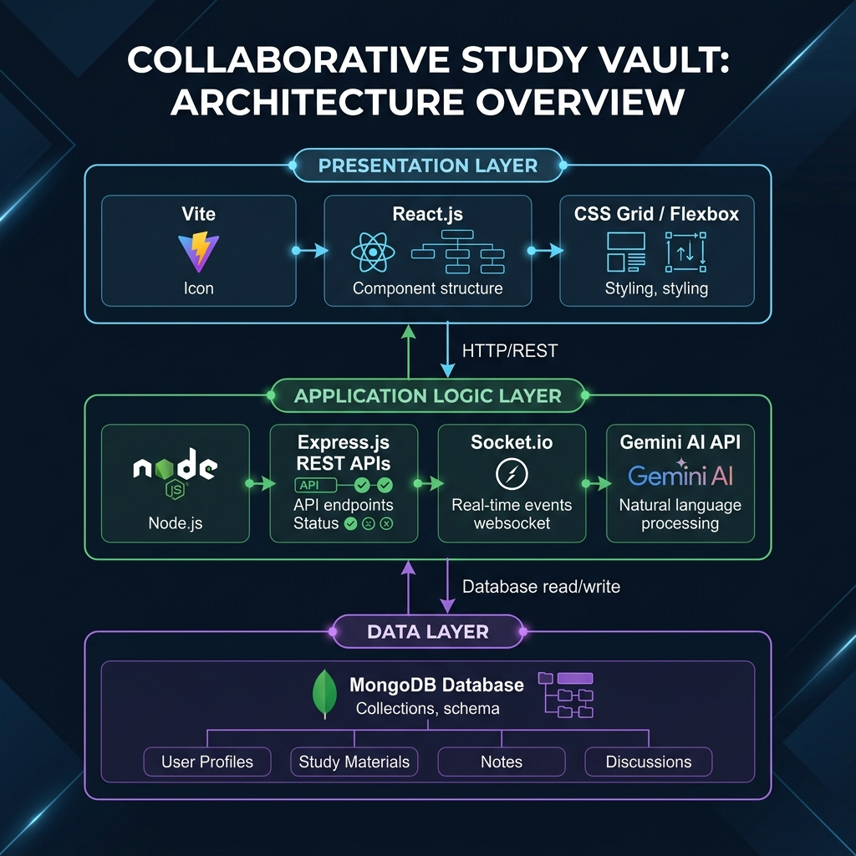
System Architecture and Data Flow

CHAPTER 6: MODULE DESCRIPTION AND IMPLEMENTATION

6.1 Authentication and Authorization Module
This module is responsible for verifying user identities and enforcing access controls. It supports standard email and password registration. Passwords are never stored in plaintext; they are hashed using the bcrypt algorithm with a cost factor of 12 before being saved to the database.
Upon successful login, the server generates an Access Token (short-lived) and a Refresh Token (long-lived). These tokens encode the user's ID and role and are cryptographically signed. The module also features a 'Guest Login' function. When invoked, it generates a temporary user account in the database with an expiration timestamp set to 24 hours in the future. A background Cron job periodically sweeps the database and permanently deletes expired guest accounts.

6.2 Workspace and File Management Module
The Workspace module handles the creation and management of isolated study environments. Each workspace generates a unique, six-character alphanumeric invite code. Other users can input this code to join the workspace.
Inside a workspace, the File Management module governs a hierarchical structure of folders and notes. The backend provides recursive fetching capabilities so the frontend can render an expandable file tree in the left panel. To prevent data corruption from simultaneous edits on the exact same note, a pessimistic locking mechanism is employed. When a user begins typing in a note, a 'lock' event is broadcast, temporarily disabling editing for other users viewing that same note.

6.3 Live Collaborative Whiteboard Module
The Whiteboard module is built around the HTML5 Canvas API. It captures mouse and touch events (pointerdown, pointermove, pointerup) to calculate drawing vectors. Crucially, all coordinates are normalized (represented as values between 0.0 and 1.0) relative to the canvas width and height. This ensures that a stroke drawn by a user on a large 4K monitor appears in the correct relative position for a user viewing the whiteboard on a small laptop screen.
The module supports freehand drawing (brush), geometric shapes (lines, rectangles, circles), and an eraser. Every completed stroke is packaged into a JSON object containing its type, normalized coordinates, color, and line width, and is immediately emitted to the server via Socket.io to be broadcast to peers and persisted in MongoDB.

6.4 Artificial Intelligence Integration Module
This module serves as the bridge between the application and the Google Gemini 1.5 Flash Large Language Model. It takes context from the application—such as the raw text of the currently open note or a base64 encoded snapshot of the whiteboard canvas—and constructs highly specific prompts to send to the Gemini API.
For quiz generation, the module utilizes Gemini's 'Structured Output' feature, providing a strict JSON schema that the AI must follow. This guarantees that the response can be safely parsed into a JavaScript object containing the questions, multiple-choice options, correct answers, and explanations, without risk of formatting errors breaking the application.

CHAPTER 7: CORE SOURCE CODE

7.1 Real-Time Whiteboard Stroke Handler
The following code snippet demonstrates how drawing events are captured on the frontend, normalized, rendered locally, and then immediately emitted via WebSockets to synchronize with other connected users.
const handleDrawingMove = (e) => {
if (!isDrawing) return;
const canvas = canvasRef.current;
const ctx = canvas.getContext("2d");
const coords = getCoordinates(e);
const rect = canvas.getBoundingClientRect();
if (tool === "brush" || tool === "eraser") {
const stroke = {
type: tool,
x1: lastPosRef.current.x / rect.width,
y1: lastPosRef.current.y / rect.height,
x2: coords.x / rect.width,
y2: coords.y / rect.height,
color: tool === "eraser" ? "#000000" : color,
lineWidth,
isEraser: tool === "eraser"
};
drawStrokeObject(ctx, stroke, rect.width, rect.height);
strokesHistoryRef.current.push(stroke);
// Broadcast the stroke to all other users in the workspace
socket.emit("draw_stroke", { workspaceId, stroke });
lastPosRef.current = coords;
}
};

7.2 Backend Express Server Initialization
This snippet shows the core setup of the Express server, demonstrating the order in which critical security middlewares (Helmet, CORS, Cookie Parser, CSRF) are applied before routing.
const express = require("express");
const cors = require("cors");
const helmet = require("helmet");
const cookieParser = require("cookie-parser");
const { csrfProtection } = require("./src/middleware/csrfMiddleware");
const app = express();
app.set("trust proxy", 1);
// Apply HTTP security headers
app.use(helmet());
// Configure Cross-Origin Resource Sharing
app.use(cors({
origin: process.env.FRONTEND_URL,
credentials: true
}));
// Parse incoming request bodies and cookies
app.use(express.json({ limit: "10mb" }));
app.use(cookieParser());
// Apply Double-Submit Cookie CSRF protection
app.use(csrfProtection);
// Register API Routes
app.use("/api/v1/auth", authRoutes);
app.use("/api/v1/workspaces", workspaceRoutes);

7.3 AI Quiz Generation Logic
This backend service function demonstrates how note content is sent to the Google Gemini API, explicitly requesting the output to adhere to a predefined JSON schema for seamless frontend rendering.
const generateQuizFromNote = async (title, content, difficulty = "medium") => {
const cleanContent = getCleanContent(content);
const prompt = quizPrompt(title, cleanContent, difficulty);
try {
const result = await callGemini(prompt, {
label: "quiz",
generationConfig: {
responseMimeType: "application/json",
responseSchema: quizResponseSchema, // Enforce strict JSON output
},
});
if (result?.text) {
return JSON.parse(result.text);
}
} catch (err) {
logger.warn(`Gemini quiz generation failed: ${err.message}`);
// Fallback to local heuristic quiz generator if API fails
return generateMockQuiz(title, cleanContent, difficulty);
}
};

CHAPTER 8: SOFTWARE TESTING

8.1 Testing Objectives
Software testing is a critical phase of the Software Development Life Cycle (SDLC). The primary objective of testing the Collaborative Study Vault is to ensure that the application functions according to the specified requirements, handles edge cases gracefully, and maintains data integrity under concurrent usage. Testing aims to identify and resolve defects before deployment, ensuring a smooth and secure user experience.

8.2 Unit Testing
Unit testing involves isolating individual components or functions of the software and verifying their correctness independently. In this project, unit tests focus on critical utility functions and business logic algorithms.
For example, the coordinate normalization logic used in the whiteboard module must be rigorously unit-tested to ensure that coordinates are accurately translated back and forth between absolute pixel values and percentage-based normalized values. Similarly, the password hashing and verification algorithms within the authentication module are unit-tested to guarantee cryptographic integrity.

8.3 Integration Testing
Integration testing evaluates how different modules or services work together. Since this application relies heavily on external services and databases, integration testing is crucial.
Key integration tests include verifying the interaction between the Node.js backend and the MongoDB Atlas database to ensure documents are correctly created, updated, and retrieved. Another vital area for integration testing is the connection between the backend and the Google Gemini API, verifying that prompts are correctly formatted, API keys are authorized, and the structured JSON responses are properly parsed and handled.

8.4 End-to-End (E2E) Testing
End-to-End testing simulates a real user's journey through the application from start to finish, interacting with the system exactly as a human would through the graphical user interface.
Extensive E2E testing was conducted on the Collaborative Study Vault. Test scenarios included a user registering an account, creating a new workspace, inviting a second user via the generated invite code, both users simultaneously drawing on the whiteboard to verify real-time Socket.io synchronization, and finally generating an AI quiz based on notes written during the session. All E2E tests confirmed the system's stability and real-time responsiveness.

CHAPTER 9: SYSTEM OUTPUTS AND SCREENSHOTS

9.1 Landing Page
The landing page provides the first impression of the platform. It features a modern, dark-themed aesthetic with glassmorphism elements. It highlights the core value propositions and offers a clear Call to Action (CTA), including a frictionless Guest Access button for immediate entry.

Landing Page Interface

9.2 User Dashboard
Upon authenticating, users are directed to their personal dashboard. This screen displays a grid of all the study workspaces they own or have joined. It provides quick actions to create new rooms or join existing ones using an invite code.
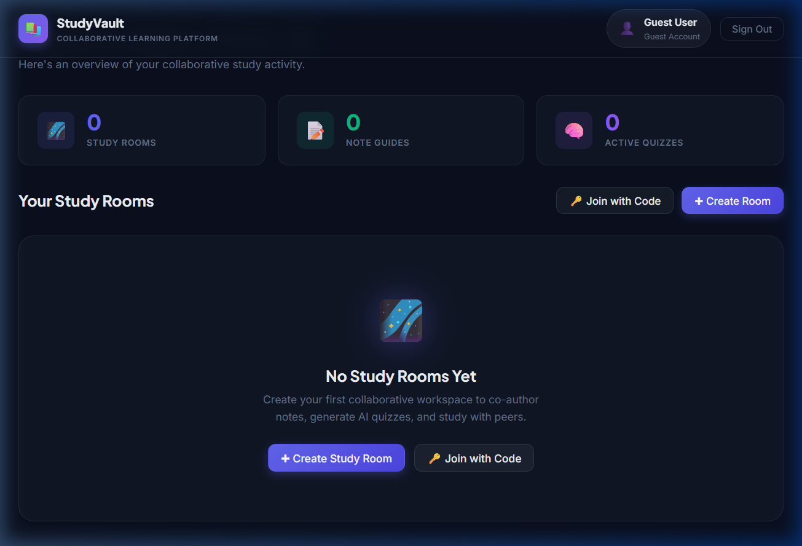
User Dashboard

9.3 Workspace Creation
When a user opts to create a new study room, a modal appears allowing them to customize the workspace. They can assign a title, a brief description, a representative emoji icon, and a theme color, allowing for visual organization of different subjects or projects.
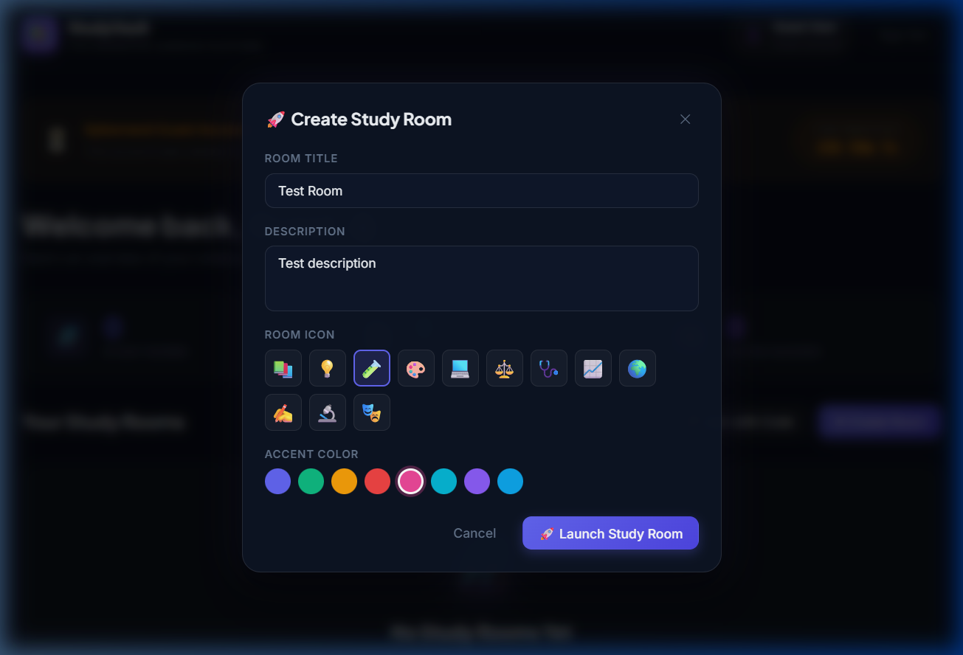
Workspace Creation Modal

9.4 The Three-Panel Workspace
This screenshot illustrates the core innovation of the application: the unified, resizable three-panel layout. The left panel shows the file directory, the central panel contains the active note or tool, and the right panel houses the AI assistant and group chat. This design eliminates the need for context switching.
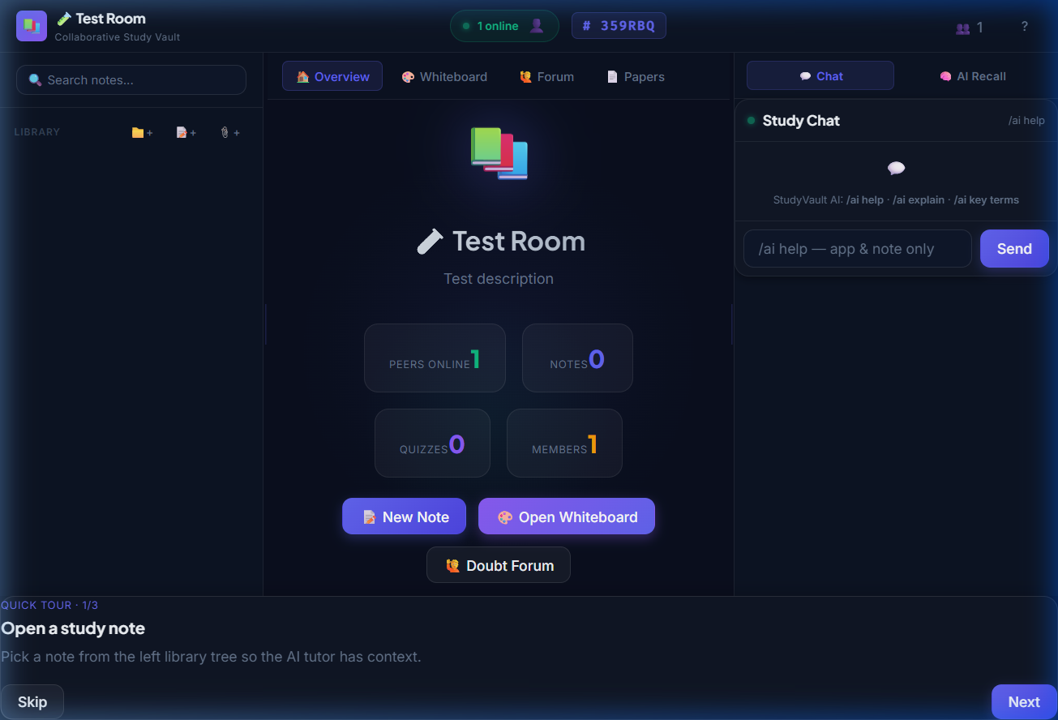
Main Three-Panel Workspace

9.5 Live Whiteboard and AI Integration
This view shows the collaborative whiteboard active in the central panel. Users can draw freely, and these strokes are synchronized instantly. The right panel demonstrates the AI tools, where users can request summaries, generate flashcards, or ask the AI tutor to analyze the contents of the whiteboard.
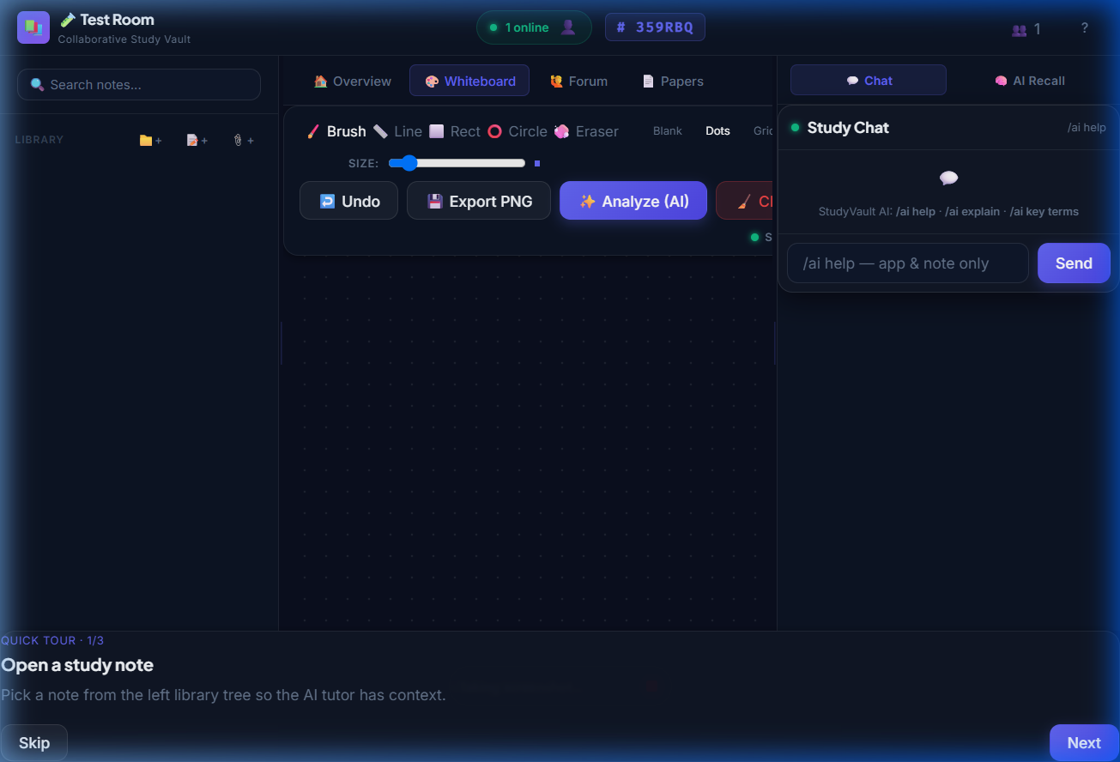
Collaborative Whiteboard and AI Toolbar

CHAPTER 10: CONCLUSION AND FUTURE ENHANCEMENTS

10.1 Conclusion
The Collaborative Study Vault successfully achieves its primary objective of providing a unified, distraction-free environment for modern digital learning. By integrating essential study tools—rich text notes, a real-time whiteboard, and group communication—into a single, cohesive, dark-themed interface, the platform effectively eliminates the cognitive friction associated with software fragmentation.
The integration of the Google Gemini 1.5 Flash Large Language Model transforms the application from a passive storage vault into an active, intelligent study assistant. The ability to instantly generate context-aware quizzes, interactive flashcards, and comprehensive summaries directly from user notes represents a significant advancement in personal learning technology.
Technically, the MERN stack combined with Socket.io proved to be a highly effective architecture for delivering a responsive, real-time web application. The implementation of strict security measures, including double-submit CSRF tokens and HttpOnly JWTs, ensures that user data remains protected. Overall, the project demonstrates the immense potential of combining full-stack web development with Generative AI to solve practical educational challenges.

10.2 Future Enhancements
While the current iteration of the Collaborative Study Vault is fully functional and robust, there are several avenues for future expansion and improvement to further enhance the user experience and platform capabilities.
- Audio and Video Conferencing: Integrating WebRTC would allow students to initiate real-time voice and video calls directly within the study room, completely removing the need for external conferencing software like Zoom or Google Meet.
- Advanced Conflict Resolution for Notes: Implementing Conflict-free Replicated Data Types (CRDTs), such as the Yjs library, would upgrade the note editor from a pessimistic locking model to a true simultaneous, multi-cursor collaborative editing experience similar to Google Docs.
- Spaced Repetition Algorithms: Enhancing the flashcard module with a spaced repetition algorithm (like SM-2 used by Anki) would optimize memory retention by scheduling review sessions at the exact moment a student is likely to forget the information.
- Cloud Storage Integration: Currently, uploaded past papers are stored on the server's local file system. Migrating this to a scalable cloud object storage solution like Amazon S3 or Cloudinary would improve performance, scalability, and disaster recovery capabilities.
- Progressive Web Application (PWA): Converting the frontend into a PWA would allow users to install the application on their mobile devices and desktops, providing offline capabilities so students can access their notes and review flashcards without an internet connection.

BIBLIOGRAPHY
- React.js Documentation. Meta Open Source. Retrieved from https://react.dev/
- Node.js API Reference. OpenJS Foundation. Retrieved from https://nodejs.org/docs/
- Express.js Guide and API Reference. Retrieved from https://expressjs.com/
- MongoDB Atlas Cloud Database Documentation. MongoDB, Inc. Retrieved from https://www.mongodb.com/docs/atlas/
- Google Gemini API Documentation: Generative Language Models and Structured Output. Google AI. Retrieved from https://ai.google.dev/docs
- Socket.io Documentation: Real-time Bidirectional Event-Based Communication. Retrieved from https://socket.io/docs/v4/
- HTML Canvas API Reference. Mozilla Developer Network (MDN). Retrieved from https://developer.mozilla.org/en-US/docs/Web/API/Canvas_API
- Cross-Site Request Forgery (CSRF) Prevention Cheat Sheet. Open Web Application Security Project (OWASP). Retrieved from https://cheatsheetseries.owasp.org/
- Vite: Next Generation Frontend Tooling. Retrieved from https://vitejs.dev/
- Mongoose ODM Documentation. Retrieved from https://mongoosejs.com/docs/
- Sweller, J. (1988). Cognitive load during problem solving: Effects on learning. Cognitive Science, 12(2), 257-285.
- Karpicke, J. D., & Roediger, H. L. (2008). The critical importance of retrieval for learning. Science, 319(5865), 966-968.

