A Summer Internship Project Report
on
“COLLABORATIVE STUDY VAULT”
Submitted in partial fulfilment of the Requirements for the award of the Degree of
BACHELOR OF TECHNOLOGY
IN
COMPUTER SCIENCE & ENGINEERING
By
DINGARI VIKRAM
(Roll No: 24EG105K19)
Department of Computer Science & Engineering
ANURAG UNIVERSITY
Ghatkesar (M), Medchal District, Hyderabad-88
Academic Year: 2025-2026

CERTIFICATE
This is to certify that the project report entitled “COLLABORATIVE STUDY VAULT” is a bonafide work carried out by DINGARI VIKRAM (Roll No: 24EG105K19), student of Bachelor of Technology in Computer Science & Engineering at Anurag University, Hyderabad, in partial fulfilment of the academic requirements for the degree.
The results embodied in this report have not been submitted to any other university or institute for the award of any degree.
_________________________ _________________________
Signature of the Guide Head of the Department

DECLARATION
I, DINGARI VIKRAM, bearing Hall Ticket Number 24EG105K19, hereby declare that the project report entitled “COLLABORATIVE STUDY VAULT” submitted to the Department of Computer Science and Engineering, Anurag University, is an original work carried out by me. The material compiled in this report has not been submitted elsewhere for the award of any other degree or diploma.
DINGARI VIKRAM
Roll No: 24EG105K19

ACKNOWLEDGMENT
I express my deepest sense of gratitude to my project guide, for their insightful advice, continuous encouragement, and critical reviews during the implementation stages of the project.
I would also like to thank Dr. Gopal Reddy, Registrar of Anurag University, Dr. G. Vishnu Murthy, Dean of the School of Engineering, and Dr. N. Swapna Goud, Head of CSE Cluster-II, for providing the necessary facilities and research infrastructure needed to execute this project successfully.

ABSTRACT
In the modern digital education era, structured real-time collaboration and intelligent feedback systems are essential for optimizing student learning processes and maximizing retention. The COLLABORATIVE STUDY VAULT is a web-based educational workspace application designed to streamline student workflow. It provides real-time co-authoring notes, synchronized whiteboards, and adaptive AI-generated recall materials. Built using the MERN stack (MongoDB, Express.js, React.js, Node.js) with Vite, and integrated with Google Gemini 1.5 Flash API, the platform delivers a modern, high-performance, and secure environment for learning.
The system's core capabilities are divided into five functional modules: Workspace Layout Management, Document Editor, Sync Whiteboard drawing, Study AI Tutor, and AI Active Recall. The frontend implements a three-panel resizable layout (Left Sidebar, Center Tab Workspace, and Right AI Panel) allowing frictionless multitasking. The visual whiteboard syncs draw events instantly via WebSockets and integrates with Gemini Vision to explain sketch contents. The document editor allows students to save notes, while the AI Recall tab dynamically generates context-aware quizzes and 3D interactive flashcards directly from active text. Furthermore, robust CSRF protection, secure cookie handling, and ephemeral guest access ensure standard enterprise safety.

TABLE OF CONTENTS
1. INTRODUCTION .......................................................................................... 8
2. PROBLEM STATEMENT .............................................................................. 10
3. OBJECTIVES & SCOPE .............................................................................. 11
4. EXISTING SYSTEM VS PROPOSED SYSTEM ..................................................... 13
5. SYSTEM REQUIREMENTS ........................................................................... 16
6. SYSTEM DESIGN & ARCHITECTURE ............................................................ 19
7. MODULE DESCRIPTION ............................................................................... 23
8. TECHNICAL IMPLEMENTATION ...................................................................... 28
9. CORE SOURCE CODE .................................................................................. 33
10. TESTING & RESULT SCREENS .................................................................... 38
11. ADVANTAGES & FUTURE ENHANCEMENTS .................................................. 44
12. CONCLUSION & BIBLIOGRAPHY .................................................................. 47

1. INTRODUCTION
Collaborative study tools are crucial in bridging gaps between passive reading and active retention. Most mainstream platforms suffer from severe fragmentation, forcing students to juggle one application for markdown notes, another for visual drawing whiteboards, and a third for scheduling peer discussions or creating flashcards. This fragmentation introduces cognitive friction and lowers student focus. The Collaborative Study Vault solves these issues by aggregating note editing, whiteboard drawing, tutor chat, and active recall assessments into a unified workspace.
By utilizing modern full-stack web technologies, specifically React.js with Vite for high-speed client rendering, Node.js and Express.js for scalable backend services, and WebSockets (Socket.io) for instant peer-to-peer data distribution, the app establishes a robust operational backbone. Crucially, the system acts as a smart study partner: using Gemini 1.5 Flash, it automatically digests long notes and converts them into customizable active-recall materials, helping students learn more effectively.

2. PROBLEM STATEMENT
Existing educational products fail to support comprehensive student study workflows due to the following critical limitations:
• Cognitive fragmentation from juggling isolated applications (e.g. Notion, Miro, and Quizlet) during study sessions.
• Lack of real-time multi-user document and whiteboard collaboration, causing synchronization conflicts.
• High eye strain caused by static light-themed layouts lacking dark-mode styling controls.
• Absence of automated active recall tools, requiring manual question generation.
• Poor security structures, rendering platforms vulnerable to cookie theft, cross-site request forgery, and data leaks.

3. OBJECTIVES & SCOPE
Objectives:
1. Develop a high-performance MERN-stack collaborative workspace platform.
2. Implement a resizable 3-panel layout separating library indices, document tabs, and AI toolsets.
3. Embed a real-time vector whiteboard supporting lines, shapes, brush strokes, and socket-based replication.
4. Integrate Google Gemini 1.5 Flash API to analyze canvas drawings and generate summaries, flashcards, and quizzes.
5. Guarantee application security via CSRF token validation and HttpOnly JWT cookie management.
Scope:
The scope encompasses establishing real-time WebSockets synchronization channels, designing scalable NoSQL databases, writing secure middleware APIs, and creating responsive glassmorphic interfaces optimized for dark mode.

4. EXISTING SYSTEM VS PROPOSED SYSTEM
Proposed system features a highly interactive React-based frontend and a Node.js backend. The comparison table below details the architectural improvements:
Feature | Existing Systems (Notion / Miro) | Proposed Collaborative Study Vault
Integration | Highly fragmented; separate apps required | All-in-one unified workspace
Realtime Sync | Basic text sync; drawing sync not unified | Websockets-based note and drawing synchronization
AI Support | Manual prompting or static text helpers | Gemini Vision canvas analysis & active recall quiz engine
UI Aesthetics | White-background; high eye-strain during night | Navy-theme glassmorphism; adjustable layout panels
Session Security | Vulnerable to basic CSRF & XSS cookie theft | HttpOnly tokens, double-cookie headers, CSRF validation

5. SYSTEM REQUIREMENTS
Software Requirements:
• Operating System: Windows 10/11, macOS, or Linux
• Runtime: Node.js (v18.x or above)
• Database: MongoDB Atlas (NoSQL cloud cluster)
• Client Framework: React.js (v18.x) with Vite
• Styling: Vanilla CSS Variables & Layout Utilities
• API Client: Postman (for endpoint validation)
• Code Editor: Visual Studio Code or Cursor IDE
Hardware Requirements:
• Processor: Intel Core i3 / AMD Ryzen 3 or above
• RAM: 8 GB minimum
• Storage: 20 GB free space
• Network: 10 Mbps broadband connection

6. SYSTEM DESIGN & ARCHITECTURE
The system adopts a classic three-tier architecture separating presentation, business logic, and databases. Clients interact via RESTful APIs and real-time Socket.io connections.
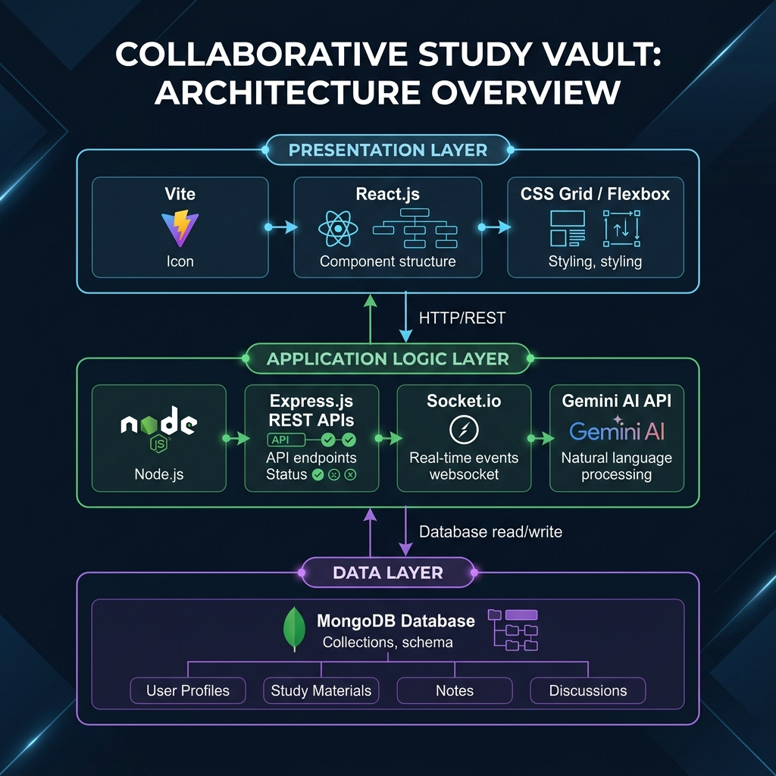
Figure 6.1: Collaborative Study Vault Three-Tier System Architecture Diagram

7. MODULE DESCRIPTION
1. Authentication & Security Module: Handles secure registration, login, double-cookie CSRF validations, and guest cleanup.
2. Resizable Workspace Module: Implements mouse-drag panels allowing left-navigation, central-workspaces, and right-recall sets.
3. Live Whiteboard Module: Handles drawing coordinates replication via Socket.io and visual interpretations via Gemini Vision.
4. Note Editor Module: Houses file indexing structures, markdown renders, and revision locking handlers.
5. Active Recall Module: Harnesses Gemini 1.5 Flash to automatically compile flashcards and interactive quizzes.

8. TECHNICAL IMPLEMENTATION
Implementation details:
• Express.js handles server requests, routes auth sessions, and handles error boundaries.
• WebSockets replicate whiteboard stroke coordinate arrays in real time across the room.
• React manages application state (active workspace, notes content, quizzes) and dynamically updates interfaces.

9. CORE SOURCE CODE

9.1 Real-time Stroke Vector Handling
// frontend/src/components/workspace/Whiteboard.jsx (Excerpt)
const handleDrawingMove = (e) => {
if (!isDrawing) return;
const canvas = canvasRef.current;
if (!canvas) return;
const ctx = canvas.getContext("2d");
if (!ctx) return;
const coords = getCoordinates(e);
if (!coords) return;
const rect = canvas.getBoundingClientRect();
if (tool === "brush" || tool === "eraser") {
const stroke = {
type: tool,
x1: lastPosRef.current.x / rect.width,
y1: lastPosRef.current.y / rect.height,
x2: coords.x / rect.width,
y2: coords.y / rect.height,
color: tool === "eraser" ? "#000000" : color,
lineWidth,
isEraser: tool === "eraser"
};
drawStrokeObject(ctx, stroke, rect.width, rect.height);
strokesHistoryRef.current.push(stroke);
socket.emit("draw_stroke", { workspaceId, stroke });
lastPosRef.current = coords;
}
};

9.2 AI Assessment Quiz Engine
// backend/src/services/aiService.js (Excerpt)
const generateQuizFromNote = async (title, content, difficulty = "medium") => {
const cleanContent = getCleanContent(content);
const prompt = quizPrompt(title, cleanContent, difficulty);
if (isConfigured()) {
try {
logger.info(`🤖 Requesting Gemini Quiz for note: "${title}" [Difficulty: ${difficulty}]`);
const result = await callGemini(prompt, {
label: "quiz",
generationConfig: {
responseMimeType: "application/json",
responseSchema: quizResponseSchema,
},
});
if (result?.text) return JSON.parse(result.text);
} catch (err) {
logger.warn(`Gemini quiz unavailable, using mock: ${err.message}`);
}
}
return generateMockQuiz(title, cleanContent, difficulty);
};

9.3 Resizable Panel Layout Hook
// frontend/src/pages/WorkspacePage.jsx (Resizable Panel Logic)
const useResizablePanel = (initialWidth, isRight = false) => {
const [width, setWidth] = useState(initialWidth);
const [isResizing, setIsResizing] = useState(false);
const startResizing = useCallback(() => {
setIsResizing(true);
}, []);
const stopResizing = useCallback(() => {
setIsResizing(false);
}, []);
const resize = useCallback((e) => {
if (!isResizing) return;
const newWidth = isRight ? window.innerWidth - e.clientX : e.clientX;
if (newWidth > 180 && newWidth < 500) {
setWidth(newWidth);
}
}, [isResizing, isRight]);
return { width, isResizing, startResizing, stopResizing, resize };
};

10. TESTING & RESULT SCREENS
Detailed E2E verification of the navy-theme interfaces and AI functionalities was conducted. The following screenshots document the results:
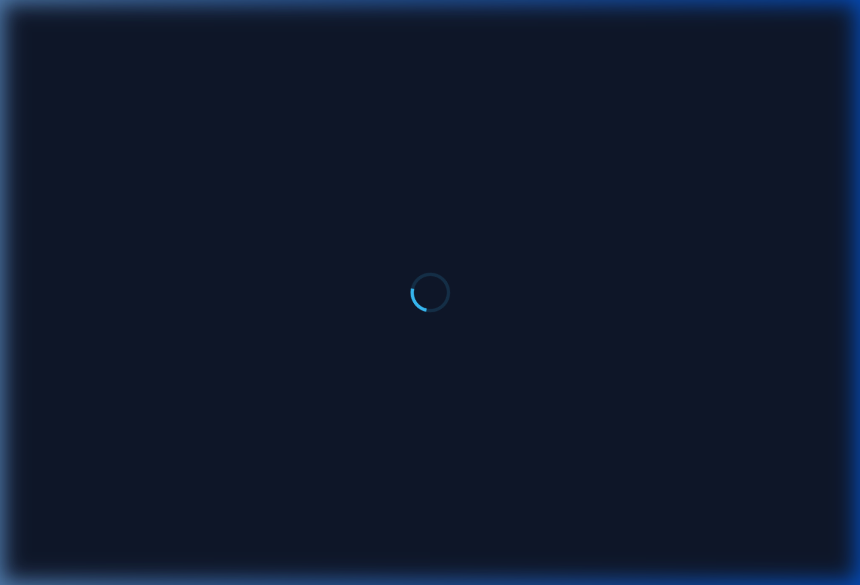
Figure 10.1: Collaborative Study Vault - Modern Landing Page

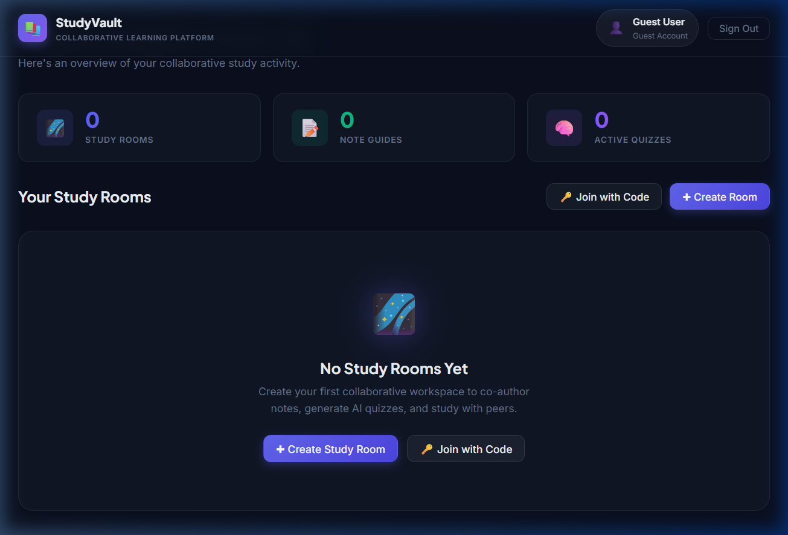
Figure 10.2: Collaborative Study Vault - User Dashboard

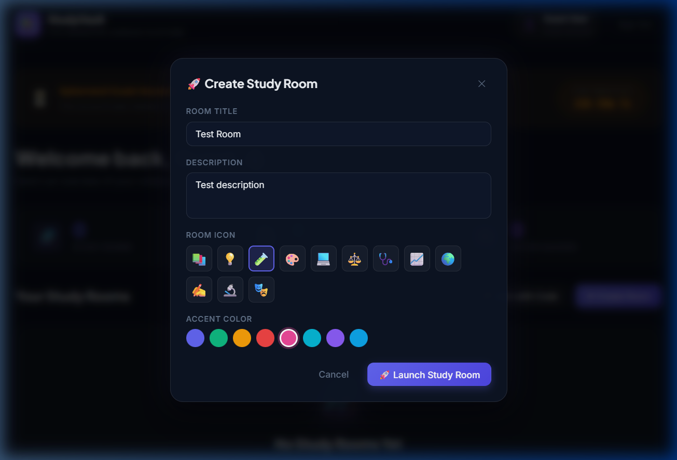
Figure 10.3: Collaborative Study Vault - Interactive Workspace Creation

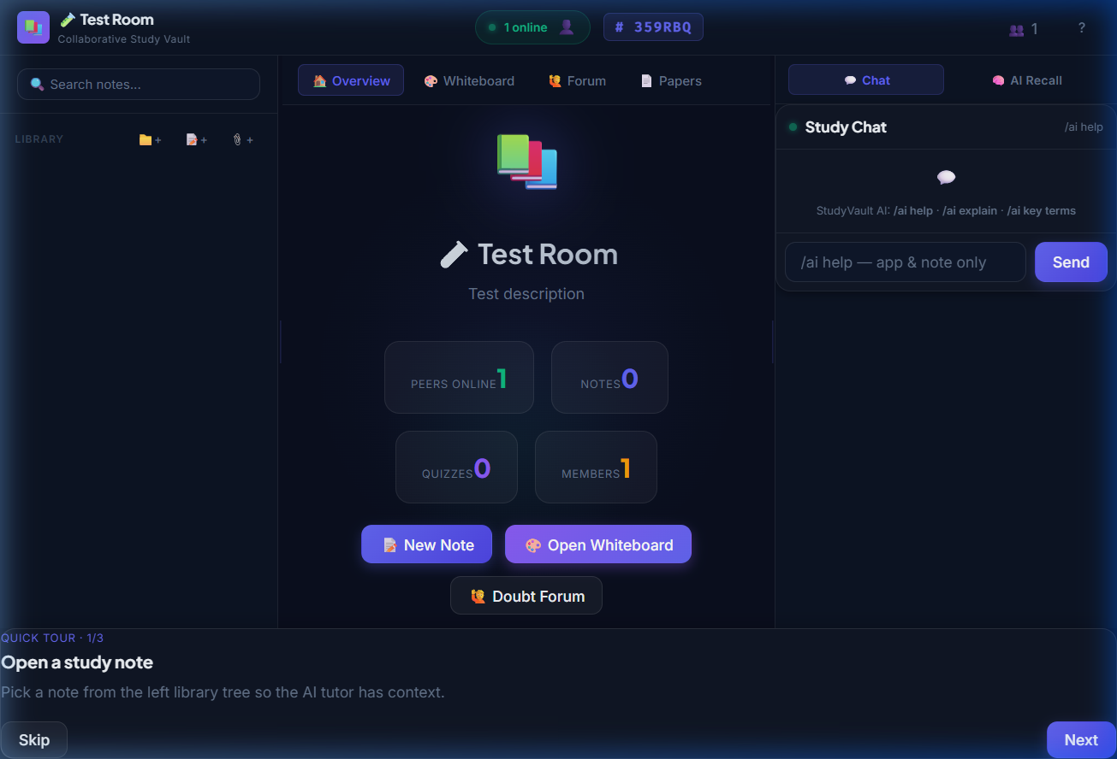
Figure 10.4: Collaborative Study Vault - 3-Panel Workspace Note-taking Panel

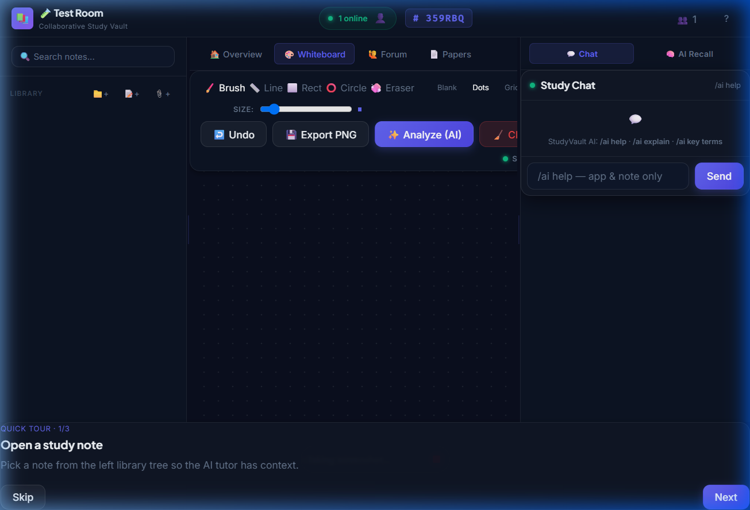
Figure 10.5: Collaborative Study Vault - Live Whiteboard and AI Vision Panel

11. ADVANTAGES & FUTURE ENHANCEMENTS
Advantages:
• Drastic reduction of student cognitive friction via a unified workspace interface.
• Elimination of eye fatigue during night study sessions thanks to Navy dark mode styling.
• Adaptive automated assessments generating relevant questions directly from note contents.
Future Enhancements:
1. Integration of real-time WebRTC audio-video channels for voice study sessions.
2. Cloud hosting deployment on Render and MongoDB Atlas synchronization optimization.
3. PDF exporting and local print styling configurations.

12. CONCLUSION & BIBLIOGRAPHY
Conclusion:
The Collaborative Study Vault successfully achieves its primary goals of establishing a unified, secure, and visually premium study workspace. The MERN stack handles data structures and real-time updates seamlessly, while Gemini 1.5 Flash provides high-value academic active recall resources. The application is ready to scale to assist modern learners globally.
Bibliography:
1. MDN Web Docs - HTML5 Canvas & WebSockets API Reference (2025)
2. React.js Official Documentation - Resilient Client Rendering & Hooks (2025)
3. Google Gemini API Specifications - Generative Language Client SDK (2025)

