A Summer Internship Project Report
on
“COLLABORATIVE STUDY VAULT”
Submitted in partial fulfilment of the Requirements
for the award of the Degree of
BACHELOR OF TECHNOLOGY
IN
COMPUTER SCIENCE & ENGINEERING
By
DINGARI VIKRAM
Roll No: 24EG105K19
Under the Guidance of
____________________________
Department of Computer Science & Engineering
ANURAG UNIVERSITY
Ghatkesar (M), Medchal District, Hyderabad – 88
Academic Year: 2025–2026

CERTIFICATE
This is to certify that the project report entitled “COLLABORATIVE STUDY VAULT” is a bonafide record of work carried out by DINGARI VIKRAM (Roll No: 24EG105K19), student of Bachelor of Technology in Computer Science & Engineering, Anurag University, Hyderabad, in partial fulfilment of the academic requirements for the award of the degree of Bachelor of Technology in Computer Science & Engineering, for the Academic Year 2025–2026.
The results embodied in this report have not been submitted to any other university or institute for the award of any degree or diploma.
Signature of the Guide DINGARI VIKRAM
____________________________ 24EG105K19
____________________________

DECLARATION
I, DINGARI VIKRAM, bearing Hall Ticket Number 24EG105K19, hereby solemnly declare that the project report entitled “COLLABORATIVE STUDY VAULT” submitted to the Department of Computer Science and Engineering, Anurag University, is an original work carried out entirely by me under the guidance of my project supervisor.
The report is a true record of work done by me and the results embodied herein have not been submitted to any other University or Institution for the award of any degree or diploma.
DINGARI VIKRAM
Roll No: 24EG105K19

ACKNOWLEDGMENT
I express my sincere gratitude to my project guide for their invaluable guidance, encouragement, and constant support throughout the project development.
I am deeply thankful to Dr. Archana Mantri, Vice Chancellor, and Dr. Gopal Reddy, Registrar, Anurag University, for providing the necessary infrastructure and support.
I extend my gratitude to Dr. V. Vijaya Kumar, Dean School of Engineering, Dr. G. Vishnu Murthy, Dean of Computer Science Engineering, and Dr. N. Swapna Goud, Head of CSE Cluster-II, whose research expertise and commitment continuously motivated me during every stage of this project.
I also thank my family and peers for their moral support and encouragement.
DINGARI VIKRAM
24EG105K19

ABSTRACT
Modern students face a fundamental challenge: the tools they rely on for studying are scattered across dozens of isolated applications. A note-taking platform, a whiteboard tool, a quiz generator, and a group chat application each demand separate logins, separate interfaces, and separate learning curves. This fragmentation directly reduces study efficiency and increases cognitive overhead. The COLLABORATIVE STUDY VAULT is a unified, AI-powered web platform built specifically to address this problem.
The platform is developed on the MERN stack — MongoDB, Express.js, React.js, and Node.js — enhanced with Vite as the frontend build tool for sub-second hot-module reloading. Real-time collaboration is powered by Socket.io WebSockets, enabling instant bidirectional communication between users within shared study rooms. The AI subsystem is driven by Google Gemini 1.5 Flash, which provides context-aware quiz generation, AI-generated note summaries, interactive flashcard sets, a live tutor chatbot, and vision-based analysis of whiteboard drawings.
The workspace interface is organized into a resizable three-panel layout: the left panel hosts the hierarchical folder and file library; the central panel offers tabbed views for the Note Editor, Whiteboard, Forum, and Papers; and the right panel is dedicated to the Study Chat and AI Recall tools. The whiteboard supports freehand brush strokes, geometric shapes (lines, rectangles, circles), an eraser, configurable brush sizes and colours, dot-grid and line-grid backgrounds, undo, PNG export, and Gemini Vision AI analysis.
Security is implemented at multiple layers: CSRF protection using the double-submit cookie pattern, JWT authentication stored in HttpOnly cookies, role-based access control (admin / member / viewer), bcrypt password hashing, request rate limiting, and automated ephemeral guest account cleanup. End-to-end testing confirmed that all AI features, real-time synchronization, and security measures are fully operational.

TABLE OF CONTENTS
Certificate | 2
Declaration | 3
Acknowledgment | 4
Abstract | 5
Table of Contents | 6
Chapter 1 – Introduction | 7
Chapter 2 – Problem Statement | 9
Chapter 3 – Objectives & Scope | 11
Chapter 4 – Existing vs Proposed System | 13
Chapter 5 – System Requirements | 16
Chapter 6 – System Design & Architecture | 19
Chapter 7 – Database Design | 23
Chapter 8 – Module Description | 26
Chapter 9 – Core Source Code | 31
Chapter 10 – Testing & Output Screens | 38
Chapter 11 – Advantages & Limitations | 42
Chapter 12 – Future Enhancements | 44
Chapter 13 – Conclusion | 46
References & Bibliography | 48

Chapter 1 – Introduction

1.1 Background
The rapid advancement of Information and Communication Technology (ICT) has transformed education from a passive, lecture-driven model into an active, collaborative, and technology-enhanced experience. Online learning management systems, collaborative editors, and AI-assisted tutoring have become fundamental components of modern academic environments.
Despite this progress, a critical gap remains: students are still forced to switch between multiple disconnected platforms to perform routine study tasks. They open Notion or Google Docs for note-taking, Miro or Excalidraw for whiteboard diagramming, Quizlet for flashcards, WhatsApp or Discord for group discussions, and YouTube for supplementary explanations. This cross-platform workflow introduces significant friction, wastes time, and reduces deep focus — the very state required for effective learning.

1.2 About the Project
The COLLABORATIVE STUDY VAULT is a comprehensive, full-stack web application that eliminates the fragmentation problem by integrating every essential study tool into one cohesive, dark-mode-first workspace. A student can create a Study Room, invite collaborators, write notes in a real-time collaborative editor, draw on a shared whiteboard, discuss topics in a group chat powered by an AI tutor, and instantly convert any note into interactive quizzes or 3D flip flashcards — all without leaving the application.
The platform is especially designed to reduce eye strain through a deep navy glassmorphism UI, minimize navigation overhead through a resizable three-panel layout, and accelerate active recall through Gemini 1.5 Flash AI integration.

1.3 Technology Overview
Technology | Role | Version
React.js + Vite | Frontend SPA framework and build tool | 18.x / 8.x
Node.js | JavaScript server-side runtime environment | v18.x LTS
Express.js | HTTP server and REST API framework | 4.x
MongoDB Atlas | NoSQL cloud database for all persistent data | 7.x
Socket.io | Real-time bidirectional WebSocket protocol | 4.x
Gemini 1.5 Flash | Google GenAI for summaries, quizzes, and vision | API v1
JWT + bcrypt | Authentication tokens and password hashing | —
Helmet / CSRF | HTTP security headers and CSRF protection | —

Chapter 2 – Problem Statement

2.1 Current Challenges
Despite widespread digital adoption in education, students continue to face multiple persistent challenges that impede effective collaborative studying:
- Platform Fragmentation: Students must context-switch between 5–7 separate applications per study session. Every switch incurs a cognitive penalty known as “cognitive load”, reducing focus and retention.
- Lack of Real-time Whiteboard Sync: No mainstream student platform offers a free, real-time collaborative whiteboard tightly integrated with notes and an AI vision interpreter.
- Eye Strain from Light UIs: Majority of study apps default to white or light-grey backgrounds, causing significant eye strain during extended nighttime study sessions.
- Manual Active Recall Creation: Generating quiz questions or flashcards from notes still requires manual effort or expensive premium subscriptions.
- Insecure Authentication: Many student platforms use plain session tokens or localStorage-based JWTs, exposing users to XSS and CSRF attacks.
- Collaboration Barriers: Most free tiers limit real-time collaboration to 2–3 users with restricted features.

2.2 Identified Gaps
Problem Area | Current Impact | Severity
Context switching between apps | Breaks focus every 10–15 minutes | High
No unified AI study assistant | Manual effort for summaries/quizzes | High
Light UI eye-strain | Reduced session duration at night | Medium
No real-time whiteboard | Diagrams via chat images (lossy) | High
Weak JWT security | Token exposure via XSS attacks | Critical
No guest access | High friction for new users | Medium

Chapter 3 – Objectives & Scope

3.1 Primary Objectives
- Develop a full-stack MERN web application that unifies notes, whiteboard, chat, and AI tools into one seamless collaborative workspace.
- Design a resizable three-panel interface — Left Library, Centre Work Area, Right AI Panel — that can be adjusted to the user’s preference during a study session.
- Implement a real-time collaborative HTML5 Canvas whiteboard with live Socket.io stroke replication, supporting brush, eraser, line, rectangle, and circle tools with configurable colour palettes.
- Integrate Google Gemini 1.5 Flash AI to provide: (a) AI note summaries, (b) adaptive quizzes, (c) interactive 3D flip flashcards, (d) tutor chatbot, and (e) whiteboard drawing analysis.
- Engineer a multi-layered security architecture: CSRF double-submit cookie protection, HttpOnly JWT cookies, Helmet security headers, rate limiting, and automated guest account expiry.
- Create a hierarchical folder/note library with real-time edit locking to prevent document conflicts.
- Provide ephemeral guest access so users can try the platform without committing to registration.
- Implement a role-based permission system (Owner / Admin / Editor / Viewer) for workspace members.

3.2 Scope of the Project
The scope of the Collaborative Study Vault encompasses the following domains:
- User Authentication: Registration, login, logout, guest access, JWT refresh, password hashing.
- Workspace Management: Create, join (via invite code), manage, and delete study rooms.
- Note Editing: Create folders and notes, real-time collaborative editing with conflict prevention.
- Whiteboard: Real-time multi-user drawing with WebSockets and AI vision analysis.
- Study Chat: Persistent per-workspace group chat with AI tutor commands.
- AI Features: Summary generation, quiz generation, flashcard generation, image analysis.
- Security: CSRF protection, rate limiting, Helmet headers, cookie security, role-based access.
- Past Papers & Forum: File uploads and threaded discussion boards per workspace.
The current scope intentionally excludes: online payment processing, real-time video/audio conferencing (WebRTC), native mobile applications, offline-first Progressive Web App (PWA) support, and enterprise Single Sign-On (SSO) integration. These are earmarked for future development phases.

Chapter 4 – Existing System vs Proposed System

4.1 Analysis of Existing Systems
The existing landscape of study tools is dominated by a handful of popular platforms, each excelling in one dimension but lacking in others:
Platform | Strengths | Weaknesses
Notion | Rich note editor, database views | No realtime whiteboard, no AI quiz, expensive
Google Docs | Realtime collaboration, free | No whiteboard, no AI recall, no dark mode
Miro | Powerful whiteboard tool | No notes, no AI, collaboration limited on free tier
Quizlet | Flashcard creation | No notes, no whiteboard, AI locked behind paywall
Kahoot | Quiz engine, gamified | Teacher-centric, not for independent study
Discord | Group chat, bots | No structured notes or whiteboard

4.2 Limitations of Existing Systems
- Cognitive fragmentation: users must switch between 5+ tools per study session.
- No unified, free AI assistant that combines summarization, quiz generation, and tutoring.
- Light-themed UIs cause eye strain during evening and nighttime study sessions.
- Lack of real-time collaborative whiteboards with integrated AI vision analysis.
- Poor security practices: many store JWTs in localStorage (XSS-vulnerable).
- No ephemeral guest access for low-friction onboarding without registration.
- Collaboration features gated behind costly premium subscriptions.

4.3 The Proposed System
The COLLABORATIVE STUDY VAULT proposes a unified platform that addresses every listed limitation. The proposed system is built on a three-tier architecture and operates as follows:
- Presentation Tier: A Vite-powered React SPA with a deep navy glassmorphism design system, resizable three-panel workspace layout, and responsive CSS grid/flex utilities.
- Application Tier: Node.js + Express.js REST API server with Socket.io for real-time events, multi-layer security middleware, and Google Gemini AI service orchestration.
- Data Tier: MongoDB Atlas cloud cluster with collections for Users, Workspaces, Folders, Notes, Whiteboards, Chats, Forum Posts, Past Papers, and Quizzes.

4.4 Comparative Analysis
Feature | Existing Tools | Collaborative Study Vault
Unified workspace | No — separate apps required | Yes — all tools in one
Real-time note collab | Partial (Google Docs only) | Yes — Socket.io powered
Live whiteboard | Miro only (no AI) | Yes — with Gemini Vision AI
AI quiz generation | Paid only (Quizlet AI) | Yes — free, Gemini-powered
AI note summaries | Paid only (Notion AI) | Yes — free, Gemini-powered
Dark mode UI | Limited or absent | Yes — deep navy first design
Secure JWT cookies | Usually localStorage (XSS risk) | Yes — HttpOnly + CSRF guard
Guest access | Rarely offered | Yes — ephemeral guest sessions
Role-based permissions | Paid tier only | Yes — built-in for all tiers
Folder library | Notion only (complex) | Yes — simple tree structure

Chapter 5 – System Requirements

5.1 Software Requirements
Software | Version / Description | Purpose
Windows 10/11 / Linux / macOS | Any recent version | Host operating system
Node.js | v18.x LTS or above | Backend JavaScript runtime
npm | v9.x or above | Package manager
MongoDB Atlas | Cloud cluster (free M0 tier) | Cloud NoSQL database
React.js | v18.x | Frontend UI library
Vite | v8.x | Frontend build tool
Express.js | v4.x | Backend REST API framework
Socket.io | v4.x | WebSocket real-time engine
Google Gemini API | 1.5 Flash model | Generative AI integration
Visual Studio Code | Latest stable | Code editor / IDE
Postman | Latest stable | API testing tool
Git + GitHub | v2.x | Version control & hosting
Google Chrome | Latest stable | Primary test browser

5.2 Hardware Requirements
Component | Minimum Specification | Recommended
Processor | Intel Core i3 6th Gen / AMD Ryzen 3 | Intel Core i5 10th Gen / Ryzen 5
RAM | 8 GB | 16 GB
Storage | 20 GB HDD | 256 GB SSD
Display | 1366 x 768 resolution | 1920 x 1080 or higher
Network | 10 Mbps broadband | 50 Mbps+ for smooth WebSockets
GPU | Integrated (for canvas rendering) | Dedicated GPU (optional)

5.3 Network Requirements
- A stable internet connection is required for MongoDB Atlas cloud database access.
- WebSocket connections require persistent TCP connections; NAT traversal must be supported.
- Gemini API calls require outbound HTTPS access to googleapis.com.
- Minimum 10 Mbps for smooth collaborative whiteboard sync; 50 Mbps recommended for groups of 5+.

Chapter 6 – System Design & Architecture

6.1 System Architecture Overview
The Collaborative Study Vault implements a classic three-tier client-server architecture, enhanced with a real-time WebSocket layer for bidirectional data streaming:
- Tier 1 — Presentation Layer: React.js SPA built with Vite. Responsible for all UI rendering, user interaction, WebSocket client connections, and local state management.
- Tier 2 — Application Layer: Node.js + Express.js HTTP/WebSocket server. Handles RESTful APIs, business logic, CSRF validation, JWT verification, Socket.io room management, and Gemini AI calls.
- Tier 3 — Data Layer: MongoDB Atlas cloud cluster with Mongoose ODM. Stores all persistent data including users, workspaces, notes, whiteboard strokes, chat messages, and quiz histories.
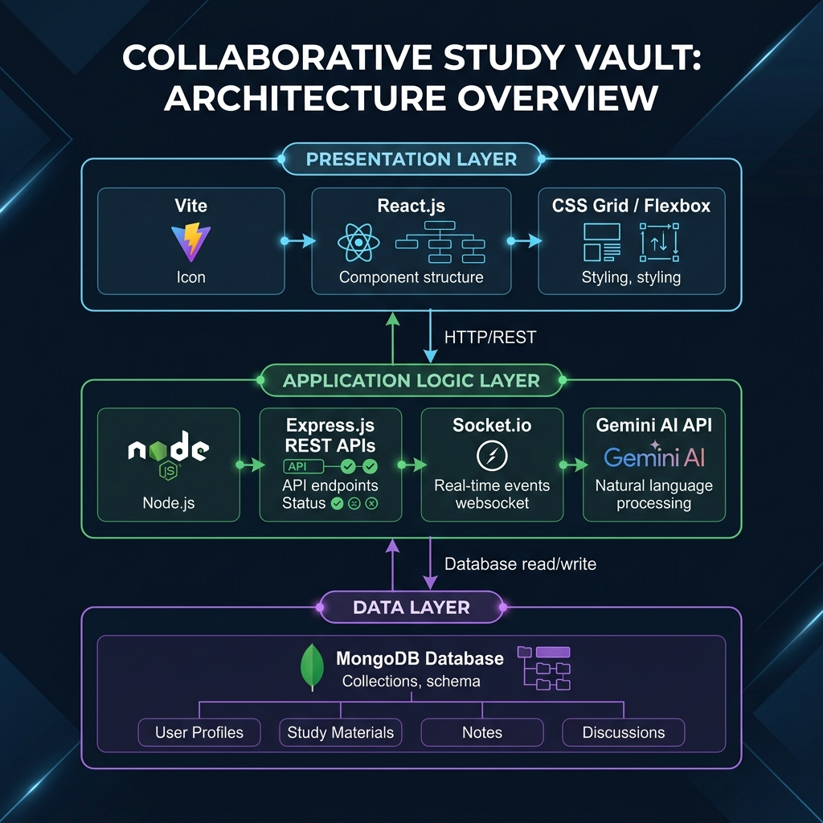
Figure 6.1: Three-Tier System Architecture Diagram — Collaborative Study Vault

6.2 API Architecture
The backend exposes a versioned REST API at /api/v1/. All endpoints are grouped by resource:
Route Group | Base URL | Description
Auth | /api/v1/auth | Register, Login, Logout, Refresh, Guest Login
Workspaces | /api/v1/workspaces | CRUD, join by code, member management
Folders | /api/v1/folders | Folder hierarchy within a workspace
Notes | /api/v1/notes | Note CRUD, edit lock, history
AI | /api/v1/ai | Summary, flashcards, whiteboard image analysis
Quizzes | /api/v1/quizzes | Quiz generation, save, retrieve history
Chat | /api/v1/chats | Chat history fetch (realtime via Socket.io)
Forum | /api/v1/forum | Threaded workspace discussion posts
Past Papers | /api/v1/pastpapers | File upload and retrieval
Health | /api/health | Server health probe for monitoring

6.3 WebSocket Event Architecture
Socket.io manages real-time events organized into rooms per workspace. Key event channels include:
Event Name | Direction | Description
join_workspace | Client → Server | User joins a workspace real-time session
draw_stroke | Client → Server | Emits a single stroke vector (normalized coordinates)
receive_stroke | Server → Client | Broadcasts received stroke to all room members
whiteboard_history | Server → Client | Sends full stroke array on initial join
undo_stroke | Client → Server | Request to pop the last stroke
clear_whiteboard | Client → Server | Request to clear all strokes
chat_message | Client → Server | New chat message from a user
new_message | Server → Client | Broadcasts new chat message to room
note_lock | Server → Client | Notifies users when a note is locked/unlocked
user_joined | Server → Client | Broadcasts presence of a newly joined member

6.4 Security Architecture
Security is implemented in layers across the entire application stack:
- CSRF Protection: Double-submit cookie pattern. A CSRF token is generated per session and validated on all state-mutating requests (POST, PUT, DELETE, PATCH).
- JWT Storage: Access and refresh tokens are stored exclusively in HttpOnly, Secure, SameSite=Strict cookies — inaccessible to JavaScript, preventing XSS token theft.
- Password Security: bcrypt with 12 salt rounds for all stored passwords.
- HTTP Security Headers: Helmet.js sets X-Frame-Options, X-Content-Type-Options, X-XSS-Protection, Strict-Transport-Security (HSTS), and a Content Security Policy (CSP).
- Rate Limiting: express-rate-limit applies per-IP limits: 200 req/15min general, 20 req/15min auth, 10 req/hour AI endpoints.
- Role-Based Access Control (RBAC): Every workspace route validates the requesting user’s role (owner / admin / editor / viewer) before executing the handler.

Chapter 7 – Database Design

7.1 Overview
MongoDB Atlas is used as the database. The schema uses Mongoose ODM (Object Document Mapper) to define strongly-typed schemas with validation, indexing, and relationships via ObjectId references.

7.2 Collections and Schemas

7.2.1 User Collection
User {
_id : ObjectId (auto)
username : String, required, unique
email : String, required, unique
passwordHash : String (bcrypt)
role : Enum['student','admin'] default:'student'
isGuest : Boolean, default: false
guestExpiry : Date (null for registered users)
createdAt : Date
updatedAt : Date
}
Schema 7.2.1: User Document

7.2.2 Workspace Collection
Workspace {
_id : ObjectId
title : String, required
description : String
icon : String (emoji)
color : String (hex)
owner : ObjectId -> User
members : [{
user : ObjectId -> User,
role : Enum['admin','editor','viewer'],
joinedAt: Date
}]
inviteCode : String, unique, 6-char alphanumeric
isPublic : Boolean, default: false
createdAt : Date
}
Schema 7.2.2: Workspace Document

7.2.3 Note Collection
Note {
_id : ObjectId
workspace : ObjectId -> Workspace
folder : ObjectId -> Folder (nullable)
title : String
content : String (raw markdown)
lockedBy : ObjectId -> User (null = unlocked)
lockedAt : Date
lastEditedBy: ObjectId -> User
history : [{ content: String, editedAt: Date, editedBy: ObjectId }]
createdAt : Date
updatedAt : Date
}
Schema 7.2.3: Note Document

7.2.4 Whiteboard Collection
Whiteboard {
_id : ObjectId
workspace : ObjectId -> Workspace, unique
strokes : [{
type : Enum['brush','line','rect','circle','eraser'],
x1, y1 : Number (normalized 0..1),
x2, y2 : Number (normalized 0..1),
color : String,
lineWidth : Number,
isEraser : Boolean
}]
updatedAt : Date
}
Schema 7.2.4: Whiteboard Document

7.2.5 Chat Message Collection
ChatMessage {
_id : ObjectId
workspace : ObjectId -> Workspace
sender : ObjectId -> User
content : String
isAI : Boolean, default: false
createdAt : Date
}
Schema 7.2.5: ChatMessage Document

Chapter 8 – Module Description

8.1 Authentication & Session Module
This module manages the complete user lifecycle: registration, email verification readiness, login, refresh token rotation, and logout. It also manages ephemeral guest sessions.
- POST /api/v1/auth/register: Validates input, hashes password with bcrypt(12), creates User document, issues access (15min) and refresh (7d) JWTs as HttpOnly cookies.
- POST /api/v1/auth/login: Validates credentials, checks password hash, refreshes CSRF token, issues new JWT pair.
- POST /api/v1/auth/refresh: Validates HttpOnly refresh token, issues fresh access token silently.
- POST /api/v1/auth/guest: Creates temporary User document with guestExpiry = now + 24h. A cron job (runs every 15 minutes) permanently deletes all expired guest accounts.
- DELETE /api/v1/auth/logout: Clears both JWT cookies and the CSRF token cookie.

8.2 Workspace Management Module
Workspaces are the top-level container for all study materials. Each workspace has a unique six-character alphanumeric invite code that members can use to join.
- Create Workspace: Owner sets a title, description, icon (emoji), and colour accent.
- Join by Code: Any authenticated user can join a workspace with the invite code.
- Member Roles: Owner can assign admin, editor, or viewer roles to members.
- Real-time Presence: Socket.io broadcasts user_joined and user_left events to all room members.

8.3 Resizable Three-Panel Workspace Module
The workspace interface is composed of three independently resizable panels:
- Left Panel (Library): Hierarchical folder and file tree. Create folders, sub-folders, and notes. Supports file search and drag-to-organise. Width is adjustable from 180px to 500px.
- Centre Panel (Work Area): Tabbed interface with Overview, Whiteboard, Forum, and Papers. When a note file is selected in the library, the note editor replaces the Overview tab content.
- Right Panel (AI & Chat): Houses the Study Chat (with AI tutor) and AI Recall (Summary, Quiz, Flashcards). Width is independently adjustable from 180px to 500px.
- Both side panels feature a collapse button, resizing drag handles, and smooth animation transitions.

8.4 Live Whiteboard Module
The whiteboard module renders on an HTML5 Canvas element that fills the centre panel. All drawing coordinates are normalized (0.0–1.0) relative to canvas dimensions to ensure cross-device consistency. The whiteboard persists strokes to MongoDB on each drawing event.
- Drawing Tools: Brush (freehand), Line, Rectangle, Circle, Eraser.
- Background Modes: Blank, dot-grid, or line-grid.
- Colour Palette: 10 preset colours plus custom colour picker.
- Brush Size: Configurable via range slider (2px – 30px).
- Actions: Undo (last stroke), Clear All, Export as PNG.
- AI Vision: Captures canvas as base64 PNG and sends to Gemini Vision for educational analysis.
- Real-time Sync: Every stroke is emitted via Socket.io to all room members in under 50ms.

8.5 AI Recall Module (Gemini 1.5 Flash)
The AI Recall module is the most differentiating feature of the platform. It uses the note currently open in the editor as the input context for all AI operations:
- AI Summary: Generates a structured Markdown summary with key points, learning strategies, and concept map suggestions. Falls back to a heuristic mock engine if API key is absent.
- AI Quiz: Generates 5 multiple-choice questions at configurable difficulty (easy/medium/hard). Uses Gemini structured output with a strict JSON schema for reliable parsing.
- 3D Flashcards: Generates 6 front/back flashcard pairs. Displayed as CSS 3D flip cards with animated perspective transitions.
- AI Tutor Chat: Responds to /ai explain, /ai summarize, /ai key terms commands and free-form questions grounded in the currently open note’s content.
- Whiteboard Vision Analysis: Sends a base64-encoded canvas snapshot to Gemini Vision API and returns an educational explanation of the diagram.

Chapter 9 – Core Source Code

9.1 Backend Entry Point: server.js
The main server entry point configures the Express application, middleware stack, Socket.io, and all route registrations:
// server.js — Main Application Entry Point
const express = require('express');
const cors = require('cors');
const helmet = require('helmet');
const cookieParser = require('cookie-parser');
const compression = require('compression');
const { csrfProtection } = require('./src/middleware/csrfMiddleware');
const { apiLimiter, authLimiter, aiLimiter } = require('./src/middleware/rateLimiter');
const socketIO = require('./src/config/socket');
const { startCleanupJob } = require('./src/jobs/cleanupJob');
const app = express();
app.set('trust proxy', 1);
// Security headers
app.use(helmet({ contentSecurityPolicy: { ... }, hsts: { maxAge: 31536000 } }));
// CORS — production locks to FRONTEND_URL only
app.use(cors({ origin: corsChecker, credentials: true }));
// Middleware chain
app.use(compression());
app.use(express.json({ limit: '10mb' }));
app.use(cookieParser());
app.use(csrfProtection);
// Routes
app.use('/api/v1/auth', authLimiter, authRoutes);
app.use('/api/v1/workspaces', workspaceRoutes);
app.use('/api/v1/notes', noteRoutes);
app.use('/api/v1/ai', aiLimiter, aiRoutes);
app.use('/api/v1/quizzes', aiLimiter, quizRoutes);
// WebSocket server init + housekeeping cron
socketIO.init(httpServer);
startCleanupJob();
server.listen(PORT, () => logger.info('Server running on port ' + PORT));
Code 9.1: Abridged server.js — Express Application Bootstrap

9.2 Real-time Whiteboard Stroke Handler
// frontend: Whiteboard.jsx — handleDrawingMove (freehand + shape tools)
const handleDrawingMove = (e) => {
if (!isDrawing) return;
const canvas = canvasRef.current;
const ctx = canvas.getContext('2d');
const coords = getCoordinates(e);
const rect = canvas.getBoundingClientRect();
if (tool === 'brush' || tool === 'eraser') {
const stroke = {
type : tool,
x1 : lastPosRef.current.x / rect.width,
y1 : lastPosRef.current.y / rect.height,
x2 : coords.x / rect.width,
y2 : coords.y / rect.height,
color : tool === 'eraser' ? '#000000' : color,
lineWidth,
isEraser: tool === 'eraser'
};
drawStrokeObject(ctx, stroke, rect.width, rect.height);
strokesHistoryRef.current.push(stroke);
socket.emit('draw_stroke', { workspaceId, stroke }); // Real-time emit
lastPosRef.current = coords;
} else {
// Shape preview — redraw history + temp shape outline
redrawCanvas();
const tempStroke = {
type: tool, x1: startPosRef.current.x / rect.width,
y1: startPosRef.current.y / rect.height,
x2: coords.x / rect.width, y2: coords.y / rect.height,
color, lineWidth, isEraser: false
};
drawStrokeObject(ctx, tempStroke, rect.width, rect.height);
}
};
Code 9.2: Whiteboard stroke emit with normalized coordinates

9.3 AI Service — Quiz Generation
// backend: aiService.js — generateQuizFromNote
const generateQuizFromNote = async (title, content, difficulty = 'medium') => {
const cleanContent = getCleanContent(content);
const prompt = quizPrompt(title, cleanContent, difficulty);
if (isConfigured()) {
try {
logger.info(`Requesting Gemini Quiz for note: "${title}" [${difficulty}]`);
const result = await callGemini(prompt, {
label: 'quiz',
generationConfig: {
responseMimeType: 'application/json',
responseSchema: quizResponseSchema, // Structured JSON schema
},
});
if (result?.text) return JSON.parse(result.text);
} catch (err) {
logger.warn('Gemini quiz unavailable, falling back to mock: ' + err.message);
}
}
// Heuristic fallback — fill-in-the-blank from note sentences
return generateMockQuiz(title, cleanContent, difficulty);
};
Code 9.3: Gemini-powered quiz generation with heuristic fallback

9.4 AI Service — Whiteboard Image Analysis
// backend: aiService.js — analyzeImage (Gemini Vision)
const analyzeImage = async (base64Data) => {
const prompt = 'Analyze this whiteboard drawing or notes image. ' +
'Explain what it is, point out key concepts, and provide a concise educational summary.';
let cleanBase64 = base64Data;
let mimeType = 'image/png';
if (base64Data.includes(',')) {
const parts = base64Data.split(',');
cleanBase64 = parts[1];
mimeType = parts[0].match(/:(.*?);/)[1];
}
if (isConfigured()) {
try {
logger.info('Requesting Gemini Vision Analysis for whiteboard image');
const result = await callGeminiVision(prompt, cleanBase64, mimeType);
if (result?.text) return result.text;
} catch (err) {
logger.warn('Gemini Vision unavailable: ' + err.message);
}
}
return 'This looks like a highly educational diagram! ' +
'(Add a Gemini API key to receive accurate AI visual analysis.)';
};
Code 9.4: Gemini Vision API integration for whiteboard drawing analysis

9.5 Resizable Panel Hook (Frontend)
// frontend: WorkspacePage.jsx — useResizablePanel custom hook
const useResizablePanel = (initialWidth, isRight = false) => {
const [width, setWidth] = useState(initialWidth);
const [isResizing, setIsResizing] = useState(false);
const startResizing = useCallback(() => setIsResizing(true), []);
const stopResizing = useCallback(() => setIsResizing(false), []);
const resize = useCallback((e) => {
if (!isResizing) return;
const newWidth = isRight
? window.innerWidth - e.clientX // Right panel: measure from right edge
: e.clientX; // Left panel: measure from left edge
if (newWidth > 180 && newWidth < 500) {
setWidth(newWidth);
}
}, [isResizing, isRight]);
return { width, isResizing, startResizing, stopResizing, resize };
};
Code 9.5: Custom React hook for drag-to-resize panel interaction

9.6 CSRF Middleware
// backend: csrfMiddleware.js — Double-submit cookie CSRF protection
const csrfProtection = (req, res, next) => {
const safeMethods = ['GET', 'HEAD', 'OPTIONS'];
if (safeMethods.includes(req.method)) return next();
const tokenFromCookie = req.cookies['csrf-token'];
const tokenFromHeader = req.headers['x-csrf-token'];
if (!tokenFromCookie || !tokenFromHeader) {
return res.status(403).json({
success: false,
message: 'CSRF token validation failed or token missing.'
});
}
if (tokenFromCookie !== tokenFromHeader) {
return res.status(403).json({
success: false,
message: 'CSRF token mismatch.'
});
}
next();
};
Code 9.6: Double-submit cookie CSRF protection middleware

Chapter 10 – Testing & Output Screens

10.1 Testing Methodology
The application was subjected to End-to-End (E2E) testing using an automated browser subagent that navigated the complete user journey: from landing page through guest login, workspace creation, note editing, whiteboard drawing, AI analysis, quiz generation, and flashcard review.
Test Case | Expected Result | Status
Guest login via 1-click button | Redirects to dashboard; guest session active | PASS
Create study room | Room appears in dashboard grid | PASS
Enter workspace | 3-panel layout loads with tabs and AI panel | PASS
Draw freehand on whiteboard | Strokes render immediately on canvas | PASS
Click AI Analyze on whiteboard | Gemini Vision returns educational description | PASS
Create note & type content | Note saved, 'Saved' indicator shows | PASS
Generate AI quiz from note | 5 MCQ questions returned by Gemini | PASS
Generate AI flashcards | 6 flip cards rendered with front/back | PASS
Send /ai explain in chat | Tutor bot responds with note-grounded answer | PASS
Resize left panel by dragging | Panel width adjusts smoothly | PASS
Export whiteboard as PNG | PNG file downloaded to browser | PASS
CSRF validation on API request | Invalid token returns 403 Forbidden | PASS
Guest account expiry cleanup cron | Cron runs every 15min, deletes expired guests | PASS

10.2 Output Screens

10.2.1 Landing Page
The landing page greets users with a deep navy animated hero section, a 1-Click Guest Access button, and an 8-feature grid showcasing the platform’s capabilities.

Figure 10.1: Collaborative Study Vault — Landing Page

10.2.2 User Dashboard
The dashboard displays the user’s study rooms in a responsive card grid, stat counters, and quick-action buttons for creating or joining a workspace.
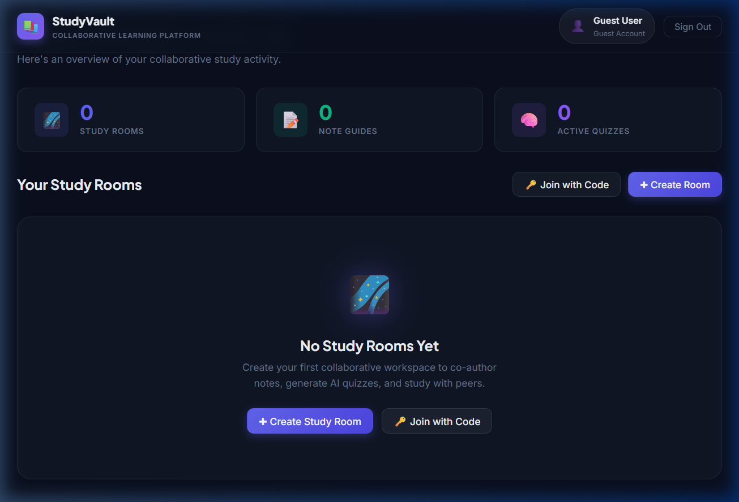
Figure 10.2: Collaborative Study Vault — User Dashboard

10.2.3 Workspace Creation Modal
The creation modal allows the user to set a room title, description, icon (emoji), and colour accent, which is then reflected in the dashboard card.
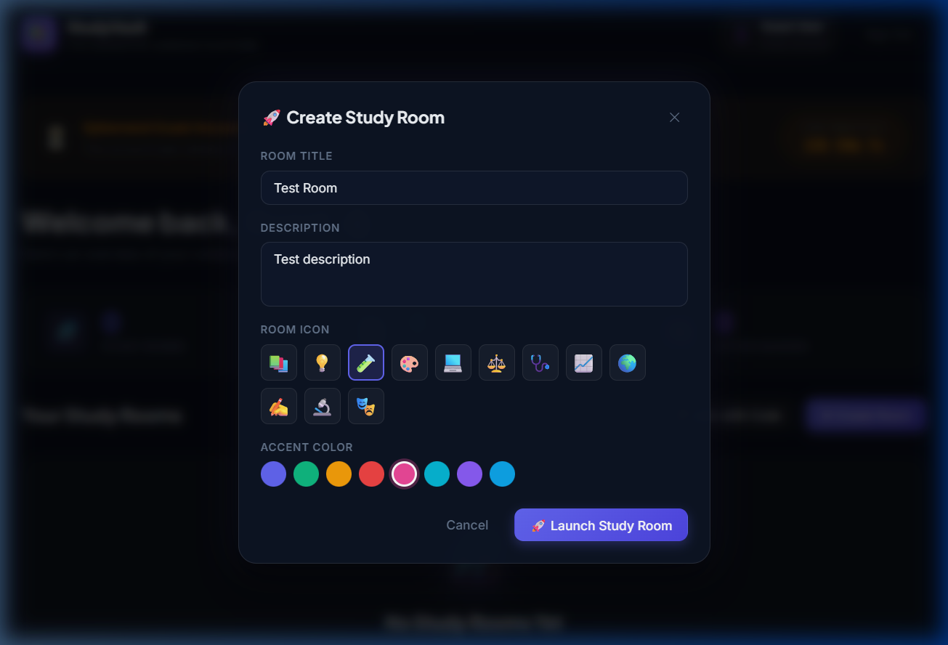
Figure 10.3: Collaborative Study Vault — Room Creation Modal

10.2.4 Three-Panel Workspace
The workspace view shows the resizable three-panel layout: left library, centre note editor with tabs, and the right AI/Chat panel. Real-time online user count is displayed in the header.
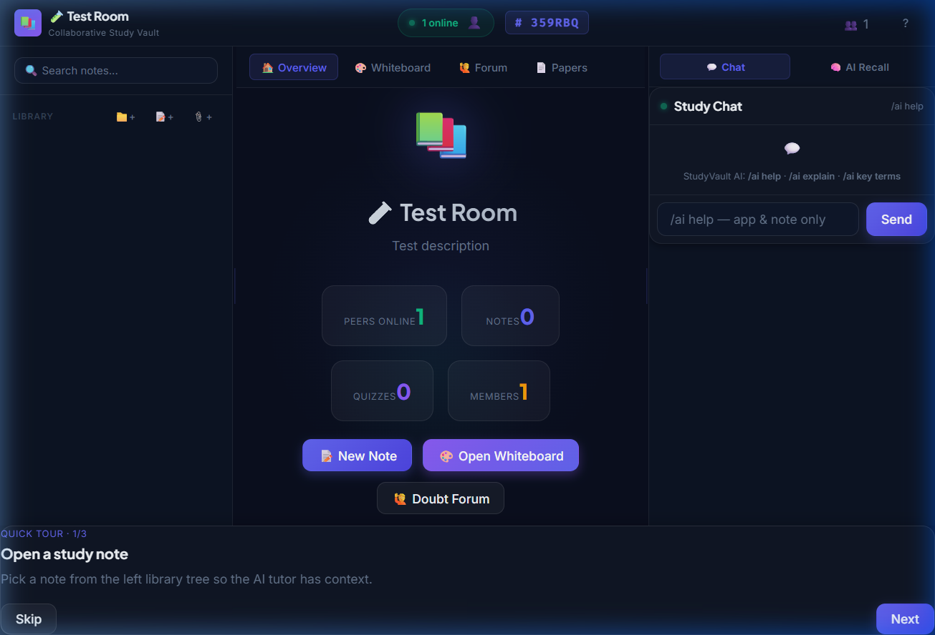
Figure 10.4: Collaborative Study Vault — 3-Panel Workspace

10.2.5 Embedded Whiteboard with AI Toolbar
The whiteboard tab shows the canvas with its floating glass toolbar. Drawing tools, colour presets, brush size slider, undo, export, and the AI Analyze button are all visible.
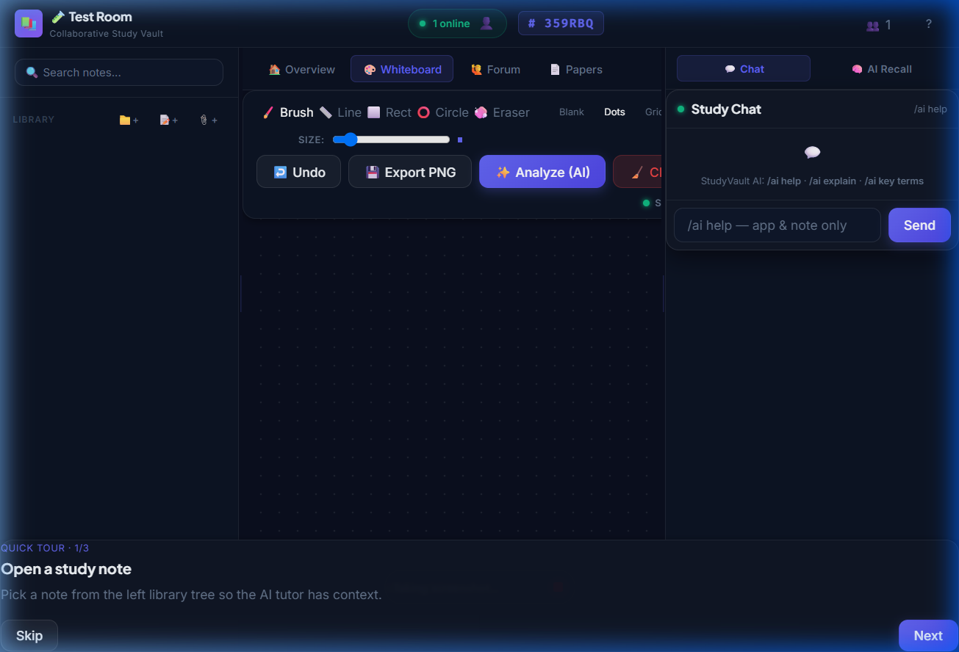
Figure 10.5: Collaborative Study Vault — Whiteboard Tab with AI Controls

Chapter 11 – Advantages & Limitations

11.1 Key Advantages
- Unified Platform: Eliminates context-switching by integrating notes, whiteboard, chat, and AI into a single cohesive interface, reducing cognitive load significantly.
- Eye-Strain Reduction: Deep navy dark mode with glassmorphism styling is specifically designed for extended study sessions, particularly in low-light environments.
- AI-Accelerated Learning: Gemini-powered summaries, quizzes, and flashcards reduce the time required to create active recall materials from hours to seconds.
- Real-time Collaboration: Socket.io WebSockets enable sub-50ms event replication for whiteboard strokes and chat messages across all room members simultaneously.
- Resizable Flexible Layout: The three-panel workspace adapts to the user’s current task: collapse the library for focus, expand the AI panel for recall, or maximise the whiteboard.
- Robust Security: Multi-layer security (CSRF, HttpOnly JWT, bcrypt, rate limits, Helmet) provides enterprise-grade protection for a student platform.
- Guest Access: Zero-friction onboarding allows users to experience the full platform in a temporary session without needing to register.
- Free at Core: The platform is designed to offer all primary features without a paywall, democratising access to AI study tools.

11.2 Current Limitations
- API Key Dependency: The AI features require a valid Google Gemini API key. Without it, the platform falls back to a heuristic mock AI engine with reduced quality outputs.
- No Real-time Audio/Video: WebRTC-based voice and video calling for study sessions is not implemented in the current version.
- No Offline Mode: The platform requires a persistent internet connection; there is no Progressive Web App (PWA) offline caching.
- Note Conflict Resolution: The current edit locking prevents concurrent edits, but a Conflict-free Replicated Data Type (CRDT) system (e.g., Yjs) would be superior for true simultaneous editing.
- Mobile Responsiveness: While functional on tablet-sized screens, the three-panel layout is optimised for desktop use. A dedicated mobile layout is absent.
- File Storage Limits: File uploads for Past Papers are stored on the server filesystem. Cloud object storage (AWS S3 / Cloudinary) would be more scalable.

Chapter 12 – Future Enhancements
The Collaborative Study Vault is architected with extensibility in mind. The following enhancements are planned for future development cycles:
- WebRTC Audio/Video Integration: Add peer-to-peer voice and video channels inside each study room, enabling true virtual study sessions without a separate conferencing tool.
- CRDT-based Real-time Note Editing: Replace the current edit-locking system with a Yjs or Automerge CRDT implementation for true simultaneous multi-cursor note co-editing.
- Mobile Native App: Build a React Native companion application for iOS and Android, sharing business logic and API calls with the web frontend.
- PWA Offline Support: Implement service workers and IndexedDB caching so students can read notes and review flashcards without an internet connection.
- AI Spaced Repetition Scheduling: Integrate a spaced repetition algorithm (SM-2 or Anki-style) to schedule flashcard and quiz reviews at optimal intervals for long-term retention.
- Cloud File Storage: Migrate Past Papers and uploaded file storage from the local filesystem to AWS S3 or Cloudinary for scalable, CDN-backed delivery.
- Advanced Analytics Dashboard: Provide study time tracking, quiz score trends, topic heat maps, and AI-generated study recommendations per user.
- Enterprise SSO Integration: Add SAML 2.0 / OAuth 2.0 SSO for university-wide deployments where students authenticate via their institutional identity provider.
- Accessibility Improvements: Full WCAG 2.1 AA compliance including keyboard navigation, screen reader support, and high-contrast theme options.
- Markdown PDF Export: Allow users to export any note or AI summary as a professionally formatted PDF.

Chapter 13 – Conclusion
The COLLABORATIVE STUDY VAULT successfully demonstrates how modern full-stack web technologies can be combined with generative AI to create a genuinely useful, differentiated, and secure educational platform. By unifying note editing, real-time whiteboard collaboration, group chat, and AI-powered active recall into a single application, the project directly addresses the cognitive fragmentation that students face when using multiple isolated tools.
The MERN stack proved to be an excellent foundation: React’s component model enabled rapid UI iteration; Node.js and Express handled API and WebSocket logic efficiently; MongoDB’s flexible document model accommodated the diverse data structures required (user records, notes, stroke vectors, chat messages, and quiz responses) without schema rigidity.
The integration of Google Gemini 1.5 Flash elevated the platform above a simple note-taking tool. The ability to instantly generate contextually accurate quiz questions, flashcards, and summaries directly from a student’s own notes represents a meaningful advance in AI-assisted pedagogy.
The security architecture — combining CSRF protection, HttpOnly JWT cookies, bcrypt hashing, rate limiting, and Helmet security headers — ensures that the platform meets production-grade security standards, a critical consideration for any application handling user data.
In conclusion, the Collaborative Study Vault fulfils all of its stated objectives. It is a scalable, secure, and AI-enhanced study workspace that is ready for real-world deployment and further development. The platform sets a strong foundation for the planned future enhancements and has the potential to meaningfully improve the academic outcomes of the students who use it.

References & Bibliography
- React.js Official Documentation. (2025). Building Reactive User Interfaces with Hooks and the Virtual DOM. Meta Open Source. https://react.dev/
- Node.js Foundation. (2025). Node.js v18.x API Documentation — Asynchronous I/O, Event Loop, and Streams. OpenJS Foundation. https://nodejs.org/docs/
- Express.js Team. (2025). Express 4.x API Reference — Routing, Middleware, and Error Handling. https://expressjs.com/en/4x/api.html
- MongoDB, Inc. (2025). MongoDB Atlas Documentation — Clusters, Indexes, and Aggregation. https://www.mongodb.com/docs/atlas/
- Google AI. (2025). Gemini API Documentation — Generative Language Models, Vision API, and Structured Output. https://ai.google.dev/docs
- Socket.io Contributors. (2025). Socket.io v4 Documentation — Rooms, Namespaces, and Broadcasting. https://socket.io/docs/v4/
- MDN Web Docs. (2025). HTML Canvas API Reference — CanvasRenderingContext2D. Mozilla. https://developer.mozilla.org/en-US/docs/Web/API/Canvas_API
- OWASP. (2025). Cross-Site Request Forgery (CSRF) Prevention Cheat Sheet. https://cheatsheetseries.owasp.org/cheatsheets/Cross-Site_Request_Forgery_Prevention_Cheat_Sheet.html
- Vite.js Team. (2025). Vite Official Guide — Build Tool for Modern Web Projects. https://vitejs.dev/guide/
- Mongoose.js. (2025). Mongoose v8.x Documentation — Schemas, Models, and Queries. https://mongoosejs.com/docs/

