**sudo apt install openjdk-8-jdk openjdk-8-jre**

**java -version**

**sudo nano /etc/environment**

Type in the first line

JAVA_HOME=”/usr/lib/jvm/java-8-openjdk-amd64”

JRE_HOME=”/usr/lib/jvm/java-8-openjdk-amd64/jre”

export JAVA_HOME=/usr/lib/jvm/java-8-openjdk-amd64

export JRE_HOME=/usr/lib/jvm/java-8-openjdk-amd64/jre

unzip onos-1.12.0.zip

cd onos-1.12.0/

cd bin

ls

./onos-service

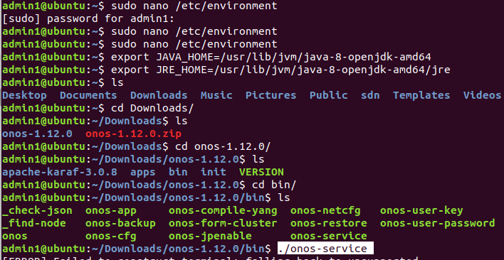

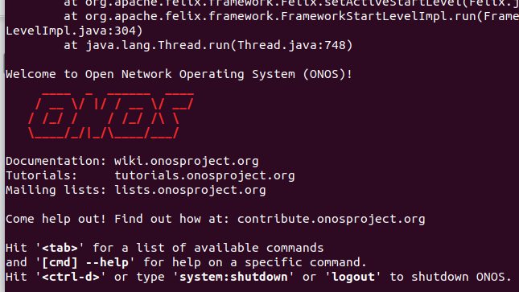

Go to browser in localhost:8181/onos/ui/index.html

username - onos

Password - rocks

