PORTAL ASSIGMNENT_DAY_05

1. Create Employee table with same structure as EMP table.

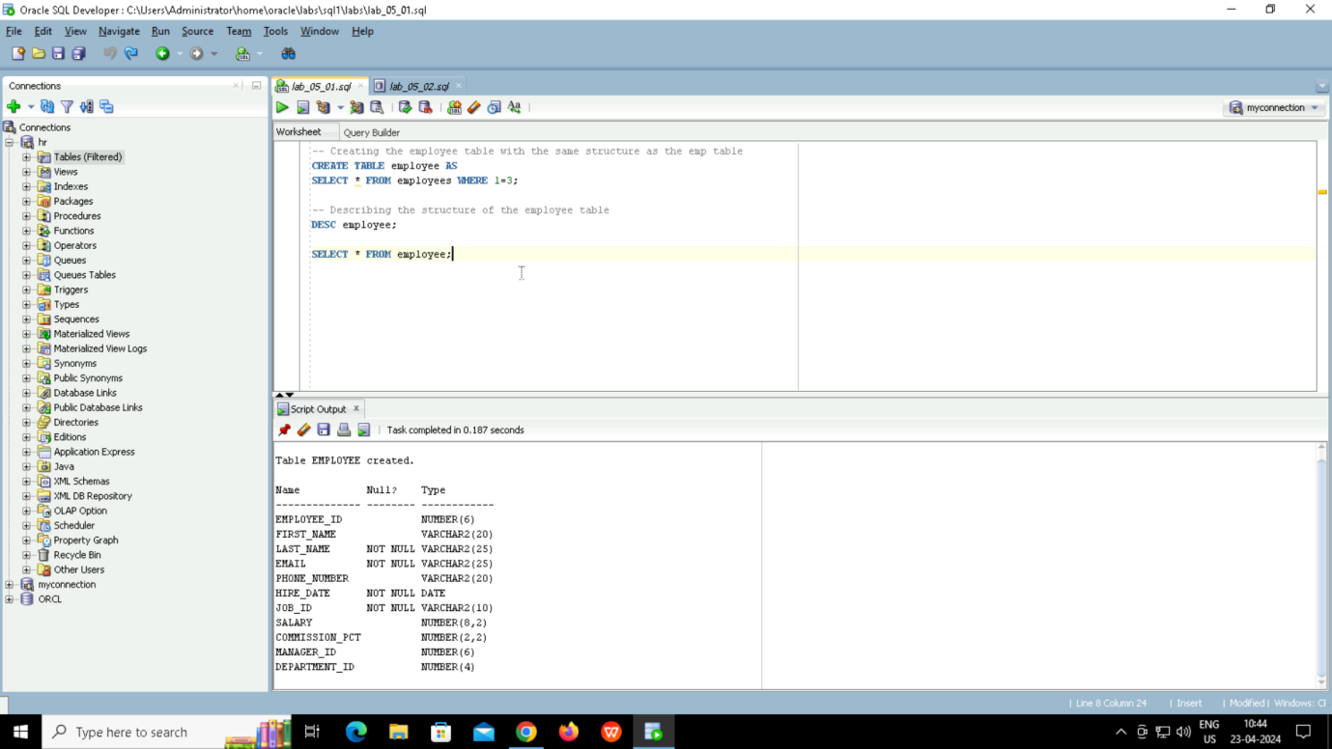

2. . Write a query to populate Employee table using EMP table’s empno, ename, sal, deptno columns.

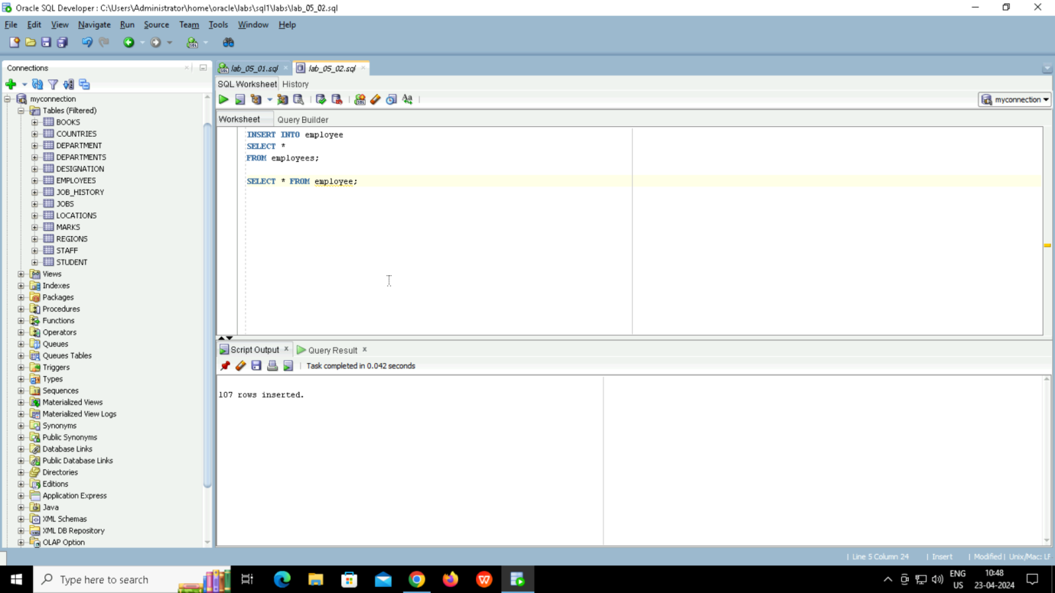

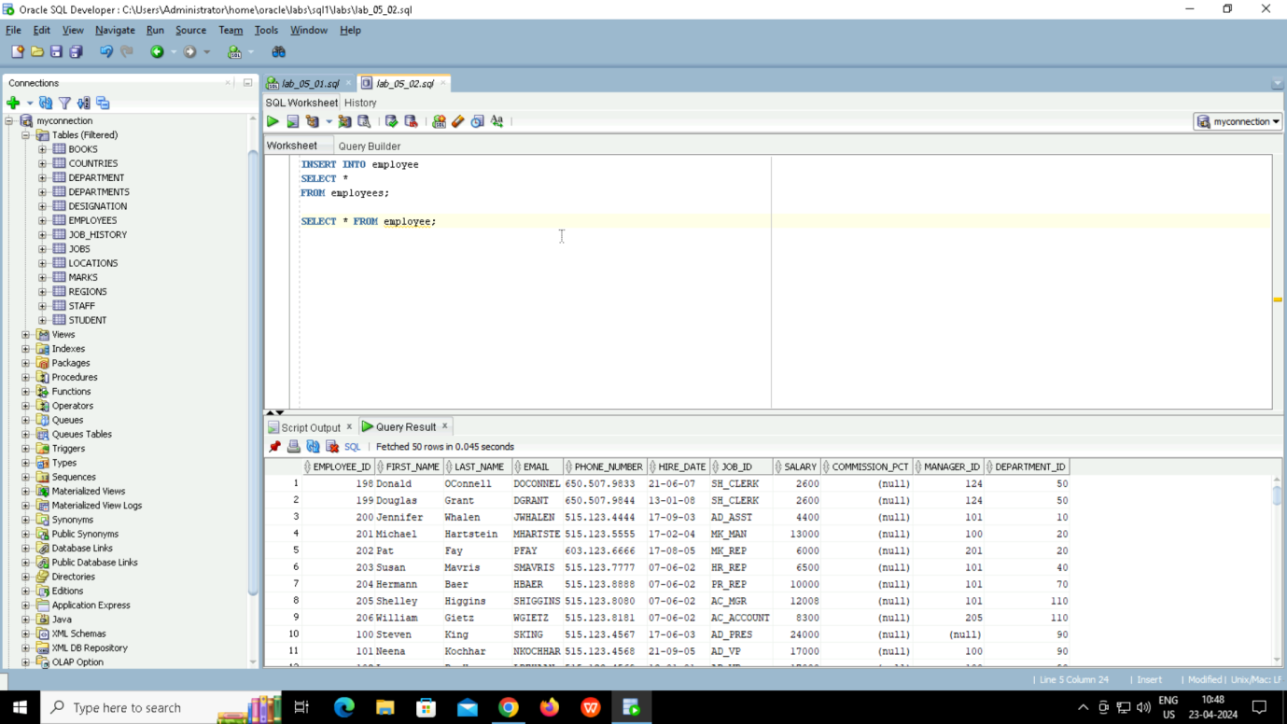

3. Write a query to change the job and deptno of employee whose empno is 7698 to the job and deptno of employee having empno 7788.

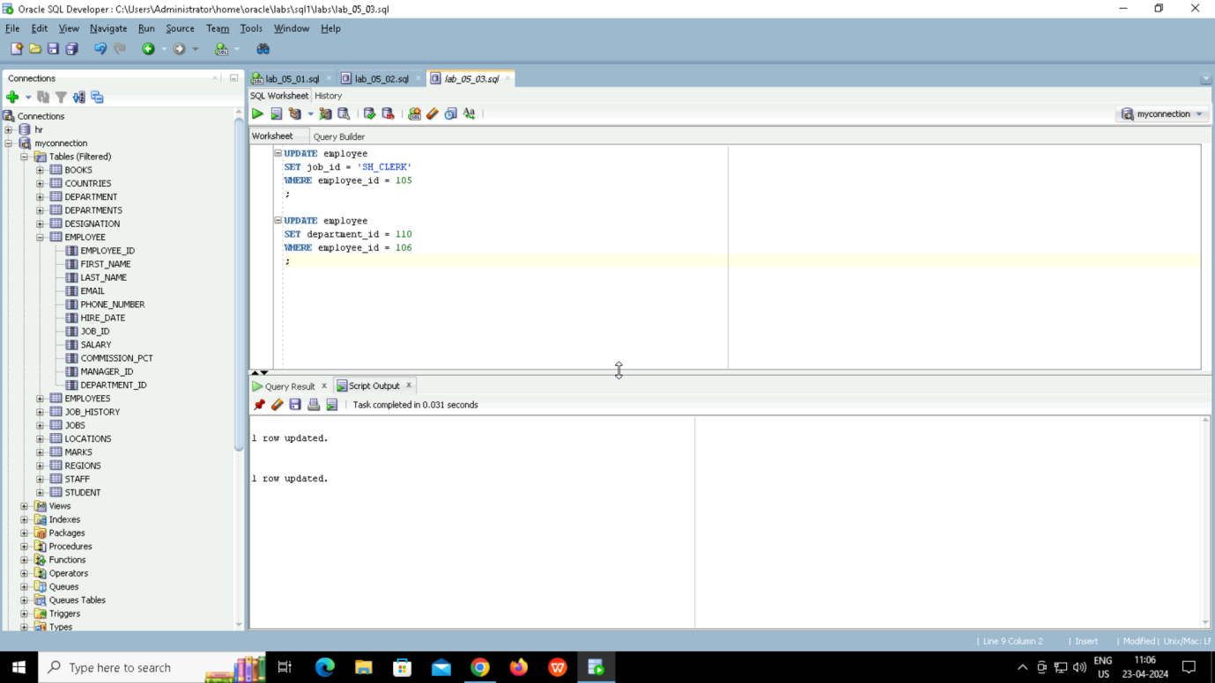

4. . Delete the details of department whose department name is ‘SALES’.

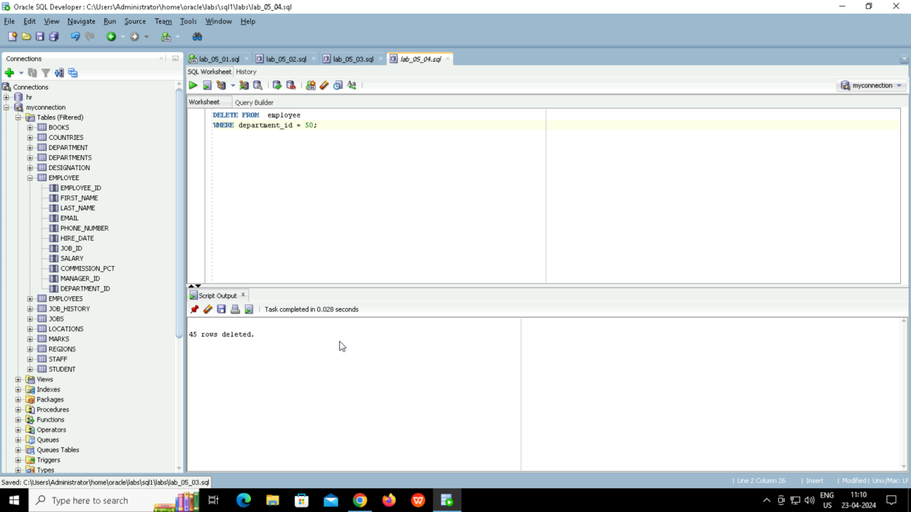

5. Write a query to change the deptno of employee with empno 7788 to that of employee having empno 7698.

