**AIM:**

To Design DFA using simulator to accept the input bcaaaaaaaaaaaaaa, bc, and c

**DESIGN:**

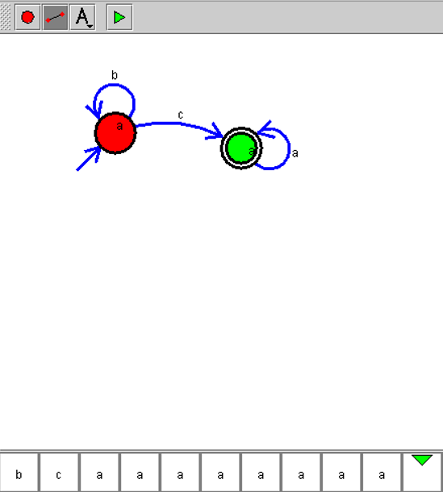

**RESULT:**

Hence, the design was executed successfully.