**AIM:**

To Design NFA using simulator to accept the input aaaaaa

**DESIGN:**

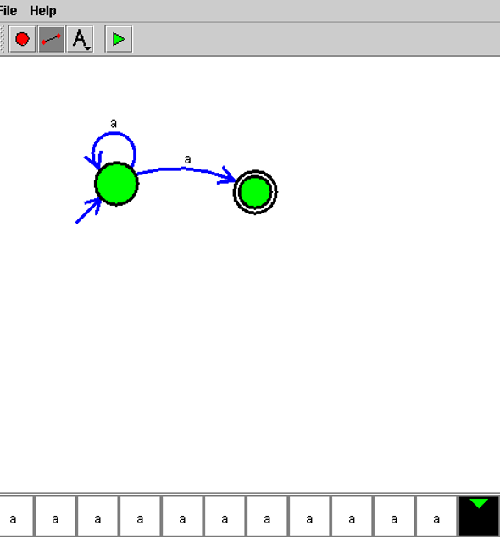

**RESULT:**

Hence, the design was executed successfully.