**AIM:**

To Design TM using simulator to accept the input a^nb^n

**DESIGN:**

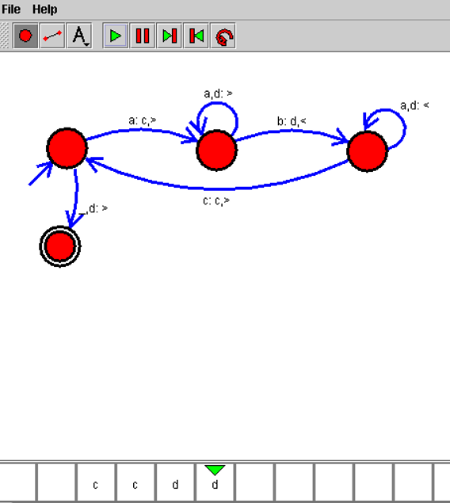

**RESULT:**

Hence, the design was executed successfully.