**AIM:**

To Design PDA using simulator to accept the input aabbbbc ( L=a^nb^2n)

**DESIGN:**

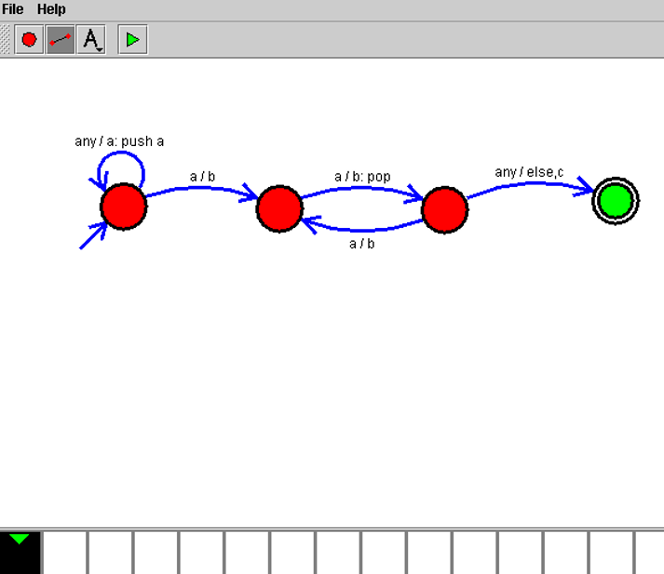

**RESULT:**

Hence, the design was executed successfully.