**AIM:**

To Design TM Simulation for Palindrome W= ababa c

**DESIGN:**

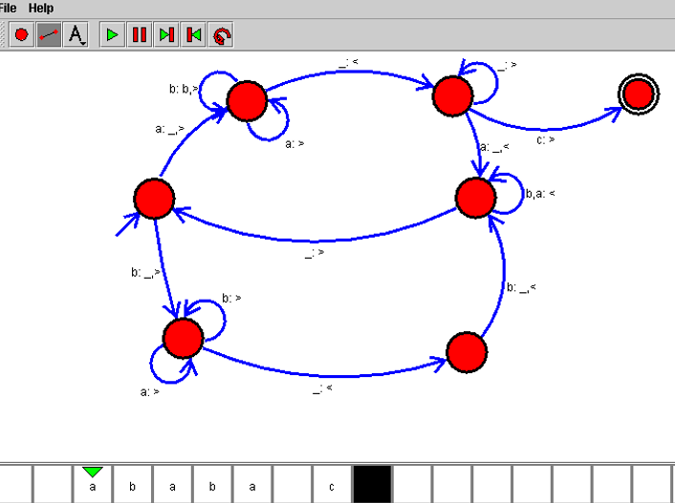

**RESULT:**

Hence, the design was executed successfully.