**AIM:**

To Design TM to perform addition of W= aa + aaaa and After Addition of a’s = aaaaaa

**DESIGN:**

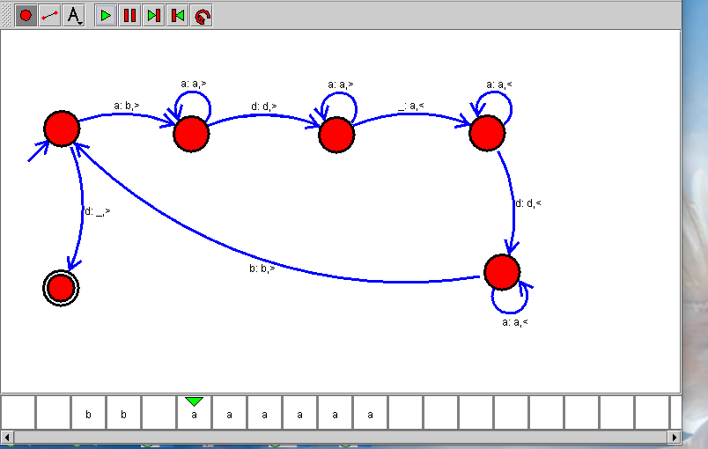

**RESULT:**

Hence, the design was executed successfully.