**AIM:**

To Design TM to perform subtraction of W= aaa-aa

**DESIGN:**

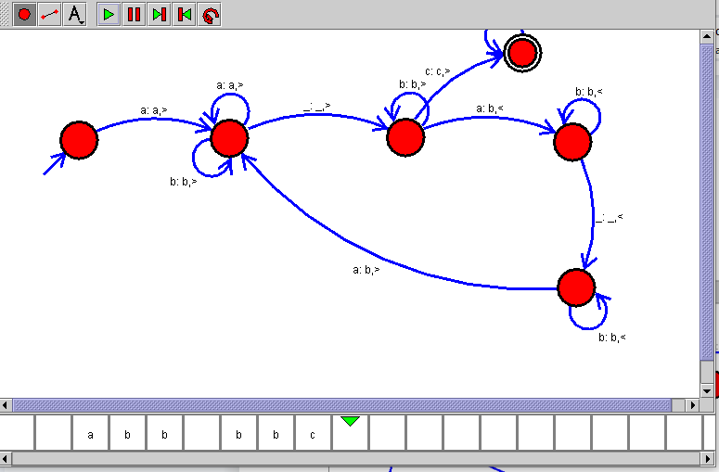

**RESULT:**

Hence, the design was executed successfully.