**AIM:**

To Design TM to perform string comparison for W = aba aba

**DESIGN:**

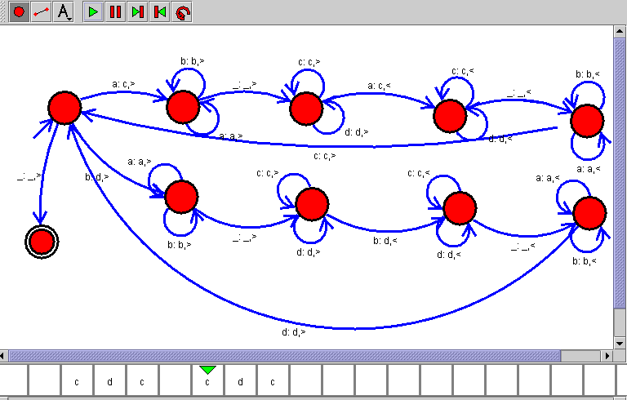

**RESULT:**

Hence, the design was executed successfully.