**AIM:**

To Design DFA using simulator to accept odd number of a’s

**DESIGN:**

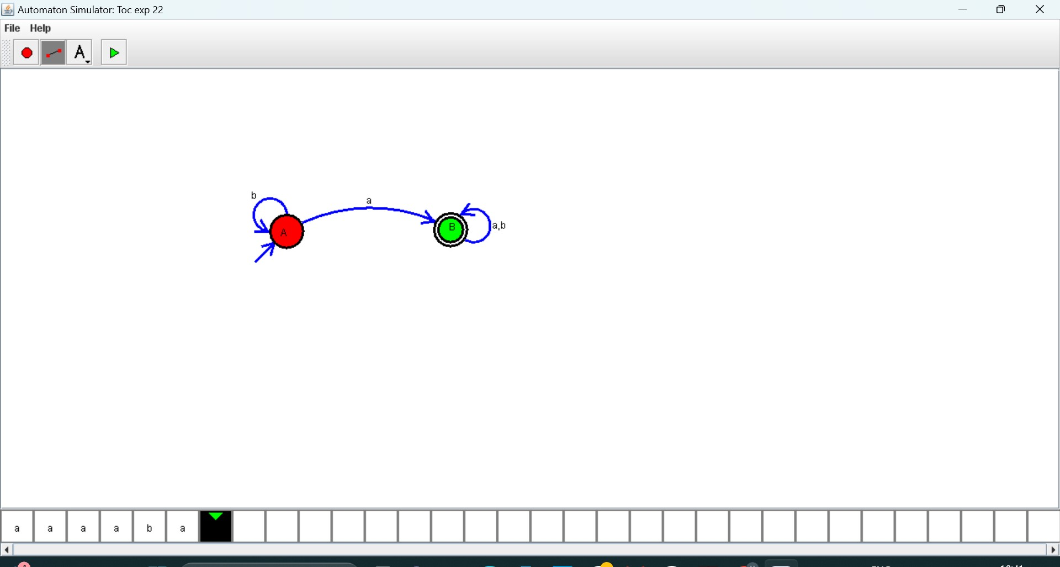

**RESULT:**

Hence, the design was executed successfully.