**AIM:**

To Design DFA using simulator to accept the string the end with ab over set {a, b)} w= aaabab

**DESIGN:**

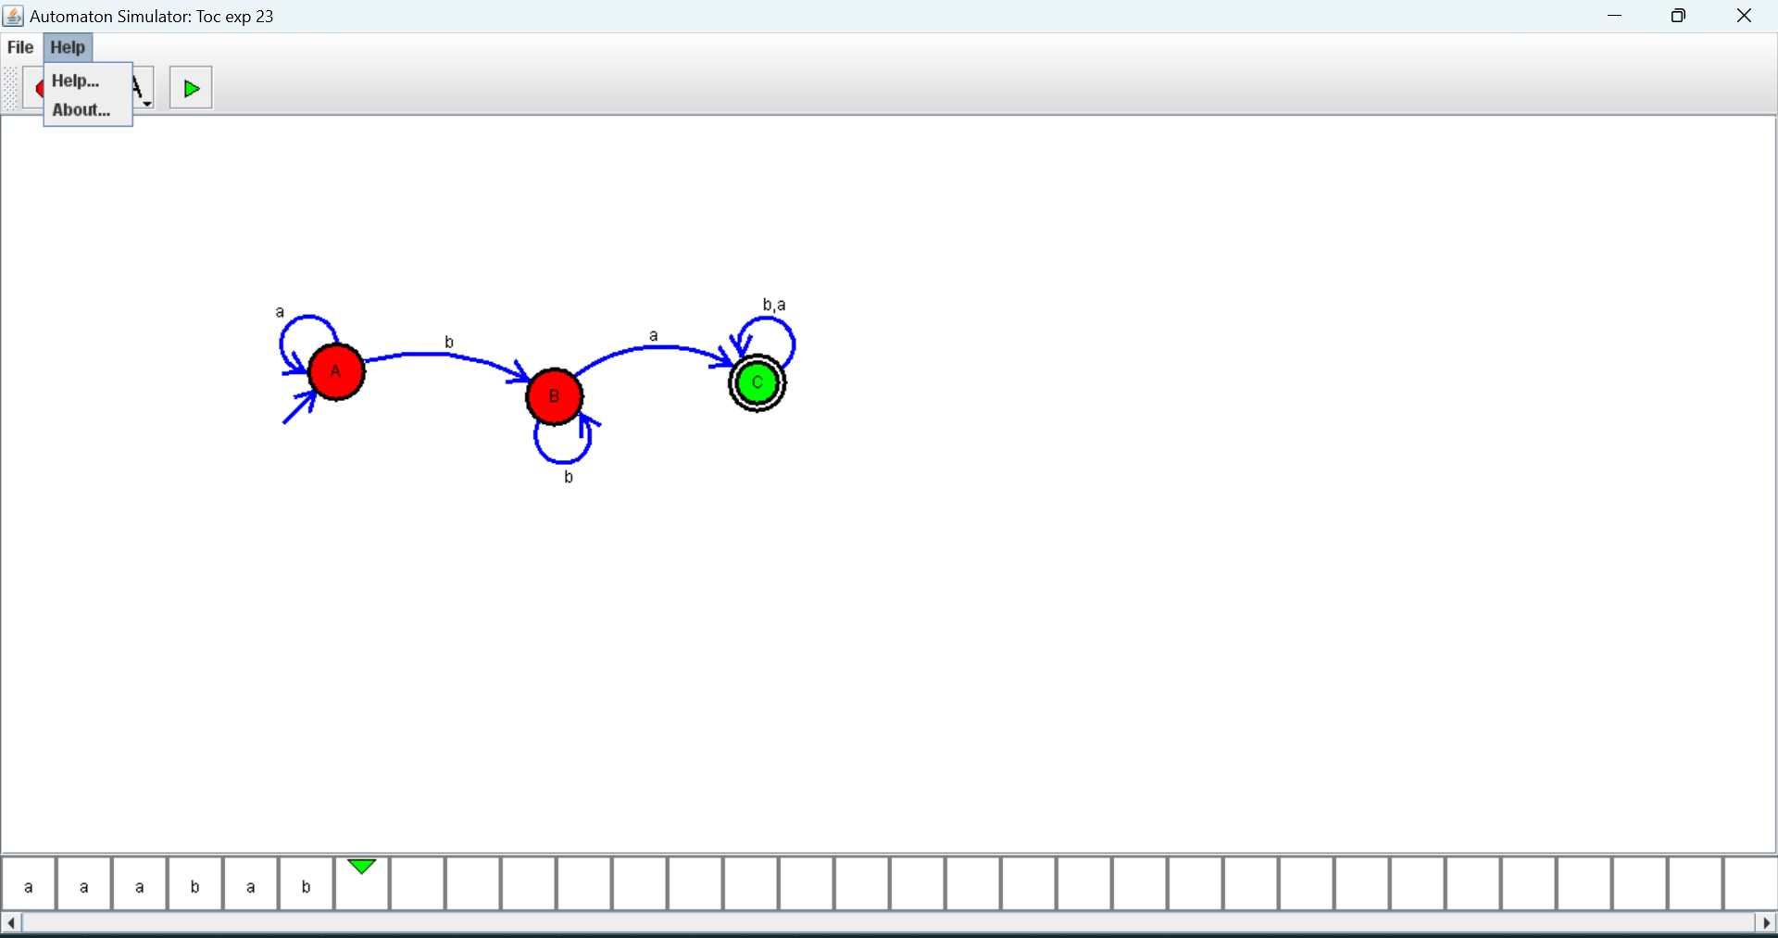

**RESULT:**

Hence, the design was executed successfully.