**AIM:**

To Design DFA using simulator to accept the string having ‘ab’ as substring over the set {a,b}

**DESIGN:**

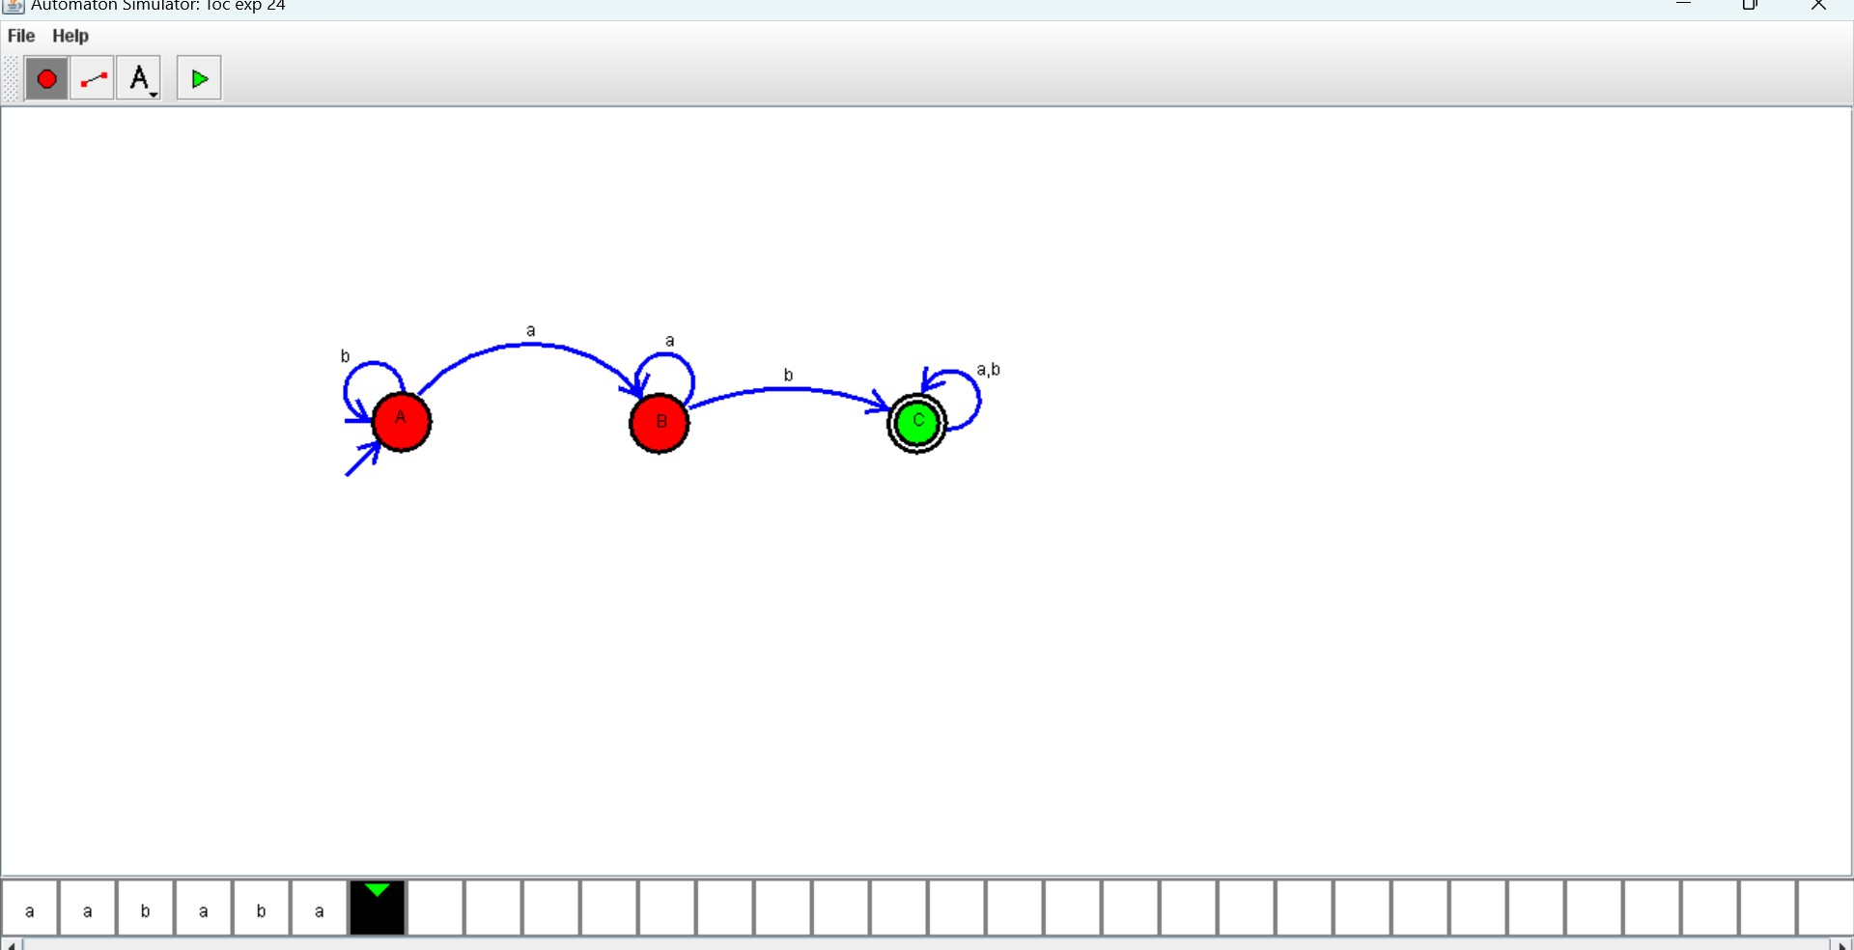

**RESULT:**

Hence, the design was executed successfully.