**AIM:**

To Design DFA using simulator to accept the string start with a or b over the set {a, b}

**DESIGN:**

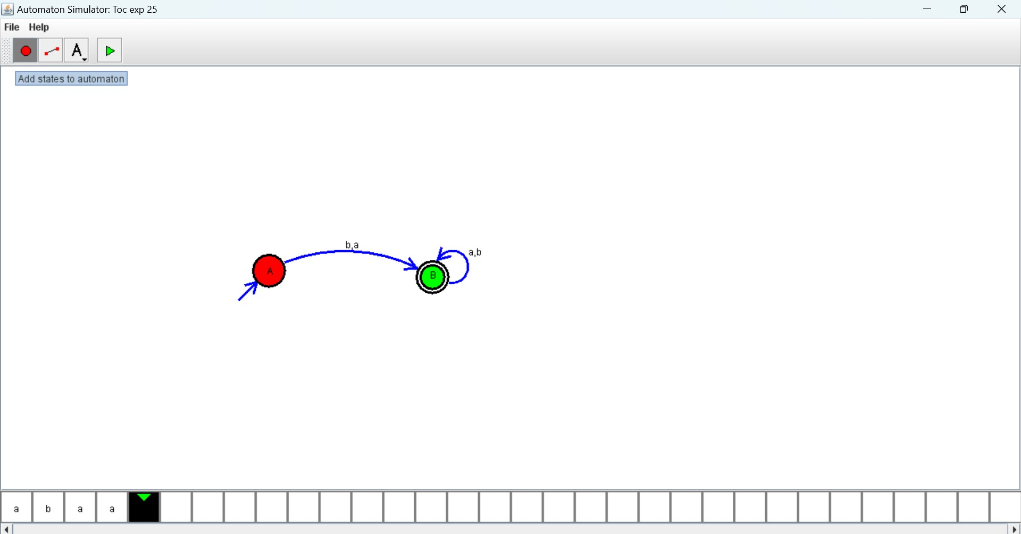

**RESULT:**

Hence, the design was executed successfully.