**CHAPTER - 1**

**INTRODUCTION**

* 1. **INTRODUCTION**

The study of atomic structure has been a cornerstone of modern physics, offering profound insights into the fundamental nature of matter. Over the years, various atomic models have been proposed to describe the intricate behaviour of electrons within atoms. Among these models, the Dirac atomic model stands out for its incorporation of relativistic effects, offering a deeper understanding of atomic phenomena.

In this project, we delve into the simulation and visualization of the Dirac atomic model's predictions regarding the maximum probability distribution of electrons within each energy level of the hydrogen atom. By employing Euler's method within the familiar framework of Excel, we aim to elucidate the complex dynamics of electron motion in atomic systems.

A key aspect of our investigation involves a comparative analysis with the predictions of Bohr's atomic model. By juxtaposing the energy levels calculated by these two models, we seek to discern the subtle yet significant differences in their respective descriptions of atomic structure.

Moreover, our exploration extends beyond mere theoretical speculation. We aim to derive practical implications from our findings, particularly concerning the upper limit for atomic stability. Through the lens of the fine-structure constant, we investigate the threshold beyond which electrons are no longer able to remain bound within the atom, shedding light on the fundamental constraints imposed by nature.

By undertaking this project, we aspire to contribute to the ongoing dialogue surrounding atomic theory and advance our comprehension of the microscopic world. Through empirical simulation and rigorous analysis, we endeavour to uncover new insights into the behaviour of atoms, paving the way for further discoveries in the realm of quantum physics.

**CHAPTER - 2**

**GENERAL FORMULATION OF THE PROBLEM**

**2.1 STATEMENT OF THE PROBLEM**

In this project we want to analyze and solve the following problems.

* To find the maximum probability distribution of electron in different energy levels of Hydrogen atom using Dirac atom model.
* To draw the probability distribution curve of electron in different energy levels of Hydrogen atom using Dirac atom model.
* Comparison between the probability distribution of electron in Bohr atom model and Dirac atom model.
* To find the maximum probability distribution of electron in ground state for different atoms using Dirac atom model.
* To draw the probability distribution curve of electron in ground state for different atoms using Dirac atom model.
* To find the maximum possible atomic number.

**CHAPTER - 3**

**LITERATURE REVIEW**

**3.1 INTRODUCTION**

Within the vast landscape of atomic physics, the quest to comprehend the intricate dance of electrons within atoms has been a driving force behind numerous theoretical models and computational approaches. Among these, the Dirac atomic model stands as a pinnacle of theoretical achievement, incorporating the principles of quantum mechanics and special relativity to provide a comprehensive description of atomic structure.

In this literature review, we embark on a journey through the evolution of atomic models, focusing particularly on the intricacies of the Dirac atomic model and the computational techniques employed to elucidate its predictions. We delve into the historical development of atomic theory, tracing the evolution from the pioneering work of Niel’s Bohr to the groundbreaking contributions of Paul Dirac.

Bohr's atomic model, with its quantized electron orbits and spectral line predictions, laid the foundation for our understanding of atomic structure in the early 20th century. However, as experimental techniques advanced and theoretical challenges arose, it became evident that Bohr's model could not fully account for the complexities of atomic behaviour, particularly at high speeds and energies where relativistic effects become significant.

Enter Paul Dirac, whose visionary synthesis of quantum mechanics and special relativity revolutionized our conception of atomic physics. Dirac's atomic model introduced the concept of negative-energy states, antimatter, and relativistic corrections to the energy levels of electrons within atoms. By incorporating the Dirac equation, a relativistic wave equation for electrons, into the framework of quantum mechanics, Dirac provided a more robust description of atomic structure that transcended the limitations of previous models.

However, the mathematical formalism of the Dirac equation presents its own set of challenges, requiring sophisticated computational methods to extract meaningful predictions. Herein lies the significance of employing Euler's method within the familiar realm of Excel. By discrediting the Dirac equation and iteratively solving it using Euler's method, researchers can simulate the behaviour of electrons within atoms and visualize their spatial distributions with relative ease.

Through this literature review, we aim to explore the theoretical underpinnings of the Dirac atomic model, the computational techniques used to study it, and the insights gained from these endeavours. By synthesizing the wealth of knowledge accumulated in the field of atomic physics, we hope to shed light on the fundamental nature of matter and contribute to the ongoing quest for a deeper understanding of the microscopic world.

**3.2 ATOMIC STRUCTURE OF MATTER**

**3.2.1 Dalton’s atomic theory**

Dalton's atomic model, proposed by John Dalton in the early 19th century, was a significant advancement in our understanding of the nature of matter. Dalton's model was developed as part of his atomic theory, which he presented in 1803.

* + - 1. **Key points of Dalton's atomic model include:**

**Indivisibility of Atoms:**

According to Dalton, atoms are indivisible and indestructible particles. They are the fundamental building blocks of matter and cannot be divided into smaller particles.

**Conservation of Mass:**

Dalton proposed that in a chemical reaction, atoms are rearranged but not created or destroyed. The total mass of the reactants is equal to the total mass of the products.

**Definite Proportions:**

Dalton suggested that compounds are formed by the combination of atoms in simple, whole-number ratios. In other words, the composition of a compound is always constant.

**Multiple Proportions:**

Dalton observed that when two elements form more than one compound, the masses of one element that combine with a fixed mass of the other element are in simple whole-number ratios.

**3.2.2 Thomson’s atom model**

Thomson's atomic model, also known as the "plum pudding model," was proposed by Sir J.J. Thomson in 1904. At that time, the understanding of the atom was in its early stages. Thomson's model was developed in response to the discovery of electrons by himself and his experiments with cathode rays.

**3.2.2.1 According to Thomson's model:**

**Structure:**

The atom was considered to be a positively charged sphere, much like a "pudding", with negatively charged electrons embedded within it, resembling "plums" in the pudding.

**Charge Distribution:**

The positive charge in the atom was distributed uniformly throughout the sphere, while the negatively charged electrons were scattered within it.

**Neutral Overall:**

The model aimed to maintain overall electrical neutrality, as the positive and negative charges were assumed to be balanced.

**Size:**

Thomson did not make specific predictions about the size of the electron or the distribution of electrons within the atom.

**3.2.3 Rutherford’s atom model**

Rutherford's atomic model, proposed by the New Zealand physicist Ernest Rutherford in 1911, was a significant advancement in our understanding of the structure of atoms. Before Rutherford's model, the prevailing idea was J.J. Thomson's "plum pudding" model, which suggested that atoms were composed of a positively charged "pudding" with negatively charged electrons scattered throughout, like "plums."

Rutherford's experiments involved bombarding a thin gold foil with alpha particles (positively charged particles). He expected the alpha particles to pass through the foil with only minor deflections, based on the prevailing model. However, some alpha particles were deflected at large angles, and some even bounced back. This unexpected result led Rutherford to propose a new atomic model.

**3.2.3.1 Key features of Rutherford's model:**

**Nucleus:**

Rutherford suggested that atoms have a small, dense, positively charged nucleus at the centre. This nucleus contains protons, which are positively charged particles. The nucleus is surrounded by empty space where electrons move.

**Electron Orbits:**

Electrons, which are negatively charged, orbit the nucleus at a distance. The model didn't specify the exact path of electron orbits but proposed that electrons moved in orbits, much like planets orbiting the sun.

**Empty Space:**

The majority of the atom is empty space. The electrons, being much lighter than the nucleus, occupy a relatively large volume compared to the tiny, dense nucleus.

Rutherford's model marked a transition from the previous understanding of the atom and laid the foundation for further developments in atomic theory. Later models, such as Bohr's model and the quantum mechanical model, refined our understanding of the behaviour of electrons within atoms, ultimately leading to the modern understanding of atomic structure.

**3.2.4 Bohr’s atom model**

**3.2.4.1 Postulates**

Niels Bohr proposed his atomic model in 1913 as an improvement to Rutherford's model. Bohr's model was particularly successful in explaining the spectral lines of hydrogen. Here are the key postulates of Bohr's atom model:

**Quantized Electron Orbits:**

Bohr proposed that electrons orbit the nucleus in discrete, quantized orbits. Each orbit corresponds to a specific energy level. Electrons are not allowed to exist in between these orbits.

**Fixed Energy Levels:**

Electrons in Bohr's model occupy fixed energy levels, and they do not radiate energy while in these orbits. Electrons can only change their energy levels by absorbing or emitting specific amounts of energy, corresponding to the difference in energy between two allowed orbits.

**Angular Momentum Quantization:**

Bohr introduced the concept of quantized angular momentum. The angular momentum of an electron in a specific orbit is quantized and is an integer multiple of h/2π, where h is Planck's constant. mvr = $\frac{nh}{2π}$

**Electron Emission and Absorption:**

Electrons can jump from one orbit to another by either absorbing or emitting a quantum of energy. When an electron moves to a lower energy level, it emits a photon, and when it moves to a higher energy level, it absorbs a photon.

**Stationary Orbits:**

Bohr proposed that electrons in these quantized orbits are stable and do not radiate energy as long as they remain in these stationary states. Despite its success in explaining certain phenomena, Bohr's model had limitations and was eventually replaced by more advanced models, such as the quantum mechanical model, which provides a more comprehensive understanding of the behaviour of electrons in atoms. Bohr's model laid the groundwork for the development of quantum theory in atomic physics.

**3.2.4.2 The Bohr Formulae**

Based on these, Bohr derived the formulae for

* The radii of the stationary orbit
* The total energy of the electron

Consider an atom whose nucleus has a positive charge Ze and mass ‘m’. For Hydrogen, Z=1. Consider ‘n’ electron of charge (-e) and mass m, revolving around the nucleus.

The Electrostatic force of attraction between the nucleus and the electron is

= $\frac{1}{{4πε}_{0}}\frac{Ze\left(-e\right)}{r^{2}}$.…… (1)

The centrifugal force on the electron = $\frac{{mv}^{2}}{r}$……. (2)

The system will be stable if $\frac{{mv}^{2}}{r}= \frac{1}{{4πε}_{0}}\frac{Ze(-e)}{r^{2}}$.…… (3)

According to Bohr’s first postulate, mvr =

(Or) v =

v2 =

Substituting the value of v2 in equation – (3)

$$\frac{m}{r}\left(\frac{n^{2}h^{2}}{{4π}^{2}r^{2}m^{2}}\right)=\frac{1}{{4πε}_{0}}\frac{{Ze}^{2}}{r^{2}}$$

rn =

It is called Bohr radius.

**3.2.4.3 Calculation of total Energy:**

The total energy of the electron in any orbit is the sum of its kinetic and potential energies.

Potential Energy of the electron = $\int_{∞}^{r}{\frac{{Ze}^{2}}{{4πε}_{0}r^{2}}dr}$

= $-\frac{1}{{4πε}_{0}}\frac{{Ze}^{2}}{r}$

Kinetic energy of electron = ${\frac{mv}{2}}^{2}$ = $\frac{{Ze}^{2}}{{4πrε}_{0}}$ [using eqn. (3)]

Therefore, the total energy of the electron En = Potential energy + Kinetic energy

En =

En = Substitute the value of ‘r’

$∴$ En =

**3.2.4.4 Frequency of the radiation emitted by the atom:**

If an electron jumps from an outer initial orbit n2 of higher energy of an inner orbit n1 of lower energy, the frequency of the radiation emitted is given by,

ν = $\frac{{En}_{2 }{- En}_{1}}{h}$

For Hydrogen Z =1,

ν = $\frac{{me}^{4}}{{8ε}_{0}h^{3}}\left[\frac{1}{n_{1}^{2}} - \frac{1}{n_{2}^{2}}\right]$

Wave number,

$\overline{ν}= \frac{{me}^{4}}{{8ε}_{0}{ch}^{3}}\left[\frac{1}{n_{1}^{2}} - \frac{1}{n_{2}^{2}}\right]$ [Because = ν = $\frac{1}{λ}= \frac{ν}{c}$]

$$\overline{ν}=R\left[\frac{1}{n_{1}^{2}} - \frac{1}{n_{2}^{2}}\right]$$

R = $\frac{{me}^{4}}{{8ε}_{0}{ch}^{3}}$

‘R’ is known as Rydberg constant, its value = 1.091 7 m-1

**3.2.4.5 Failure of Bohr Model:**

* In Bohr’s theory, we have two rival theories, viz., classical and quantum. The equilibrium is governed by the classical laws, while the emission of radiation is explained by quantum rules.
* The theory does not give any information about the relative intensities of different lines.
* Bohr’s theory could not explain the *fine structure of the spectral lines.*
* With the help of Bohr’s theory, it is difficult to treat dynamical problems of atoms containing more than one valence electron.
* Bohr model could not explain how the orbital electrons in an atom are distributed around the nucleus.
* Bohr’s theory could not explain Zeeman Effect and Stark Effect in which the spectral lines could be split up under the influence of magnetic and electric fields.

**3.3 QUANTUM MECHANICAL MODEL**

**3.3.1 Dirac atom model**

**3.3.1.1 Dirac’s equation of a central field force (H-atom)**

The Dirac equation for central field force is given by

**HΨ = EΨ**

or  **{**c $\vec{α}$ $∙$**p + $β$ ${mc}^{2}$ + V**(r)**} $Ψ$ = E $Ψ$**  ……. (1)

with **V**(r) **= $- \frac{{Ze}^{2}}{r}$,**

i.e. Dirac equation for an electron in a Coulomb’s field of a nucleus is

**HΨ = {**c $\vec{α}$ $∙$**p + $β$ ${mc}^{2} - \frac{{Ze}^{2}}{r}$**  **} $Ψ$**

The Hamiltonian takes the form

**H ={**c $\vec{α}$ $∙$**p + $β$ ${mc}^{2} - \frac{{Ze}^{2}}{r}$**  **}** ……. (2)

For central field force the vector and scalar potentials will be

**A** = 0, $ϕ$**(r)** = $ϕ$**(r)**

Now (1) reduces to

{(**E $–$** e $ϕ$) $–$ $\vec{α}$ (c**p $–$** e**A**) $–$ $β$ ${mc}^{2}$**} $Ψ$ = 0**  ……. (3)

We write in equation (3)

$Ψ= \left({Ψ_{A} \atop Ψ_{B}}\right)$**,**  ……. (4)

Where $Ψ_{A}$ and $Ψ_{B}$ are still two component function. If we use the explicit form of the Dirac matrices, then equation (3) reads

$\left\{\left[\begin{matrix}0 & 1 \\ 1 & 0\end{matrix}\right]\vec{σ}∙\left(cp – eA\right)+\left[\begin{matrix}1 & 0 \\ 0 & -1\end{matrix}\right]{mc}^{2}\right\}\left({Ψ_{A} \atop Ψ_{B}}\right)= \left(E –eϕ \right)\left({Ψ_{A} \atop Ψ_{B}}\right)$……. (5)

This is equivalent to two coupled equations

$\vec{σ}∙\left(cp – eA\right)Ψ_{B}+ {mc}^{2}Ψ_{A}= \left(E –eϕ \right)Ψ_{B} ,$……. (6a)

$\vec{σ}∙\left(cp – eA\right)Ψ_{A}+ {mc}^{2}Ψ_{B}= \left(E –eϕ \right)Ψ_{A} ,$……. (6b)

Here $\vec{σ}$ are 2 $×$ 2 Pauli spin matrices and $Ψ_{A}$**, $Ψ_{B}$** each have two components. From (6b)

$Ψ_{B}{=\left(E –eϕ+{mc}^{2} \right)}^{-1}{\vec{σ}∙\left(cp – eA\right)Ψ}_{A}$……. (7a)

On putting **E** = **E $'$** + ${ mc}^{2}$,

$Ψ_{B}{=\left(E^{'}–eϕ+{2mc}^{2} \right)}^{-1}{\vec{σ}∙\left(cp – eA\right)Ψ}_{A}$……. (7b)

The non relativistic limit is

**E $'$** << ${mc}^{2}$, $eϕ$ **<< ${mc}^{2}$**  , $p≈mv$

We solve four equation (6a) and (6b) with

$eϕ=- \frac{{Ze}^{2}}{r} ,$ $A=0$

Also writing $Ψ_{A}= \left({u_{1} \atop u_{2}}\right)$**, $Ψ_{B}= \left({u_{3} \atop u_{4}}\right)$,** we get

$-\frac{1}{ħc}\left[E+ \frac{{Ze}^{2}}{r}-{mc}^{2}\right]u_{1}+\frac{{∂u}_{4}}{∂x}-i\frac{{∂u}_{4}}{∂y}+\frac{{∂u}_{3}}{∂z}=0$……. (8a)

$-\frac{1}{ħc}\left[E+ \frac{{Ze}^{2}}{r}-{mc}^{2}\right]u_{2}+\frac{{∂u}_{3}}{∂x}-i\frac{{∂u}_{3}}{∂y}+\frac{{∂u}_{4}}{∂z}=0$……. (8b)

$-\frac{1}{ħc}\left[E+ \frac{{Ze}^{2}}{r}-{mc}^{2}\right]u_{3}+\frac{{∂u}_{2}}{∂x}-i\frac{{∂u}_{2}}{∂y}+\frac{{∂u}_{1}}{∂z}=0$……. (8c)

$-\frac{1}{ħc}\left[E+ \frac{{Ze}^{2}}{r}-{mc}^{2}\right]u_{4}+\frac{{∂u}_{1}}{∂x}-i\frac{{∂u}_{1}}{∂y}+\frac{{∂u}_{2}}{∂z}=0$……. (8d)

These are four Dirac differential equations for a coulomb field.

**3.3.1.2 Solution of Dirac’s equation of a central field force (H-atom)**

The Dirac equation in a central field can be separated exactly in spherical co-ordinates.

[ $\left(E –eϕ \right)- \vec{σ}∙ p-β$ ${mc}^{2}$**] $Ψ=0$** ……. (1)

We first want to introduce the radial momentum.

Let us define the radial momentum and velocity operators as

$p_{r}= \frac{1}{r}\left(r∙p-iħ\right)$……. (2a)

= $r^{-1}\left[{xp}_{x}+{yp}_{y}+{zp}_{z}-iħ\right]= -iħ\left(\frac{∂}{∂r}+\frac{1}{r}\right)$……. (2b)

and $α_{r}=r^{-1}\left(\vec{α} ∙r\right)$……. (3)

Both operators $p_{r}$ and $α_{r}$ are hermitian which may be seen as follows:

$p_{r}^{†}$ = $\left(p∙ r+iħ\right)r^{-1}$

= $\left(p_{x}x {+ p}_{y}y+p_{z}z+iħ \right)r^{-1}$

= $\left({xp}_{x} {+ yp}_{y}+zp_{z}-2iħ \right)r^{-1}$

$p_{r}^{†}$ $=\left(rp_{r}-iħ\right)r^{-1}$……. (4)

We have

$$\left[r,{rp}_{r}\right]=r\left[r,p_{r}\right]+\left[r,r\right]p_{r}=r\left[r,p_{r}\right]$$

Also using (2a) $\left[r,{rp}_{r}\right]=\left[r, \left(r∙p-iħ\right)\right]= \left[r,{xp}_{x} {+ yp}_{y}+zp_{z}-iħ \right]$

= $\left[r,{xp}_{x}\right]+\left[r,yp_{y}\right]+\left[r,{zp}_{z}\right]-\left[r,iħ\right]$

= $x\left[r,p_{x}\right]+y\left[r,p_{y}\right]+z\left[r,p_{z}\right]- 0$

=i $ħ\left(x\frac{∂r}{∂x}+y\frac{∂r}{∂y}+z\frac{∂r}{∂z}\right)$

=i $ħ\left(x.\frac{x}{r}+y.\frac{y}{r}+z.\frac{z}{r}\right)=iħ \frac{x^{2}+ y^{2}+ z^{2}}{r}$

= i $ħ$ r

$\left[r,{rp}_{r}\right]= r\left[r,p_{r}\right]=$ i $ħ$ r

or $\left[r,p_{r}\right]=iħ, i.e. rp_{r}-p_{r}r=iħ$

or $rp_{r}-$ $iħ= p_{r}r$

and $p_{r}^{†}$ $=\left(rp_{r}-iħ\right)r^{-1}=p_{r}rr^{-1}=p_{r}$……. (5)

This show that operator $p_{r}$ is hermitian.

For operator $α_{r}$, we have

$$α_{r}^{2}=\frac{1}{r^{2}}\left(\vec{α} ∙r\right)\left(\vec{α} ∙r\right)=1$$

$α_{r}∙r=$ $r^{-1}\left(\vec{α} ∙r\right)r= r^{-1}\left(\vec{α} ∙r\right)r$

$∴$ $α_{r}^{†}$ r = ${\left(rα_{r}\right)}^{†}= \left(\vec{α} ∙r\right)= α_{r}r$

i.e. $α_{r}^{†}$ = $α_{r}$……. (6)

This shows that operator $α_{r}$ is Hermitian.

Let us now introduce operator k defined by

$ħ k= β\left[ \vec{σ}' ∙L+ħ\right]$……. (7)

where $\vec{σ}'$ = $\left[\begin{matrix}\vec{σ} & 0 \\ 0 & \vec{σ}\end{matrix}\right]$, $\vec{σ}$ being Pauli spin matrices

and  **L = r $×p$**

Then obviously

$ħ^{2}k^{2}={β^{2}\left[ \vec{σ}' ∙L+ħ\right]}^{2}={\left[\vec{σ}' ∙L+ħ\right]}^{2}$……. (8)

= ${\left( \vec{σ}' ∙L\right)}^{2}+2ħ\left( \vec{σ}' ∙L\right)+ħ^{2}$ (since $β^{2}=1)$

Now using $\vec{α}$ = $ρ_{1}{\vec{σ}}^{'}=\vec{σ}'ρ_{1}$……. (9a)

with $ρ_{1}=\left[\begin{matrix}0 & 1 \\ 1 & 0\end{matrix}\right]=\left[\begin{matrix}\begin{matrix}0 & 0 \\ 0 & 0\end{matrix} & \begin{matrix}1 & 0 \\ 0 & 1\end{matrix} \\ \begin{matrix}1 & 0 \\ 0 & 1\end{matrix} & \begin{matrix}0 & 0 \\ 0 & 0\end{matrix}\end{matrix}\right]$ ……. (9b)

and the identity $\left(\vec{α} ∙B\right)\left(\vec{α} ∙C\right)=B ∙C+i\vec{σ}'∙$ $B× C$……. (10)

we find replacing **B** and **C** each by **L**

$\left( \vec{σ}' ∙L\right)\left( \vec{σ}' ∙L\right)=L∙L+i\vec{σ}'∙L×L$

= ${ L }^{2}+i\vec{σ}'∙\left(iħL\right)$

$={L }^{2}-ħ\vec{σ}'∙L$……. (11)

Using this equation, (8) gives

$$ħ^{2}k^{2}={L }^{2}-ħ{\vec{σ}}^{'}∙L+2ħ\left( \vec{σ}' ∙L\right)+ħ^{2}$$

= ${L }^{2}- ħ\left( \vec{σ}' ∙L\right)+ħ^{2}$

= ${\left(L+\frac{1}{2}ħ{\vec{σ}}^{'}\right)}^{2}+ \frac{1}{4}ħ^{2}$……. (12)

The quantity $L+\frac{1}{2}ħ{\vec{σ}}^{'}$ is the total angular momentum **J**; so we many write

$ħ^{2}k^{2}=J^{2}+ \frac{1}{4}ħ^{2}$……. (13)

The total angular momentum **J** has Eigen values j (j+1) $ħ^{2}$, j being half a positive odd integer.

Then Eigen values $ħ^{2}k^{2}$ of are

$\left[j\left(j+1\right)ħ^{2}+ \frac{1}{4}ħ^{2}\right]$,

Therefore the Eigen values of operator $k^{2}$ are

$j\left(j+1\right)+ \frac{1}{4}={\left(j+\frac{1}{2}\right)}^{2}$

and hence k has values

k = $± 1, ± 2, ± 3,…$……. (14)

As $α_{r}$ anti commutes with $β$, we have

$$α_{r}β+βα_{r}= r^{-1}\left(rα_{r}β+βrα_{r}\right)$$

$= r^{-1}\left[\left(\vec{α} ∙r\right)β+β\left(\vec{α} ∙r\right)\right]=0$……. (15)

Finally we have

$\frac{1}{r}\left(\vec{α} ∙r\right)\left(\vec{α} ∙p\right)$ = $\frac{1}{r}\left[\left(r∙p\right)+i\vec{σ}'∙r×p\right]$

= $\frac{1}{r}\left(r∙p\right)+\frac{i}{r}{\vec{σ}}^{'}∙L= \left(p_{r}+iħr^{-1}\right)+\frac{i}{r}{\vec{σ}}^{'}∙L$

Using $α_{r}$ = $\frac{1}{r}\left(\vec{α} ∙r\right)$ we have

$$α_{r}\left(\vec{α} ∙p\right)= p_{r}+iħr^{-1}+\frac{i}{r}{\vec{σ}}^{'}∙L$$

${α_{r}}^{2}\left(\vec{α} ∙p\right)= α_{r}p_{r}+iħr^{-1}α_{r}+\frac{i}{r}α_{r}{\vec{σ}}^{'}∙L$

Using $α_{r}$ = 1 we have

$$\left(\vec{α} ∙p\right)= α_{r}p_{r}+ir^{-1}α_{r}\left({\vec{σ}}^{'}∙L+ħ\right)$$

= $α_{r}p_{r}+ir^{-1}α_{r} β ħk$ [using (7)]

i.e. $\left(\vec{α} ∙p\right)= α_{r}p_{r}+iħr^{-1}α_{r} βk$……. (16)

Thus the Hamiltonian for an electron in a central force field A = 0 and V = V(r) is given by

**H =** c $\vec{α}$ $∙$**p + $β$ ${mc}^{2}$ + V**(r)

**= $cα_{r}p_{r}+iħr^{-1}cα_{r} βk$**  **+ $β$ ${mc}^{2}$ + V**(r)……. (17)

Using definitions (2), (3) and (7) and preceding relations we get following relations

$α_{r}k-{kα}_{r}$ = 0, $βk-$ $kβ=0$……. (18a)

$p_{r}k-kp_{r}$ = 0, $α_{r}p_{r}-p_{r}α_{r}=0$……. (18b)

These relations obviously show that k commutes with the Hamiltonian and so is a constant of motion. Let us now choose a representation in which **H** and k are diagonal and are represented by numbers **E** and k respectively. $α_{r}$ And $β$ can then by represented by Hermitian matrices that satisfy the relations

${α_{r}}^{2}= β^{2}=1 and α_{r}β-α_{r}β = 0$……. (19)

Since here we have only two matrices anti commuting, we need not be consider a 4 $×$ 4 matrix representation and 2 $×2$ matrices are sufficient to serve the purpose.

For example we can put

$β= \left[\begin{matrix}1 & 0 \\ 0 & -1\end{matrix}\right]and α_{r}=\left[\begin{matrix}0 & -i \\ i & 0\end{matrix}\right]$……. (20)

Consequently in such a case we many replace ${\vec{σ}}^{'},$ by usual $\vec{σ}$.

**3.3.1.3 Solution of the equation:**

Now the angular and spin parts of the wave function are fixed by the requirement that $Ψ$ be an Eigen function of the operator k defined by (7). We need not describe them here.

We are solely concerned with the radial part and write the Eigen function as a two-rowed vector.

$Ψ\left(r\right)= \left[\begin{matrix}\frac{1}{r}F(r) \\ \frac{1}{r}G(r)\end{matrix}\right]$…….. (21)

Then the Dirac equation using (17) for [H $Ψ$ (r) = E $Ψ$ (r) using (17) for H and (21) for $Ψ$ (r)] for central field is written

$\left\{-iħc\left[\begin{matrix}0 & -i \\ i & 0\end{matrix}\right]\left(\frac{∂}{∂r}+\frac{1}{r}\right)+\frac{iħck}{r}\left[\begin{matrix}0 & -i \\ i & 0\end{matrix}\right]\left[\begin{matrix}1 & 0 \\ 0 & -1\end{matrix}\right]+\left[\begin{matrix}1 & 0 \\ 0 & -1\end{matrix}\right]{mc}^{2}+V(r)\right\}\left[\begin{matrix}\frac{1}{r}F(r) \\ \frac{1}{r}G(r)\end{matrix}\right]=E \left[\begin{matrix}\frac{1}{r}F(r) \\ \frac{1}{r}G(r)\end{matrix}\right]$

or $-iħc\left[\begin{matrix}0 & -i \\ i & 0\end{matrix}\right]\left[\begin{matrix}\frac{1}{r}\frac{∂}{∂r}F(r) \\ \frac{1}{r}\frac{∂}{∂r}G(r)\end{matrix}\right]+\left\{\frac{iħck}{r}\left[\begin{matrix}0 & i \\ i & -1\end{matrix}\right]+\left[\begin{matrix}1 & 0 \\ 0 & -1\end{matrix}\right]{mc}^{2}+V(r)\right\}\left[\begin{matrix}\frac{1}{r}F(r) \\ \frac{1}{r}G(r)\end{matrix}\right]= E \left[\begin{matrix}\frac{1}{r}F(r) \\ \frac{1}{r}G(r)\end{matrix}\right]$...(22)

This is equivalent to following two equations

$-\frac{ħ}{r}\frac{∂}{∂r}G(r)-\frac{ħck}{r^{2}}G(r)+\left[{mc}^{2}+V\left(r\right)\right]\frac{1}{r}F(r)=$**E $\frac{1}{r}F(r)$**

and $-\frac{ħ}{r}\frac{∂}{∂r}F\left(r\right)+\frac{ħck}{r^{2}}F(r)+\left[- {mc}^{2}+V\left(r\right)\right]\frac{1}{r}G(r)=$**E $\frac{1}{r}G(r)$**

or $\frac{∂}{∂r}G\left(r\right)+\frac{k}{r}G\left(r\right)+\left\{\frac{E-{mc}^{2}- V\left(r\right)}{ħc}\right\}F\left(r\right)=0$……. (23a)

and $\frac{∂}{∂r}F\left(r\right)+\frac{k}{r}F\left(r\right)+\left\{\frac{E-{mc}^{2}- V\left(r\right)}{ħc}\right\}G\left(r\right)=0$……. (23b)

Let us now make the following substitutions

$λ_{1}= \frac{{mc}^{2}+E}{ħc} ;λ_{2}= \frac{{mc}^{2}-E}{ħc}$

$ρ= λr with λ=\sqrt{\left(λ_{1}λ_{2}\right)}$ = $\frac{{\left(m^{2}c^{4}-E^{2}\right)}^{1/2}}{ħc}$……. (24)

Then $\frac{∂G}{∂r}=\frac{∂G}{∂ρ}\frac{∂ρ}{∂r}=λ\frac{∂G}{∂ρ}$

and $\frac{∂F}{∂r}=\frac{∂F}{∂ρ}\frac{∂ρ}{∂r}=λ\frac{∂F}{∂ρ}$

Substituting these values in (23); we get

$\left(\frac{d}{dρ}+\frac{k}{ρ}\right)G-\left(\frac{λ_{2}}{λ}+\frac{V}{ħcλ}\right)F=0 …a$

and $\left(\frac{d}{dρ}-\frac{k}{ρ}\right)F-\left(\frac{λ_{1}}{λ}-\frac{V}{ħcλ}\right)G=0$…b …….(25)

**3.3.1.4 The Hydrogen atom:**

For hydrogen like atoms

**V**(r) = $-\frac{{Ze}^{2}}{r}$……. (26)

If we substitute

$γ=$ $\frac{{Ze}^{2}}{ħc}$ = Z $α$ fine structure constant ……. (27)

then $\frac{V}{ħcλ}$ becomes $\frac{γ}{ρ}$,

so that equation (25) takes the form

$\left(\frac{d}{dρ}+\frac{k}{ρ}\right)G-\left(\frac{λ_{2}}{λ}-\frac{γ}{ρ}\right)F=0 …a$

and $\left(\frac{d}{dρ}-\frac{k}{ρ}\right)F-\left(\frac{λ_{1}}{λ}+\frac{γ}{ρ}\right)G=0$…b …….(28)

In order to take asymptotic part, we further substitute

F( $ρ)$ = f( $ρ)e^{-ρ} and G(ρ) = g(ρ)e^{-ρ}$…….(29)

then $\frac{dF}{dρ}$ = $\left(\frac{df}{dρ}-f\right)e^{-ρ}= \left(f'-f\right)e^{-ρ}$

$\frac{dG}{dρ}$ = $\left(\frac{dg}{dρ}-g\right)e^{-ρ}= \left(g'-g\right)e^{-ρ}$

where dashes denotes differentiation with respect to $ρ$ so that equation (28) becomes

$g^{'}-g+\frac{k}{ρ}g-\left(\frac{λ_{2}}{λ}-\frac{γ}{ρ}\right)f=0 …a$

and $f^{'}-f-\frac{k}{ρ}f-\left(\frac{λ_{1}}{λ}+\frac{γ}{ρ}\right)g=0 …b$……. (30)

As in the non-relativistic case of hydrogen atom, we look the solution for equations (30) in the form of power series

$f=ρ^{s}\sum_{v=0}^{∞}{a_{v}ρ^{v}= \sum_{v}{a_{v}}ρ^{s+v},a_{0}≠0}$…a

and $g=ρ^{s}\sum_{v=0}^{∞}{b_{v}ρ^{v}= \sum_{v}{b_{v}}ρ^{s+v},b_{0}≠0}$…b …….(31)

The solution must not to be singular at the origin and the local square integrability must be maintained.

From (31), we have

$f^{'}= \sum_{v}{a_{v}\left(s+v\right)}ρ^{s+v-1}$…a

$g^{'}=\sum_{v}{b_{v}\left(s+v\right)}ρ^{s+v-1}$…b ……. (32)

Substituting (31) and (32) in equation (30); we get

$\sum_{v}{b_{v}\left(s+v\right)}ρ^{s+v-1}-\sum_{v}{b_{v}}ρ^{s+v}+\frac{k}{ρ}\sum_{v}{b_{v}}ρ^{s+v}-\left(\frac{λ_{2}}{λ}-\frac{γ}{ρ}\right)\sum_{v}{a_{v}}ρ^{s+v}=0$

and $\sum_{v}{a_{v}\left(s+v\right)}ρ^{s+v-1}-\sum_{v}{a_{v}}ρ^{s+v}-\frac{k}{ρ}\sum_{v}{a_{v}}ρ^{s+v}-\left(\frac{λ_{1}}{λ}+\frac{γ}{ρ}\right)\sum_{v}{b_{v}}ρ^{s+v}=0$

Equating coefficient of $ρ^{s+v-1}$ equal to zero, we obtain the recurrence relation for v > 0

$\left(s+v+k\right)b_{v}-b_{v-1}+γa_{v}-{\frac{λ_{2}}{λ}a}_{v-1}=0 …a$

and $\left(s+v-k\right)a_{v}-a_{v-1}-γb_{v}-{\frac{λ_{1}}{λ}b}_{v-1}=0 …b$…….(33)

When v = 0, the equation analogous to (33) are

$\left(s+k\right)b_{0}+γa_{0}=0$…a

and $\left(s-k\right)a_{0}-γb_{0}=0$…b ……. (34)

Equation (34) will have non-vanishing solutions only if the determinant of their coefficients vanishes. i.e.

$$\left|\begin{matrix}γ & s+k \\ s-k & -γ\end{matrix}\right|=0$$

i.e. ${-γ}^{2}-\left(s^{2}-k^{2}\right)=0$ or $s^{2}=k^{2}-γ^{2}$ i.e. $s=±\sqrt{\left(k^{2}-γ^{2}\right)}$

Because of solution to be non-singular at the origin, we take the upper-sign + for s, i.e.

$s=\sqrt{\left(k^{2}-γ^{2}\right)}$……. (35)

To find the relation between $a_{v}$ and $b_{v}$ we multiply (33a) by $λ_{1}$ and (33b) by $λ_{2}$ and then subtract, so that

$b_{v}\left[λ\left(s+v+k\right)+λ_{2}γ\right]+a_{v}\left[λγ-λ_{2}\left(s+v-k\right)\right]=0$

or $b_{v}\left[λ\left(s+v+k\right)+λ_{2}γ\right]=a_{v}\left[λ_{2}\left(s+v-k\right)-λγ\right]=0$…….(36)

Let us now examine the behaviour of the solution for large v.

For large values of v equations (33) and (36) give

$a_{v}=\frac{2}{v}a_{v-1} and b_{v}=\frac{2}{v}b_{v-1}$

This means that asymptotically *f, g $≈$ $e^{2ρ}$* . Hence regular solutions can be obtained only if both the series (31) terminate at v = n $'$ (say), so that

$a_{n^{'}+1}=b_{n^{'}+1}=0$

Then both equations (33) give the relation

$a_{n^{'}}=-\frac{λ}{λ_{2}}b_{n^{'}}$……. (37)

To obtain the energy levels we set v = n $'$ in (36) and use (37); so that

$b_{n'}\left[λ\left(s+n'+k\right)+λ_{2}γ\right]=-\frac{λ}{λ_{2}}b_{n'}\left[λ_{2}\left(s+n'-k\right)-λγ\right]$

As $b_{n'}≠0,$ we have

$λ\left(s+n'+k\right)+λ_{2}γ+λ\left(s+n^{'}-k\right)-\frac{λ^{2}}{λ_{2}}γ=0$

or 2 $\left(s+n'\right) λ=\left(\frac{λ^{2}}{λ_{2}}-λ_{2}\right)γ$

i.e. 2 $\left(s+n'\right) λ=\left(λ_{1}-λ_{2}\right)γ$ (since $λ^{2}=$ $λ_{1}λ_{2}$)……. (38a)

i.e. 2 $\left(s+n'\right) λ=\frac{2E}{ħc}γ$……. (38b)

This incidently shows that E > 0.

Squaring (28b), we get

${4\left(s+n'\right)}^{2}λ^{2}=\frac{{4E}^{2}}{ħ^{2}c^{2}}γ^{2}$

Using (24) for $λ^{2}= \frac{m^{2}c^{4}-E^{2}}{ħ^{2}c^{2}}$

we get ${\left(s+n'\right)}^{2}\left( \frac{m^{2}c^{4}-E^{2}}{ħ^{2}c^{2}}\right)=$ $\frac{E^{2}}{ħ^{2}c^{2}}γ^{2}$

or $E^{2}\left[{\left(s+n'\right)}^{2}+γ^{2}\right]=m^{2}c^{4}{\left(s+n'\right)}^{2}$

$∴$ $E^{2}=\frac{m^{2}c^{4}{\left(s+n'\right)}^{2}}{{\left(s+n'\right)}^{2}+γ^{2}}$

$∴$ $E={mc}^{2}{\left[1+\frac{γ^{2}}{{\left(s+n'\right)}^{2}}\right]}^{-1/2}$……. (39)

This well knows Summerfield relation for energy of hydrogen like atoms. This formula gives a fairly good account for hydrogen spectrum.

The fine structure is obtained by expanding in power of $γ.$

$E={mc}^{2}\left\{1-\frac{1}{2}\frac{γ^{2}}{{\left(s+n'\right)}^{2}}+\frac{3}{8}\frac{γ^{4}}{{\left(s+n'\right)}^{4}}+…\right\}$

$={mc}^{2}\left[1-\frac{1}{2}\frac{γ^{2}}{{\left\{{n'+\left|k\right|\left(1-\frac{γ^{2}}{k^{2}}\right)}^{1/2}\right\}}^{2}}+\frac{3}{8}\frac{γ^{4}}{{\left\{{n'+\left|k\right|\left(1-\frac{γ^{2}}{k^{2}}\right)}^{1/2}\right\}}^{4}}+…\right]$ Using (35)

$={mc}^{2}\left[1-\frac{1}{2}\frac{γ^{2}}{{\left(n^{'}+\left|k\right|-\frac{γ^{2}}{2\left|k\right|}\right)}^{2}}+\frac{3}{8}\frac{γ^{4}}{{\left(n^{'}+k\right)}^{2}}+…\right]$

$={mc}^{2}\left[1-\frac{1}{2}\frac{γ^{2}}{{\left(n^{'}+\left|k\right|\right)}^{2}}\left\{1-\frac{γ^{2}}{\left(n^{'}+\left|k\right|\right)\left|k\right|}\right\}+\frac{3}{8}\frac{γ^{4}}{{\left(n^{'}+k\right)}^{2}}+…\right]$

$={mc}^{2}\left[1-\frac{1}{2}\frac{γ^{2}}{{\left(n^{'}+\left|k\right|\right)}^{2}}-\frac{γ^{4}}{2\left|k\right|{\left(n^{'}+\left|k\right|\right)}^{3}}+\frac{3}{8}\frac{γ^{4}}{{\left(n^{'}+\left|k\right|\right)}^{4}}+…\right]$

$E={mc}^{2}-\frac{{mc}^{2}γ^{2}}{{2n}^{2}}-\frac{{mc}^{2}γ^{4}}{{2n}^{4}}\left(\frac{n}{\left|k\right|}-\frac{3}{4}\right)+…$....... (40)

Where n = $n^{'}+\left|k\right|$ is the total angular momentum,

Note that the energy Eigen value depends only on k which is connected with total angular momentum.

**3.3.1.5 Hydrogen spectrum according to Dirac equation**

For $n^{'}>0$ all positive and negative integral values of k are permissible. Of course the total quantum number n must be fixed. For $n^{'}$ = 0, a restriction arises, According to (34) and (37).

$\frac{b_{0}}{a_{0}}=\frac{γ}{s+k'} ;\frac{b_{0}}{a_{0}}=- \frac{λ}{λ_{1}}$……. (41)

For k positive, s - k is negative as s < $\left|k\right|$ and the first expression is negative, while the second is always negative. For negative k, the first expression is positive while the second is negative. This is a contradiction. Hence for n = 0 only positive values of k are allowed.

This is a way to connect k with orbital angular momentum. For this we must make a non-relativistic approximation, when orbital angular momentum becomes will defined.

In the non-relativistic case, F is must larger then the G and we simply replace $β$ by -1 and $\vec{σ}'$ by $\vec{σ}$ in eqn. (12), then

${\left(L+\frac{1}{2}ħ\vec{σ}\right)}^{2}=L^{2}+ħ\vec{σ}∙L+\frac{3}{4}ħ$

or $J^{2}=L^{2}+ħ\vec{σ}∙L+\frac{3}{4}ħ$

Hence

$ħ\vec{σ}∙L+ħ^{2}=j\left(j+1\right)ħ^{2}-l\left(l+1\right)ħ^{2}-\frac{3}{4}ħ^{2}+ħ^{2}$

$ħk=j\left(j+1\right)ħ-l\left(l+1\right)ħ-\frac{3}{4}ħ+ħ$

or $k=j\left(j+1\right)-l\left(l+1\right)-\frac{1}{4}$

$k=\left(l+\frac{1}{2}\right)\left(l+\frac{3}{2}\right)-l\left(l+1\right)-\frac{1}{4}$ If j = $l+\frac{1}{2}$

$=\left(l^{2}+2l+\frac{3}{4}-l^{2}-l+\frac{1}{4}\right)≈l+1$

and $=\left(l+\frac{1}{2}\right)\left(l+\frac{3}{2}\right)-l\left(l+1\right)-\frac{1}{4}=-l$ If j = $l-\frac{1}{2}$

and thus $k=\left\{\begin{aligned}l+1 if j = l+\frac{1}{2} \\ -l if j = l-\frac{1}{2} \end{aligned}\right.$…….(42)

Consider n = 1; the ground state; $n^{'}$ can be zero or one, but k $≠0$. So $n^{'}$ = 0. In that case k = +1. From (42) it follows that in the non-relativistic case, the state is $S_{1/2}$.

For $n^{'}=2$,

$n^{'}=0$, $\left|k\right|=2 ;k=2$ so the state is $P_{3/2}$.

$n^{'}=1$, $\left|k\right|=1 ,$ $\left\{\begin{aligned}k= +1 the state is S_{1/2}. \\ k= -1 the state is P_{1/2}.\end{aligned}\right.$

The last two states are degenerate and determined by $\left|k\right|$ only.

For $n^{'}=2,$

$n^{'}=0, \left|k\right|=2$, we get $D_{5/2}$

$n^{'}=1,$ $\left|k\right|=2$, $\left\{\begin{aligned}k= +2 P_{3/2}; \\ k= -2 D_{3/2}.\end{aligned}\right.$

$n^{'}=2,$ $\left|k\right|=1$, $\left\{\begin{aligned}k= +1 S_{1/2}; \\ k= -1 P_{1/2}.\end{aligned}\right.$

Hence the energy spectrum is.

**Dirac Schrödinger**

**__________**3 $D_{5/2}$**__________**3 $S_{1/2}, P_{1/2}, P_{3/2}, D_{1/2}, D_{3/2}$

**__________**3 $P_{3/2}, D_{3/2}$

**__________**3 $S_{1/2}$, $P_{1/2}$

**__________**2 $P_{3/2}$

**__________**2 $S_{1/2}$, $P_{1/2}$**__________**2 $S_{1/2}$, $P_{1/2}, P_{3/2}$

**__________**1 $S_{1/2}$**__________**1 $S_{1/2}$

Fig.

In 1947 W.E. Lamb and R.C. Rutherford observed a splitting between 2 $S_{1/2}$ and ${2P}_{1/2}$ state of hydrogen atom not accounted by equation (40). The shift is well known **Lamb-shift** and can be accounted satisfactorily if we consider the interaction of electron with the quantised radiation field.

**3.4 SOLVING ORDINARY DIFFERENTIAL EQUATION**

**3.4.1 Euler’s Method**

Difficult–to–solve differential equations can always be approximated by numerical methods. We look at one numerical method called Euler’s Method. Euler’s method uses the readily available slope information to start from the point (x0,y0) then move from one point to the next along the polygon approximation of the graph of the particular differential equation to ultimately reach the terminal point, (xn, yn). Al though interested in determining all of the points along the differential equation, it is often the case that the value of yn at the terminal point is of most interest. More specifically, let y = f(x) be the solution to the differential equation

$\frac{dy}{dx}=f\left(x,y\right)$*With initial condition, when x = x0 , y = y0*  …….(1)

Euler method is the simplest method to solve the initial valued differential equation as given above.

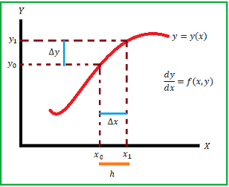

*x1 = x0 + h* …….(2)

(x0, y0) = *f* (x0, y0)

***=*** *f*(x0, y0)

*= h f* (x0, y0)

*y1 – y0 = h f* (x0, y0)

*y1 = y0 + h f* (x0, y0)

*y2 = y1 + h f* (x1, y1)

*yn +1= yn + h f* (xn , yn) n = 1, 2, … …….(3)

In this formula is used to calculate the ordinary differential equation with initial condition this is known as Euler’s method.

**3.4.2 Solving Euler’s method in Excel**

Start MS Excel and save the workbook file with the name "ODE Solution.xlsx". Design the template as shown in figure 1.

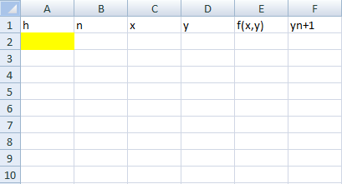

**Figure1**. Template for solving ODE’s by Euler's method in Excel.

Solve the example problem, the problem is given by

Solve $\frac{dy}{dx}=$ *2x +3y* with initial condition x = 0, y = 1 and h = 0.1 using Euler’s method. (5 steps)

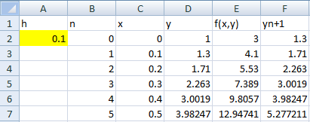

**Figure2**. Solution of the problem using Euler’s method in Excel.

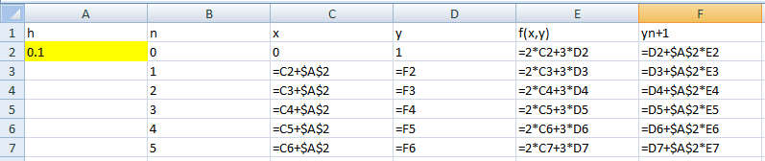

**Figure 3:** Formulas use in Excel sheet.

* Develop a template for solving ODEs using Euler’s method.
* We know that the h value and initial value of x, y. Assign the value of h in A2 cell, initial value of x assign in C2 cell, similarly y value assign in D2cell.
* We know that the n value is 0, 1, 2, ... the value of n assign in the range of B2:B7.
* In the range of C2:C7, enter the value of x in the interval is [0; 0.5]. (ref.eqn.2)
* The f(x, y) value is given the problem, calculate the value using this formula **E2 = 2*C2 + 3*D2** in the E2 cell and drag the range E2:E7.
* Calculate yn + 1 using this formula **F2 = D2 + $A$2 * E2** in the F2 cell and drag the range F2:F7. The dollar simple denote the value is constant it can’t be change.(ref.eqn.3)
* The value of yn + 1 assign in the cell **D3 = F2** and drag the range D3:D7.

**3.4.3 Excel functions**

**$ (Absolute Reference):**

* In Excel, the $ symbol is used to create an absolute reference in a cell formula.
* When you use an absolute reference, it means that the cell reference doesn't change when you copy the formula to other cells.
* For example, if you have a formula "**=A1*$B$2**" and you copy it to another cell, the reference to cell B2 remains fixed, while the reference to A1 will change relative to the new position of the formula.

**MAX Function:**

* The MAX function in Excel is used to find the largest value in a range of cells.
* Its syntax is **= MAX (number1, number2 …)**.
* You can input multiple values or cell references as arguments, and it will return the highest value among them.
* For example, **= MAX (A1:A10)** will return the largest value in cells A1 through A10.

**VLOOKUP Function:**

* VLOOKUP stands for "Vertical Lookup."
* It is used to search for a value in the leftmost column of a table and then return a value in the same row from a column you specify.
* Its syntax is **= VLOOKUP (lookup_value, table_array, col_index_num, [range_lookup]).**
* The **lookup_value** is the value you want to search for.
* The **table_value** is the range of cells that contains the data.
* The **col_index_num** is the column number in the table_array from which the matching value should be returned.
* Range lookup is an optional argument that specifies whether to find an exact match or an approximate match.
* For example, **= VLOOKUP (A1, B1:D10, 3, FALSE)** will search for the value in A1 within the range B1 to D10, and if found, return the value in the third column of that range.

**CHAPTER - 4**

**STATEMENT OF THE PROBLEM AND SOLUTION**

**4.1 STATEMENT OF THE PROBLEM:**

In this project we want to achieve the following goals,

* To find the maximum probability distribution of electron in different energy levels of Hydrogen atom using Dirac atom model.
* To draw the probability distribution curve of electron in different energy levels of Hydrogen atom using Dirac atom model.
* Comparison between the probability distribution of electron in Bohr atom model and Dirac atom model.
* To find the maximum probability distribution of electron in ground state for different atoms using Dirac atom model.
* To draw the probability distribution curve of electron in ground state for different atoms using Dirac atom model.
* To find the maximum possible atomic number using Dirac atom model.

All the above problems are simulating by M.S-Excel.

**4.2 SOLUTION OF THE PROBLEM:**

To, Solve the above problem let us take Dirac Relativistic formula

V(r) =

=

1 = , 2 = and 2 =

Where,

Z is Atomic number.

e is charge of electron (1.610-19J).

m0 is rest mass of the electron (9.10910-31kg).

c is velocity of light (2.997108m/s).

0 is Permittivity of free space (8.85410-12 fm-1).

h is Plank’s constant (6.62610-34 Js).

Is Total Angular momentum (1, 2, 3 …).

k is Eigen Value operator ($± 1, ± 2, ± 3,…$).

V is Potential Energy.

S is minimum power for power series expansion of f and g.

2 is probability density.

**4.2.1 Excel Worksheet**

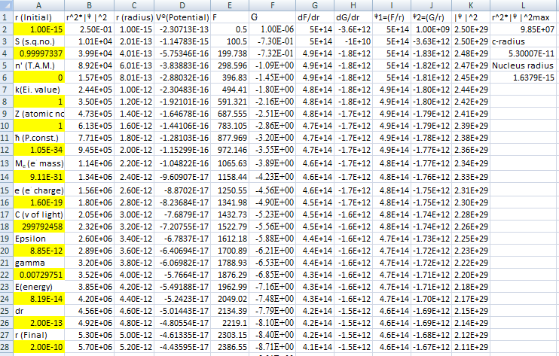

**4.2.1.1 Excel Formula sheet**

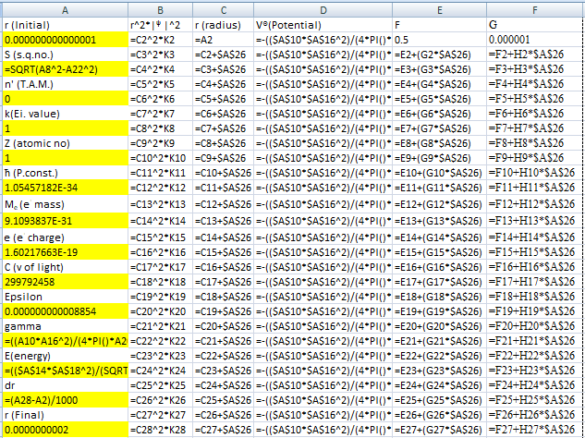

Fig: Page 1

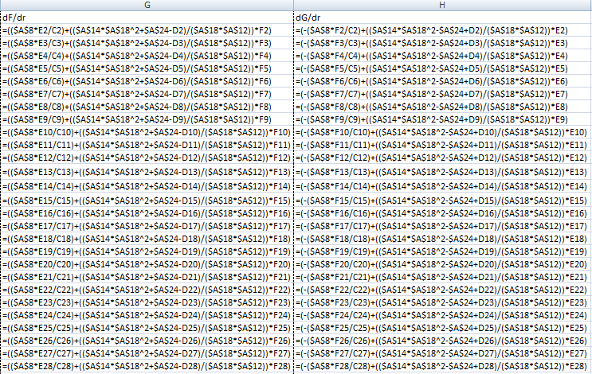

Fig: Page 2

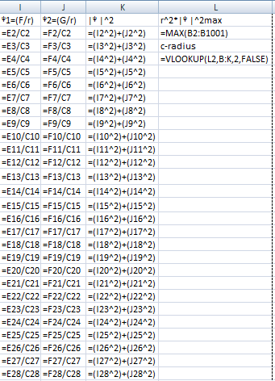

Fig: Page 3

**4.2.2 Different energy levels of the Hydrogen atom using the Dirac atom model.**

**4.2.2.1 1S1/2 Energy state of a Hydrogen atom**

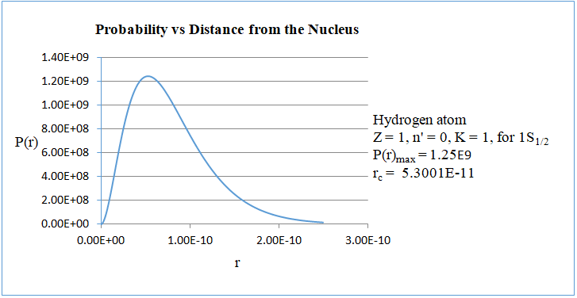

To simulate the Dirac atom model using the Euler method in Excel and plot the curve of the maximum probability distribution versus radius, we would first need to understand the probability distribution of the electron in the 1S1/2 energy state of a hydrogen atom. In this state, the total angular momentum is zero and the Eigen value is 1.

The simulation reveals that the maximum probability is 1.25109 at the corresponding radius of 5.300110-11 meters.

This simulation would provide a visual representation of how the maximum probability distribution changes with radius in the 1S1/2 energy state of a hydrogen atom according to the Dirac atom model.

**4.2.2.2 2S1/2 Energy state of a Hydrogen atom**

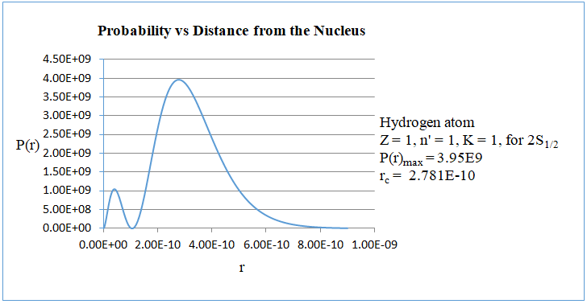

To simulate the Dirac atom model using the Euler method in Excel and plot the curve of the maximum probability distribution versus radius, we would first need to understand the probability distribution of the electron in the 2S1/2 energy state of a hydrogen atom. In this state, the total angular momentum is 1 and the Eigen value is 1.

The simulation reveals that the maximum probability is 3.95109 at the corresponding radius of 2.78110-10 meters.

This simulation would provide a visual representation of how the maximum probability distribution changes with radius in the 2S1/2 energy state of a hydrogen atom according to the Dirac atom model.

**4.2.2.3 2P1/2 Energy state of a Hydrogen atom**

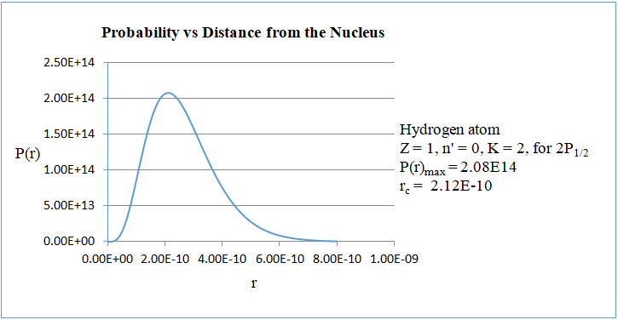

To simulate the Dirac atom model using the Euler method in Excel and plot the curve of the maximum probability distribution versus radius, we would first need to understand the probability distribution of the electron in the 2P1/2 energy state of a hydrogen atom. In this state, the total angular momentum is 0 and the Eigen value is 2.

The simulation reveals that the maximum probability is 2.081014 at the corresponding radius of 2.1210-10 meters.

This simulation would provide a visual representation of how the maximum probability distribution changes with radius in the 2P1/2 energy state of a hydrogen atom according to the Dirac atom model.

**4.2.2.4 2P1/2 Energy state of a Hydrogen atom.**

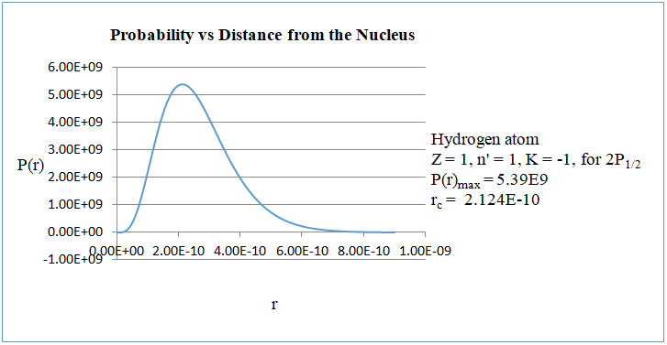

To simulate the Dirac atom model using the Euler method in Excel and plot the curve of the maximum probability distribution versus radius, we would first need to understand the probability distribution of the electron in the 2P1/2 energy state of a hydrogen atom. In this state, the total angular momentum is 1 and the Eigen value is -1.

The simulation reveals that the maximum probability is 5.39109 at the corresponding radius of 2.12410-10 meters.

This simulation would provide a visual representation of how the maximum probability distribution changes with radius in the 2P1/2 energy state of a hydrogen atom according to the Dirac atom model.

**4.2.2.5 3P3/2 Energy state of a Hydrogen atom.**

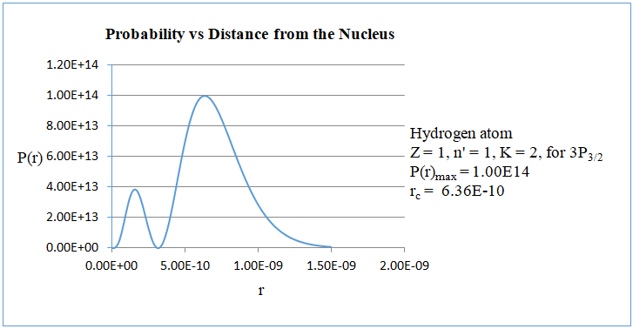

To simulate the Dirac atom model using the Euler method in Excel and plot the curve of the maximum probability distribution versus radius, we would first need to understand the probability distribution of the electron in the 3P3/2 energy state of a hydrogen atom. In this state, the total angular momentum is 1 and the Eigen value is 2.

The simulation reveals that the maximum probability is 1.001014 at the corresponding radius of 6.3610-10 meters.

This simulation would provide a visual representation of how the maximum probability distribution changes with radius in the 3P3/2 energy state of a hydrogen atom according to the Dirac atom model.

**4.2.2.6 3D3/2 Energy state of a Hydrogen atom.**

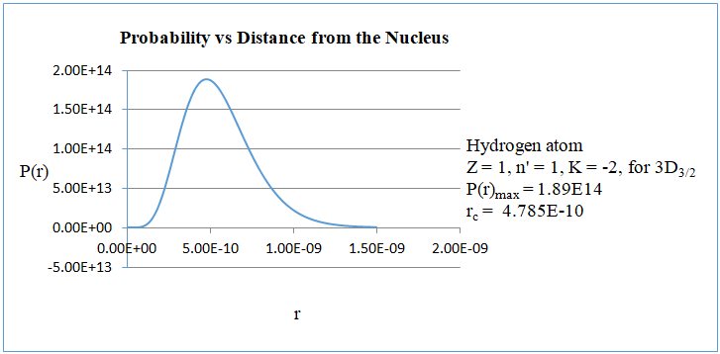

To simulate the Dirac atom model using the Euler method in Excel and plot the curve of the maximum probability distribution versus radius, we would first need to understand the probability distribution of the electron in the 3D3/2 energy state of a hydrogen atom. In this state, the total angular momentum is 1 and the Eigen value is -2.

The simulation reveals that the maximum probability is 1.891014 at the corresponding radius of 4.78510-10 meters.

This simulation would provide a visual representation of how the maximum probability distribution changes with radius in the 3D3/2 energy state of a hydrogen atom according to the Dirac atom model.

**4.2.2.7 3D5/2 Energy state of a Hydrogen atom.**

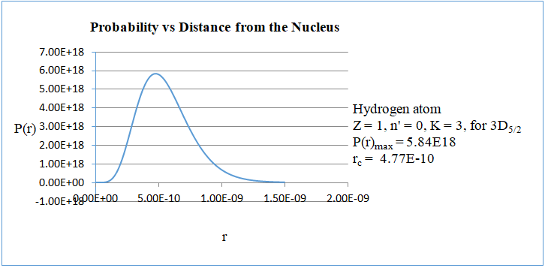

To simulate the Dirac atom model using the Euler method in Excel and plot the curve of the maximum probability distribution versus radius, we would first need to understand the probability distribution of the electron in the 3D5/2 energy state of a hydrogen atom. In this state, the total angular momentum is 0 and the Eigen value is 3.

The simulation reveals that the maximum probability is 5.841018 at the corresponding radius of 4.7710-10 meters.

This simulation would provide a visual representation of how the maximum probability distribution changes with radius in the 3D5/2 energy state of a hydrogen atom according to the Dirac atom model.

**4.2.3 Comparison between the Radius of different Energy levels of Hydrogen according to the Dirac and Bohr models.**

|  |  |  |  |  |  |  |  |  |
| --- | --- | --- | --- | --- | --- | --- | --- | --- |
| $n^{'}$ (T.A.M) | **k**  (E.V) | **Orbit** | **P(r)max** | **Dirac**  **Radius** | **Dirac E.level**  (eV) | **n**  (P.Q.N) | **Bohr radius** | **Bohr**  **E.level**  (eV) |
| 0 | 1 | 1S1/2 | 1.25109 | 5.3010-11 | -13.6 | 1 | 5.2910-11 | -13.6 |
| 0 | 2 | 2P1/2 | 2.081014 | 2.1210-10 | -3.41 | 2 | 2.1210-10 | -3.40 |
| 0 | 3 | 3D5/2 | 5.841018 | 4.7710-10 | -1.51 | 3 | 4.7610-10 | -1.51 |
| 1 | 1 | 2S1/2 | 3.95109 | 2.7810-10 | -3.41 | 2 | 2.1210-10 | -3.40 |
| 1 | -1 | 2P1/2 | 5.39109 | 2.1210-10 | -3.41 | 2 | 2.1210-10 | -3.40 |
| 1 | 2 | 3P3/2 | 1.001014 | 6.3610-10 | -1.51 | 3 | 4.7610-10 | -1.51 |
| 1 | -2 | 3D3/2 | 1.891014 | 4.7810-10 | -1.51 | 3 | 4.7610-10 | -1.51 |

Starting with the Dirac model, the table provides information such as the principal quantum number n, the total angular momentum n', the corresponding energy value k, the orbit, the maximum probability distribution multiplied by P(r)max, the corresponding radius rc, the principal quantum number n, and the Bohr radius.

In the Dirac model, the energy levels are determined by the principal quantum number n, representing the shell or energy level of the electron. The total angular momentum n' determines the subshell or orbital within each energy level. The energy values k represents the energy associated with each orbital, with higher energy levels having greater values of k. The orbit indicates the specific type of orbital within each energy level (e.g., 1s1/2, 2s1/2, 2p1/2, 2p3/2, and 3d3/5). The maximum probability distribution multiplied by P(r)max indicates the maximum probability of finding the electron within a certain radius rc, which corresponds to the Bohr radius for each energy level.

On the other hand, in the Bohr model, the energy levels are determined solely by the principal quantum number n, with each level corresponding to a specific shell or orbit. The energy of each level is given by k = -13.6/n2 eV. The Bohr model does not take into account the concept of subshells or the maximum probability distribution of electrons within orbits.

Comparing the two models, we can observe that the Bohr model provides a simplified description of the energy levels of hydrogen, based solely on the principal quantum number n, while the Dirac model provides a more detailed understanding by incorporating the total angular momentum n', specific orbital’s, and maximum probability distributions. Additionally, the Dirac model predicts slightly different energy values and corresponding radii compared to the Bohr model.

In conclusion, the comparison between the energy levels of hydrogen according to the Dirac and Bohr models reveals significant differences in their approaches and predictions. While the Bohr model provides a simplified description based solely on the principal quantum number n, the Dirac model offers a more comprehensive understanding by incorporating additional factors such as the total angular momentum n', specific orbital’s, and maximum probability distributions. Furthermore, the experimental data highlights discrepancies between the predictions of the two models, particularly in terms of energy values and corresponding radii. These differences underscore the limitations of the Bohr model and emphasize the importance of more advanced quantum mechanical approaches like the Dirac model for accurately describing the behaviour of hydrogen atoms. Overall, the comparison highlights the advancements made in our understanding of atomic structure and the need for sophisticated theoretical frameworks to fully capture the complexities of quantum systems.

**4.2.4 Ground state electron probability distributions of various atoms using the Dirac atom model.**

**4.2.4.1 Atomic Number Z = 1 like Hydrogen atom**



To simulate the Dirac atom model using the Euler method in Excel and plot the curve of the maximum probability distribution versus radius, one must first comprehend the electron probability distribution in the 1s1/2 energy state of a specific atom. In this state, the total angular momentum is zero, the Eigen value is 1, and the atomic number is 1 (indicating hydrogen).

The simulation demonstrates that the maximum probability is 1.25109 at the corresponding radius of 5.300110-11 meters.

**4.2.4.2 Atomic Number Z = 8 like Oxygen atom**

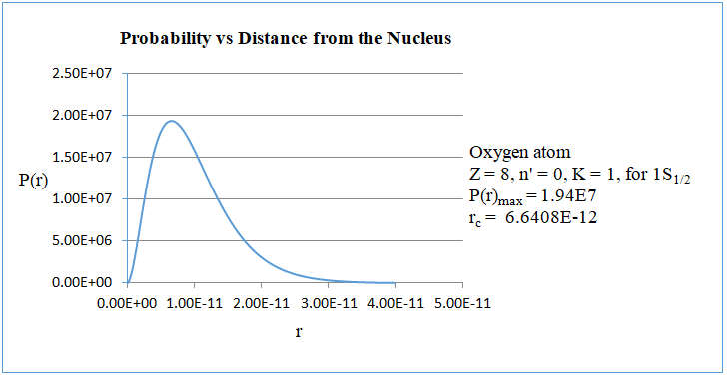

To simulate the Dirac atom model using the Euler method in Excel and plot the curve of the maximum probability distribution versus radius, one must first comprehend the electron's probability distribution in the 1s1/2 energy state of a specific atom. In this state, the total angular momentum is zero, the Eigen value is 1, and the atomic number is 8 (indicating Oxygen).

The simulation demonstrates that the maximum probability is 1.94107 at the corresponding radius of 6.640810-12 meters.

**4.2.4.3 Atomic Number Z = 20 like Calcium atom**

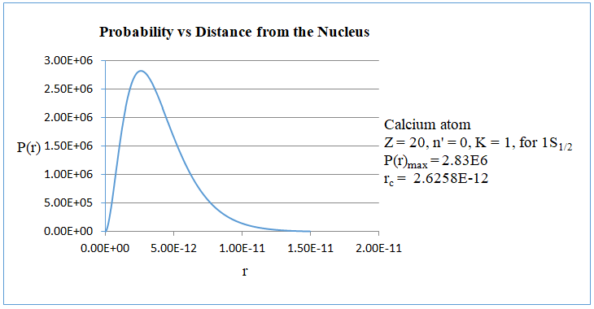

To simulate the Dirac atom model using the Euler method in Excel and plot the curve of the maximum probability distribution versus radius, one must first comprehend the electron's probability distribution in the 1s1/2 energy state of a specific atom. In this state, the total angular momentum is zero, the Eigen value is 1, and the atomic number is 20 (indicating Calcium).

The simulation demonstrates that the maximum probability is 2.83106 at the corresponding radius of 2.625810-12 meters.

**4.2.4.4 Atomic Number Z = 50 like Tin atom**

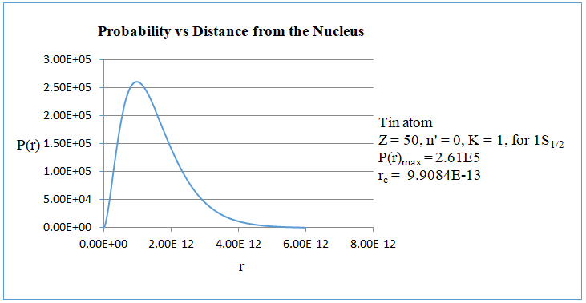

To simulate the Dirac atom model using the Euler method in Excel and plot the curve of the maximum probability distribution versus radius, one must first comprehend the electron's probability distribution in the 1s1/2 energy state of a specific atom. In this state, the total angular momentum is zero, the Eigen value is 1, and the atomic number is 50 (indicating Tin).

The simulation demonstrates that the maximum probability is 2.61105 at the corresponding radius of 9.908410-13 meters.

**4.2.4.5 Atomic Number Z = 82 like Lead atom**

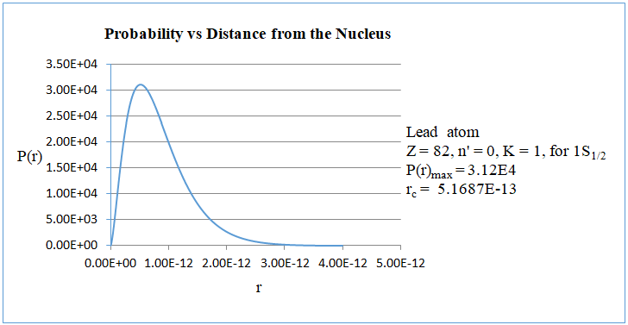

To simulate the Dirac atom model using the Euler method in Excel and plot the curve of the maximum probability distribution versus radius, one must first comprehend the electron's probability distribution in the 1s1/2 energy state of a specific atom. In this state, the total angular momentum is zero, the Eigen value is 1, and the atomic number is 82 (indicating Lead).

The simulation demonstrates that the maximum probability is 3.12104 at the corresponding radius of 5.168710-13 meters.

**4.2.4.6 Atomic Number Z = 126 like Unbihexium atom**

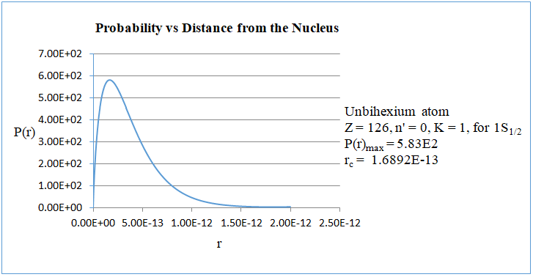

To simulate the Dirac atom model using the Euler method in Excel and plot the curve of the maximum probability distribution versus radius, one must first comprehend the electron's probability distribution in the 1s1/2 energy state of a specific atom. In this state, the total angular momentum is zero, the Eigen value is 1, and the atomic number is 126 (indicating Unbihexium).

The simulation demonstrates that the maximum probability is 5.83102 at the corresponding radius of 1.689210-13 meters.

**4.2.4.7 Atomic Number Z = 137 like Untriseptium atom**

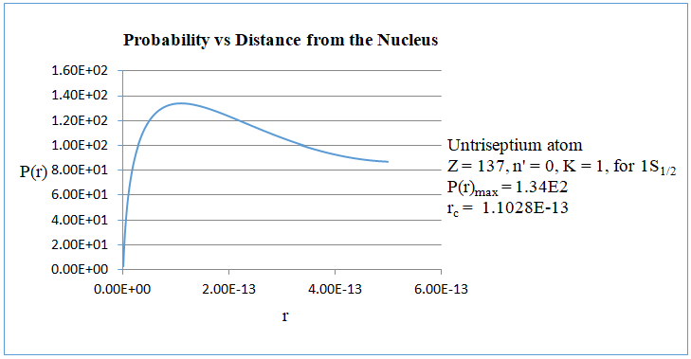

To simulate the Dirac atom model using the Euler method in Excel and plot the curve of the maximum probability distribution versus radius, one must first comprehend the electron's probability distribution in the 1s1/2 energy state of a specific atom. In this state, the total angular momentum is zero, the Eigen value is 1, and the atomic number is 137 (indicating Untriseptium).

The simulation demonstrates that the maximum probability is 1.34102 at the corresponding radius of 1.102810-13 meters.

**4.2.4.8 Atomic Number Z = 138 like Untrioctium atom**

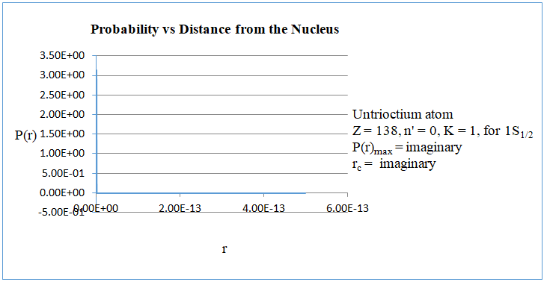

To simulate the Dirac atom model using the Euler method in Excel and plot the curve of the maximum probability distribution versus radius, one must first comprehend the electron's probability distribution in the 1s1/2 energy state of a specific atom. In this state, the total angular momentum is zero, the Eigen value is 1, and the atomic number is 138 (indicating Untrioctium).

The simulation demonstrates that the calculation is not possible. So, the result becomes imaginary (The imaginary indicates orbital electron being captured by the nucleus). For the atomic number Z = 138 we did not get the probability distribution of the electron. That is the electron motion is not possible to that atomic number. From this result we conclude the Maximum possibility of atomic number is 137.

**4.2.5 The impossibility of an atomic number greater than 137.**



Fig.1

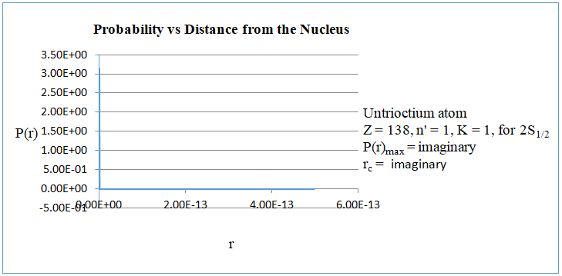

Fig.2

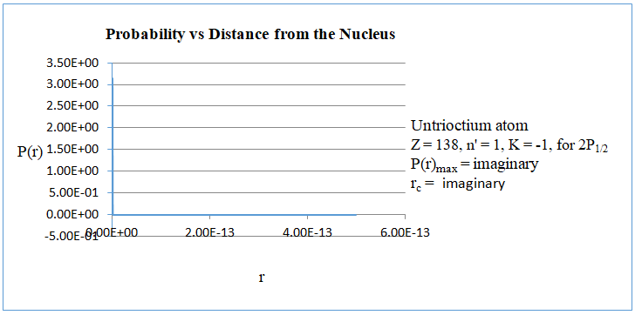

Fig.3

The impossibility of an atomic number greater than 137 in the Dirac atom model. Because,

$$s=±\sqrt{\left(k^{2}-γ^{2}\right)}$$

We take the upper-sign + for s, Because of solution to be non-singular at the origin.

$$s=\sqrt{\left(k^{2}-γ^{2}\right)}$$

The value of s is depending on the k (Eigen value) and $γ$ (gamma value). The Eigen value of 1S1/2, 2S1/2, 2P1/2 orbital electron is 1. So the value of s is

S is +ve when $γ$ < 1 or S is imaginary when $γ$ > 1

The value of gamma is directly proportional to the atomic number Z and the value of s inversely proportional. The value atomic number is increases when the value of gamma also increases and value s is decreases. For atomic numbers ranging from 1 to 137, the value of s is positive. However, for atomic numbers greater than 137, the value of s becomes imaginary. It is well-established that a negative value of s is not physically feasible, as it would imply an orbital electron being captured by the nucleus. Therefore, the maximum possible atomic number is 137. For atomic numbers exceeding 137, the electrons in the K and L orbital’s are captured by the nucleus. The atomic number 138, the 1S1/2, 2S1/2, 2P1/2 orbital electron’s are captured by the nucleus. Shown in fig.1, 2, and 3.

**4.2.5.1 The impossibility in the Analysis of the Bohr atom model.**

$L=rmv=nħ$……. (1)

${ v}^{2}= \frac{n^{2}{ ħ}^{2}}{r^{2}m^{2}}$

$\frac{1}{{4πε}_{0}}\frac{{Ze}^{2}}{r^{2}}= \frac{m}{r}\frac{n^{2}{ ħ}^{2}}{r^{2}m^{2}}$

$r= \frac{{4πε}_{0}n^{2}ħ^{2}}{{mZe}^{2}}$…….(2)

Substituting these values in (1); we get the velocity of orbital electron

$$v= \frac{nħ}{rm}= \frac{{mnħZe}^{2}}{{m4πε}_{0}n^{2}ħ^{2}}$$

$$v= \frac{1}{{4πε}_{0}}\frac{{Ze}^{2}}{nħ}$$

Note: $\frac{1}{{4πε}_{0}}\frac{e^{2}}{cħ}= \frac{1}{137}$ Fine structure constant.

$∴$ $v= \frac{Z}{n}\frac{1}{137}c$……. (3)

When Z becomes larger than 137 for n = 1, v > c. We know that According to Special theory of Relativity, the maximum velocity is the speed of light. Therefore, the velocity of an electron in the ground state with an atomic number larger than 137 being greater than the speed of light is not possible; thus, it becomes imaginary mass and energy. Maybe it is possible to convert tachyons.

**CHAPTER - 5**

**CONCLUSION**

The Dirac atomic model is simulated in Excel to visualize the maximum probability distribution of electrons within each energy level of the hydrogen atom. Additionally, a comparison is made with Bohr's predictions of radii at different energy levels. According to our investigation, for atomic numbers up to 137, the value of s is positive. Beyond 137, it becomes imaginary, which is not physically possible as it implies an electron being captured by the nucleus. Therefore, the maximum atomic number is 137. For higher atomic numbers, electrons in the K and L orbital’s are captured by the nucleus. The implication of the fine structure constant in the Dirac atom model is notable. Up to atomic number 136, the position of the ground state electron decreases. However, at atomic number 137, it increases, albeit the energy of the electron decreases. Upon reaching atomic number 138, both the position and energy become imaginary. The implication of the fine structure constant in the Bohr atom model is that when Z exceeds 137 for n = 1, v > c. Since we know that According to Special theory of Relativity, the maximum velocity is the speed of light, it follows that the velocity of an electron in the ground state with an atomic number greater than 137 cannot surpass the speed of light; thus, it becomes imaginary mass and energy. Maybe it is possible to convert tachyons.

**CHAPTER – 6**

**REFERENCE**

1. Dirac, P. A. M. (1928).The quantum theory of the electron. Part I. Proceedings of the Royal Society of London. Series A, Containing Papers of a Mathematical and Physical Character, 117(778), 610-624. <https://doi.org/10.1098/rspa.1928.0023>
2. Dirac, P. A. M. (1928). The quantum theory of the electron. Part II. Proceedings of the Royal Society of London. Series A, Containing Papers of a Mathematical and Physical Character, 118(779), 351-361. <https://doi.org/10.1098/rspa.1928.0056>
3. Darwin, C. G. (1928). The wave equations of the electron. Proceedings of the Royal Society of London. Series A, Containing Papers of a Mathematical and Physical Character, 118(780), 654-680. <https://doi.org/10.1098/rspa.1928.0076>
4. Martin, P. C., & Glauber, R. J. (1958). Relativistic theory of radiative orbital electron capture. Physical Review, 109(4), 1307-1325. <https://doi.org/10.1103/physrev.109.1307>
5. Euler H, Institutions calculi integralis. *Volume primum (1768), Opera Omnia, Vol. XI B G Teubneri Lipsiae et Berolini MCMXIII.*
6. Pushap, L. S. (2021). Euler’s method for solving initial value problems in ordinary differential equations. *The international journal of engineering and science*. <https://doi.org/10.9790/1813-1002014548>
7. Trofimets, E. N., & Trofimets, V. Y. (2020). Research of numerical methods for solving ordinary differential equations in MS Excel. Journal of Physics: Conference Series, 1691(1), 012049. <https://doi.org/10.1088/1742-6596/1691/1/012049>
8. Dalton, J. (1893). Foundations of the atomic theory: Comprising papers and extracts by John Dalton, William Hyde Wollaston, M. D., and Thomas Thomson, M. D. (1802-1808).
9. Baily, C. (2012). Early atomic models – from mechanical to quantum (1904–1913). The European Physical Journal H, 38(1), 1-38. <https://doi.org/10.1140/epjh/e2012-30009>
10. Thomson, G. P. (1928). Experiments on the diffraction of cathode rays. Proceedings of the Royal Society of London. Series A, Containing Papers of a Mathematical and Physical Character, 117(778), 600-609. <https://doi.org/10.1098/rspa.1928.0022>
11. Thomson, G. P. (1928). Experiments on the diffraction of cathode rays.—II. Proceedings of the Royal Society of London. Series A, Containing Papers of a Mathematical and Physical Character, 119(783), 651-663. <https://doi.org/10.1098/rspa.1928.0120>
12. Rutherford, E. (1911). LXXIX. The scattering of α and β particles by matter and the structure of the atom. The London, Edinburgh, and Dublin Philosophical Magazine and Journal of Science, 21(125), 669-688. <https://doi.org/10.1080/14786440508637080>
13. Bohr, N. (1913). I. On the Constitution of atoms and molecules. The London, Edinburgh, and Dublin Philosophical Magazine and Journal of Science, 26(151), 1-25. <https://doi.org/10.1080/14786441308634955>
14. Sommerfeld, A. (1923). Atomic structure and spectral lines. Undefined Publishing.
15. Dhar, J., & Sudarshan, E. C. (1968). Quantum Field theory of interacting tachyons. Physical Review, 174(5), 1808-1815. <https://doi.org/10.1103/physrev.174.1808>
16. Satya**,** P**.,** Swati, S. (2019). *Quantum mechanics.* Kedar Nath Ram NathPublishing.
17. Kiruthiga, M. R. (2016). Modern physics (18th ed.). S. Chand Publishing.
18. Balagurusamy, E. (1999). Numerical methods. Undefined Publishing.
19. Rajaraman, V. (2018). Computer oriented numerical methods. PHI Learning Pvt. Publishing.
20. Sastry, S. S. (2012). Introductory methods of numerical analysis. PHI Learning Pvt. Publishing.
21. *Reading material on MS-Excel* (2010), Regional training institute 20, Sarojini Naidu Marg, Allahabad, UP
22. [*www.chat.gpt.com*](http://www.chat.gpt.com)