**PROPOSED SYSTEM**

**Public Transportation Efficiency Analysis**

**Data Collection:**

* Real-Time Data: Collect real-time data from various sources such as GPS trackers on vehicles, ticketing systems, and traffic management systems. This includes information on vehicle location, passenger counts, travel times, and delays.
* Ridership Data: Gather data on passenger demographics, including age, gender, and location, to understand user preferences and needs.
* Traffic Data: Incorporate traffic and road condition data to assess the impact of external factors on transit efficiency.

**Data Storage and Management:**

* Set up a centralized database to store and manage the collected data securely.
* Use data warehouses or big data technologies for efficient data processing and analysis.

**Data Processing and Analysis:**

* Develop algorithms to process and clean the data, handling missing values and outliers.
* Apply data analytics techniques to assess various aspects of public transportation efficiency, such as:
* On-time performance of vehicles.
* Frequency and reliability of services.
* Ridership trends and demand patterns.
* Route and schedule optimization.
* Cost-effectiveness and resource allocation.
* Environmental impact assessment.

**Visualization:**

* Create interactive dashboards and data visualization tools to present the analyzed data to stakeholders in a user-friendly manner.
* Use maps, charts, and graphs to convey information effectively.

**Reporting and Alerts:**

* Generate automated reports that highlight key performance metrics and trends.
* Implement alert systems to notify transit authorities of significant disruptions or issues in real-time.

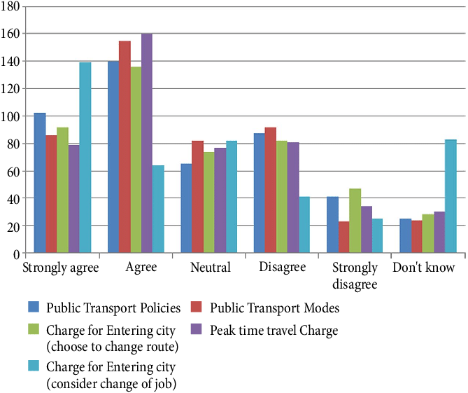

**Machine Learning and Predictive Models:**

* Implement machine learning models to predict future ridership and demand patterns.
* Use predictive maintenance models to reduce downtime and improve the reliability of transportation vehicles.

**Integration:**

* Integrate the efficiency analysis system with other transit management systems, such as ticketing and fare collection, to provide a holistic view of public transportation operations.

**User Feedback and Surveys:**

* Collect feedback from passengers through surveys and mobile apps to gauge user satisfaction and identify areas for improvement.

**Privacy and Security:**

* Ensure that data collection and storage comply with privacy regulations.
* Implement robust security measures to protect sensitive transit data from unauthorized access.

**Continuous Improvement:**

* Use the insights gained from the analysis to make data-driven decisions for improving public transportation efficiency.
* Regularly update and refine the system to adapt to changing conditions and requirements.

**Stakeholder Collaboration:**

* Collaborate with transit agencies, local governments, and other stakeholders to gather insights and ensure the system aligns with their goals and objectives.

**Public Awareness:**

* Promote the availability of the analysis system to the public to foster transparency and accountability in the transportation system.
* By implementing such a system, transportation authorities can make data-driven decisions to optimize public transportation services, improve efficiency, and enhance the overall commuter experience.