***AI Ludo Game***

AI based Two Players Ludo Game

**Abstract:**

The Ludo Game project is composed in Python. This is a simple GUI based method board game which is really understandable. Speaking about the gameplay, all the playing policies are the same much like real time LUDO. This is a GUI based 2 player game computer vs. player. All the game motions are to be done by hand by the player. On Computer side, all the action and decision made up the computer himself based on their integrated intelligence. The 2D GUI is designed using Tkinter python libraries.

**Introduction:**

**Tkinter:** Python offers multiple options for developing GUI (Graphical User Interface). Out of all the GUI methods, tkinter is most commonly used method. It is a standard Python interface to the Tk GUI toolkit shipped with Python. Python with tkinter outputs the fastest and easiest way to create the GUI applications. Creating a GUI using tkinter is an easy task.

**Ludo:** Ludo is a board game played by 2-4 players. Each player is assigned a specific color and given four pieces. In this board game 2 players i.e. Computer and player move their pieces from start to finish according to the dice rolls. Various variations are seen in the way player or computer play Ludo. In this game player play with yellow and Computer play with red pieces. The movement of the pieces is determined by the dice. Players are not allowed to move a piece out of the room area unless they roll a 6 on the dice. In this game, players have to carefully play their pieces otherwise, they have a risk of sending back to the starting point to start all over again. When a player 1’s piece lands on square that is already occupied by Player 2’s piece of different color, Player 2’s piece is returned to its starting point. Player who brings all their pieces to the finish wins the game.

**Artificial Intelligence: Game Techniques Ludo**

The technique we used to make our computer player intelligent is starting from the red start position we assign number from 1 to 52 to all the board square boxes as there are 52 boxes in our Game board except home entrance boxes. And Adjust all the pieces path changing directions by apply checks on the specific number block and change position accordingly. On random Computer choose his one piece to play on getting 6. For finding the best move Computer calculate the distance from the Player2 all pieces and take moves accordingly.

Logic and conditions on which the computer take action and decision to move their pieces and win:

Only one coin is outside the room:

* If computer has only one piece in the play area then there is no choice and computer move that one piece until the next six.
* On next six, the computer first check that if the any one of the yellow pieces on board are not on safe position and distance b/w the red piece to yellow piece is between 6 to 12 then on choosing new piece to play computer continue their 1st piece to move on the probability that it might be hit any yellow piece and then gain another chance. Otherwise randomly select new piece to come

More than one coin is outside the room:

* if any red piece is at region near to or equal to 39 that is close to red home and any yellow coin is in the region 40 to 46 and after adding the current number in the coin position if red coin comes in front of the yellow coin then computer didn’t move it.
* If after adding the current red coin number any one yellow is getting hit, then move that coin.
* If the red coin is in front of the yellow coin then calculate the distance from the all the yellow coin to that red coin and take the coin that has least distance.
* If the red coin is behind the yellow coin then calculate the distance from red coin to all the yellow coin and take the coin that has min distance.
* If any one of the condition is not satisfy then computer move that coin first that is closest to the home.

**Human Player:**

The same board boxing numbering strategy used for human to play. In case of Human Player all the game motions are to be done by hand by the player.

**System Play:**

When the game is opened, start window appears that prompts the user to start the game clicking on “Start” button. Then the game interface is displayed and the red is computer side and yellow in player side. The player must roll the die by clicking on the “Roll dice” button at right. Until the value is 6, no piece can be moved. Once it is 6, the same player gets another chance to roll and that value can be used to move the piece. Next, there is a computer turn and there is also a dice and “Roll dice” button for computer. By clicking on the specific number button on their box sides that corresponds to the specific piece Player and Computer move their pieces. If you press the wrong button a piece number that is inside the room a dialogue box appears that directs player. When a player’s piece overlaps the other player piece, the latter piece is sent to home box and the former piece players gets an another chance to roll the dice. The one who ensures all the pieces get inside the center wins the game. As soon as the game is won, a dialog box appears showing who won the game.

**Specialty:**

By modification in rules, Ludo can become a lot more fun. In our game, we have incorporated Quick Mode. In quick mode, it is mandatory for both players to knock down (hit) at least one piece of its opponent otherwise its coins are not permitted to enter their house and they will restart the journey. Once they make a hit, all coins can enter their room and complete their journey.

**GUI Start Window**

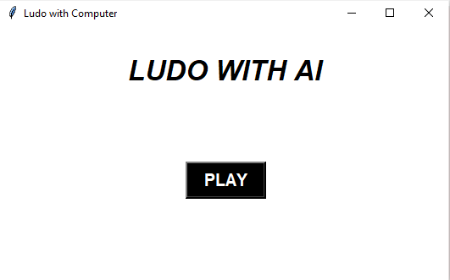

**Game board**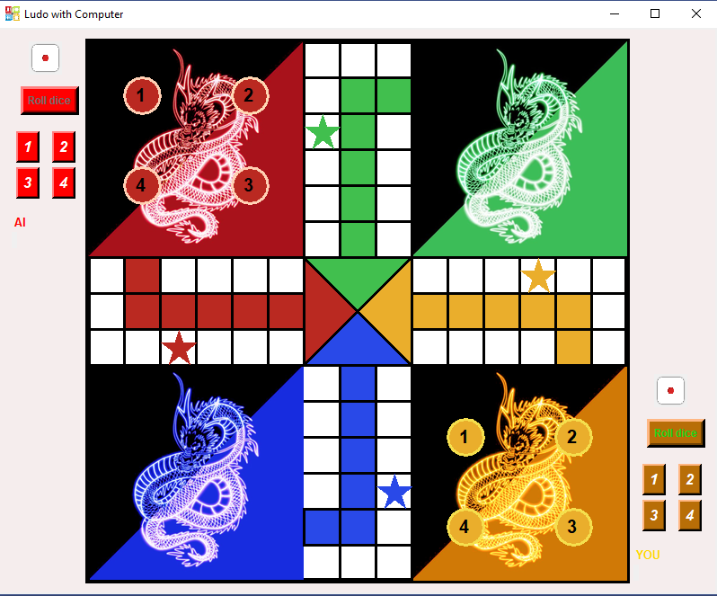

.**Conclusion:**

This project implements a LUDO game in player vs. Computer GUI format. It allows the user to play the game by simply opening the python code and prompting the game to start. The game interface is very simple and is easy to understand by the user. The game performance is fast and efficient.