1. Job failed because of compile errors. [SCREENSHOT01]

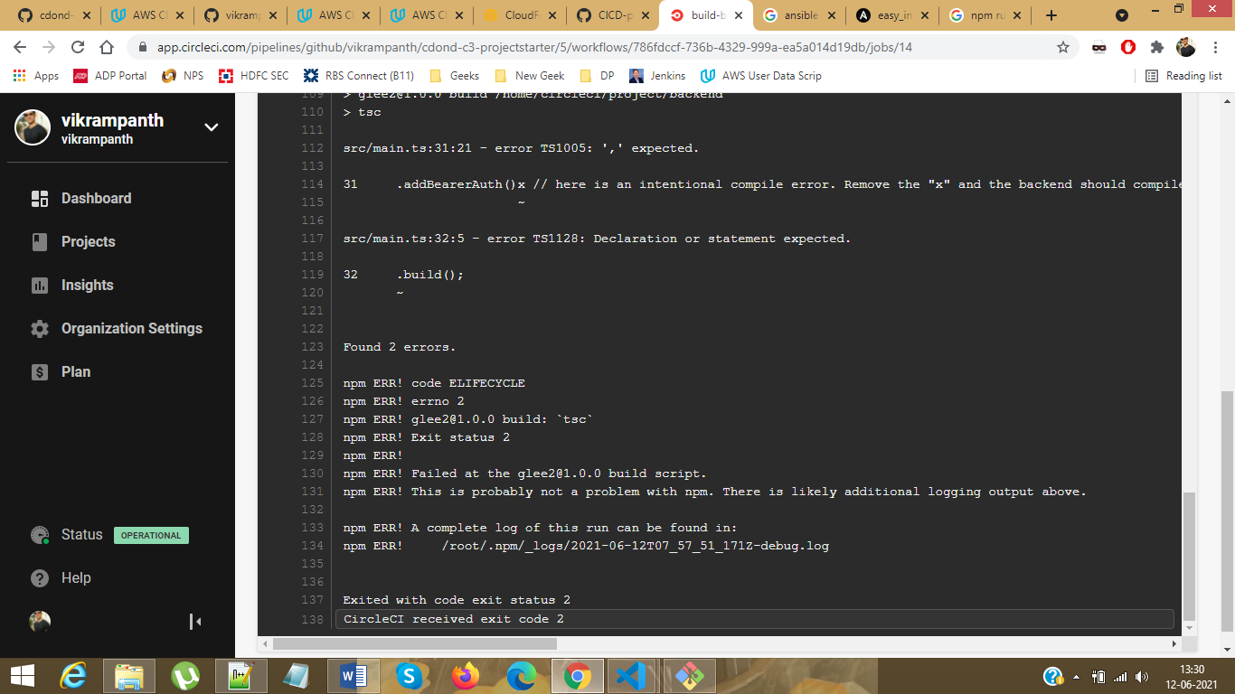

1. Job failed because of unit tests. [SCREENSHOT02]

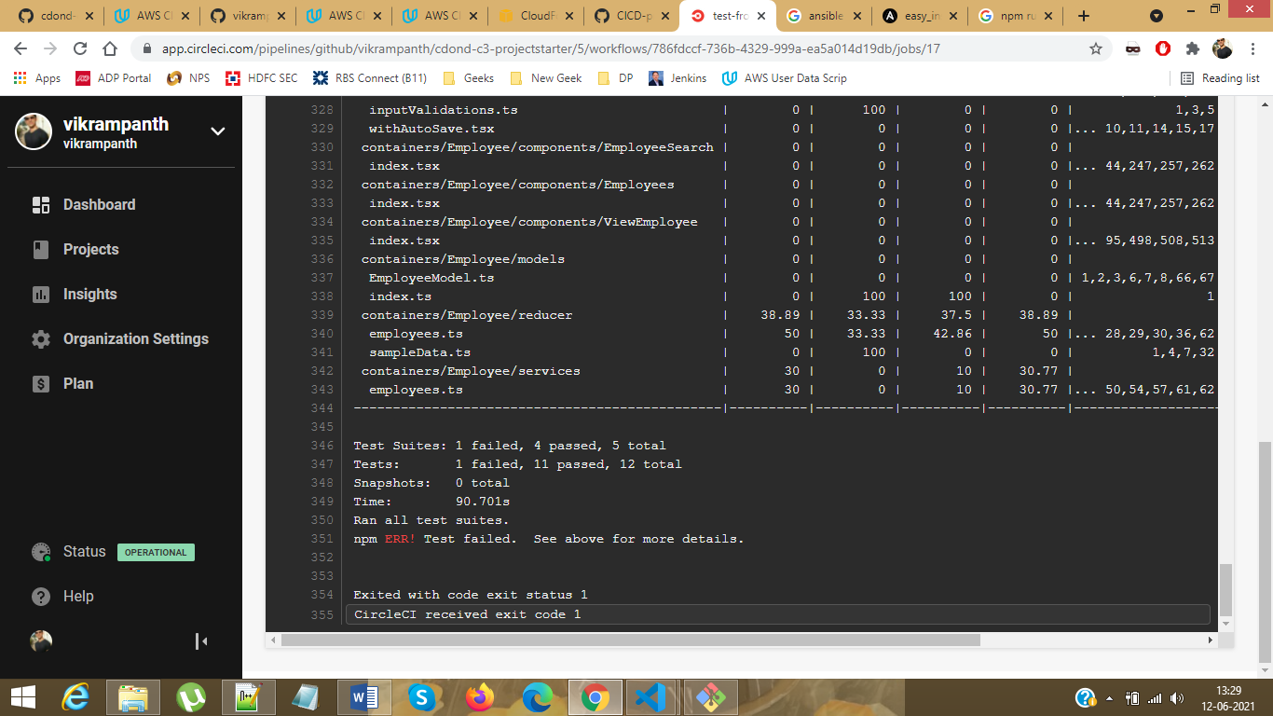

1. Job that failed because of vulnerable packages. [SCREENSHOT03]

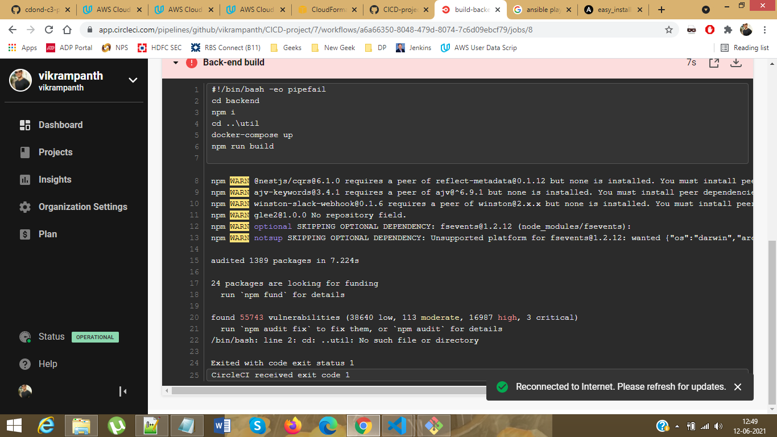

1. An alert from one of your failed builds. [SCREENSHOT04]

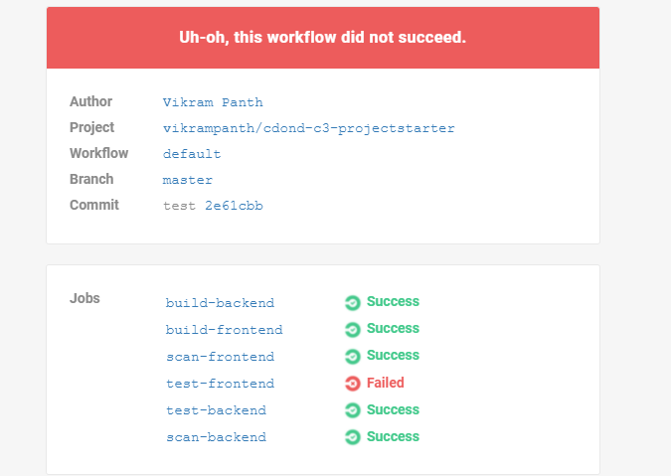

1. Appropriate job failure for infrastructure creation. [SCREENSHOT05]

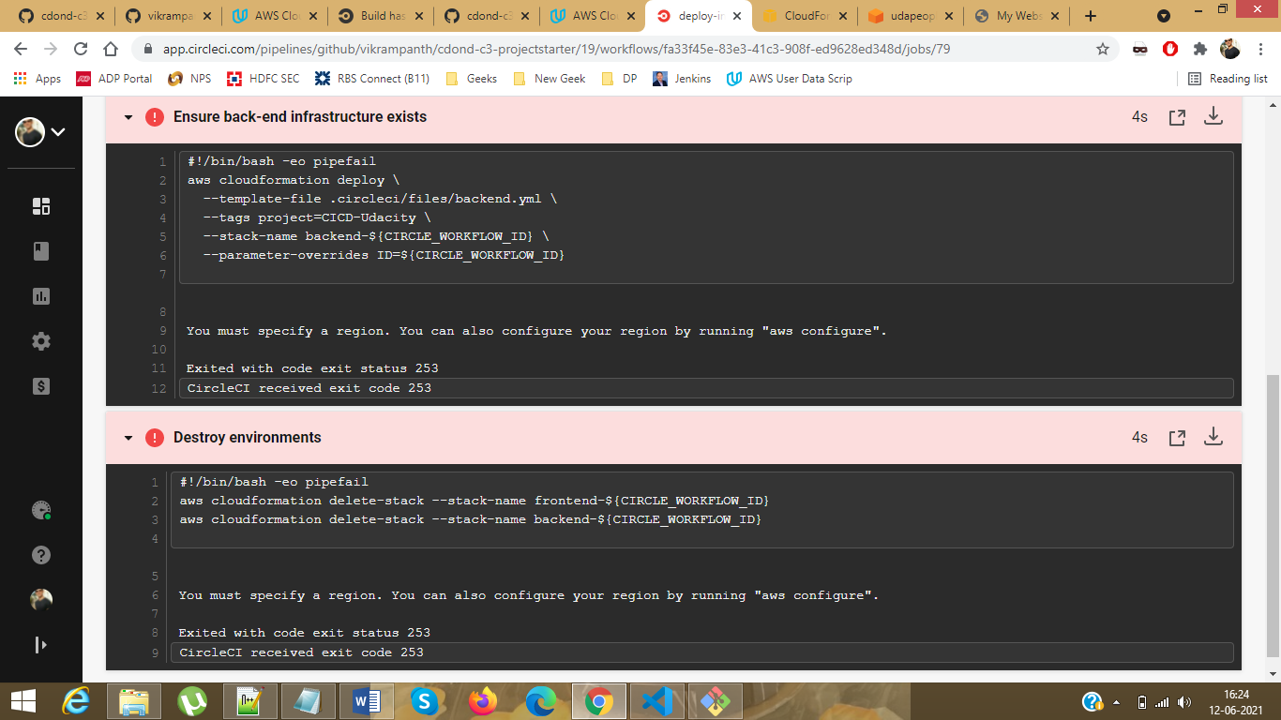

1. Appropriate job failure for the smoke test job. [SCREENSHOT06]

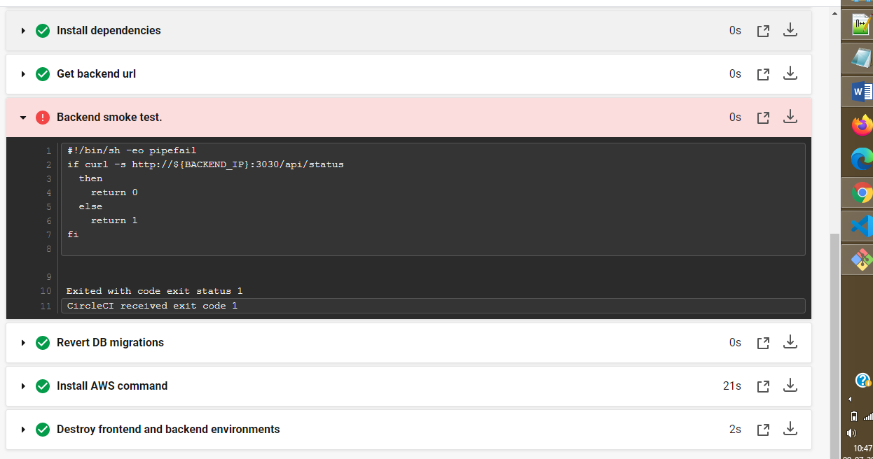

1. Successful rollback after a failed smoke test. [SCREENSHOT07]

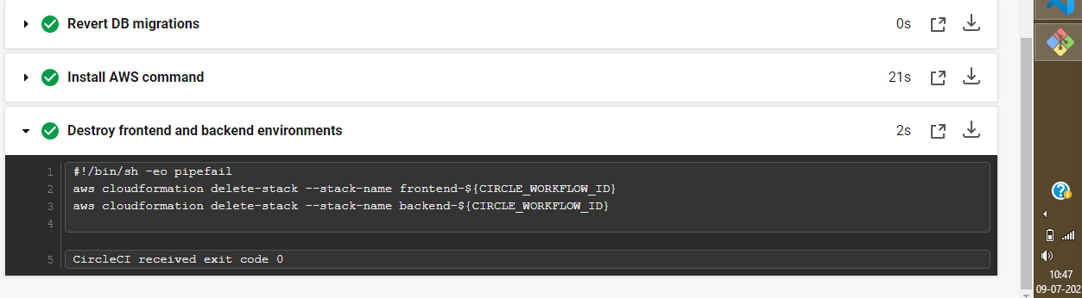

1. Successful promotion job. [SCREENSHOT08]
2. Successful clean-up job. [SCREENSHOT09]
3. Only deploy on pushed to master branch. [SCREENSHOT10]
4. Provide a screenshot of a graph of your EC2 instance including available memory, available disk space, and CPU usage. [SCREENSHOT11]
5. Provide a screenshot of an alert that was sent by Prometheus. [SCREENSHOT12]