Exercises –Generics

1. Create a token generation system

When we walk in to bank we will collect a token and we will wait in a queue. Once our token number is called or displayed on screen we will go to the specific counter and we will do our transactions there.

UI Screen will look like below

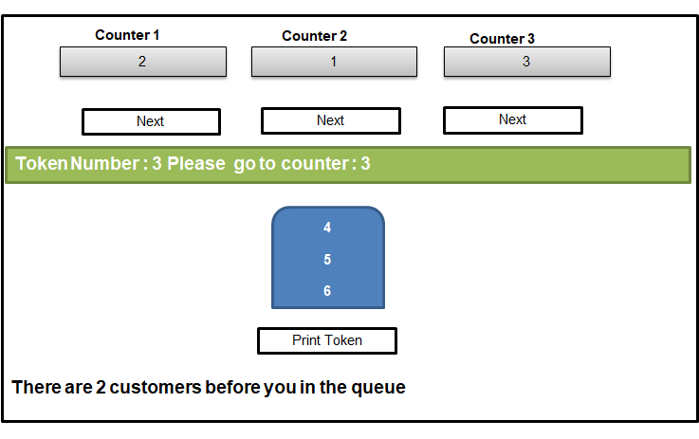

1. Browser Back button implementation using Stack

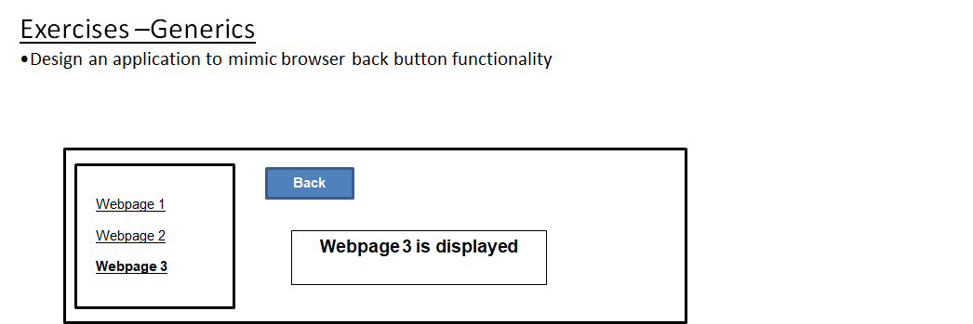

Exercises –LINQ

1.Create an Employee class with following properties

EmployeeID  
FirstName  
LastName  
AnnualSalay  
Gender

Add Employees to a generic list. Write LINQ or Lambda expressions for the following

1. Select EmployeeID and display data
2. Select FirstName and Gender into anonymoustypes
3. Calculate monthly salary as (AnunualSalary/12) and Fullname= Firstname+” “+Lastname and display results

2, Create a Student class with following properties

StudentID  
Name  
TotalMarks   
Add Students to a generic list. Write LINQ or Lambda expressions for the following

1.Sort data by TotalMarks and StudentID

2. Implement Paging to Student data

Please Enter Page Number – 1,2,3, or 4

1

Displaying Page 1 data

101 Sam 900

102 rick 300

103 Tom 500

Please Enter Page Number – 1,2,3, or 4

5

Please enter valid page number between 1 to 4

Please Enter Page Number – 1,2,3, or 4