**Implement SSL,BASIC,TOKENBased security mechanisms for Course tracker system api service**

**Implement OWIN KathanHost authentication and Authorization to API Service**

**Exercises-WEBAPI2**

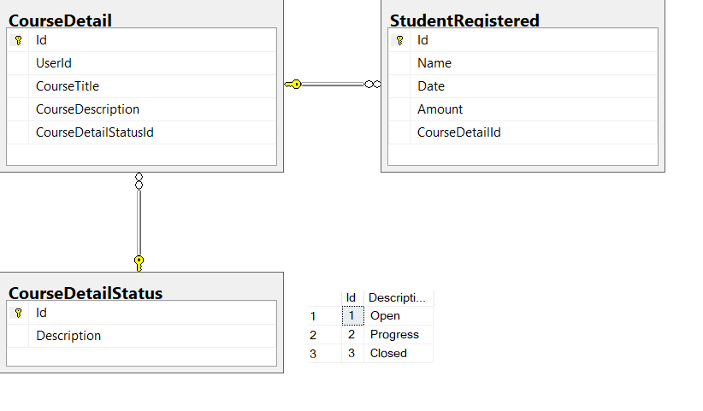

CREATE A WEBAPI SERVICE WITH CRUD, SORTIG, PAGING, FILTERING (SELECTING FIELDS)

Implement following cases

1. Api/CourseDetails/
2. Api/CourseDetails/1
3. Api/CourseDetails/RegisteredStudents
4. Api/CourseDetails/RegisteredStudents/1
5. Api/CourseDetails/
6. Api/Tracker/REgisteredStudents/ courseid =🡺get registered courses
7. Api/tracker/CourseDetails/ staus =🡺based on status
8. Api/Tracker/RegisteredStudents/ date =🡺display students based on registered date
9. No Of students registered for a particular course
10. Apply Security(Authentication & Authorization), versioning

Consume above designed APISERVICE in a MVC application

WebApplication Screens as follows

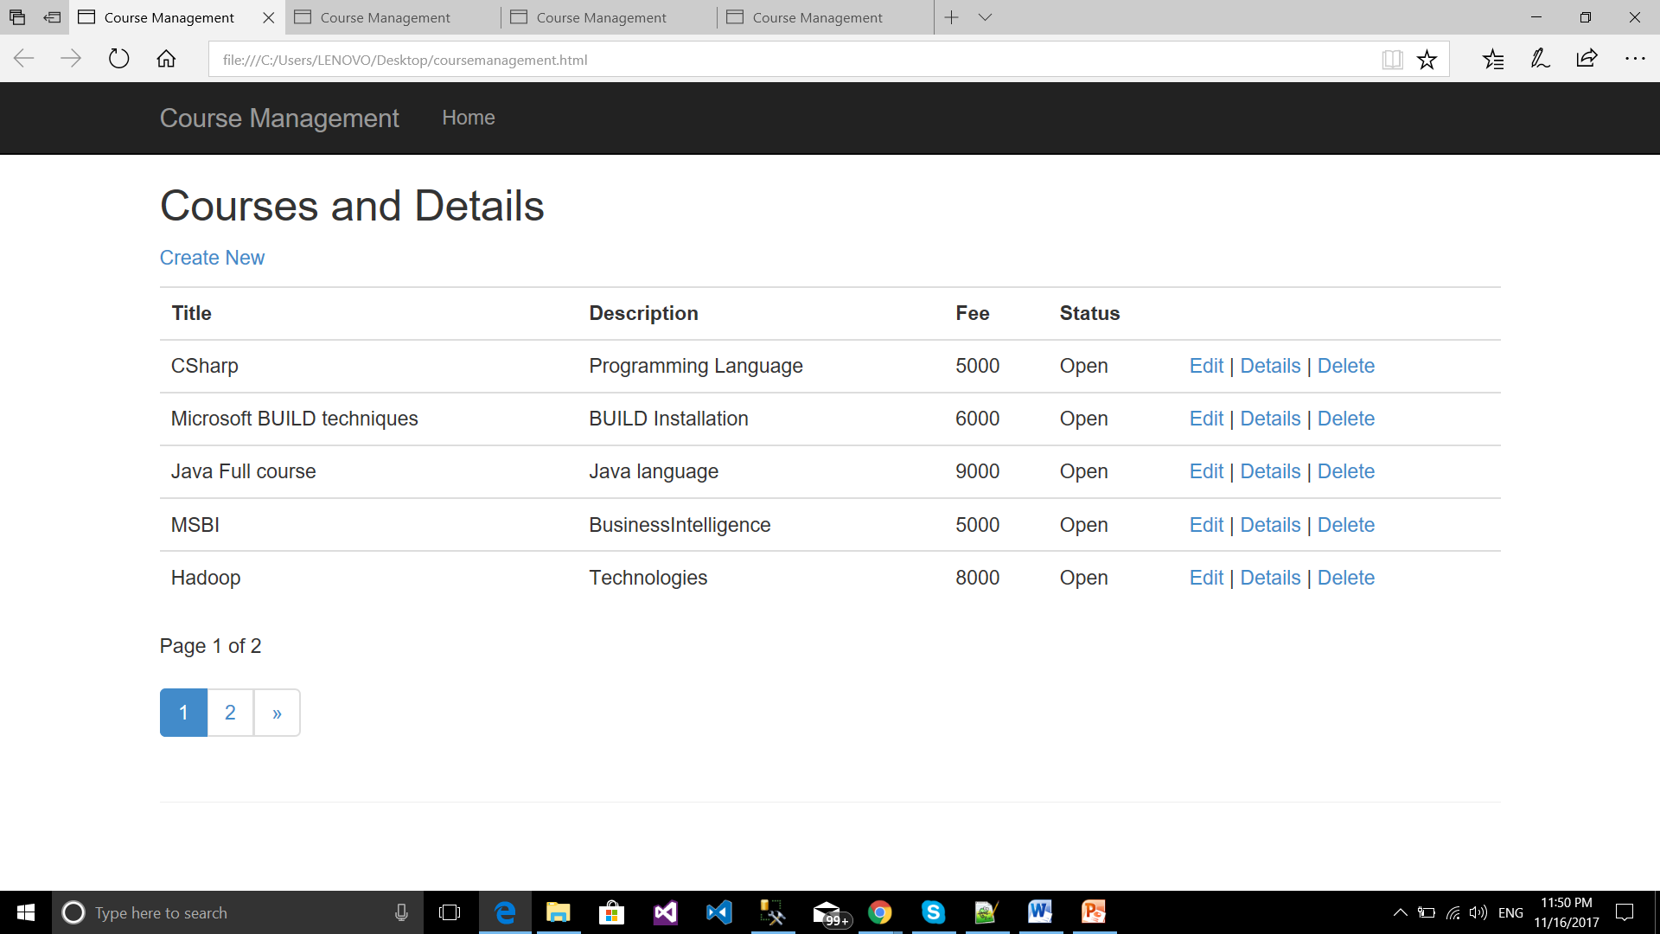

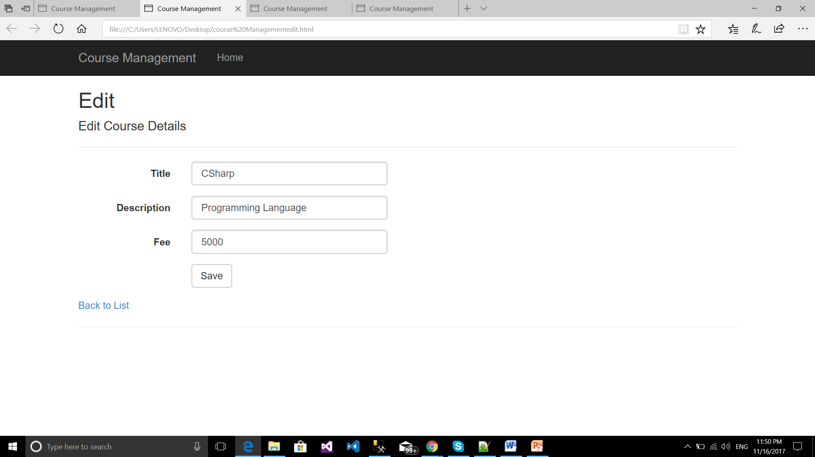

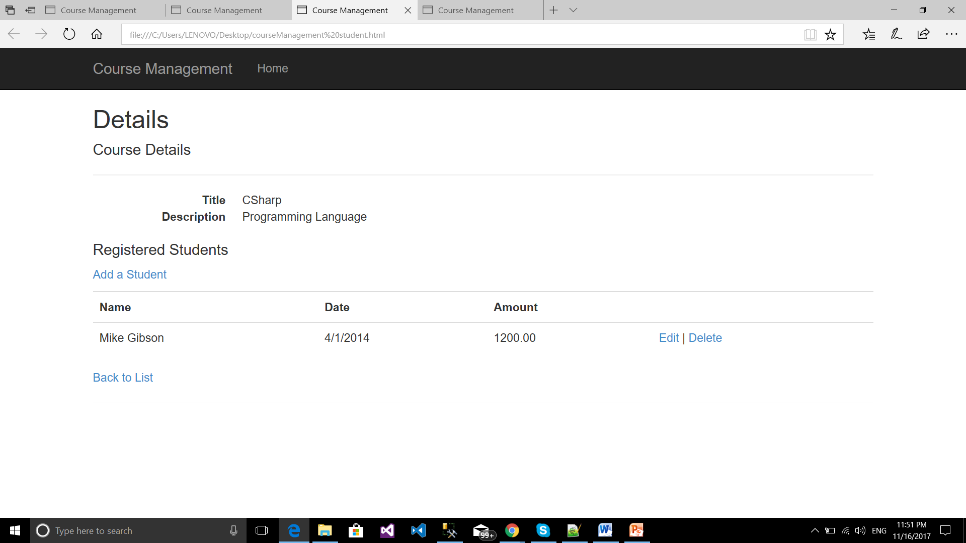

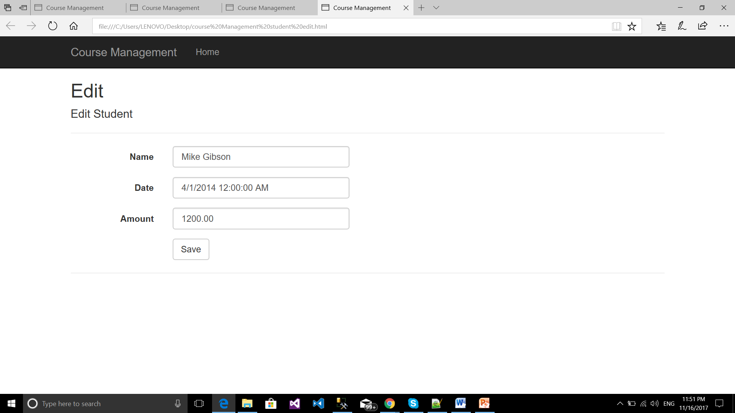

Implement Security and Versioning.