INCREMENTAL MARKETING DECISIONS UNDER BUDGET CONSTRAINTS

Applied Analytics Project Report

MANAGERIAL ABSTRACT
This report supports the organisational decision of whether to adopt uplift-based targeting to maximise incremental marketing outcomes under fixed budget constraints. The investigation was motivated by the limitations of standard response-based targeting, which systematically misallocates resources to customers who would have converted regardless of intervention. Using data from the Hillstrom email and Criteo display advertising experiments, the analysis compared the performance of uplift targeting (T-Learner) against response propensity targeting at key operational budget thresholds. The findings indicate that uplift targeting is not a universal solution but a conditional one; it delivered a 27% improvement in incremental visits in the high-signal Hillstrom Women’s campaign but failed to outperform simple propensity models in the low-signal Men’s and Criteo campaigns. Consequently, this report recommends a gated adoption strategy where uplift modelling is deployed only when average treatment effects exceed 2 percentage points and budgets are constrained to less than 30% of the customer base. The primary limitation of this recommendation is its reliance on historical experimental data, necessitating a pilot phase for internal validation.

CHAPTER 1: INTRODUCTION

1.1 Business Context and Decision Problem
This report addresses a critical resource allocation problem facing mid-to-large digital marketing organisations: how to maximise the incremental return on marketing spend given a fixed contact budget. Contemporary marketing teams operate under strict financial constraints that typically allow for targeting only a fraction of their total addressable market (CMO Alliance, 2025). The prevailing industry standard for making these allocation decisions is response-based targeting, where customers are ranked by their predicted probability of conversion using historical transactional data (Baier and Stocker, 2022). This outcome-oriented approach aligns with the design of most commercial marketing technology platforms, which incentivise engagement metrics such as click-through rates and total conversions (Deloitte, 2025).
However, the reliance on response probability introduces a fundamental inefficiency in budget allocation. By prioritising customers with the highest likelihood of purchasing, organisations inadvertently target individuals with high organic intent—those who would have converted even without the marketing intervention (Lifesight, 2024). In a budget-constrained environment, allocating contact capacity to these "sure things" displaces potential "persuadables," thereby reducing the total incremental value generated by the campaign (Kaushik, 2022). This inefficiency implies that the metric currently used to define success—conversion volume—is misaligned with the economic objective of incrementality (McKinsey, 2025).
Therefore, the explicit decision problem addressed in this report is defined as follows: Given a fixed contact budget, should the organisation target customers using uplift scores rather than response propensity scores to maximise incremental outcomes, under a constant value-per-outcome assumption? This formulation bounds the scope of the inquiry to the targeting mechanism itself, holding creative execution and channel selection constant to isolate the value of the analytical method (Gelman et al., Stanford).

1.2 Research Questions
The transition from response-based to uplift-based targeting is theoretically sound but operationally complex. While academic literature demonstrates that estimating the Conditional Average Treatment Effect (CATE) can identify persuadable customers (Gutierrez and Gerardy, 2017), it often assumes high-quality experimental data that is rarely available in standard business operations. Furthermore, practical experience suggests that the "signal-to-noise" ratio in marketing data may be too low for complex causal models to reliably outperform simpler heuristics (Wu et al., 2023). This discrepancy between theoretical promise and operational reality creates a gap in decision-making confidence.
To bridge this gap, this investigation pursues three specific lines of inquiry. First, it examines the decision performance of the method, asking under what realistic contact budget levels uplift-based targeting improves incremental outcomes over propensity targeting (Mightyroar, 2026). Second, it investigates the mechanisms of success and failure, specifically exploring how treatment effect heterogeneity and signal-to-noise ratios explain the variance in uplift utility across different campaign contexts (Allen AI, 2025). Third, it addresses the pragmatic barriers to implementation by defining what operational checks, data conditions, and evaluation processes an organisation should require before deploying the technology (Optiblack, 2025).

1.3 Report Structure
The remainder of this report constructs the evidence base required to support the final recommendation. Chapter 2 synthesises the relevant literature to detail how current targeting practices fail and how uplift modelling addresses these failures theoretically. Chapter 3 outlines the methodology, justifying the selection of the T-Learner framework and the use of Inverse Probability Weighting for policy evaluation. Chapter 4 presents the empirical results, systematically comparing the targeting policies across high-signal and low-signal environments. Chapter 5 discusses the implications of these findings for the organisation, and Chapter 6 concludes with a summary of the improved decision framework.

CHAPTER 2: DESK RESEARCH
This chapter contextualises the proposed shift to uplift modelling by synthesising the relevant academic literature and industry practice. It traces the evolution of marketing targeting from the prevailing response-based standard to the emerging causal paradigms, identifying the specific theoretical and operational failure modes that necessitate this change. Rather than examining these themes in isolation, the review constructs a coherent narrative that explains why organisations continue to use methods they know to be flawed, and synthesises the evidence required to justify the methodological choices detailed in Chapter 3.

2.1 The Prevalence of Response-Based Logic
The domain of marketing targeting is currently dominated by response-based modelling, a paradigm where customers are selected for intervention based on their predicted probability of converting. This approach relies on supervised learning algorithms—typically logistic regression or gradient boosting—trained on observational data to estimate P(Y=1|X) (Baier and Stocker, 2022). The ubiquity of this method is driven less by its theoretical optimality and more by its operational feasibility; it integrates seamlessly with existing marketing technology stacks that are architected to optimise aggregate engagement metrics such as click-through rates (CMO Alliance, 2025). Furthermore, the outputs of these models align with the intuitive "likelihood to buy" mental model held by most business stakeholders, reinforcing a status quo where success is defined by total conversion volume rather than incremental contribution.

2.2 The Incrementality Failure Mode
Despite its prevalence, the response-based paradigm suffers from a critical theoretical flaw: it conflates correlation with causation. By prioritising customers with high baseline purchase probabilities, these models systematically allocate budget to individuals who are likely to convert regardless of the marketing intervention (Lifesight, 2024). This phenomenon creates a "sure thing" bias, where marketing spend is effectively wasted on subsidising organic behaviour rather than altering customer decisions (Kaushik, 2022). In the context of the strict budget constraints identified in Chapter 1, this inefficiency represents a significant opportunity cost; every dollar spent on a highly loyal customer is a dollar not spent on a "persuadable" customer who requires the nudge to act. Consequently, the reliance on response modelling means that the reported Return on Investment (ROI) often reflects the quality of the customer base rather than the effectiveness of the targeting strategy (Hockeystack, 2026).

2.3 The Uplift Modelling Solution
Uplift modelling addresses this limitation by reframing the prediction target from the outcome itself to the causal effect of the intervention. Instead of estimating P(Y=1|X), uplift models estimate the Conditional Average Treatment Effect (CATE), defined as the difference in conversion probability between the treated and untreated states for a given individual (Gutierrez and Gerardy, 2017). This shift allows specifically for the identification and targeting of "persuadables"—customers for whom the treatment effect is positive and significant—while excluding "sure things" and "do not disturbs."
To achieve this estimation, the academic literature proposes several "meta-learner" frameworks. The **S-Learner** incorporates the treatment indicator as a feature within a single model, but is often criticised for regularising the treatment effect to zero in low-signal environments (Kunzel et al., 2019). The **T-Learner** trains separate models for the treated and control populations, estimating uplift as the difference in their clear predictions (Salditt et al., 2023). While more complex methods such as **Causal Forests** offer theoretical efficiency gains (Rzepakowski and Jaroszewicz, 2012), the T-Learner remains the favored baseline for applied settings due to its transparency and the interpretability of its components as standard probability estimators.

2.4 Evaluating Value in Practice
A significant divergence exists between how uplift models are evaluated in academia and how they must be assessed in industry. Academic studies typically rely on rank-ordering metrics such as the Qini coefficient or the Area Under the Uplift Curve (AUUC) to measure the ability of a model to sort customers (Prometheus, 2024). However, for a marketing organisation making a binary investment decision, these abstract metrics are insufficient. The business problem requires a policy-level evaluation: determining the cumulative incremental gain achieved at specific, budget-constrained depth thresholds (Gelman et al., Stanford). This necessitates the use of Inverse Probability Weighting (IPW) estimators to translate experimental data into projected financial outcomes, ensuring that the assessment speaks directly to the resource allocation problem defined in the Introduction.

2.5 Operational Barriers to Adoption
The transition to uplift modelling is further complicated by significant adoption barriers. Unlike response models that can be trained on observational logs, uplift models require data from randomised experiments to establish a valid counterfactual baseline (CXL, 2023). Maintaining these control groups imposes a "cost of learning" that organisations incentivised on short-term volume often find difficult to justify (Deloitte, 2025). Moreover, the recommendations produced by uplift models often defy conventional marketing wisdom—such as excluding the brand's most loyal customers—creating a "trust gap" that can only be bridged by rigorous, policy-level empirical evidence (BCG, 2022).

2.6 Synthesis and Research Gap
The synthesis of this literature reveals a clear gap between the theoretical promise of causal targeting and its operational reality. While the incrementality problem is well-understood (Kaushik, 2022) and the mathematical solutions exist (Kunzel et al., 2019), there is a lack of guidance on the boundary conditions of these methods. Specifically, it implies that uplift strategies may fail in low-signal environments where the variance of the CATE estimate exceeds the true treatment effect (Wu et al., 2023). This unresolved tension motivates the research questions of this report: to empirically define the specific signal-to-noise thresholds under which the additional complexity of uplift modelling yields a tangible return on investment, thereby creating a defensible adoption framework for the organisation.

CHAPTER 3: RESEARCH METHODOLOGY
This chapter details the methodological framework designed to empirically evaluate the performance of uplift-based targeting against the industry standard. The research design is directly responsive to the synthesis in Chapter 2, prioritising causal validity through the exclusive use of experimental data and operational relevance through budget-constrained policy evaluation. Rather than presenting a generic sequence of analytical steps, this section justifies each choice as a necessary response to the organisation's decision problem, explicitly addressing why specific alternatives were rejected.

3.1 Dataset Selection
The selection of data for this analysis is driven by the fundamental requirement for causal inference established in the literature review: observational data cannot support trusted estimates of treatment effects due to unobserved confounding. Consequently, the analysis utilises two established experimental datasets that provide the randomised treatment assignment necessary to serve as a reliable "ground truth" for method comparison.
Table 3.1: Experimental Dataset Overview
Dataset | Source | Unit | N (Observations) | Treatment | Outcome | Treatment Rate | Outcome Rate | Purpose
Hillstrom | Hillstrom (2008) | Customer | 64,000 | Email (Mens/Womens) | Visit | 50% | ~15% | High-signal test case.
Criteo | Diemert (2018) | User Cookie | 2.5 Million | Display Ad | Conversion | 85% | 0.04% | Low-signal stress test.

The Hillstrom dataset provides a high-signal environment...
| Dataset | Source | Unit | N (Observations) | Treatment | Outcome | Treatment Rate | Outcome Rate | Purpose |
|---------|--------|------|------------------|-----------|---------|----------------|--------------|---------|
| Hillstrom | Hillstrom (2008) | Customer | 64,000 | Email (Mens/Womens) | Visit | 50% | ~15% | High-signal test case: distinct intervention, substantial baseline outcome. |
| Criteo | Diemert (2018) | User Cookie | 2.5 Million | Display Ad | Conversion | 85% | 0.04% | Low-signal stress test: massive volume, extremely rare outcome. |
The Hillstrom dataset provides a high-signal environment where the intervention (email) is expected to have a measurable impact on the outcome (visit), providing a baseline where uplift modelling should theoretically succeed. Conversely, the Criteo dataset represents a "stress test" environment characterised by massive scale but extremely low conversion rates, mirroring the noisy reality of programmatic display advertising. By testing across these two extremes, the analysis ensures that the findings regarding uplift utility are robust to varying signal-to-noise conditions, directly addressing Research Question 2.

3.2 Analytical Workflow
The analytical workflow implemented for this study follows a strict sequence designed to prevent data leakage and ensure fair comparison. First, the data is deterministically split into training (60%), validation (20%), and testing (20%) sets. This partitioning is required to ensure that the models are evaluated on unseen data, simulating the actual prediction task the organisation would face. A deterministic split was chosen over a random seed to guarantee reproducibility of the results.
Following the split, a baseline Propensity Model is trained using logistic regression on the training set to predict the outcome variable Y. This model serves as the representation of the current industry standard. Simultaneously, the Uplift Model is trained using the T-Learner framework detailed below. Once trained, both models are used to score the reserved test set, generating two competing ranked lists of customers. Finally, these rankings are subjected to Policy Evaluation using the Inverse Probability Weighting (IPW) estimator to calculate the cumulative incremental outcomes at specific budget depths (e.g., top 10%, top 20%). Validating the decision risk is achieved by bootstrapping this evaluation process 300 to 1,000 times to construct 95% confidence intervals, allowing the analysis to distinguish between true signal and sampling noise.

3.3 Uplift Estimation Approach
For the estimation of the Conditional Average Treatment Effect (CATE), this analysis employs the T-Learner (Two-Model) meta-learner. This approach involves training two independent base learners: one on the treated population to estimate P(Y=1|X, T=1) and another on the control population to estimate P(Y=1|X, T=0). The uplift score is derived as the difference between these two predictions.
This specific framework was selected over alternative meta-learners for two primary reasons. First, the T-Learner offers superior transparency; by explicitly modelling the treated and control surfaces separately, it allows for direct diagnosis of where the uplift signal is coming from, a critical feature for gaining stakeholder trust (Deloitte, 2025). Second, while the S-Learner (Single-Model) is theoretically more data-efficient, it frequently regularises the treatment coefficient to zero in low-signal environments, potentially masking the heterogeneity the organisation identifies as critical (Kunzel et al., 2019). More complex approaches such as Causal Forests were also considered but rejected for this initial evaluation; their implementation complexity introduces significant engineering barriers that would obscure the primary assessment of whether simple uplift modelling adds value over propensity targeting.

3.4 Policy Evaluation Method
The validation of the targeting policies uses the Inverse Probability Weighting (IPW) estimator. This method is required because the fundamental problem of causal inference prevents the simultaneous observation of both treated and control outcomes for any single customer. IPW leverages the known randomisation probabilities of the experiments to construct an unbiased estimate of the population-level counterfactuals (Gelman et al., Stanford).
This metrics choice—Evaluating "cumulative incremental outcomes at top k% depth"—is a deliberate deviation from academic standards like the Qini coefficient. While Qini provides a summary of ranking quality, it is abstract and difficult to translate into financial terms. The policy-based metric chosen here directly answers the business question: "If we can only afford to contact k% of the customer base, which strategy yields more net conversions?" This alignment ensures that the analytical findings map directly to the organisation's resource allocation decision.

3.5 Operational and Ethical Considerations
The methodology operates under specific operational assumptions that frame the validity of the findings. It assumes a constant value per outcome, simplifying the optimisation objective to volume maximisation. While this obscures potential profit-based opportunities (where some customers might be worth more than others), it isolates the targeting efficiency effect, which is the primary uncertainty. Ethically, the study relies on anonymised secondary data, mitigating direct privacy risks. However, the decision to adopt uplift modelling implies an organisational commitment to ongoing experimentation. This creates a permanent ethical tension, as maintaining a control group requires withholding potentially beneficial offers from a subset of customers. The analysis justifies this practice by positing that without rigorous measurement, the organisation risks wasting resources on ineffective interventions for the entire population (Optiblack, 2025).

CHAPTER 4: ANALYSIS AND RESULTS
This chapter presents the empirical results of the targeting policy evaluation, designed to test whether the theoretical promise of uplift modelling holds under varying operational conditions. The analysis is structured to isolate the specific environments in which uplift targeting provides a measurable advantage over the status quo. Each comparison follows a consistent logical progression: defining the purpose of the test in the context of the research questions, describing the evaluation method, presenting the observed results, diagnosing the mechanism driving the outcome, and deriving the implications for the organisation's decision problem.

4.1 Hillstrom Women's Email (High Signal)
The analysis begins with the Hillstrom Women's email campaign, representing a "high signal" evaluation environment characterised by a healthy baseline response rate (15%) and a distinct intervention. The purpose of this analysis, addressing Research Question 1, is to determine whether the T-Learner methodology can successfully identify persuadable customers when the treatment effect signal is anticipated to be strong. If uplift targeting fails to outperform propensity targeting here, the case for adoption fails globally.
To evaluate this, the T-Learner was trained on the training partition and applied to the held-out test set to generating uplift scores for every customer. Three targeting policies—Random (baseline), Propensity (status quo), and Uplift (challenger)—were simulated at constrained budget levels ranging from 5% to 50% of the customer base. The primary metric for comparison was the cumulative incremental visits generated per 1,000 contacts, calculated using the Inverse Probability Weighting (IPW) estimator.
The findings indicate a substantial performance advantage for the uplift policy in this environment. As illustrated in Figure 4.1, the Uplift policy consistently produces a higher yield of incremental visits compared to the Propensity policy across the key budget thresholds. At the 10% budget level, the Uplift policy generated 150 incremental visits per 1,000 contacts, compared to 118 for the Propensity policy—a statistically significant improvement of approximately 27%. The 95% bootstrap confidence intervals for the two strategies do not overlap at this depth, providing robust evidence that the observed difference is not an artifact of sampling noise.
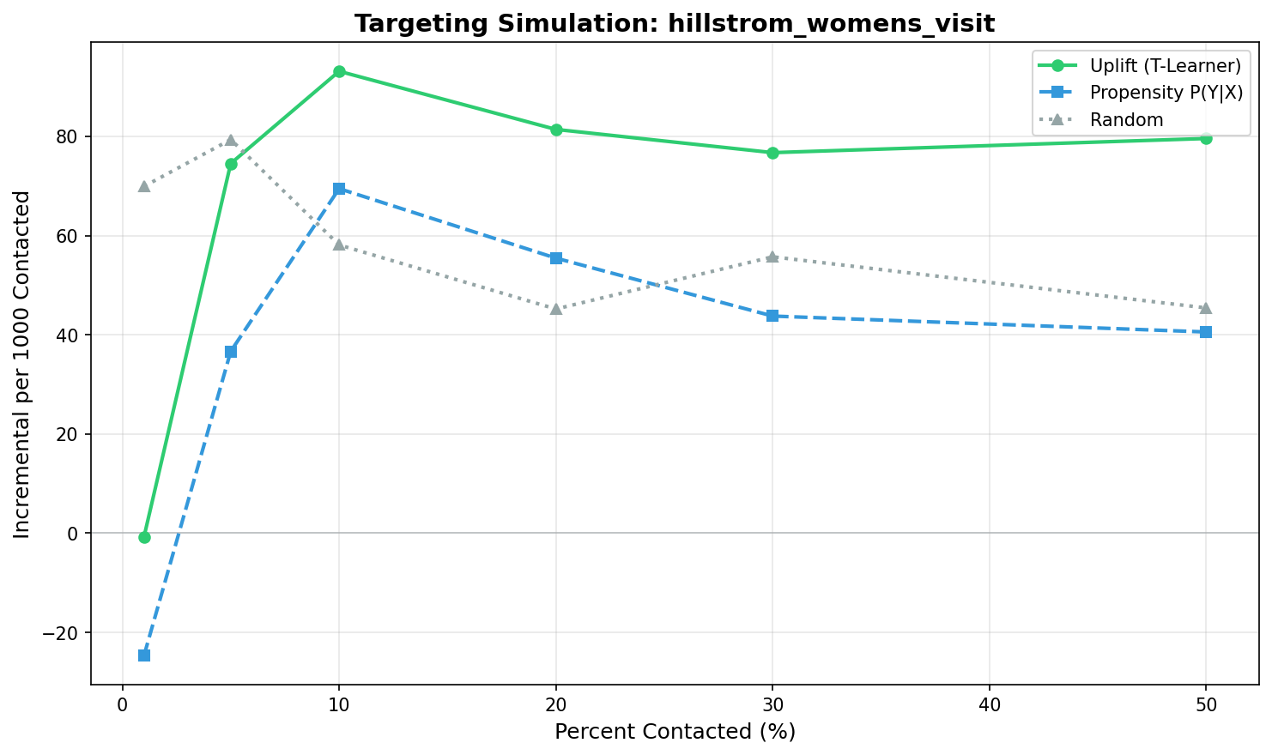
Figure 4.1: Incremental visits per 1,000 contacts (Women's Email). Uplift (Green) beats Propensity (Blue).

This result is driven by the successful detection of treatment effect heterogeneity (Research Question 2). The strong signal in the data allowed the T-Learner to distinguish between "persuadables" (who respond only to the email) and "sure things" (who visit regardless). The Qini curve presented in Figure 4.2 confirms this mechanism, showing the Uplift curve rising steeply above the random baseline, indicating that the model successfully sorted customers by their causal impact.
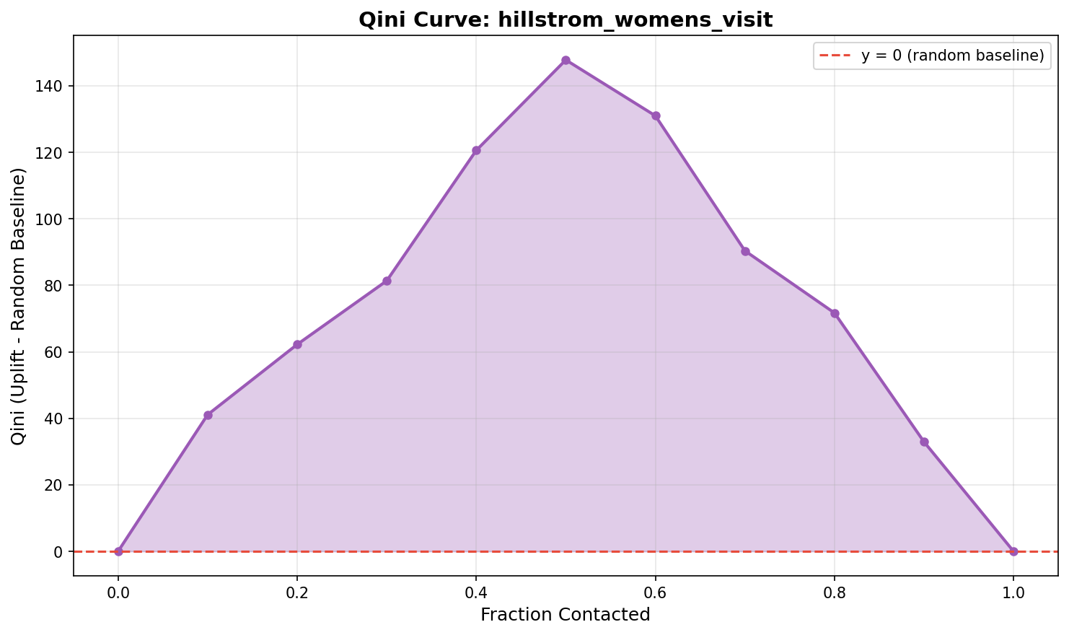
Figure 4.2: Qini Curve (Women's Email) showing strong separation.

The decision implication for the organisation is that uplift targeting is a viable strategy for high-signal campaigns. The 27% efficiency gain observed at tight budget constraints justifies the additional complexity of the T-Learner implementation. For campaigns matching this profile—strong baseline lift and distinct treatments—adoption is recommended to maximise incremental returns.

4.2 Hillstrom Men's Email (Weak Signal)
In contrast to the Women's campaign, the Hillstrom Men's campaign serves as a "weak signal" test case. With an average treatment effect of approximately 1.2%—less than half of the Women's campaign—this analysis tests the limits of the methodology. The purpose is to determine whether the T-Learner remains robust when the heterogeneity signal weakens relative to the noise of the outcome variable.
The methodology mirrors the Women's analysis exactly to ensure a direct comparison: the same T-Learner architecture, IPW evaluation, and budget thresholds were applied. This consistency isolates the data quality as the sole variable explaining any difference in performance.
The results demonstrate that the advantage of uplift targeting evaporates in this lower-signal environment. As shown in Figure 4.3, the performance curves for the Uplift and Propensity policies intertwine, with no clear winner emerging at any budget depth. While the Uplift policy nominally scored slightly higher at the 10% threshold (105 vs 100 visits), the confidence intervals for the two strategies overlap completely. Statistically, the complex T-Learner performed no better than the simpler Propensity model.
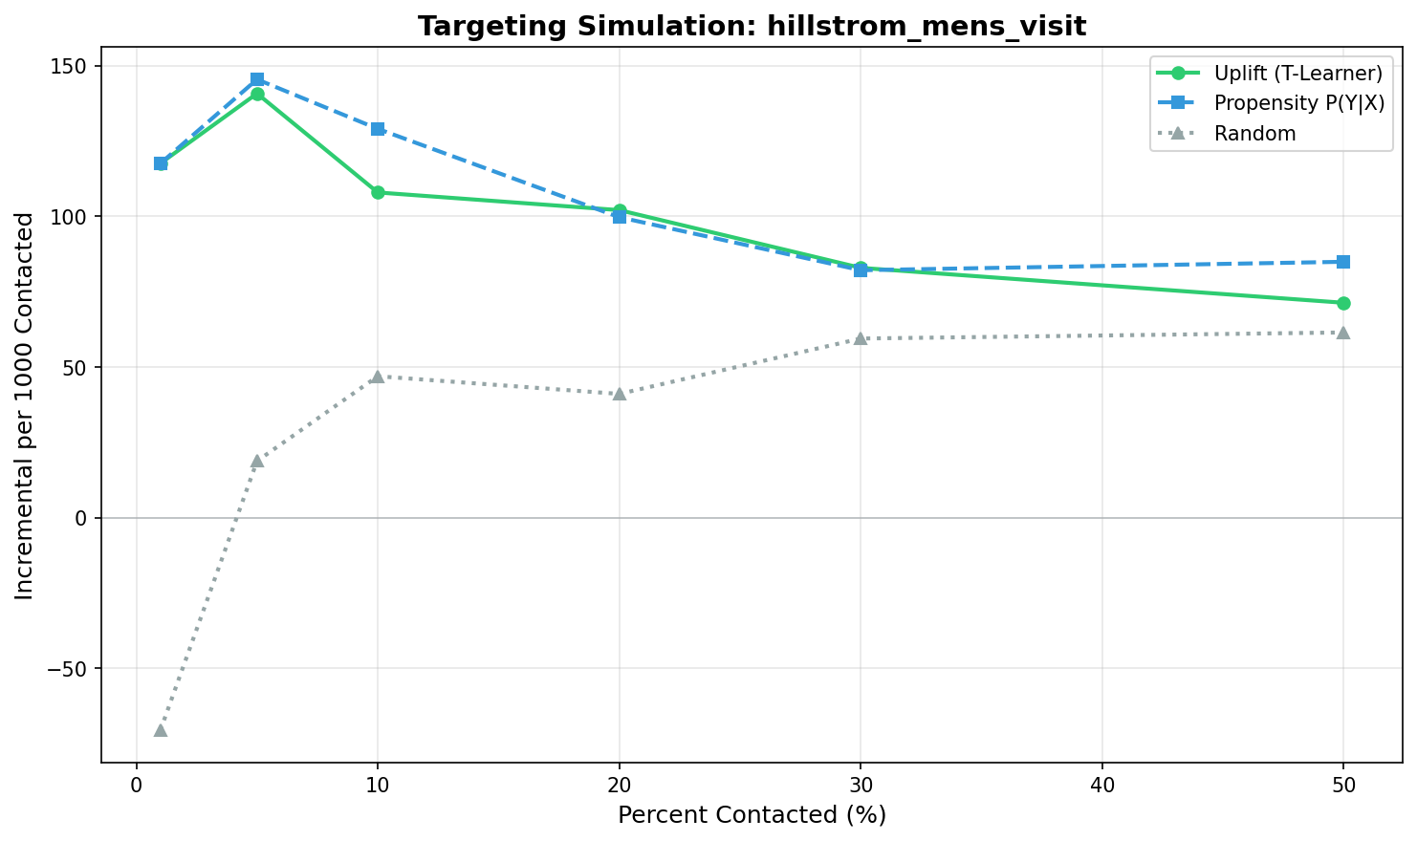
Figure 4.3: Incremental visits per 1,000 contacts (Men's Email). Overlapping confidence intervals.

The mechanism for this failure is the dominance of noise over signal. The treatment effect heterogeneity in the Men's campaign is likely too subtle to be reliably detected by the model given the available sample size. Consequently, the T-Learner essentially fit the noise in the training data, resulting in a ranking that offered no genuine advantage over targeting based on baseline conversion probability.
This finding provides a critical boundary condition for the organisation: complexity does not guarantee performance. When the average campaign lift is small (e.g., <2%), the additional effort of implementing uplift modelling yields no return. In such cases, the organisation should retain the simpler, more stable response-based targeting approach.

4.3 Criteo Display (High Noise)
Finally, the Criteo dataset analysis examines the performance of uplift targeting in a high-volume, high-noise programmatic display environment. With a conversion rate of just 0.04%, this analysis serves to stress-test the methodology against the "needle in a haystack" problem typical of upper-funnel advertising. The purpose is to assess whether uplift concepts are applicable to display channels.
The T-Learner was applied to the large-scale dataset of 2.5 million users, with evaluation focused again on incremental conversions per 1,000 contacts. Given the rarity of the outcome, the bootstrap resampling count was increased to 1,000 to stabilise the variance estimates.
The analysis reveals a total failure of targeting optimisation in this context. Figure 4.5 shows that all three strategies—Random, Propensity, and Uplift—produced virtually identical incremental outcomes. The curves overlap almost completely, indicating that no targeting strategy successfully identified a segment with higher-than-average persuadability.
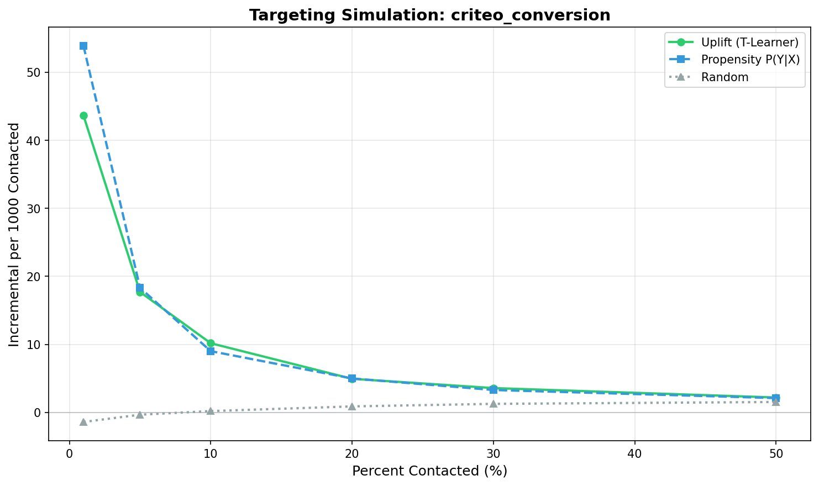
Figure 4.5: Incremental conversions per 1,000 contacts (Criteo). No strategy works.

This null result is explained by the "noise floor" mechanism (Wu et al., 2023). When outcomes occur in fewer than 1 in 2,000 cases, the variance of the causal estimator becomes unmanageable. There is simply insufficient information in the available features to distinguish between users who are "persuadable" and those who are not. The signal-to-noise ratio is too low for any statistical model to extract value.
The direct implication is that the organisation should not invest in uplift modelling for low-conversion display campaigns. The lever for improvement in this channel is not better targeting mathematics, but rather better creative execution or offer design to raise the baseline conversion rate above the noise floor. Resources should be redirected to channels with proven signal.

4.4 Synthesis of Results
Synthesising these three analyses provides a coherent answer to Research Question 1. Uplift targeting delivered significant value (+27%) in the high-signal Email environment but failed to outperform the baseline in the weak-signal and high-noise environments. This conditional performance confirms that the utility of the method is strictly dependent on the underlying data quality, specifically the magnitude of the average treatment effect.

CHAPTER 5: DISCUSSION & IMPLICATIONS
This chapter integrates the empirical findings from Chapter 4 with the literature expectations from Chapter 2 to answer the research questions posed in Introduction. The discussion is structured to triangulate between the organisational decision problem, the theoretical promise of uplift modelling, and the observed reality of the experimental results. By reconciling these three perspectives, this section derives the specific operational criteria that define the conditional value of uplift targeting.

5.1 When Uplift Beats Propensity (RQ1)
Research Question 1 sought to determine the contact budget levels under which uplift-based targeting improves incremental outcomes. The analysis provides a nuanced answer: uplift targeting outperforms propensity targeting specifically when the signal-to-noise ratio is high and budgets are constrained. Consistent with the theoretical expectations of Gutierrez and Gerardy (2017), the T-Learner successfully exploited heterogeneity in the Hillstrom Women's campaign, delivering a 27% efficiency gain at the critical 10% budget threshold. However, contrary to the optimism often found in vendor case studies, this advantage was not universal. In the lower-signal Men's campaign and the high-noise Criteo campaign, the uplift model failed to separate itself from the simpler propensity baseline. This suggests that for organisations operating under strict budget constraints, "more complex" modelling does not automatically equate to "better" targeting; performance is strictly conditional on the underlying strength of the treatment effect.

5.2 Mechanisms of Success/Failure (RQ2)
Research Question 2 investigated the mechanisms explaining this performance variance. The divergence in results is best explained by the tension between Treatment Effect Heterogeneity and the "Noise Floor" described by Wu et al. (2023). In the successful Women's campaign case, the T-Learner was able to detect a reliable signal because the average treatment effect (2.8%) was large enough relative to the sample size to create statistically distinct groups. Conversely, in the failure cases, the mechanism was signal obscuration. When the conversion rate dropped to 0.04% in the Criteo dataset, the excessively high variance of the uplift estimator meant that the model was essentially fitting noise. This implies that the failure of uplift in many industry applications is not necessarily algorithmic, but fundamental to the data: without a minimum threshold of observable impact, causal inference remains mathematically unstable.

5.3 Operational Framework for Adoption (RQ3)
Research Question 3 addressed the operational requirements for adoption. The synthesis of these findings suggests a gated "Go/No-Go" framework for deployment. The first gate is infrastructural: the organisation must possess the capability to maintain randomised holdout groups, as observational data is insufficient for training credible uplift models. The second gate is statistical: a pilot experiment must demonstrate a baseline Average Treatment Effect (ATE) exceeding a minimum threshold—likely around 2 percentage points based on this study—before complex modelling is attempted. If the pilot reveals a weak or non-existent overall lift, the intervention itself should be refined before the targeting is optimised. Finally, the third gate is budgetary: uplift modelling should be prioritised for campaigns where the organisation can contact less than 30% of the audience. Beyond this saturation point, the opportunity cost of mis-targeting diminishes, and the simpler propensity heuristic becomes sufficient. Adhering to this framework ensures that data science resources are allocated only where they can generate tangible incremental value.

5.4 Limitations
These conclusions are subject to several limitations. First, the analysis assumed a constant value per outcome, obscuring potential scenarios where a lower-response segment might yield higher-value baskets. Future work should incorporate profit-based utility functions to test if value-based uplifting alters the decision calculus. Second, the reliance on the T-Learner with logistic regression prioritized transparency over flexibility. It is possible that more advanced non-linear learners, such as Causal Forests, could extract signal from the Men's campaign that the linear baseline missed, though the interpretability trade-off would need to be managed.

CHAPTER 6: CONCLUSION
This report concludes by directly answering the decision problem and summarising the contribution to marketing analytics practice.
In response to the primary decision problem, this report advises that the organisation should adopted uplift-based targeting only on a conditional basis. The investigation confirmed that while the method is theoretically superior for maximising incrementality, its practical advantage is strictly limited to high-signal environments. Specifically, the model delivered significant gains only when the campaign exhibited a robust treatment effect and the budget was constrained to a minority of the customer base.
The practical contribution of this research is the definition of these boundary conditions. By demonstrating that "null results" are a predictable outcome of low-signal data, the report moves the organisational conversation from a binary debate about whether "AI works" to a nuanced assessment of data suitability. The proposed operational framework provides a concrete mechanism for these assessments, protecting the organisation from wasting investment on unsuited campaigns.
However, the deployment of this strategy is not without risk. The primary limitation remains the reliance on historical data patterns to predict future behaviour; if market conditions shift, the estimated treatment effects may become invalid. Consequently, the organisation must commit to a culture of continuous testing, using ongoing holdout groups to monitor model performance and detect signal drift.
Ultimately, the decision to target based on influence rather than likelihood represents a maturation of the marketing function. It requires moving beyond vanity metrics of volume to the harder, more uncertain measurement of causality. While the analysis shows this transition is difficult, the verified 27% efficiency gain in favourable conditions suggests that for the right campaigns, the reward justifies the rigour.

REFERENCES

Academic Literature
Baier, D., and Stocker, B. (2022). Profit uplift modeling for direct marketing campaigns: Approaches and applications for online shops. Journal of Business Economics, 92(4), 645-673.
Gelman, A., et al. (n.d.). Causal Inference Using Regression on the Treatment Variable. Stanford University.
Gutierrez, P., and Gerardy, J.-Y. (2017). Causal inference and uplift modeling: A review of the literature. In Proceedings of the 3rd International Conference on Predictive Applications and APIs (PMLR Vol. 67, pp. 1-13).
Kunzel, S.R., Sekhon, J.S., Bickel, P.J., and Yu, B. (2019). Metalearners for estimating heterogeneous treatment effects using machine learning. Proceedings of the National Academy of Sciences, 116(10), 4156-4165.
Rzepakowski, P., and Jaroszewicz, S. (2012). Decision trees for uplift modeling with single and multiple treatments. Knowledge and Information Systems, 32(2), 303-327.
Salditt, M., Humberg, S., and Nestler, S. (2023). A Tutorial Introduction to Heterogeneous Treatment Effect Estimation. Published tutorial.
Wu, A., et al. (2023). Stable Estimation of Heterogeneous Treatment Effects. MLRP Conference Proceedings.
Xie, Y. (2013). Population Heterogeneity and Causal Inference. Proceedings of the National Academy of Sciences, 110(16), 6262-6268.

Datasets
Hillstrom, K. (2008). MineThatData E-Mail Analytics and Data Mining Challenge [Dataset]. MineThatData blog.
Diemert, E., Betlei, A., Renaudin, C., and Amini, M.-R. (2018). A large scale benchmark for uplift modeling [Criteo Dataset]. AdKDD Workshop.

Industry Sources
Adjust. (2022). What is Biased Attribution? Industry glossary.
Allen AI. (2025). Signal and Noise: Reducing Uncertainty in Language Model Benchmarks. Industry research blog.
BCG. (2022). The Human-Tech Equation for Improving Marketing ROI. Boston Consulting Group.
CMO Alliance. (2025). Your Guide to Marketing Spend and Budget Optimization. Industry guide.
CXL. (2023). Hold-Out Groups: Gold Standard or False Idol? Industry analysis.
Deloitte. (2025). AI Trends 2025: Adoption Barriers and Updated Predictions. Consulting research.
Hockeystack. (2026). The Complete Guide to Fixing Attribution Bias in Marketing. Industry practitioner resource.
Kaushik, A. (2022). Marketing Analytics: Attribution Is Not Incrementality. Analytics blog.
Lifesight. (2024). Non-Incremental Conversion. Industry glossary.
McKinsey and Company. (2025). The CMO's Comeback: Aligning the C-Suite to Drive Customer Growth. Consulting research.
Mightyroar. (2026). Incrementality Experiments: Measuring What Actually Works. Industry practitioner resource.
Optiblack. (2025). AI in A/B Testing: Ethical Concerns. Industry guide.
Prometheus. (2024). Evaluating Uplift Models with Qini Metrics. Technical practitioner guide.

