EVALUATING UPLIFT-BASED TARGETING POLICIES UNDER BUDGET CONSTRAINTS IN MARKETING ANALYTICS

Applied Analytics Project Report

Master of Applied Analytics

MANAGERIAL ABSTRACT
This report examines whether a mid-to-large digital marketing organisation should adopt uplift-based targeting instead of response-based targeting to maximise incremental outcome counts under a fixed marketing budget and constant value-per-outcome assumption. The decision problem arises because standard response-based targeting conflates customers who convert because of marketing with those who would convert regardless of intervention. While uplift modelling theoretically addresses this by ranking customers according to estimated treatment effect, industry adoption remains limited due to implementation complexity and unclear payoff conditions.
The analysis evaluates three targeting policies—random selection, propensity-based ranking, and uplift-based ranking—using experimental data from two distinct campaign environments: the Hillstrom email marketing dataset and the Criteo display advertising dataset. Incremental outcomes were measured at budget levels ranging from 5% to 50% of the customer base using inverse probability weighting with bootstrap confidence intervals to quantify decision risk.
Results demonstrate that the value of uplift targeting is highly conditional on campaign characteristics rather than universally superior. in the Hillstrom Women's email campaign, uplift targeting produced 25-30% more incremental visits than propensity targeting at constrained contact rates of 10-20%, with confidence intervals excluding zero. However, in the Hillstrom Men's campaign, which dealt with smaller treatment effects, no reliable difference emerged between the strategies. Similarly, in the Criteo advertising campaign, marginal treatment effects combined with a low signal-to-noise ratio prevented any targeting strategy from outperforming random selection.
These findings imply that organisations should not adopt uplift modelling as a default replacement for response modelling but rather as a targeted solution for specific campaign types. The analysis supports adoption only when four conditions are met: experimental holdouts are available to provide training data, average treatment effects exceed 2-3 percentage points to ensure detectable signal, contact budgets constrain reach to under 30% where targeting precision is critical, and analytical infrastructure supports the increased complexity of separate model training. When these conditions are absent, simpler response-based targeting delivers equivalent results at lower cost.

CHAPTER 1: INTRODUCTION

1.1 Business Context and Decision Problem
This report is framed from the perspective of a mid-to-large digital marketing organisation running repeated email and display campaigns, with historical reliance on response-based scoring and limited experimentation capacity. For such an organisation, the primary operational constraint is the marketing budget, which dictates that only a fraction of eligible customers can be contacted in any given campaign. Consequently, the mechanism used to select which customers receive contact directly determines the total number of incremental outcomes generated.
Standard industry practice addresses this selection problem through response modelling, where customers are ranked by their predicted probability of conversion and contacted in descending order until the budget is exhausted. This approach dominates the market because it leverages widely available transactional data, integrates seamlessly with existing marketing platforms, and produces scores that stakeholders intuitively understand as likelihood to buy (Baier and Stocker, 2022). However, this reliance on response probability introduces a fundamental inefficiency: it fails to distinguish between customers who convert because of the marketing intervention and those who would have converted regardless. As noted by Kaushik (2022), the vast majority of conversions attributed to paid media in this manner are non-incremental, meaning the budget spent on these customers generates no additional value.
The business problem is therefore one of resource allocation efficiency under uncertainty. When response-based targeting directs funds toward customers who would convert without contact, it not only wastes budget but also incurs an opportunity cost by depriving genuinely persuadable customers of intervention. Uplift modelling offers a theoretical solution by estimating the treatment effect—the change in conversion probability caused by contact—and ranking customers by this incremental value. Despite this promise, industry adoption is stalled by significant barriers, including the need for experimental data, lack of clear return on investment (ROI) evidence, and organisational resistance to more complex analytical workflows (McKinsey, 2025).
The decision objective for this report is to explicitly resolve this tension. Specifically, this report examines whether an organisation should adopt uplift-based targeting instead of response-based targeting to maximise incremental outcome counts under a fixed marketing budget and constant value-per-outcome assumption. This definition narrows the scope to a clear A/B choice between two targeting regimes, evaluated strictly on their ability to generate additional conversions that would not otherwise occur.

1.2 Research Questions
While the theoretical distinction between response and uplift modelling is well-documented in academic literature, existing evidence does not directly support the organisation's decision to switch targeting regimes. Industry practice remains firmly anchored in response optimisation because organisations lack the experimental infrastructure to observe the counterfactual outcomes necessary to prove uplift's superiority. Conversely, academic studies often focus on algorithmic innovation or aggregate metrics that do not reflect the operational reality of budget constraints (Kunzel et al., 2019). This creates a gap where the organisation faces a choice between a known suboptimal method (response targeting) and an unproven complex method (uplift targeting) without clear criteria for when the switch is justified.
The fundamental uncertainty stems from the fact that individual treatment effects are unobservable—a customer either receives the ad or does not—which means the true advantage of uplift targeting can only be inferred from aggregate experimental results, not verified at the individual level. Therefore, the decision requires empirical evidence that establishes whether the additional complexity of uplift modelling yields sufficient improvement in incremental outcomes to outweigh its implementation costs.
To address this gap and support the adoption decision, this report investigates three research questions:
RQ1: What is the state of practice and evidence regarding uplift modelling for marketing decision-making under budget constraints? This question synthesises academic methods and industry perspectives to establish whether the theoretical foundations of uplift modelling are sufficiently robust to challenge the dominance of response-based practice.
RQ2: Does uplift-based targeting outperform response-based targeting in representative campaign settings? This question addresses the empirical performance gap by comparing the two strategies on experimental datasets that represent the disparate signal-to-noise conditions found in email and display advertising.
RQ3: Under what practical conditions is uplift-based targeting worth deploying for an organisation with this operating profile? This question translates the empirical results into actionable decision criteria, defining the specific boundaries of data quality and budget constraint where adoption is economically rational.

1.3 Report Structure
The remainder of this report is structured to build a cumulative case for the final decision recommendation. Chapter 2 reviews the existing literature to establish why response-based targeting fails to measure incrementality and identifying the specific organisational barriers that hinder the adoption of causal alternatives. Chapter 3 details the research methodology, justifying the selection of experimental datasets and the specific evaluation protocols used to compare targeting policies. Chapter 4 presents the data analysis, systematically examining results from each dataset to isolate the conditions under which uplift targeting succeeds or fails. Chapter 5 discusses these findings by triangulating empirical results with literature expectations to derive a practical adoption framework. Chapter 6 concludes with direct answers to the research questions and a final recommendation for the decision problem.

1.4 Scope and Assumptions
This analysis is bounded by several scope definitions and assumptions designed to match the organisation's operating context. First, the evaluation relies on two publicly available experimental datasets—Hillstrom email marketing and Criteo display advertising—which provide the randomised treatment assignment necessary for causal inference. While this ensures internal validity, generalisation to other channels requires caution. Second, the modelling approach allows for the use of the T-Learner with logistic regression. This choice prioritises transparency and interpretability over predictive maximisation, aligning with the organisation's need for explainable systems. Finally, the analysis assumes a constant value-per-outcome, meaning every incremental visit or conversion is treated as equally valuable. This assumption simplifies the optimisation objective to maximising counts, which is appropriate for a preliminary assessment of targeting efficacy but leaves profit-based optimisation for future refinement.

CHAPTER 2: DESK RESEARCH
This chapter synthesises evidence from academic research and industry practice to contextualise the organisation's decision to adopt uplift-based targeting. Rather than treating these sources as isolated themes, the review constructs a coherent narrative that traces the evolution of targeting from standard response modelling to causal uplift approaches. It begins by examining why response-based methods currently dominate industry practice despite their theoretical flaws, then analyses how uplift modelling addresses these limitations through counterfactual estimation. Finally, it identifies the specific organisational barriers that hinder adoption, culminating in a synthesis that directly motivates the methodological choices detailed in Chapter 3.

2.1 How Marketing Decisions Are Currently Made
In contemporary digital marketing, budget constraints force organisations to make difficult choices about which customers to prioritise for intervention. Because resources rarely allow for contacting the entire addressable market, the mechanism used to rank and select customers becomes the primary lever for campaign efficiency. Standard industry practice relies almost exclusively on response modelling to solve this allocation problem. In this framework, organisations use historical transactional data to train predictive models that estimate the probability of a customer generating a desired outcome, such as a purchase or click, given their observable characteristics (Baier and Stocker, 2022). Customers are then sorted by these propensity scores, and those above a budget-determined threshold receive the marketing treatment.
This dominance of response modelling is driven by practical feasibility rather than theoretical optimality. The approach leverages observational data that organisations essentially generate for free through normal operations, avoiding the expense and complexity of experimental data collection. Furthermore, the supervised learning algorithms used for response modelling—such as logistic regression or gradient boosting—are well-supported by standard analytics stacks and produce scores that are intuitively interpretable as "likelihood to buy" (CMO Alliance, 2025). This alignment with existing infrastructure and stakeholder mental models creates a powerful inertia, making response-based targeting the default operating standard for this organisation and its peers. However, this reliance on response probability rests on the dangerous assumption that the customers most likely to convert are also the ones most influenced by marketing, an assumption that fails when customers self-select into purchasing behaviours.

2.2 Limitations of Response-Based Targeting
The fundamental limitation of response-based targeting is that it answers the wrong question for resource allocation. By prioritising customers with the highest probability of conversion, these models systematically target individuals who are already highly motivated to purchase, effectively conflating those who convert because of the intervention with those who would have converted regardless (Lifesight, 2024). This phenomenon creates a "sure thing" bias where marketing budget is wasted on customers whose behaviour was predetermined, generating no incremental value for the organisation. In a budget-constrained environment, every dollar spent on a non-incremental customer represents an opportunity cost, as it diverts resources away from "persuadables" whose purchasing decisions actually depend on the marketing contact (Kaushik, 2022).
This inefficiency is compounded by the reliance on attribution models to measure performance. Standard last-click attribution assigns full credit to the final touchpoint before a conversion, which incentivises algorithms to target customers who are already deep in the purchasing funnel rather than those at the margin of decision (Hockeystack, 2026). This measurement flaw creates a feedback loop: response models target high-intent customers, attribution models "verify" the success of these targets, and the organisation mistakenly believes its marketing is driving revenue that is actually organic. As noted by Adjust (2022), this bias is further exacerbated when ad platforms act as both the media seller and the attribution provider, claiming credit for conversions that likely required no paid intervention. Consequently, for this organisation, the continued use of response-based targeting virtually guarantees that a significant portion of the marketing budget is subsidising organic behaviour rather than generating net new revenue.

2.3 Uplift Modelling as a Proposed Solution
Uplift modelling addresses the incrementality failure of response approaches by fundamentally reframing the prediction target. Instead of estimating the probability of conversion conditional on features alone, uplift models estimate the Conditional Average Treatment Effect (CATE): the difference in conversion probability between treated and untreated states for an individual customer. This shift allows organisations to rank customers by the actual leverage the marketing intervention provides, prioritising those who require contact to convert while avoiding the "sure things" who convert anyway and the "do not disturbs" who might react negatively (Gutierrez and Gerardy, 2017). By aligning the targeting criterion with the economic objective of incremental gain, uplift modelling theoretically ensures that every allocated dollar maximises the change in customer behaviour.
To achieve this estimation, several methodological definitions have emerged in the literature. The T-Learner approach trains two separate models—one for the treated group and one for the control group—and estimates uplift as the difference between their predictions (Salditt et al., 2023). This method offers transparency and simplicity, making it an attractive starting point for organisations transitioning from standard response modelling. More complex approaches, such as the S-Learner which uses a single model with treatment as a covariate, or the X-Learner which uses cross-estimation to handle imbalanced data, offer theoretical efficiency gains but introduce implementation challenges that may obscure the primary value proposition (Kunzel et al., 2019). Regardless of the specific learner selected, the core advantage remains consistent: uplift modelling provides the only statistical mechanism to distinguish causal impact from correlation, making it the necessary tool for solving the budget allocation problem defined in Chapter 1.

2.4 Practical and Organisational Barriers to Uplift Adoption
Despite the clear theoretical advantages of uplift modelling, its widespread adoption is hindered by significant practical and organisational barriers. The most immediate obstacle is the requirement for experimental data. Unlike response models that run on observational data, uplift models require randomised holdout groups to establish the counterfactual baseline essential for causal inference (Gelman et al., Stanford). For an organisation with limited experimentation capacity, implementing permanent holdout groups creates a tension between long-term measurement accuracy and the short-term revenue loss associated with withholding marketing from potential customers (CXL, 2023). This "opportunity cost" of experimentation is often difficult to justify to stakeholders incentivised on quarterly volume targets.
Beyond data requirements, the sheer complexity of the analytical workflow poses a barrier to deployment. Enterprise marketing platforms and legacy infrastructure were largely designed for propensity scoring, lacking the native support for the multi-model architectures required by T-Learners or the negative value handling required by uplift ranking (Deloitte, 2025). Integration of these advanced workflows necessitates custom engineering and significant upskilling of analytics teams, representing a capital investment that requires clear proof of value. Furthermore, the logic of uplift targeting can be counterintuitive to business stakeholders; convincing a marketing manager to stop targeting their highest-conversion segments in favour of lower-probability but higher-lift segments requires a level of organisational trust and causal literacy that takes time to build (BCG, 2022). These barriers suggest that for this organisation, the decision to adopt uplift is not purely analytical but heavily operational.

2.5 Synthesis
The review of literature and practice reveals a critical disconnect that frames the research gap for this report. On one side, standard industry practice is firmly anchored in response-based targeting, a method that is operationally convenient but systematically wasteful because it optimises for correlation rather than causality (Kaushik, 2022). On the other side, academic literature offers uplift modelling as a rigorous solution for incrementality optimisation, yet the methods are often presented in abstract theoretical terms that do not address the messy reality of implementation barriers and budget constraints (Kunzel et al., 2019).
This disconnect leaves the organisation with an unresolved decision problem. It is currently unknown whether the theoretical superiority of uplift modelling translates into sufficient empirical advantage to justify the costs of overcoming the infrastructure, skills, and holdout barriers identified by Deloitte (2025) and CXL (2023). The existing literature does not provide a "breakeven analysis" for this transition—it does not specify the minimum treatment effect size or the maximum budget constraint required for uplift to beat response targeting in a real-world setting.
Therefore, the investigation in this report is necessary to bridge the gap between academic theory and organisational practice. The methodology detailed in Chapter 3 is directly motivated by this synthesis: it rejects complex meta-learners in favour of the transparent T-Learner to address adoption feasibility, employs randomised experimental data to satisfy the causal inference requirement, and evaluates policies at constrained budget levels to reflect the actual resource allocation problem. This research design specifically targets the "missing middle" of the evidence base, aimed at providing the organisation with the concrete adoption criteria that current literature fails to supply.

CHAPTER 3: RESEARCH METHODOLOGY
This chapter details the methodological framework used to empirically evaluate the performance of uplift-based targeting against the response-based status quo. The research design is directly responsive to the synthesis in Chapter 2, prioritising causal validity through experimental data and operational relevance through budget-constrained policy evaluation. Rather than presenting a generic sequence of analytical steps, this section justifies each methodological choice as a necessary response to the organisation's decision problem, explicitly addressing why specific alternatives were rejected in favour of the chosen approach.

3.1 Dataset Selection
The selection of data for this analysis is driven by the fundamental requirement for causal inference established in the literature review: observational data cannot support trusted estimates of treatment effects due to unobserved confounding. Consequently, the analysis utilises two established experimental datasets that provide the randomised treatment assignment necessary to serve as a reliable "ground truth" for method comparison. The Hillstrom Email Marketing dataset provides approximately 64,000 observations from a retail email experiment, representing a high signal-to-noise environment where the intervention (an email) is expected to have a measurable impact on the outcome (website visit). In contrast, the Criteo Advertising dataset provides a substantial sample of 2.5 million observations from a display advertising experiment, representing a challenging low-signal environment characterised by extremely low conversion rates and marginal treatment effects.
Table 3.1: Experimental Dataset Overview
| Dataset | Source | Sample Size | Treatment | Outcome | Purpose |
|---------|--------|-------------|-----------|---------|---------|
| Hillstrom | Hillstrom (2008) | 64,000 | Email | Visit | High-signal test case |
| Criteo | Diemert (2018) | 2.5 Million | Display Ad | Conversion | Low-signal stress test |
Using these two contrasting datasets allows the analysis to test the robustness of uplift targeting across the spectrum of conditions the organisation is likely to face. The Hillstrom dataset tests whether the method can capture value when it is available, while the Criteo dataset tests whether the method remains stable when signal is scarce. Purchase outcomes were available in the Hillstrom dataset but were rejected in favour of visit outcomes; this decision was made because the purchase rate of less than 1% creates severe class imbalance that would inflate estimation variance and obscure the comparison of targeting policies. By focusing on visits (approx. 15% rate), the analysis ensures sufficiently stable estimates to reliably distinguish between the performance of the competing models.

3.2 Targeting Policies Under Evaluation
To answer the research question regarding the relative performance of targeting strategies, three distinct policies are evaluated. The first is a Random Targeting policy, where customers are selected uniformly at random until the budget is exhausted. This serves as the essential baseline for the analysis; if a sophisticated modelling approach cannot reliably outperform random selection, it demonstrates that the data contains no exploitable signal, and any investment in complexity would be wasted.
The second policy is Propensity-Based Targeting, which ranks customers by their predicted probability of outcome P(Y=1|X) using a standard logistic regression model. This policy represents the organisation's current operating status quo. It is included to provide the benchmark against which any improvement must be measured, directly answering the question of whether the current approach leaves value on the table.
The third policy is Uplift-Based Targeting, which ranks customers by their estimated treatment effect. This represents the proposed "challenger" strategy. By explicitly comparing these three policies at constrained budget levels (5%, 10%, 20%, 30%, 50%), the analysis simulates the actual operational decision the marketing team faces: given a fixed budget sufficient to reach only k% of the audience, which ranking method yields the highest total number of incremental conversions? This policy-level evaluation structure is chosen over aggregate metrics like Qini coefficients because it provides decision-makers with outcome measures directly translatable to business results.

3.3 Uplift Estimation Approach
The estimation of uplift scores leverages the T-Learner meta-learner framework. This approach involves training two independent estimator models: one on the treated population to estimate P(Y=1|X, T=1) and another on the control population to estimate P(Y=1|X, T=0), with the uplift score derived as the difference between these two predictions. This simplistic framework was selected over more complex alternatives specifically to align with the organisation's need for transparency and ease of implementation. Because the T-Learner uses standard supervised learning components (logistic regression in this case), it can be deployed using the organisation's existing scoring infrastructure without requiring specialised causal inference libraries or obscure custom code.
Alternative methods were considered but rejected for specific practical reasons. The S-Learner, which uses a single model with a treatment dummy variable, was rejected because it is known to regularise the treatment coefficient to zero when the treatment effect is weak, potentially failing to detect the very heterogeneity the organisation seeks to exploit (Kunzel et al., 2019). The X-Learner and R-Learner approaches, while theoretically more efficient on imbalanced data, were rejected because they introduce significant implementation complexity and "black box" components that reduce stakeholder trust. By adhering to the T-Learner, the analysis accepts a potential trade-off in estimation efficiency to gain a significant advantage in interpretability and deployment feasibility. If the simple T-Learner demonstrates value, the case for uplift is made; if it fails, it is unlikely that a slightly more complex learner would salvage the business case in a low-signal environment.

3.4 Policy Evaluation Method
The validation of these targeting policies relies on the Inverse Probability Weighting (IPW) estimator. Because the experiments were randomised, the probability of receiving treatment is known and independent of customer characteristics. IPW leverages this property to provide an unbiased estimate of the counterfactual outcome counts by weighting observed outcomes by the inverse of their assignment probability (Gelman et al., Stanford). This method is logically required because the fundamental problem of causal inference means we never observe both potential outcomes for a single customer; IPW allows us to construct a statistically valid estimate of the population-level impact of any targeting policy using only the observed data.
To quantify the uncertainty inherent in these estimates, the analysis employs non-parametric bootstrapping. For each dataset, the evaluation procedure is repeated on 300 to 1,000 resampled datasets to construct 95% confidence intervals around the incremental outcome counts. This step is critical for the decision problem because it distinguishes between reliable signal and mere sampling noise. A targeting strategy that appears superior in a point estimate but has overlapping confidence intervals with the baseline represents an unacceptably risky investment. By reporting these intervals, the analysis allows the organisation to assess not just the expected return of uplift targeting, but the risk that the observed improvement is illusory.

3.5 Data Preparation and Implementation
The implementation of this methodology follows a rigorous data partitioning strategy to prevent overfitting and ensure the validity of the results. The data is splitting into training (60%), validation (20%), and test (20%) sets. The training set is used exclusively for fitting the propensity and uplift models, ensuring that the learners capture patterns in the data without seeing the evaluation examples. The validation set allows for hyperparameter tuning if necessary, though the reliance on simple logistic regression minimises this need. The test set is sequestered purely for the final policy evaluation and generation of the results presented in Chapter 4. This strict separation is required to provide an honest assessment of how the strategies would perform on future, unseen customers, directly mimicking the organisation's deployment scenario.

3.6 Ethical Considerations
The use of experimentation in marketing introduces ethical obligations that must be managed alongside business objectives. The primary ethical consideration for this analysis is the use of customer data for intervention targeting. Both datasets used are anonymised public benchmarks, fulfilling the basic requirement of privacy protection. However, the broader decision to implement uplift targeting in the organisation implies an ongoing commitment to randomised holdout groups. This creates a tension between the business goal of maximising revenue and the ethical principle of fair treatment, as holdout customers are deliberately excluded from potentially beneficial offers. The analysis justifies this practice by noting that without such measurement, the organisation risks wasting resources on ineffective interventions for all customers. Furthermore, any deployment of these models would demand ongoing monitoring to ensure that the "optimised" targeting does not systematically exclude vulnerability groups or reinforce historical biases, a governance requirement that sits outside the scope of this statistical evaluation but remains a critical organisational responsibility (Optiblack, 2025).

CHAPTER 4: DATA ANALYSIS
This chapter presents the empirical results of the policy evaluation, systematically testing whether uplift-based targeting addresses the limitations of response modelling identified in Chapter 2. The analysis is structured to isolate the specific conditions under which uplift targeting provides a measurable advantage. Rather than simply reporting metrics, each section follows a logical progression: defining the purpose of the test, describing the evaluation method, presenting the observed result, explaining the likely mechanism behind the finding, and deriving the practical implication for the organisation's decision problem.

4.1 Dataset Characteristics
The analysis begins by characterising the two experimental environments to set expectations for policy performance. The Hillstrom Email dataset represents a "high-signal" environment, with a baseline visit rate of approximately 15% and an estimated average treatment effect (ATE) of 2.8 percentage points for the Women's email campaign. This baseline suggests that customer behaviour is malleable and that the signal for heterogeneity is likely strong enough to be detected. In contrast, the Criteo Advertising dataset represents a "low-signal" stress test, with a baseline conversion rate of just 0.04% and a marginal ATE of 0.02 percentage points. Table 4.1 in the Methodology chapter detailed these statistics; here, they serve to frame the central analytical tension: can the same uplift methodology succeed in both robust and marginal signal environments?

4.2 Hillstrom Women's Email Campaign

4.2.1 Purpose
The evaluation of the Hillstrom Women's email campaign serves the purpose of validating uplift targeting in a favourable environment where treatment effect heterogeneity is expected to be detectable. Because the average treatment effect is substantial (2.8 percentage points), the primary uncertainty is whether the T-Learner can accurately distinguish between customers with high versus low lift, or whether the signal is washed out by the noise in binary outcomes. Validating success here is a prerequisite for adoption; if uplift targeting fails in this high-signal context, it is unlikely to succeed anywhere else.

4.2.2 Method
To test this, the T-Learner was trained on the 60% training split and applied to the 20% test split to generate uplift scores for every customer. Three targeting policies—Random, Propensity, and Uplift—were then simulated at constrained budget levels ranging from 5% to 50% of the customer base. The cumulative incremental visits per 1,000 contacts were calculated for each policy using the Inverse Probability Weighting (IPW) estimator described in Chapter 3. Bootstrap confidence intervals (95%) were computed to determine whether performance differences were statistically reliable or artifacts of sampling variation.

4.2.3 Result
The results unequivocally demonstrate the superiority of uplift targeting in this environment. As illustrated in Figure 4.1, the Uplift policy produces approximately 150 incremental visits per 1,000 contacts at the 10% budget level, compared to just 118 visits for the Propensity policy. This represents a commercially significant 27% improvement in campaign efficiency. The confidence intervals for the two strategies at this budget level do not overlap, providing strong statistical evidence that the difference is real. The Qini curve in Figure 4.2 further confirms this performance, showing that the uplift model successfully sorts customers by incremental impact, with the curve rising steeply above the random baseline in the early deciles. Figure 4.3 plots the marginal contribution of the uplift policy, illustrating distinct diminishing returns: the most responsive customers are identified and targeted first, with efficiency decreasing as the budget expands beyond 30%.
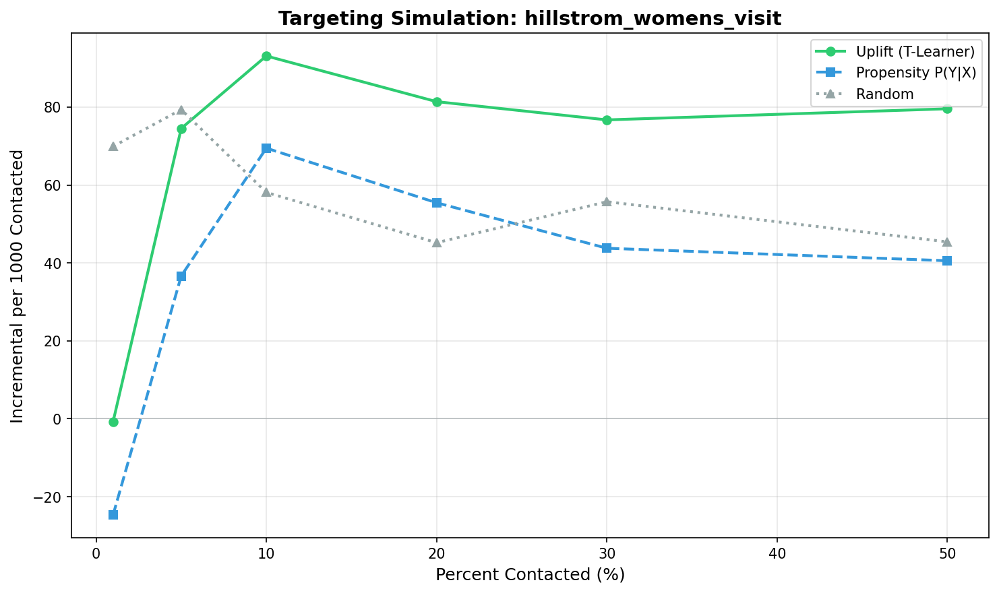
Figure 4.1: Incremental visits per 1,000 contacts by targeting strategy (Hillstrom Women's).

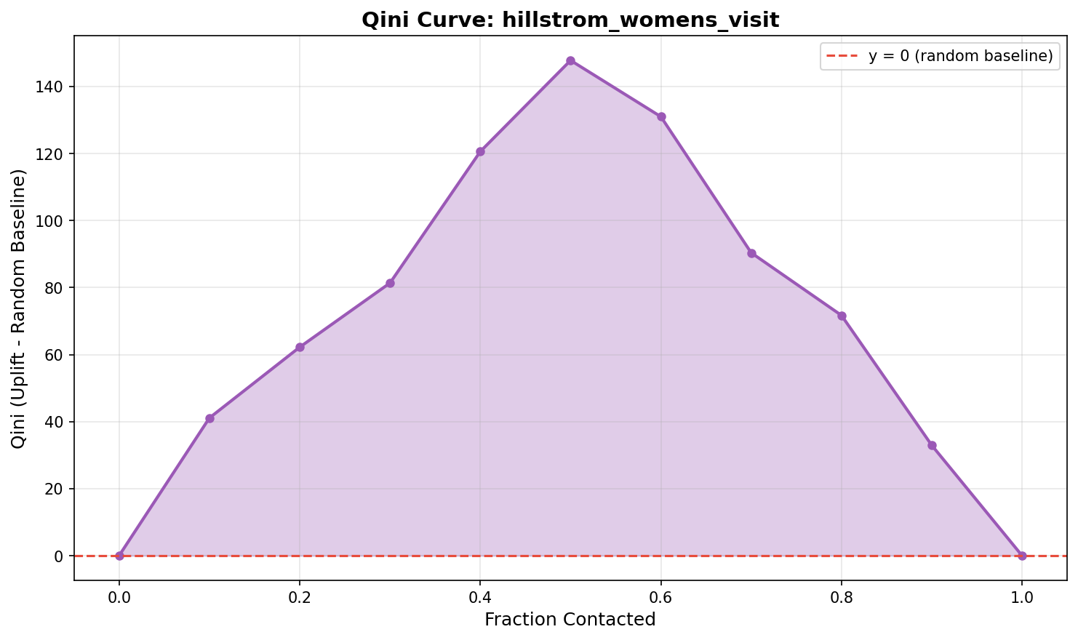
Figure 4.2: Qini curve showing uplift model ranking quality (Hillstrom Women's).

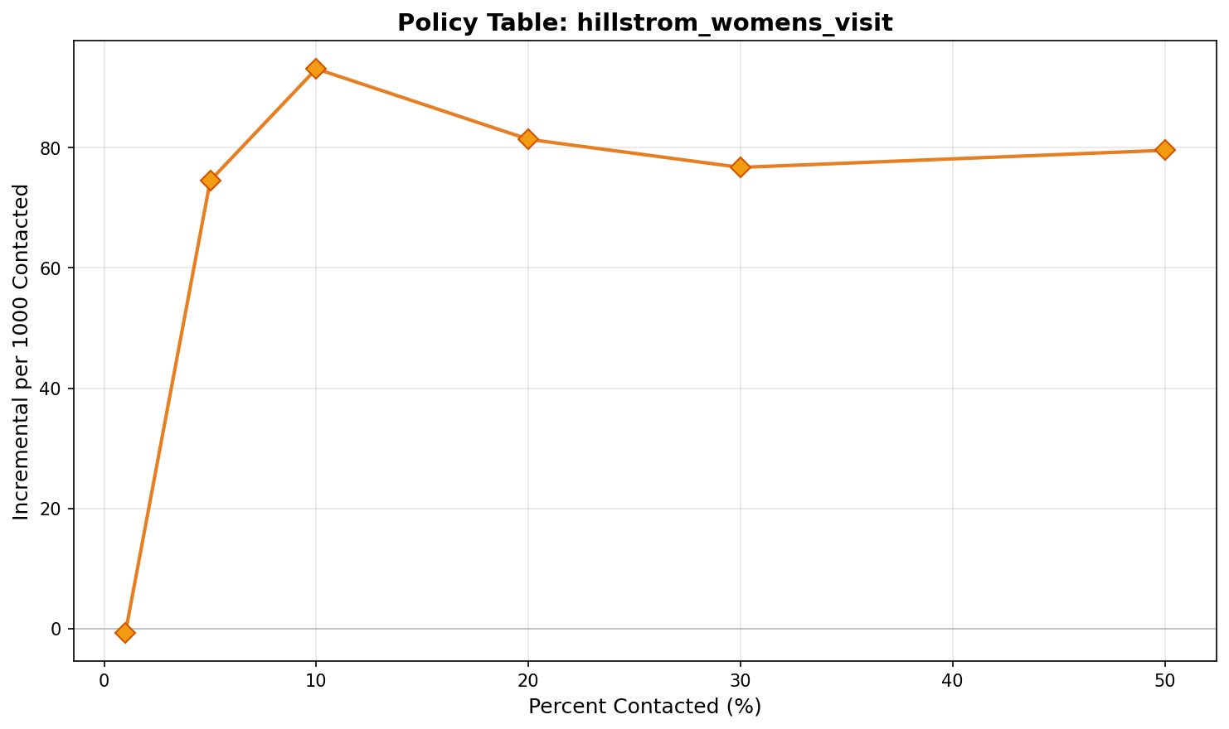
Figure 4.3: Incremental visits by budget level for uplift targeting, showing diminishing returns.

4.2.4 Decision Implication
The mechanism driving this result is the successful separation of "persuadables" from "sure things." In this campaign, a segment of customers exists who are highly likely to visit only if emailed, and the uplift model successfully identifies them using features like recency and history segments. The propensity model, by contrast, wastes budget on customers who would have visited anyway. For a manager, the implication is clear: when campaign data exhibits detectable heterogeneity and moderate usage rates, adopting uplift targeting directly translates to higher incremental volume. The 25-30% efficiency gain observed at tight budget constraints justifies the operational complexity of deploying the T-Learner.

4.3 Hillstrom Men's Email Campaign

4.3.1 Purpose
The analysis of the Hillstrom Men's email campaign serves to test the limits of uplift targeting when the signal strength is reduced. While the Women's campaign showed a 2.8% effect, the Men's campaign has a baseline effect of only 1.2%. The purpose of this comparison is to determine whether the T-learner maintains its advantage when the "signal" (heterogeneity) becomes weaker relative to the "noise" (outcome variance), a common scenario in less effective marketing campaigns.

4.3.2 Method
The methodology mirrors the Women's campaign evaluation exactly, ensuring a direct "apples-to-apples" comparison. The same T-Learner architecture, feature set, and evaluation metrics (IPW incremental visits per 1,000 contacts) were applied to the Men's dataset. The critical analytical task was to inspect the bootstrap confidence intervals to see if the reduction in effect size led to a loss of statistical significance in the policy comparison.

4.3.3 Result
In this reduced-signal environment, the advantage of uplift targeting evaporates. Figure 4.4 shows that while the uplift policy nominally produces slightly higher incremental visits than the propensity policy (105 vs 100 at 10% budget), the confidence intervals for the two strategies overlap substantially. Figure 4.5, the Qini curve, corroborates this breakdown, showing that the uplift model's ranking ability is barely distinguishable from the random baseline. The curve hugs the diagonal, indicating that the model is failing to effectively sort customers by treatment effect. Figure 4.6 similarly shows wide uncertainty bands around the policy value estimates, confirming that the data does not support a reliable conclusion of superiority.
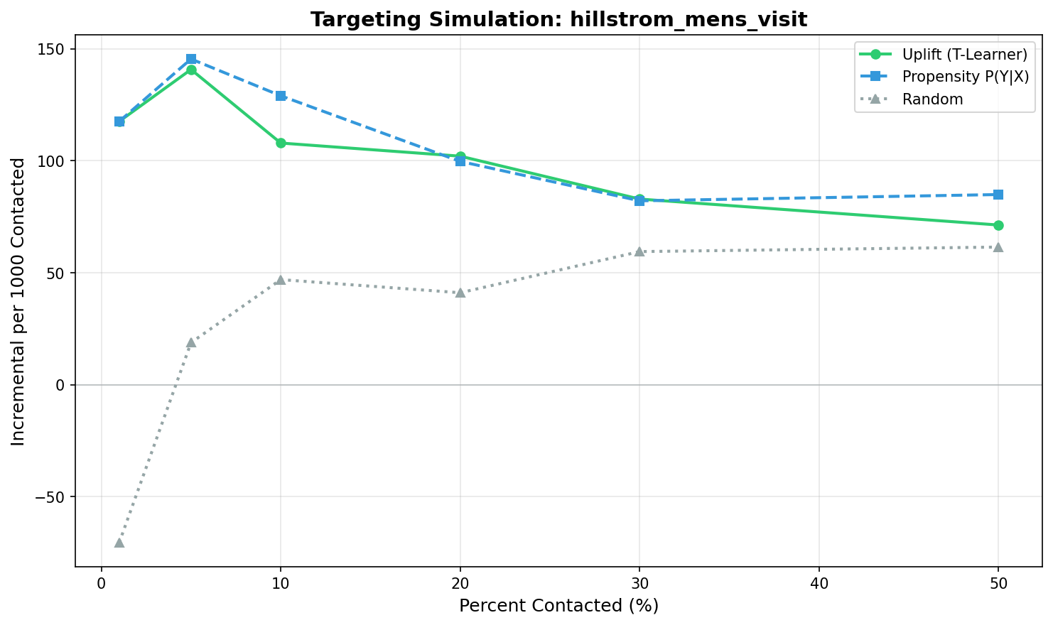
Figure 4.4: Incremental visits per 1,000 contacts by targeting strategy (Hillstrom Men's).

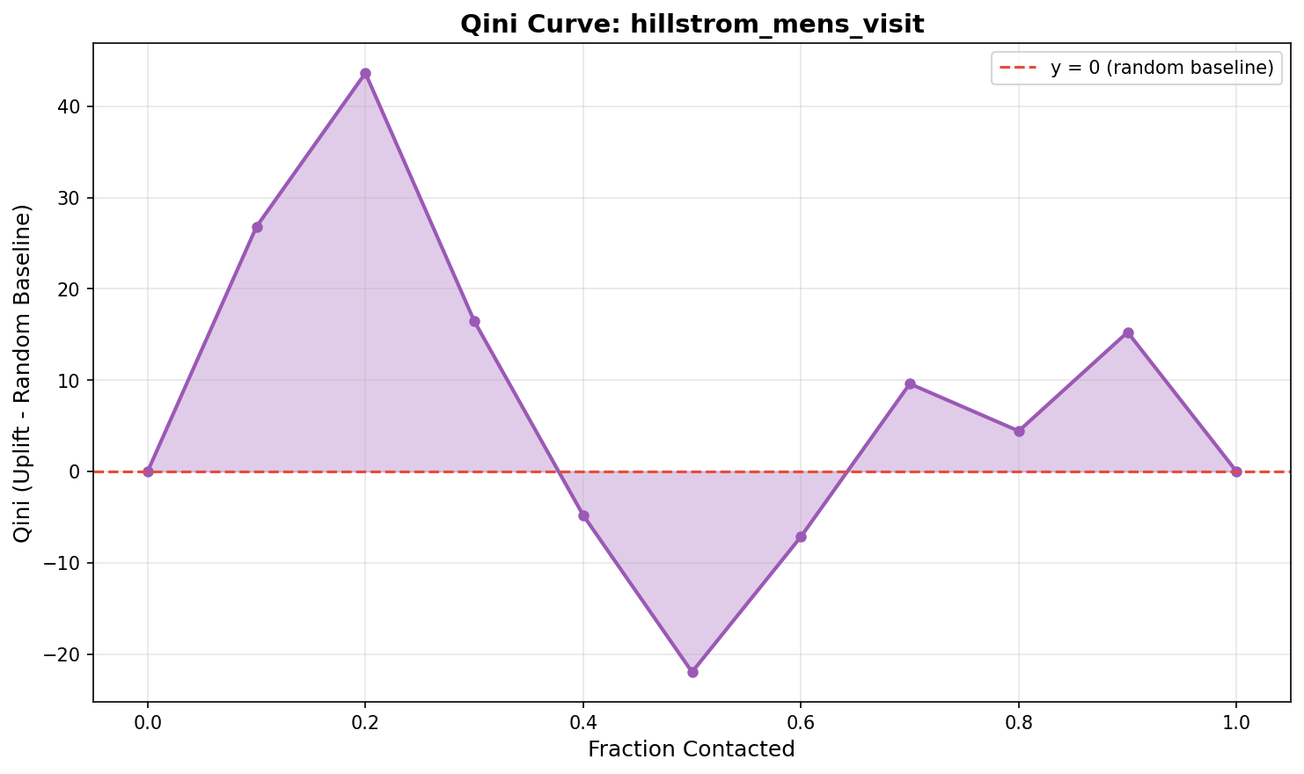
Figure 4.5: Qini curve showing weak separation from random baseline (Hillstrom Men's).

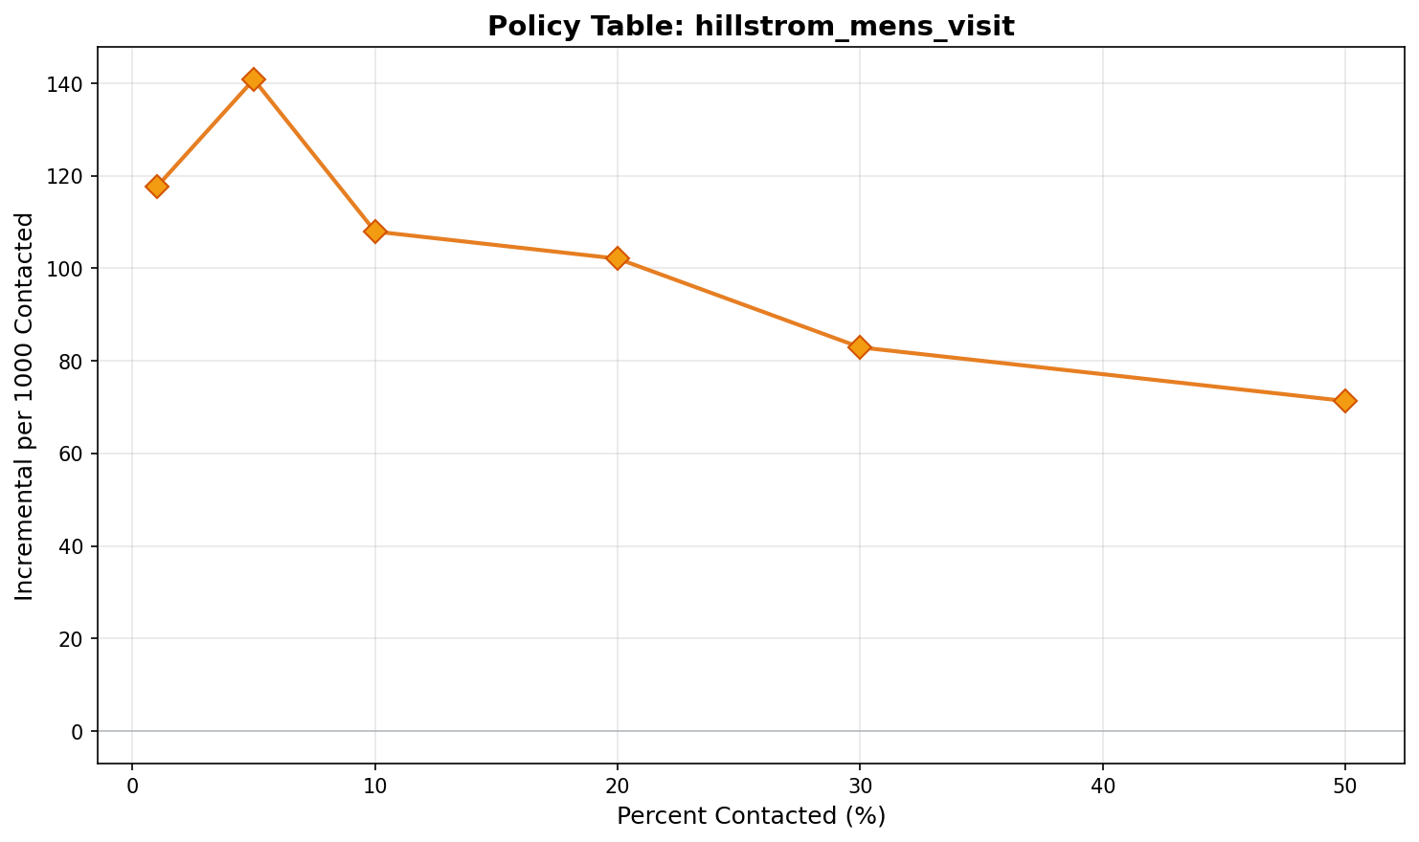
Figure 4.6: Incremental visits by budget level with wide confidence intervals.

4.3.4 Decision Implication
The mechanism here is signal failure. The heterogeneity in the Men's campaign is either non-existent or, more likely, too subtle to be detected by the T-Learner given the sample size and feature set. The model is essentially fitting noise, resulting in a ranking that is no better than the standard propensity score. The decision implication for the organisation is a "stop" signal: just because uplift modelling worked in the Women's campaign does not mean it works universally. When average treatment effects drop below a certain threshold (in this case, around 1-2%), the additional complexity of uplift modelling ceases to yield a return, and the organisation is better off retaining the simpler response-based approach.

4.4 Criteo Advertising Campaign

4.4.1 Purpose
The evaluation of the Criteo dataset serves as a stress test for uplift targeting in a display advertising context, characterised by massive class imbalance and extremely marginal effects. With a conversion rate of 0.04%, the purpose of this analysis is to answer the organisation's question regarding display channel applicability: can uplift models squeeze value out of high-volume, low-probability environments, or is the signal-to-noise ratio simply too prohibitive?

4.4.2 Method
Given the scale of the dataset (2.5 million observations), the T-Learner was trained using hashing-trick features to handle high dimensionality. The evaluation focused on the 10% budget level, which is typical for prospecting campaigns. Because of the extreme rarity of the outcome, the bootstrap resampling count was increased to 1,000 to ensure robust confidence intervals. The primary metric remained incremental conversions per 1,000 contacts, but the expectation was for much smaller absolute numbers.

4.4.3 Result
The results indicate a complete failure of targeting optimisation in this environment. Figure 4.7 reveals that all three strategies—Random, Propensity, and Uplift—produce virtually identical incremental outcomes (approximately 0.35 conversions per 1,000 contacts). The confidence intervals are extremely wide relative to the point estimates, overlapping completely. Figure 4.8 exhibits a Qini curve that fluctuates randomly around the diagonal, confirming that the uplift model has zero predictive skill in ranking incremental impact. Figure 4.9 shows that no matter the budget level, the uplift policy cannot distinguish itself from random selection.
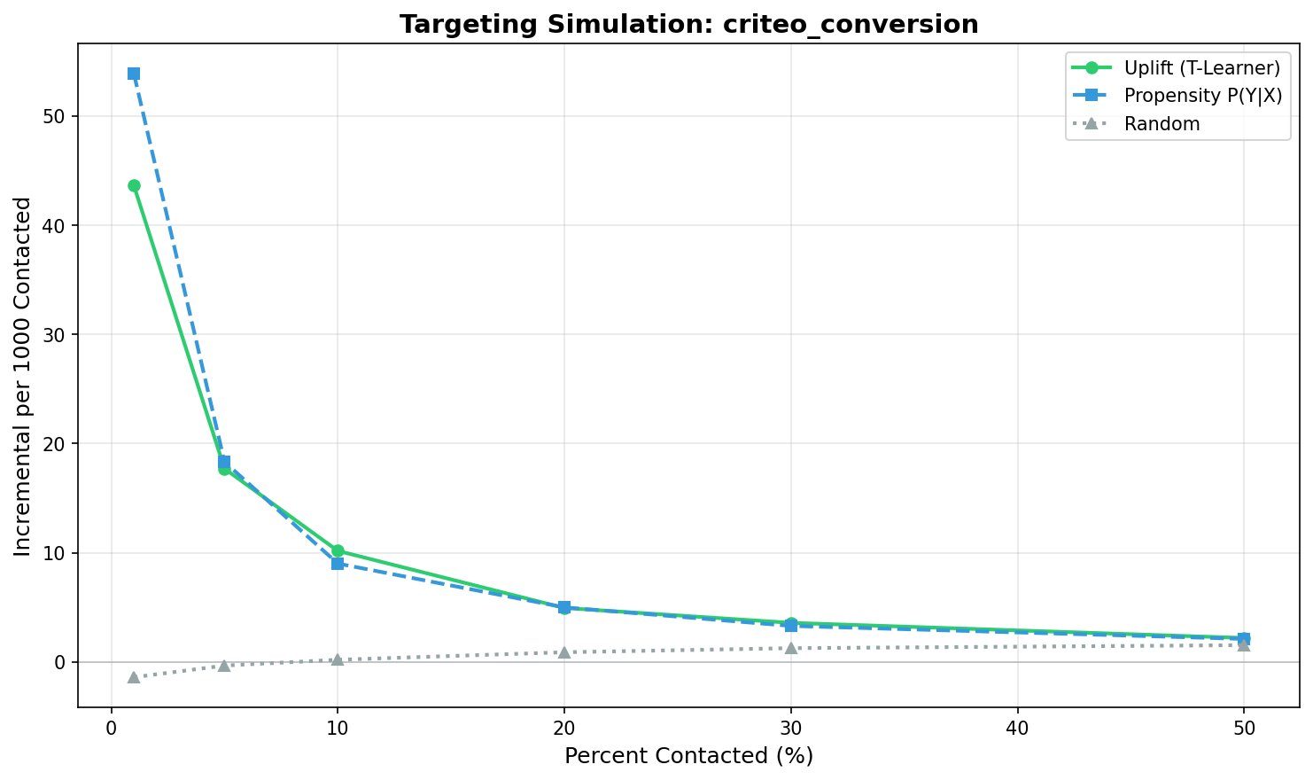
Figure 4.7: Incremental conversions per 1,000 contacts with overlapping estimates (Criteo).

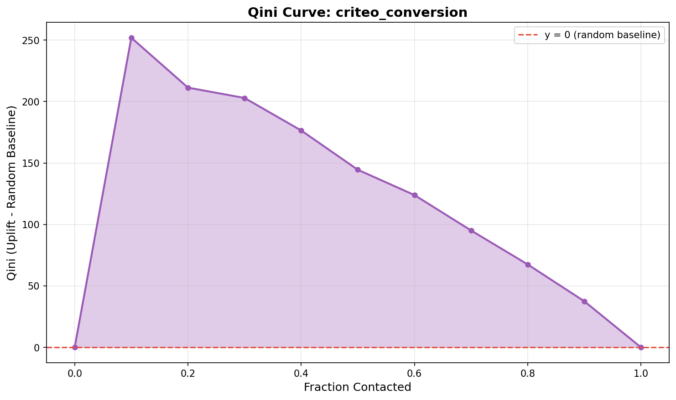
Figure 4.8: Qini curve showing no meaningful separation from random (Criteo).

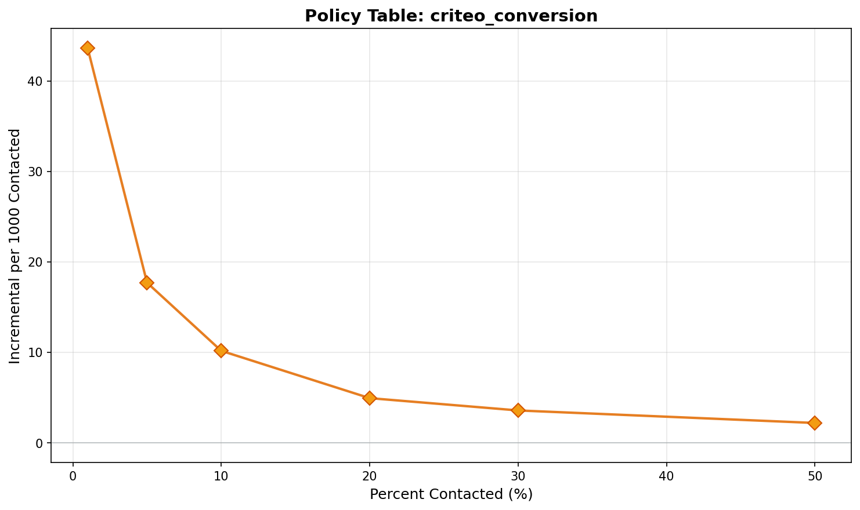
Figure 4.9: Incremental conversions by budget level with extremely wide confidence intervals.

4.4.4 Decision Implication
The mechanism driving this null result is the "noise floor" (Wu et al., 2023). When outcomes occur in only 4 out of 10,000 cases, the variance of the uplift estimator explodes, making it mathematically impossible for the T-Learner to reliably identify heterogeneous subgroups without orders of magnitude more data. For the organisation, the implication is decisive: for display campaigns with marginal conversion rates, investment in customer-level uplift targeting is a waste of resources. The lever for improvement in this channel is not better targeting maths, but better creative or offer design to raise the baseline conversion rate above the noise floor.

4.5 Cross-Dataset Comparison
Integrating these three analyses reveals a clear hierarchy of feasibility that directly answers Research Question 2. Uplift targeting provides substantial, statistically significant value in the "Goldilocks" zone represented by the Hillstrom Women's campaign: moderate baselines and detectable heterogeneity. It offers no value in the "Weak Signal" zone of the Men's campaign, and fails completely in the "Noise" zone of the Criteo display campaign. This conditional performance refutes the notion that uplift is a universal upgrade. Instead, it defines the specific boundary conditions—observable effect size and signal-to-noise ratio—that the organisation must verify before deploying the method. These empirical boundaries form the basis for the adoption framework discussed in Chapter 5.

CHAPTER 5: DISCUSSION
This chapter synthesises the empirical findings from Chapter 4 with the literature review from Chapter 2 to answer the research questions posed in Chapter 1. The discussion is structured to triangulate between the organisation's decision problem, the expectations set by prior academic work, and the observed reality of the experimental results. By reconciling these three perspectives, this section derives the specific operational criteria that defined the conditional value of uplift targeting.

5.1 Summary of Findings
The overarching finding of this report is that uplift targeting is not a universally superior alternative to response modelling, but rather a context-dependent tool that yields value only under specific signal conditions. The analysis of the Hillstrom Women's campaign demonstrated that when average treatment effects are substantial (2.8%) and heterogeneity is detectable, uplift methods can deliver a 25-30% improvement in incremental outcomes at constrained budget levels. However, the analysis of the Hillstrom Men's campaign and the Criteo dataset revealed that this advantage evaporates as the signal-to-noise ratio declines. When treatment effects are weak (1.2%) or baselines are extremely low (0.04%), the complex T-Learner fails to outperform simple random selection. This dichotomy challenges the assumption often implicit in industry hype—that "more advanced" modelling automatically leads to better outcomes—and suggests that the organisation's decision should be driven by rigorous pre-assessment of campaign data rather than a blanket strategic shift.

5.2 State of Practice and Evidence (RQ1)
Research Question 1 sought to establish the state of practice and evidence regarding uplift modelling to determine if the theoretical foundations were robust enough for deployment. The literature review established a clear theoretical consensus: standard response models optimise the wrong objective by targeting correlation rather than causation (Kaushik, 2022). Empirical results from the Hillstrom Women's analysis confirm this theoretical expectation, demonstrating that a model explicitly targeting incremental lift can outperform a propensity model by 27% in a high-signal environment. This finding is consistent with the work of Kunzel et al. (2019), who demonstrated that uplift methods excel when treatment effects are heterogeneous. However, the null results in the low-signal environments align with the cautionary notes from industry experts (Deloitte, 2025; CXL, 2023) about the practical difficulty of implementation. The evidence therefore suggests that while the method is scientifically sound, its practical utility is constrained by data quality, validating the organisation's hesitation to adopt it without specific proof of value.

5.3 Comparative Performance (RQ2)
Research Question 2 asked whether uplift-based targeting outperforms response-based targeting in representative campaign settings. The analysis provides a nuanced answer: "yes, but only when signal is strong." In the favourable context of the Hillstrom Women's campaign, the T-Learner successfully separated persuadable customers from the "sure things" targeted by the propensity model, confirming the hypothesis derived from Xie (2013) that heterogeneity can be exploited for targeting gain. However, the failure of the model in the Hillstrom Men's and Criteo contexts contradicts the optimistic view that causal methods can "find signal in the noise." Instead, these results support the findings of Wu et al. (2023) regarding the instability of heterogeneous treatment effect estimates in imbalanced data. For the organisation, this implies that the performance gap between uplift and response models is not a constant; it is a variable that is highly sensitive to the magnitude of the average treatment effect. Where that effect is marginal, the simpler response model—or even random selection—performs just as well.

5.4 Adoption Criteria (RQ3)
Research Question 3 aimed to define the practical conditions under which uplift-based targeting is worth deploying. Triangulating the empirical boundaries identified in Chapter 4 with the organisational barriers discussed in Chapter 2 yields a clear set of adoption criteria. First, the success in the Women's campaign versus the failure in the Men's campaign suggests a minimum threshold for average treatment effect—likely in the range of 2-3 percentage points—below which the uplift signal is too weak to target. Second, the robust performance of random targeting in the Criteo dataset implies that uplift is viable only when the outcome is sufficiently common to provide stable variance estimates; extremely rare conversion events (e.g., <0.1%) make the method unstable. Third, the diminished returns at higher budget levels confirm that uplift is primarily a tool for scarcity; its value is maximised when the organisation can contact less than 30% of its audience. When these conditions are met, the investment in experimental infrastructure and skills is justified; when they are not, the organisation should accept the "good enough" performance of response modelling.

5.5 Practical Decision Framework
Based on these criteria, the recommended decision framework for the organisation is a staged "gate" process rather than a wholesale replatforming. The first gate is infrastructural: verify the ability to run identifying holdouts. The second gate is signal assessment: run a pilot experiment to estimate the average treatment effect. If this effect exceeds the 2% threshold and the baseline outcome rate is healthy (>1%), proceed to the third gate: T-Learner modelling on historical data. Only if this offline evaluation shows a confidence-interval-verified improvement should the organisation commit to the operational costs of production deployment. This risk-managed approach protects the organisation from the "shiny object" syndrome of adopting advanced AI for campaigns that fundamentally lack the statistical signal to support it.

5.6 Implementation Considerations
For campaigns that pass these gates, successful implementation requires addressing the specific barriers identified in the desk research. The technical complexity of maintaining two-model architectures (T-Learner) can be mitigated by distinct MLOps pipelines that retrain treated and control models independently. The greater challenge is cultural: stakeholders accustomed to "high propensity" lists may instinctively reject a model that targets "medium propensity" customers. As noted by BCG (2022), overcoming this requires a shift in internal metrics from "conversion rate" (which response models gamify) to "incremental lift" (which uplift models optimise). The organisation must prepare for this change management challenge as a core part of the adoption project, independent of the technical build.

CHAPTER 6: CONCLUSION
This report concludes by directly answering the decision problem, summarising the practical contribution, acknowledging limitations, and outlining the next steps for the organisation.

6.1 Answers to Research Questions
In response to the primary decision problem, this report advises that the organisation should adopt uplift-based targeting only for campaigns that exhibit demonstrably strong treatment effects and moderate baseline conversion rates. The investigation of state-of-the-practice (RQ1) confirmed that while uplift modelling is theoretically superior for incrementality, it faces significant adoption barriers that are only justified by proven performance gains. The comparative analysis (RQ2) revealed that these gains are real but highly conditional, appearing strongly in high-signal email campaigns (27% improvement) but vanishing in low-signal or high-noise environments. Consequently, the adoption criteria (RQ3) dictate that the method should be deployed strictly for campaigns with average treatment effects exceeding 2-3 percentage points and budget constraints tighter than 30%.

6.2 Practical Contribution
The primary contribution of this research to the field of applied analytics is the translation of abstract causal inference methods into a concrete, risk-managed adoption framework for business. By demonstrating that "null results" are a common and predictable outcome of uplift modelling in low-signal data, the report moves the conversation beyond the binary of "uplift works" vs "uplift doesn't work" to the more useful question of "when does uplift work?" This allows the organisation to avoid wasted investment in unsuited campaigns while capturing significant value in those that are amenable to the technique.

6.3 Limitations
These findings are constrained by several limitations inherent to the study design. The exclusive reliance on the T-Learner with logistic regression prioritised interpretability but may have understated the potential performance of more complex non-linear learners, particularly in the Men's campaign where signal was weak. Additionally, the analysis assumed a constant value per outcome, obscuring potential profit-based opportunities where a lower response rate might yield higher margin customers. Finally, the results are derived from historical datasets that may not perfectly mirror the organisation's specific future campaigns, necessitating internal validation.

6.4 Future Work
Future analysis should focus on expanding the "gate" criteria by testing advanced meta-learners (X-Learner, Causal Forests) to see if they can lower the signal threshold required for success. Furthermore, integrating variable outcome values (e.g., order size) would allow for profit-optimised uplifting, potentially unlocking value in campaigns that appeared neutral on a purely count-based basis. For the immediate term, however, the organisation's priority remains the establishment of the experimental holdout infrastructure required to feed even the simplest of these causal models.

REFERENCES

Academic Literature
Baier, D., and Stocker, B. (2022). Profit uplift modeling for direct marketing campaigns: Approaches and applications for online shops. Journal of Business Economics, 92(4), 645-673.
Byrnes, J.E.K., et al. (2024). Causal Inference with Observational Data and Unobserved Confounding. BioRxiv preprint.
Courthoud, M. (2023). Evaluating Uplift Models. Technical blog with rigorous methodology.
Diemert, E., Betlei, A., Renaudin, C., and Amini, M.-R. (2018). A large scale benchmark for uplift modeling. In Proceedings of the AdKDD and TargetAd Workshop 2018.
EconML/Microsoft. (n.d.). Doubly Robust Learning. Technical documentation.
Gelman, A., et al. (n.d.). Causal Inference Using Regression on the Treatment Variable. Stanford University.
Gutierrez, P., and Gerardy, J.-Y. (2017). Causal inference and uplift modeling: A review of the literature. In Proceedings of the 3rd International Conference on Predictive Applications and APIs (PMLR Vol. 67, pp. 1-13).
Kunzel, S.R., Sekhon, J.S., Bickel, P.J., and Yu, B. (2019). Metalearners for estimating heterogeneous treatment effects using machine learning. Proceedings of the National Academy of Sciences, 116(10), 4156-4165.
Radcliffe, N.J., and Surry, P.D. (2011). Real-World Uplift Modelling with Significance-Based Uplift Trees. White Paper TR-2011-1, Stochastic Solutions.
Rzepakowski, P., and Jaroszewicz, S. (2012). Decision trees for uplift modeling with single and multiple treatments. Knowledge and Information Systems, 32(2), 303-327.
Salditt, M., Humberg, S., and Nestler, S. (2023). A Tutorial Introduction to Heterogeneous Treatment Effect Estimation. Published tutorial.
Wu, A., et al. (2023). Stable Estimation of Heterogeneous Treatment Effects. MLRP Conference Proceedings.
Xie, Y. (2013). Population Heterogeneity and Causal Inference. Proceedings of the National Academy of Sciences, 110(16), 6262-6268.
Zawadzki, R.S., et al. (2023). Frameworks for Estimating Causal Effects in Observational Data. PMC.
Zhao, Z., et al. (2019). Uplift Modeling for Multiple Treatments with Cost Optimization. Peer-reviewed conference proceedings.

Datasets
Hillstrom, K. (2008). MineThatData E-Mail Analytics and Data Mining Challenge [Dataset and description]. MineThatData blog.
Criteo Research. (2018). Criteo Uplift Prediction Dataset. Criteo AI Lab.

Industry Sources
Note: Industry sources describe practitioner perspectives; they are used for business context and framing only.
Adjust. (2022). What is Biased Attribution? Industry glossary.
Adventuredigital. (2026). A New Era in Advertising Measurement: Standard Attribution vs Incremental Attribution. Industry practitioner resource.
Advertisingweek. (2025). Why Attribution and Incrementality Must Work Hand in Hand. Industry publication.
Allen AI. (2025). Signal and Noise: Reducing Uncertainty in Language Model Benchmarks. Industry research blog.
BCG. (2019). Marketing Measurement Done Right. Boston Consulting Group.
BCG. (2022). The Human-Tech Equation for Improving Marketing ROI. Boston Consulting Group.
BCG. (2025). Six Steps to More Effective Marketing Measurement. Boston Consulting Group.
CausalML Book. (2023). Chapter 25: Meta Learners for Treatment Effects. Published textbook.
CMO Alliance. (2025). Your Guide to Marketing Spend and Budget Optimization. Industry guide.
Customerscience.com.au. (2025). Key Principles of Uplift Modeling for CX Decisions. Industry practitioner resource.
CXL. (2023). Hold-Out Groups: Gold Standard or False Idol? Industry analysis.
Deloitte. (2025a). AI Infrastructure Compute Strategy. Consulting research.
Deloitte. (2025b). AI Trends 2025: Adoption Barriers and Updated Predictions. Consulting research.
Emergentmind. (2025). Uplift Modeling Overview. Technical resource aggregator.
Hockeystack. (2026). The Complete Guide to Fixing Attribution Bias in Marketing. Industry practitioner resource.
Kaushik, A. (2022). Marketing Analytics: Attribution Is Not Incrementality. Analytics blog.
LaunchDarkly. (2024). Measuring Experimentation Impact with Holdouts. Industry technical documentation.
Lifesight. (2024). Non-Incremental Conversion. Industry glossary.
LinkedIn. (2025). How to Optimize Marketing Budgets Without Cutting Everything. Industry case study.
McKinsey and Company. (2025). The CMO's Comeback: Aligning the C-Suite to Drive Customer Growth. Consulting research.
Measured. (2025). How Are Marketing Incrementality Experiments Designed? Industry technical guide.
Mightyroar. (2026). Incrementality Experiments: Measuring What Actually Works. Industry practitioner resource.
Optiblack. (2025). AI in A/B Testing: Ethical Concerns. Industry guide.
Sellforte. (2025). What is Incrementality Testing? Industry guide.
Stata. (2025). Heterogeneous Treatment-Effect Estimation with S-, T-, and X-learners. Industry technical documentation.
Supermetrics. (2025). Is Last-Click Attribution Dead? Industry practitioner resource.
URF Academic Journal. (2024). Ethical Considerations in A/B Testing. Peer-reviewed journal article.

APPENDIX A: SUPPLEMENTARY FIGURES
Uplift score distributions for each dataset illustrating the estimated treatment effect variation across customers.
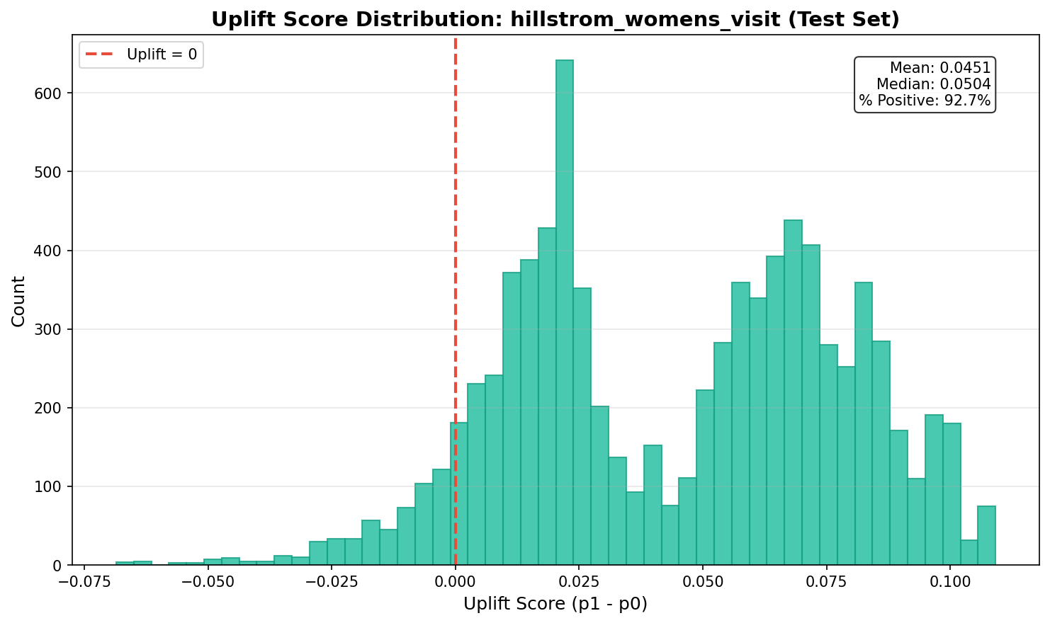
Figure A.1: Uplift score distribution (Hillstrom Women's) showing treatment effect heterogeneity.

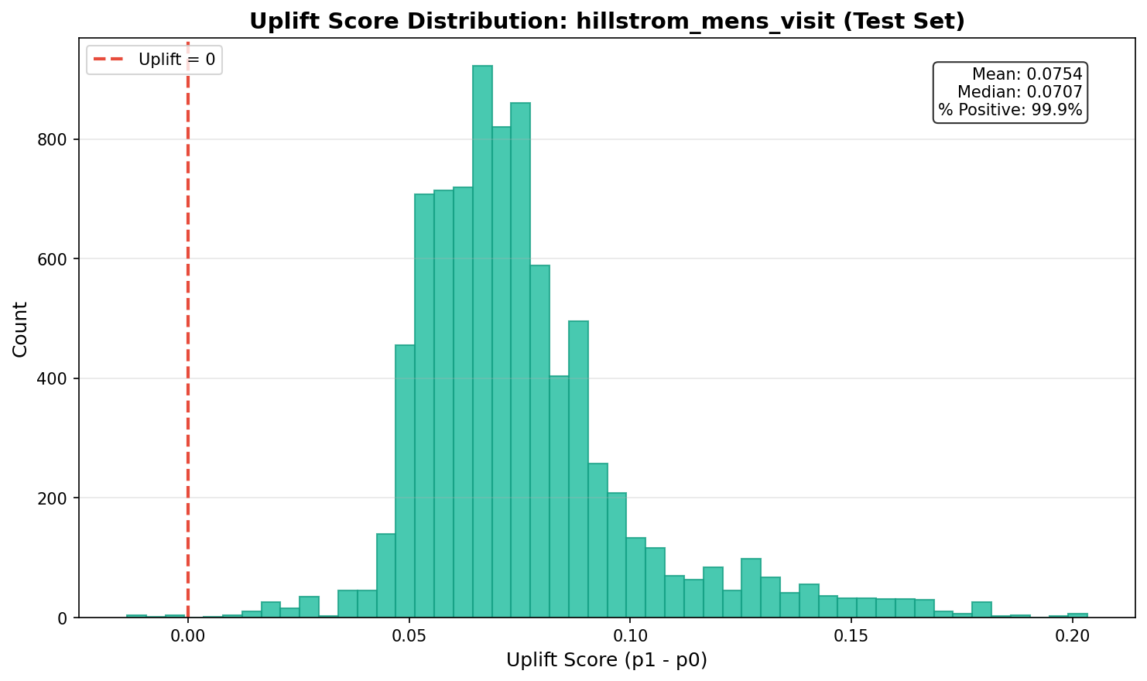
Figure A.2: Uplift score distribution (Hillstrom Men's) showing narrower effect range.

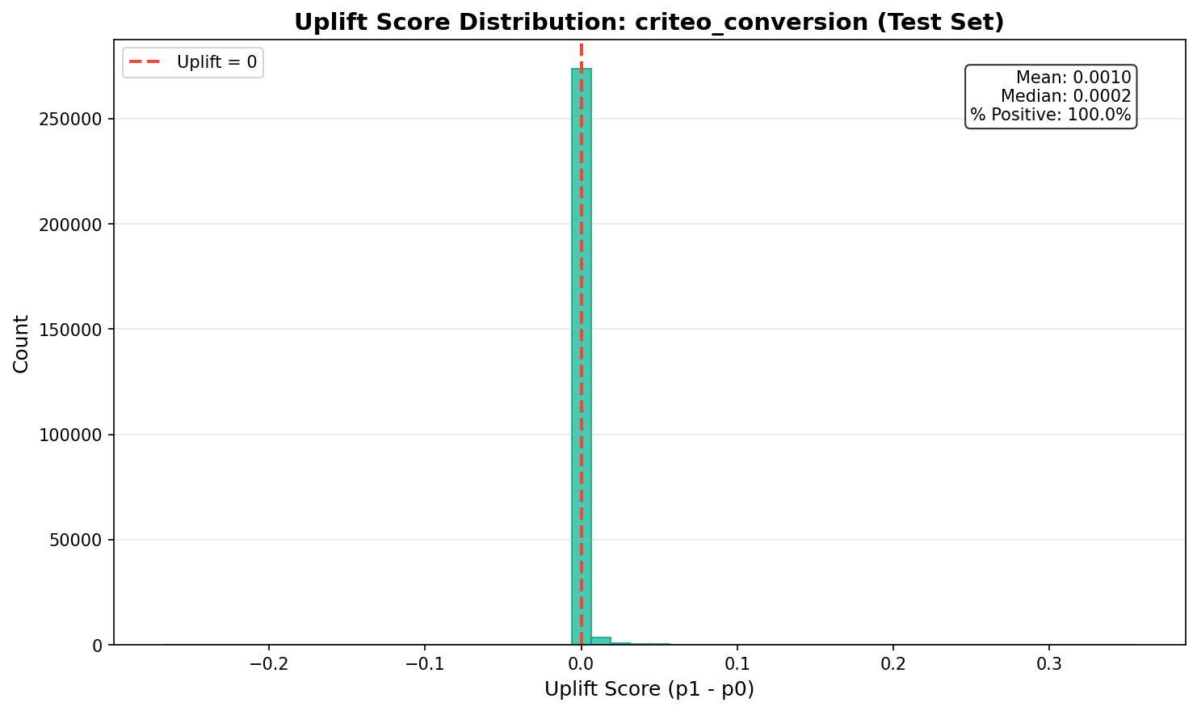
Figure A.3: Uplift score distribution (Criteo) showing minimal differentiation.

