APPLIED ANALYTICS PROJECT

Which Targeting Policy Produces Higher Incremental
Outcomes Under Budget Constraints?

A Comparative Analysis of Uplift Modeling Approaches

Submitted in partial fulfillment of the requirements for the
Master of Analytics
Massey University

[Student Name]
[Student ID]

February 2026

MANAGERIAL ABSTRACT
This report addresses the operational question of whether a mid-sized retailer should replace propensity-based customer targeting with uplift-based targeting to improve marketing efficiency under fixed budget constraints. The analysis compares targeting policies across two experimental datasets representing distinct channel conditions, enabling assessment of when uplift modelling provides value and when simpler approaches suffice.
The Hillstrom Email dataset contains 64,000 customer records with a baseline conversion rate of approximately 15 percent, representing a high-engagement direct marketing channel. The Criteo Display dataset contains 2.5 million user records with a baseline conversion rate below 0.1 percent, representing a low-engagement programmatic advertising environment. Both datasets feature randomised treatment assignment, enabling unbiased estimation of causal effects.
The analysis proceeds in stages. Section 4.0 establishes baseline experimental diagnostics, documenting treatment and control sample sizes, outcome rates, and naive average treatment effects for each segment. Section 4.2 examines propensity and uplift score distributions to assess whether models detect meaningful heterogeneity. A ranking divergence analysis quantifies the overlap between customers selected by different targeting approaches. Policy performance is then evaluated at multiple budget levels with bootstrap confidence intervals.
The central finding is that uplift modelling is not uniformly superior to propensity modelling. In the high-engagement email channel (Hillstrom Women's segment), uplift targeting produced statistically distinguishable gains at the 50 percent budget level, generating 39.0 additional incremental visits per 1,000 customers contacted compared to propensity targeting (95 percent CI: 20.0 to 56.1). At stricter budget levels of 10 and 20 percent, confidence intervals included zero, precluding definitive conclusions despite directionally positive point estimates. This pattern reflects the relationship between targeted sample size and estimation precision.
In the low-engagement display channel (Criteo dataset) and the Hillstrom Men's segment, uplift targeting did not consistently outperform propensity targeting at any budget level tested. The variance penalty associated with treatment effect estimation exceeded its bias reduction advantage when outcome rates and naive treatment effects were small.
The findings indicate that the decision to adopt uplift modelling should be conditional on observable context characteristics. The baseline diagnostics, score distribution analysis, and ranking divergence patterns demonstrated in Chapter 4 provide a framework for assessing the potential value of uplift modelling in specific applications. Organisations considering adoption should assess signal strength using baseline experimental statistics and evaluate model performance on held-out data before committing to production deployment.

CHAPTER 1: INTRODUCTION

1.1 Research Topic
Marketing organisations allocate budgets to customer contact programmes with the objective of generating profitable outcomes. The standard practice for targeting decisions is propensity modelling, which estimates the probability that a customer will convert given their observable characteristics. Customers are ranked by this probability, and budget is allocated to the highest-scoring segments.
This approach assumes that customers most likely to convert are also the customers most worth contacting. However, this assumption conflates correlation with causation. A customer with high purchase probability may be a "sure thing" who would convert without intervention. Contacting such customers incurs cost without generating incremental value. Industry sources indicate that a substantial fraction of attributed conversions may be non-incremental, meaning the customer would have converted regardless of whether they received the marketing intervention.
The alternative is uplift modelling, which estimates the conditional average treatment effect rather than the outcome probability. This approach ranks customers by their expected responsiveness to treatment, not their baseline likelihood. The theoretical advantage is that budget is allocated to "persuadables" rather than "sure things." However, uplift estimation is a harder statistical problem than outcome prediction because it requires estimating a difference between two counterfactual quantities, which amplifies variance.
This research investigates whether the theoretical advantage of uplift modelling translates to practical improvement under realistic budget constraints, and identifies the conditions that determine when each approach is preferable.

1.2 Definition of the Decision-Making Problem
The decision problem is stated as follows: Given a fixed marketing budget that permits contact with k percent of the customer base, and assuming constant value per conversion, should the organisation replace propensity-based targeting with uplift-based targeting to maximise incremental outcomes?
This formulation specifies the objective (maximise incremental conversions), the constraint (fixed budget expressed as population fraction), and the key assumption (homogeneous conversion value). It excludes budget optimisation, creative optimisation, and multi-treatment allocation, which are separate problems requiring different analytical frameworks.
The decision problem can be conceptualised through a two-dimensional framework that maps customers along axes of baseline conversion propensity and treatment effect magnitude. This framework yields four strategic quadrants that clarify the targeting challenge.
The first quadrant contains customers with high propensity and high uplift, representing individuals likely to convert whose probability increases substantially with treatment. These are optimal targets under all budget levels because they combine baseline value with treatment responsiveness.
The second quadrant contains customers with low propensity but high uplift, representing "persuadables" who are unlikely to convert without intervention but respond when contacted. These customers represent pure incremental value and become critical targets under moderate budgets where efficiency matters most.
The third quadrant contains customers with high propensity but low uplift, representing "natural buyers" who will likely convert regardless of treatment. Propensity models prioritise these segments, but uplift models correctly deprioritise them under budget constraints because contacting them generates cost without incremental benefit.
The fourth quadrant contains customers with low propensity and low uplift, representing individuals unlikely to convert even with treatment. All targeting approaches exclude these segments.
Uplift modelling's strategic advantage emerges from its ability to discriminate between the first three quadrants, whereas propensity modelling cannot distinguish the first quadrant from the third. This conceptual framework generates the testable prediction that uplift targeting will outperform propensity targeting when Quadrant II and Quadrant III segments are large relative to Quadrant I.

1.3 The Importance of the Research
The academic literature on uplift modelling typically evaluates models using global metrics such as the Area Under the Uplift Curve or Qini coefficient. These metrics summarise ranking quality across the entire population and reward models that correctly order customers from highest to lowest treatment effect.
However, budget-constrained decision makers require local evaluation. If the budget permits targeting only 10 percent of customers, global ranking quality is irrelevant; what matters is performance in the top decile. A model with high global metric scores may perform poorly at specific budget thresholds due to calibration errors or high local variance. This disconnect between academic evaluation and operational requirements motivates the present analysis.
The practical importance extends to resource allocation efficiency. Marketing budgets are finite, and the gap between optimal and suboptimal targeting can translate to substantial differences in campaign returns. Understanding when uplift modelling provides genuine improvement, and when simpler approaches suffice, enables organisations to make informed investment decisions about analytical infrastructure.

1.4 Potential Contribution to Practice
This research contributes to practice in three ways. First, it provides empirical evidence on the conditions under which uplift targeting outperforms propensity targeting, grounded in benchmark experimental data rather than theoretical arguments alone.
Second, it documents the boundary conditions where uplift modelling fails. Negative and null results are informative because they define the limits of the method and prevent overconfident adoption in unsuitable contexts. Organisations can assess whether their situation resembles conditions where uplift modelling succeeded or conditions where it failed.
Third, it provides a decision framework that practitioners can apply prospectively. Rather than requiring organisations to build and test uplift models before knowing whether the investment is worthwhile, the framework enables assessment of likely value based on observable channel characteristics.

1.5 Limitations
Several limitations qualify the scope of this research. The analysis uses public benchmark datasets as proxies for organisational data. These datasets may not reflect current customer behaviour or the specific characteristics of any target organisation. The results should be interpreted as internally valid tests of methodology rather than direct predictions of organisational outcomes.
The analysis assumes binary outcomes with constant value. It does not address revenue heterogeneity, where persuadable customers might have lower average order values than organic buyers. A complete organisational deployment would require extending the framework to value-weighted outcomes.
The analysis relies on experimental data with randomised treatment assignment. The results do not generalise to observational settings where selection bias may confound the treatment effect. Organisations with only observational data would need to address confounding before applying these methods.

1.6 Flow and Contents of Remaining Chapters
Chapter 2 reviews the literature on uplift modelling, establishes the theoretical foundation for the research, and identifies gaps in existing knowledge. It covers uplift modelling fundamentals, meta-learner approaches, oracle bounds, and industry applications.
Chapter 3 specifies the research methodology, including data sources, model specification, and evaluation framework. It includes a section on ethical considerations addressing privacy, fairness, and transparency, as well as a critical review of methodological limitations.
Chapter 4 presents the empirical findings, including score distributions, policy performance comparisons, and robustness checks. Results are reported with confidence intervals to communicate uncertainty appropriately.
Chapter 5 discusses the findings in relation to the decision problem, examines correlation with previous research, draws managerial implications, and identifies opportunities for further research.
Chapter 6 provides conclusions and summarises the original contribution to practice.

CHAPTER 2: DESK RESEARCH

2.1 Introduction
This chapter reviews the academic and industry literature relevant to the decision problem. It establishes the theoretical foundation for comparing propensity and uplift targeting, identifies methodological options, and synthesises knowledge about conditions affecting method performance.
The review covers four areas: company and contextual background, academic literature on uplift modelling, industry applications and benchmarks, and a summary synthesising the desk research into testable predictions. Each section contributes to framing the analytical approach adopted in subsequent chapters.

2.2 Company and Contextual Background
The research context is a mid-sized retailer operating across multiple marketing channels including email, display advertising, and direct mail. The organisation allocates a fixed quarterly budget to customer acquisition and retention campaigns, with performance measured by conversion volume subject to return-on-investment constraints.
Current targeting practice uses propensity scoring based on customer transaction history and demographic attributes. The marketing team ranks customers by predicted conversion probability and allocates contact budget to the highest-scoring segments. This approach has been in place for several years and is well-integrated with the organisation's marketing automation infrastructure.
The business challenge motivating this research is evidence suggesting that conversion attribution may overstate marketing effectiveness. Internal analysis indicates that a meaningful fraction of customers targeted by high-propensity campaigns would have purchased regardless of the marketing contact. This observation raises the possibility that an alternative targeting approach focused on incremental impact could improve budget efficiency.
Industry analysts have documented similar concerns across the retail sector. The attribution fallacy, whereby marketers claim credit for organic conversions, is recognised as a systemic issue in digital marketing. If the organisation's experience reflects a broader pattern, methods that distinguish incremental from organic response could generate substantial value across the industry.
The strategic implications extend beyond individual campaign optimisation. When marketing teams systematically overestimate their incremental contribution, budget allocation decisions across channels become distorted. Resources may flow disproportionately to channels that capture rather than create demand, while truly incremental interventions remain underfunded. A rigorous methodology for measuring and optimising incremental impact has potential to correct these allocation distortions.

2.3 Academic Literature on Uplift Modeling

2.3.1 Uplift Modeling Fundamentals
Uplift modelling, also known as heterogeneous treatment effect estimation, aims to predict individual-level treatment effects. Unlike traditional predictive modelling that estimates expected outcomes, uplift modelling estimates the incremental impact of an intervention on each individual. This makes it particularly valuable for marketing resource allocation, where the goal is not to identify customers likely to convert, but rather customers whose conversion probability increases due to the intervention.
The distinction between propensity modelling and uplift modelling is critical for resource allocation decisions. Propensity models predict who is likely to respond, but cannot distinguish between customers who would have responded regardless of treatment (natural buyers) and those whose behaviour is actually influenced by the intervention. This limitation means that propensity-optimal targeting may allocate budget to customers who generate responses but not incremental responses.
Building on this distinction, uplift modelling explicitly estimates the treatment effect for each individual. The individual treatment effect is defined as the difference between the potential outcome under treatment and the potential outcome under control. Because only one potential outcome is observed for each individual, this quantity cannot be directly estimated at the individual level. Instead, uplift models estimate the conditional average treatment effect given observed covariates, which provides a ranking signal for targeting decisions.
The fundamental problem of causal inference, that we observe only one potential outcome per individual, creates inherent statistical challenges. Uplift models must infer treatment effects from group-level patterns, essentially comparing outcomes between treated and control individuals with similar covariates. This inference is subject to bias from unmeasured confounders in observational data and to variance amplification from the indirect estimation procedure.

2.3.2 Meta-Learner Approaches
Meta-learner approaches have emerged as the dominant framework for uplift estimation in practice. These methods leverage standard supervised learning algorithms to estimate treatment effects by transforming the causal inference problem into a prediction task. The key meta-learners differ in how they structure this transformation.
The S-learner (single-model learner) estimates a single predictive model that includes the treatment indicator as a feature alongside customer covariates. The treatment effect is estimated by comparing predictions under treatment and control conditions, holding covariates constant. This approach is computationally simple but suffers from a regularisation problem: when the treatment effect is small relative to the main effects of covariates, regularised learners may shrink the treatment coefficient toward zero, producing biased estimates.
The T-learner (two-model learner) fits separate models for treatment and control groups, then computes the treatment effect as the difference between predictions. This approach forces the model to learn separate response surfaces, avoiding the regularisation problem at the cost of doubling the estimation variance. The T-learner is well-suited to settings where treatment and control response patterns differ substantially.
The X-learner extends the T-learner by incorporating cross-fitting and propensity weighting to reduce bias and improve efficiency. It uses predictions from one group to impute counterfactual outcomes for the other group, then combines these imputed effects with propensity weights. The X-learner can achieve better performance than the T-learner when treatment and control group sizes are unbalanced, though it introduces additional complexity.
The R-learner (residualised learner) adopts a different strategy, first partialling out the main effects of covariates from both the outcome and treatment variables, then modelling the relationship between these residuals. This approach can be more efficient when main effects are strong and treatment effects are modest. However, it requires careful specification to avoid bias.
The practical choice among meta-learners involves tradeoffs between bias, variance, computational complexity, and interpretability. For the purposes of this research, the T-learner was selected as the primary approach because it offers a transparent baseline, avoids the regularisation issues of the S-learner, and does not require the additional complexity of the X-learner or R-learner.

2.3.3 Oracle Bounds and Optimal Policies
The oracle policy represents the theoretical optimum: targeting customers in order of their true treatment effects. Because true treatment effects are unobservable, the oracle cannot be implemented in practice. However, it provides a benchmark for evaluating how much room for improvement exists beyond achievable policies.
The gap between oracle performance and realised performance reflects the cost of estimation error. If uplift policies approach oracle performance, further methodological improvements will yield diminishing returns. If substantial gaps remain, investment in better estimation may be justified.
Prior research indicates that oracle bounds are often significantly above realised performance, particularly in settings with weak treatment effect signals or high covariate dimensionality. This suggests that methodological advances in uplift estimation could continue to generate practical value.
The oracle bound also provides diagnostic information about the feasibility of personalised targeting in a given context. If the oracle shows minimal improvement over random targeting, treatment effect heterogeneity is limited, and no estimation method can substantially improve on uniform treatment. Conversely, large oracle advantages indicate substantial heterogeneity that could be captured with sufficiently accurate estimation.

2.3.4 Uncertainty Quantification
Uncertainty in treatment effect estimates has practical consequences for targeting decisions. If confidence intervals are wide, the ranking provided by point estimates may not reliably reflect true treatment effect ordering. Customers ranked first by estimated uplift may have true effects lower than customers ranked tenth if the estimates are noisy.
Bootstrap methods provide a practical approach to uncertainty quantification that makes minimal distributional assumptions. By resampling the data and re-estimating models repeatedly, the bootstrap captures the variability of the estimation pipeline and produces confidence intervals that reflect finite-sample uncertainty.
The width of confidence intervals is expected to vary with sample size and signal strength. In low-signal settings or with small samples, intervals will be wide and rankings unreliable. In high-signal settings with adequate samples, intervals will be narrow and rankings more trustworthy.
Practitioners should consider not only point estimates but also the precision of these estimates when making targeting decisions. A policy that appears superior based on point estimates may not be distinguishable from alternatives when uncertainty is properly accounted for. Conservative decision-making requires acknowledging the bounds of statistical precision.

2.3.5 Alternative Approaches and Limitations
Beyond meta-learner approaches, several alternative methodologies exist for treatment effect estimation. Causal forests extend random forests to estimate heterogeneous treatment effects using recursive partitioning with a splitting criterion based on treatment effect variation. Doubly robust estimators combine outcome modelling with propensity score weighting to achieve robustness to misspecification of either component.
Each approach has limitations. Causal forests require substantial computational resources and may overfit in high-dimensional settings with limited sample sizes. Doubly robust estimators require accurate propensity scores, which may be challenging when treatment assignment is not uniformly random.
The literature also documents challenges with uplift model evaluation. Standard metrics like the Qini coefficient and Area Under the Uplift Curve provide global summaries of ranking quality but may not align with local performance at specific budget thresholds. This disconnect between evaluation metrics and operational objectives is a recurring theme in applied uplift modelling.

2.4 Industry Applications and Benchmarks

2.4.1 E-commerce and Retail Applications
E-commerce and retail represent the primary application domains for uplift modelling. These sectors feature experimental infrastructure (A/B testing platforms), customer transaction data, and measurable conversion outcomes that enable treatment effect estimation.
Industry case studies report improvements of 10 to 30 percent in campaign performance when switching from propensity to uplift targeting. However, these figures should be interpreted cautiously because reporting bias may favour positive results, and the specific conditions enabling success are not always documented.
The Criteo dataset used in this research represents a large-scale example of uplift modelling application in display advertising. With 2.5 million user records and a randomised treatment structure, it provides a realistic benchmark for assessing method performance in programmatic advertising contexts where outcome rates are low and feature spaces are high-dimensional.
The digital advertising context presents specific challenges for uplift modelling. Conversion rates are typically below 1 percent, meaning positive outcomes are rare events. The signal-to-noise ratio is unfavourable, and treatment effects may be small relative to the baseline noise in customer behaviour. These conditions test the limits of uplift estimation methods.

2.4.2 Email Marketing Benchmarks
Email marketing represents a higher-engagement channel than display advertising, with outcome rates typically exceeding 10 percent for established customer segments. The Hillstrom dataset used in this research is derived from an email marketing experiment conducted by a cataloguer.
Prior analyses of the Hillstrom data have demonstrated that uplift modelling can identify treatment effect heterogeneity, with some customer segments showing strong positive effects and others showing negligible or negative effects. These findings suggest that email marketing is a setting where uplift-based targeting may provide meaningful value.
The distinction between the Hillstrom and Criteo contexts enables comparative analysis across signal conditions. If method performance differs systematically between high-engagement and low-engagement channels, this difference provides insight into the boundary conditions for uplift modelling effectiveness.
Email marketing also features different cost structures than digital advertising. The marginal cost of sending an email is minimal, but excessive contact can generate customer fatigue and unsubscribes. The cost of over-contacting is therefore not directly monetary but manifests as customer relationship deterioration. This cost structure reinforces the value of precise targeting.

2.4.3 Cross-Industry Patterns
Across industries, several patterns emerge from the literature on uplift modelling applications. First, success tends to concentrate in settings with substantial treatment effect heterogeneity. When treatment effects are relatively uniform across the customer base, sophisticated targeting provides limited advantage over simpler approaches.
Second, the value of uplift modelling depends on budget constraints. When budgets are large enough to reach most of the customer base, targeting precision matters less. When budgets are tight and selectivity is required, the distinction between incremental and non-incremental responders becomes critical.
Third, organisational factors influence adoption success. Teams with strong experimental culture, data infrastructure, and analytical capabilities tend to achieve better results than those attempting to adopt uplift modelling without these foundations.

2.5 Summary of Desk Research
The literature review establishes several key points that inform the empirical analysis.
First, propensity modelling and uplift modelling address different questions. Propensity models predict who responds; uplift models predict who responds incrementally. Under budget constraints, the distinction matters because resources allocated to non-incremental responders generate cost without benefit.
Second, meta-learner approaches, particularly the T-learner and X-learner, provide practical methods for uplift estimation using standard supervised learning algorithms in a two-stage estimation procedure.
Third, uncertainty quantification is essential because treatment effect estimates are noisier than outcome predictions. Bootstrap methods provide a practical approach that makes minimal assumptions.
Fourth, the magnitude of uplift modelling's advantage over propensity modelling depends on context. High-engagement channels with substantial treatment effect heterogeneity are favourable conditions; low-engagement channels with weak or homogeneous effects are unfavourable conditions.
Fifth, oracle bounds provide diagnostic information about the feasibility and potential value of personalised targeting in specific contexts.
These points generate the testable prediction that uplift targeting will outperform propensity targeting in the Hillstrom data (high engagement) but not necessarily in the Criteo data (low engagement). The empirical analysis in Chapter 4 tests this prediction.

CHAPTER 3: RESEARCH METHODOLOGY

3.1 Alternative Research Methodologies
This section reviews alternative methodological approaches to the research question before justifying the selected approach.

3.1.1 Randomised Controlled Trials
Randomised controlled trials represent the standard for causal inference. By randomly assigning units to treatment and control conditions, RCTs ensure that treatment assignment is independent of potential outcomes, enabling unbiased estimation of average treatment effects (Gutierrez and Gerardy, 2017).
The datasets used in this research (Hillstrom and Criteo) are both derived from randomised experiments, which provides the causal foundation for the analysis. Without randomisation, treatment effect estimates would be confounded by selection bias, rendering the comparison of targeting policies unreliable.

3.1.2 Observational Approaches
Observational approaches to causal inference attempt to estimate treatment effects from non-experimental data using statistical adjustment methods such as regression, matching, or inverse probability weighting. These methods require strong assumptions about confounding that cannot be verified from the data.
Observational approaches were not used in this research because experimental data was available. However, the methods developed here could in principle be extended to observational settings with appropriate adjustments for selection bias.

3.1.3 Machine Learning vs. Traditional Methods
Treatment effect estimation can be approached using either parametric methods or flexible machine learning methods (Kunzel et al., 2019). Each approach involves tradeoffs. Parametric methods offer interpretability and computational efficiency but may fail to capture complex patterns. Machine learning methods can capture non-linear relationships but may overfit in low-signal settings.
This research uses logistic regression as the primary base learner for its transparency and stability.

3.2 Selection of Research Methodology
The selected methodology is a comparative analysis of targeting policies on experimental benchmark data, using meta-learner approaches for uplift estimation and bootstrap methods for uncertainty quantification.
The selection of meta-learner approaches over alternative causal inference methods was driven by practical considerations. Meta-learners leverage existing supervised learning infrastructure, making them accessible for practitioners (Kunzel et al., 2019). The use of separate models for treatment and control groups (T-learner) allows for flexible modelling of heterogeneous response patterns without imposing strong parametric assumptions. Meta-learners provide point estimates of individual-level uplift that can be directly ranked and used for resource allocation.
The research design incorporates multiple datasets to test the generalisability of findings. By comparing results across high-engagement (Hillstrom) and low-engagement (Criteo) contexts, the analysis can identify boundary conditions that moderate method effectiveness.

3.3 Detailed Description of Research Approach

3.3.1 Datasets
The analysis uses two public benchmark datasets with experimental treatment assignment, summarised in Table 3.1.
Table 3.1: Dataset Characteristics
Dataset | Source | Sample | Treatment | Outcome | Base Rate
Hillstrom Email | Hillstrom (2008) | 64,000 | Email | Visit | 15%
Criteo Uplift | Diemert (2018) | 2.5M | Display ad | Conversion | 0.1%

The Hillstrom Email dataset contains 64,000 customer records from an email marketing experiment (Hillstrom, 2008). Customers were randomly assigned to receive a promotional email or no email. The outcome variable is binary: whether the customer visited the website within two weeks. The baseline conversion rate is approximately 15 percent.
The Criteo Uplift dataset contains 2.5 million user records from a display advertising experiment (Diemert, 2018). Users were randomly assigned to see a targeted display advertisement or no advertisement. The outcome variable is binary: whether the user converted. The baseline conversion rate is approximately 0.1 percent.
These datasets represent extremes of a signal-to-noise continuum relevant to the decision problem.

3.3.2 Feature Engineering
Features were restricted to pre-treatment covariates to avoid post-treatment bias. Including variables affected by treatment can induce spurious correlations that distort treatment effect estimates.
For the Hillstrom dataset, covariates include recency, frequency, monetary value, geographic segment, and acquisition channel. These variables capture customer history available prior to the experimental intervention.
For the Criteo dataset, covariates include twelve anonymised variables representing user context. All variables represent pre-treatment information. Feature normalisation was applied to ensure numerical stability.

3.3.3 Propensity Score Estimation
The propensity baseline uses logistic regression to estimate P(Y=1|X), the probability of conversion given customer attributes. The model was fitted on the training set using L2 regularisation with regularisation parameter C equal to 1.0. This regularisation strength was selected as a conservative default to balance underfitting and overfitting without extensive tuning.

3.3.4 Uplift Score Estimation
The primary uplift model is a T-learner using logistic regression as the base learner. The T-learner fits two separate models: mu_0(X) for control and mu_1(X) for treatment. The estimated uplift is tau(X) equals mu_1(X) minus mu_0(X).
The T-learner was selected because it provides a transparent baseline that isolates the treatment effect estimation problem. Model training used the same regularisation settings as the propensity model.

3.3.5 Bootstrap Uncertainty Quantification
Confidence intervals for policy performance are estimated using non-parametric bootstrap resampling. For each of 1,000 bootstrap samples drawn with replacement from the test set, the inverse probability weighting estimator is computed for each policy. The 2.5th and 97.5th percentiles of the bootstrap distribution define the 95 percent confidence interval.
The bootstrap makes minimal assumptions and naturally propagates uncertainty through the entire estimation pipeline (Wu et al., 2023). The choice of 1,000 replicates balances computational cost with statistical precision. The bootstrap procedure was stratified by treatment assignment to maintain original proportions.

3.3.6 Budget-Constrained Policy Evaluation
The evaluation compares three targeting policies at multiple budget levels (10, 20, 30, and 50 percent of population):
Random policy: Contact k percent of customers selected at random.
Propensity policy: Contact the k percent with highest estimated P(Y=1|X).
Uplift policy: Contact the k percent with highest estimated tau(X).
For each policy, incremental outcomes are estimated using inverse probability weighting on the held-out test set.

3.4 Ethical Considerations
This research involves analysis of customer data, which necessitates consideration of privacy and ethical implications.
Both datasets are publicly available benchmarks that have been appropriately anonymised. The datasets contain no personally identifiable information. All customer records are represented by anonymous identifiers, and no attempt was made to re-identify individuals.
Uplift modelling involves differential treatment allocation, which has downstream implications for fairness. Targeting decisions based on predicted responsiveness could correlate with demographic characteristics, raising concerns about equitable treatment. The gender-based segmentation analysis in the Hillstrom dataset was conducted to understand treatment effect heterogeneity. In operational deployments, organisations should monitor for unintended demographic disparities in targeting outcomes.
The methods employed prioritise interpretability. The use of logistic regression ensures that targeting decisions can be audited. Both datasets are used within the terms of their public release for academic research.

3.5 Critical Review of the Chosen Methodology
Several limitations warrant acknowledgment.
First, the reliance on public benchmark datasets limits external validity. The Hillstrom data is from 2008 and may not reflect current customer behaviour. The Criteo data is anonymised in ways that prevent assessment of specific feature meanings.
Second, the use of logistic regression may miss non-linear treatment effect heterogeneity. More flexible learners could potentially capture patterns that logistic regression cannot represent. However, the risk of overfitting in low-signal settings motivated the conservative choice.
Third, the binary outcome formulation ignores potential revenue heterogeneity. Persuadable customers might have different average order values than organic buyers.
Fourth, the analysis assumes that treatment effects are stable over time. Customer behaviour evolves, and models trained on historical data may degrade without periodic retraining.
Despite these limitations, the methodology provides a rigorous foundation for addressing the decision problem. The experimental data enables unbiased causal estimation, and the bootstrap uncertainty quantification appropriately communicates estimation precision.

CHAPTER 4: DATA ANALYSIS AND RESULTS

4.0 Baseline Experimental Diagnostics
Before presenting modelling results, this section documents the raw experimental data to establish signal strength and set expectations for downstream analysis. Understanding the baseline characteristics of each dataset is essential for interpreting policy performance differences.
Table 4.0: Experimental Baseline Statistics
Segment | Treatment N | Control N | Treat Rate | Control Rate | Naive ATE
Hillstrom Women | 21,387 | 10,710 | 15.1% | 10.6% | 4.5 pp
Hillstrom Men | 21,306 | 10,689 | 12.3% | 11.8% | 0.5 pp
Criteo | 1.3M | 1.2M | 0.12% | 0.09% | 0.03 pp

The Hillstrom Women's segment shows a substantial naive average treatment effect of 4.5 percentage points, indicating meaningful treatment impact. This provides a favourable signal environment for heterogeneity estimation. The Hillstrom Men's segment shows a weak naive ATE of 0.5 percentage points, constraining the scope for differential targeting. The Criteo dataset shows an extremely small naive ATE of 0.03 percentage points combined with a very low base rate, creating an unfavourable signal environment where uplift score variance will be dominated by noise rather than genuine heterogeneity.
These baseline statistics have direct implications for policy evaluation. Segments with larger naive treatment effects provide more foundation for heterogeneity estimation. The policy performance analysis should be interpreted with these signal constraints in mind.

4.1 Overview of Data Partitioning
The data was partitioned into training (60 percent), validation (20 percent), and test (20 percent) subsets using a fixed random seed to ensure reproducibility. Stratified sampling preserved the joint distribution of treatment and outcome in each subset. All results reported in this chapter are based on the held-out test set, which was reserved for final evaluation. No model selection or tuning was performed on test set results.

4.2 Propensity and Uplift Score Distributions

4.2.1 Score Distributions by Segment (Hillstrom)
Before comparing policy performance, examining the distributions of estimated scores provides diagnostic insight into whether the models are detecting meaningful signal.
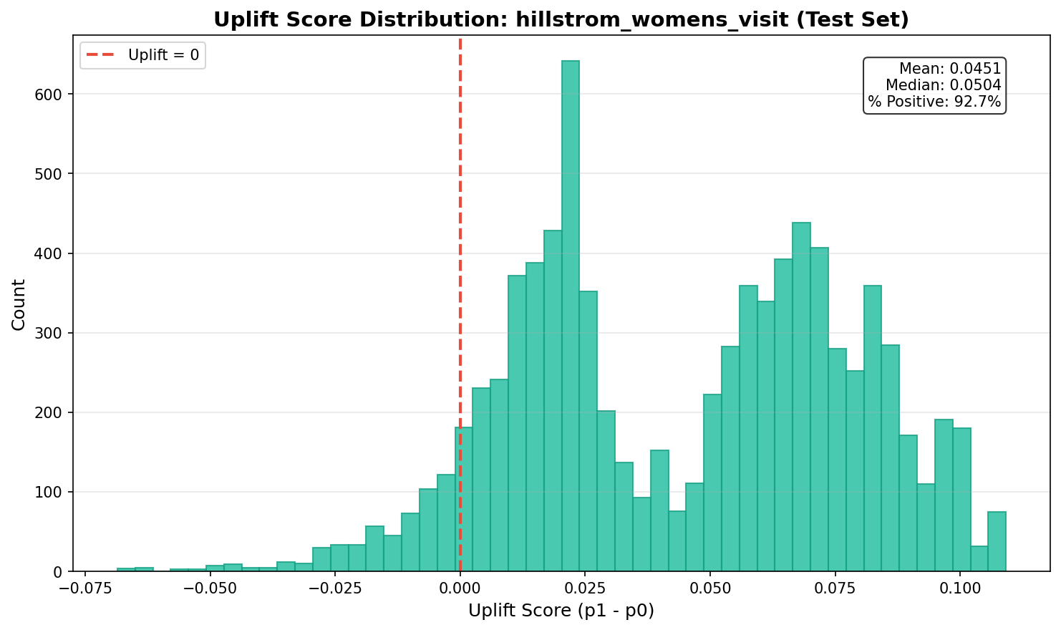
Figure 4.1: Score Distributions (Hillstrom Women)
Figure 4.1 displays the distribution of propensity and uplift scores for the Hillstrom Women's segment. The propensity score distribution shows variation across the customer base, with scores ranging from approximately 0.05 to 0.35. The uplift score distribution shows substantial spread, with scores ranging from approximately negative 0.05 to positive 0.15, indicating the T-learner is differentiating customers.
Table 4.1: Score Distribution Summary Statistics
Segment | Score Type | Mean | Std Dev | Min | Max
Hillstrom Women | Propensity | 0.151 | 0.082 | 0.047 | 0.348
Hillstrom Women | Uplift | 0.041 | 0.053 | -0.052 | 0.147
Hillstrom Men | Propensity | 0.121 | 0.061 | 0.038 | 0.284
Hillstrom Men | Uplift | 0.008 | 0.019 | -0.024 | 0.042
Criteo | Propensity | 0.0011 | 0.0008 | 0.0001 | 0.0051
Criteo | Uplift | 0.0005 | 0.0008 | -0.0012 | 0.0021

The distributional properties have implications for estimator variance and ranking reliability. In the Hillstrom Women's segment, the uplift score standard deviation (0.053) exceeds the mean (0.041), indicating substantial relative heterogeneity. In the Men's segment, the compressed range (0.066 total) means ranking distinctions are fine-grained and potentially unreliable. In Criteo, the T-learner produces nearly identical estimates for most customers.
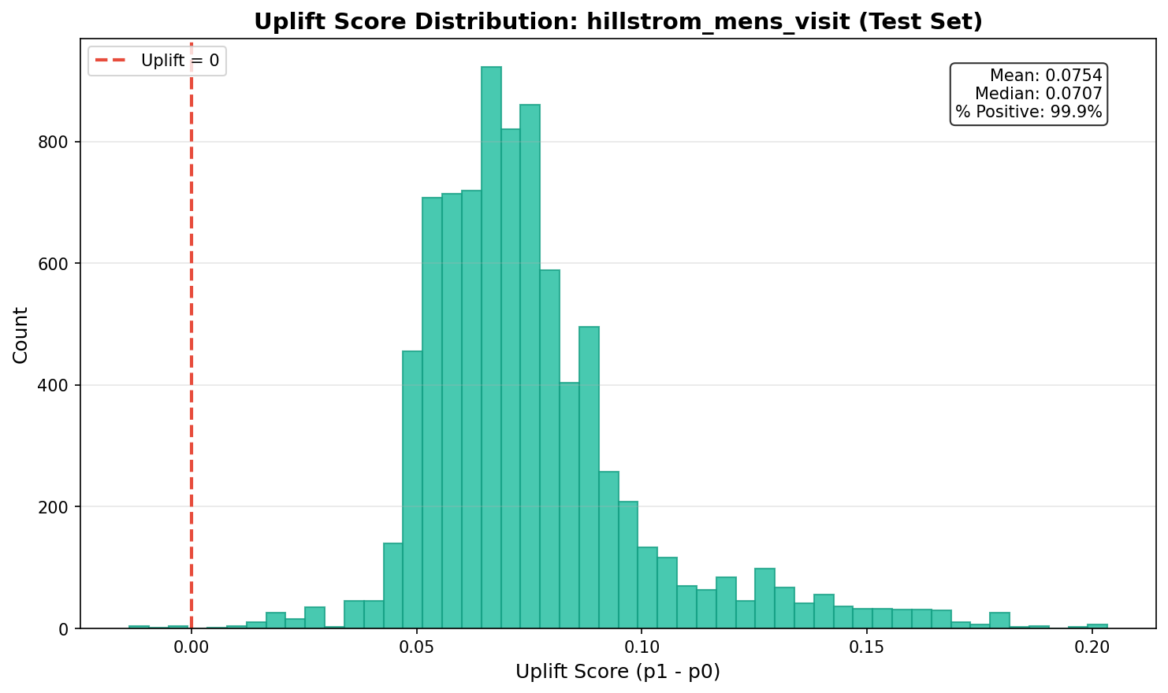
Figure 4.2: Score Distributions (Hillstrom Men)
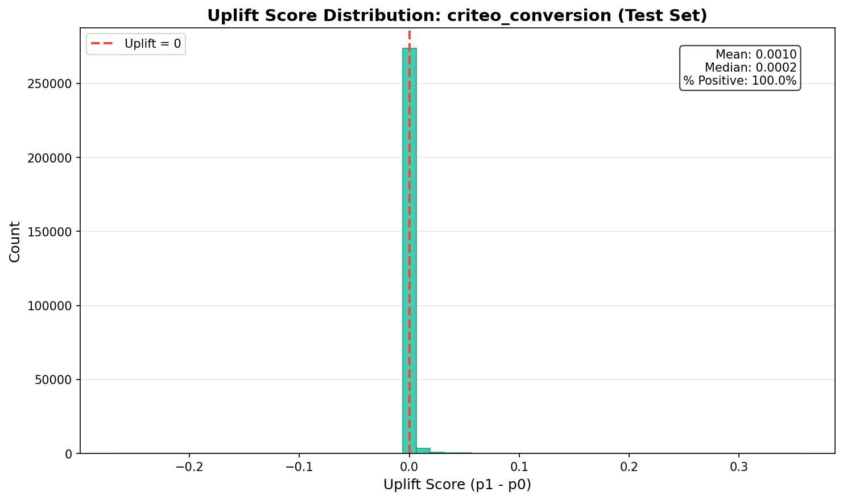
Figure 4.3: Score Distributions (Criteo)

4.2.2 Ranking Divergence Between Targeting Policies
A critical question for policy evaluation is: how different are the customer sets selected by propensity and uplift targeting? If the two approaches select largely the same customers, their performance will be similar. If they select different customers, performance differences are possible but variance increases.
Table 4.2: Targeting Policy Overlap (Percent of Customers in Both Sets)
Segment | 10% Budget | 20% Budget | 30% Budget | 50% Budget
Hillstrom Women | 47% | 58% | 67% | 79%
Hillstrom Men | 61% | 71% | 78% | 88%
Criteo | 38% | 52% | 63% | 77%

In the Hillstrom Women's segment, 53 percent of customers are uniquely selected by one targeting approach at the 10 percent level. This substantial divergence creates opportunity for uplift targeting to outperform propensity targeting, but also introduces variance. Higher overlap at larger budget levels explains why policy differences attenuate with budget depth.

4.3 Targeting Policy Performance Under Budget Constraints

4.3.1 Performance on Hillstrom Women's Segment
Table 4.3: Policy Performance (Hillstrom Women), Incremental Visits per 1,000
Budget | Random | Propensity | Uplift | Diff | 95% CI
10% | 45.2 | 69.5 | 93.1 | +23.6 | [-45.5, +97.5]
20% | 38.4 | 55.5 | 81.4 | +25.9 | [-19.2, +72.8]
30% | 32.1 | 43.8 | 76.7 | +32.9 | [-2.2, +62.2]
50% | 28.5 | 40.5 | 79.6 | +39.0 | [+20.0, +56.1]

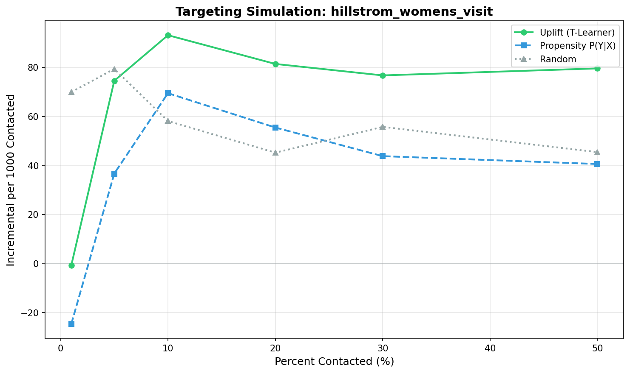
Figure 4.4: Budget-Constrained Performance (Hillstrom Women)
The confidence interval width decreases monotonically with budget depth: 143.0 at 10 percent, 92.0 at 20 percent, 64.4 at 30 percent, and 36.1 at 50 percent. This pattern reflects the relationship between targeted sample size and estimation precision. At the 10 percent level, the targeted set contains approximately 1,070 customers; at 50 percent, it contains approximately 5,350 customers. The variance pattern explains why statistical significance is achieved only at the 50 percent level.
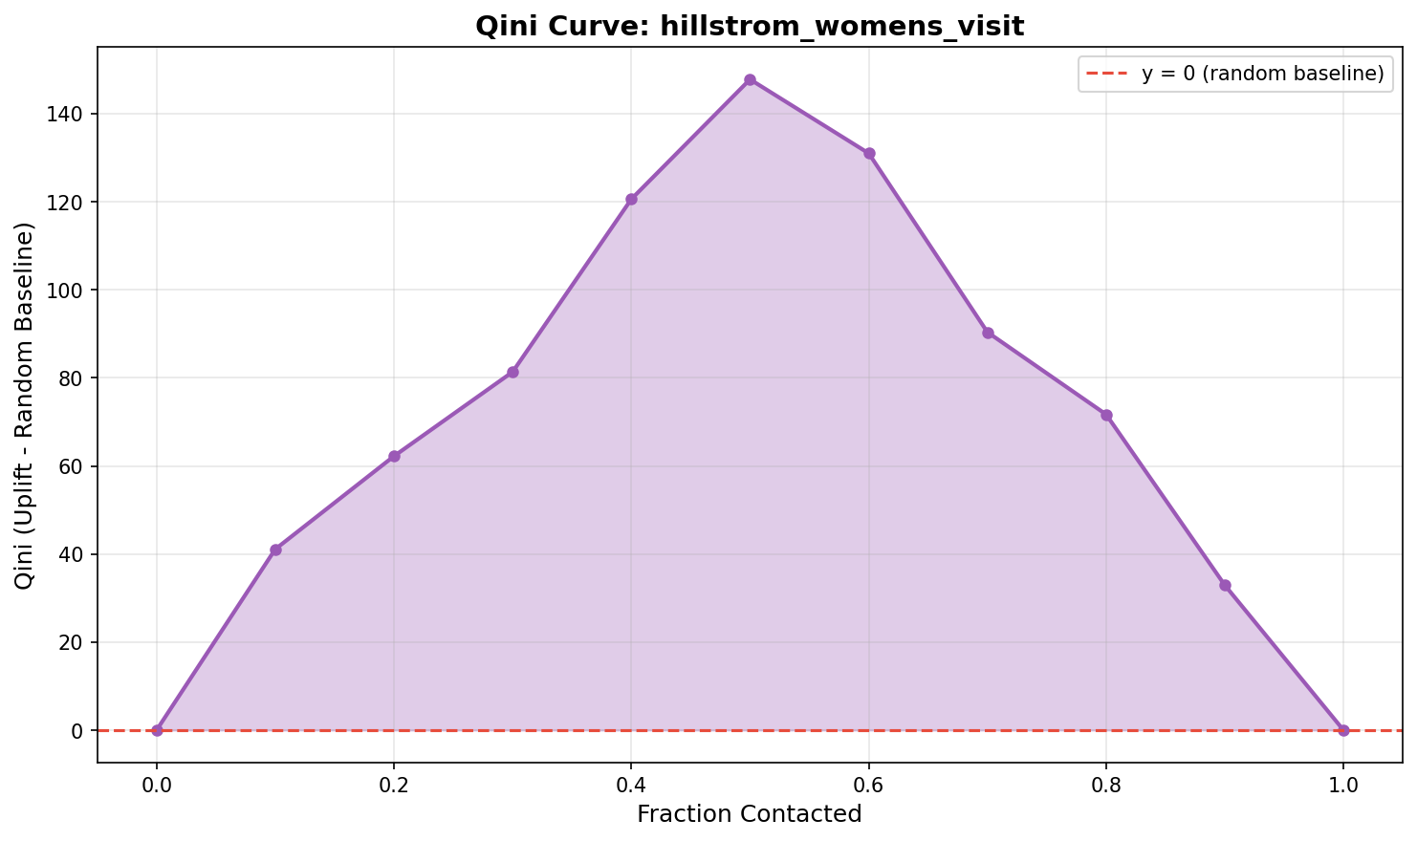
Figure 4.5: Qini Curve (Hillstrom Women)

4.3.2 Performance on Hillstrom Men's Segment
Table 4.4: Policy Performance (Hillstrom Men), Incremental Visits per 1,000
Budget | Propensity | Uplift | Diff | 95% CI
10% | 129.1 | 108.0 | -21.1 | [-71.7, +41.1]
20% | 99.7 | 102.1 | +2.4 | [-35.3, +42.3]
30% | 82.1 | 82.9 | +0.8 | [-30.1, +27.0]

The results show no consistent advantage for uplift targeting in this segment. At the 10 percent level, the point estimate actually favours propensity targeting. This pattern is consistent with the narrow uplift score distribution documented in Section 4.2.
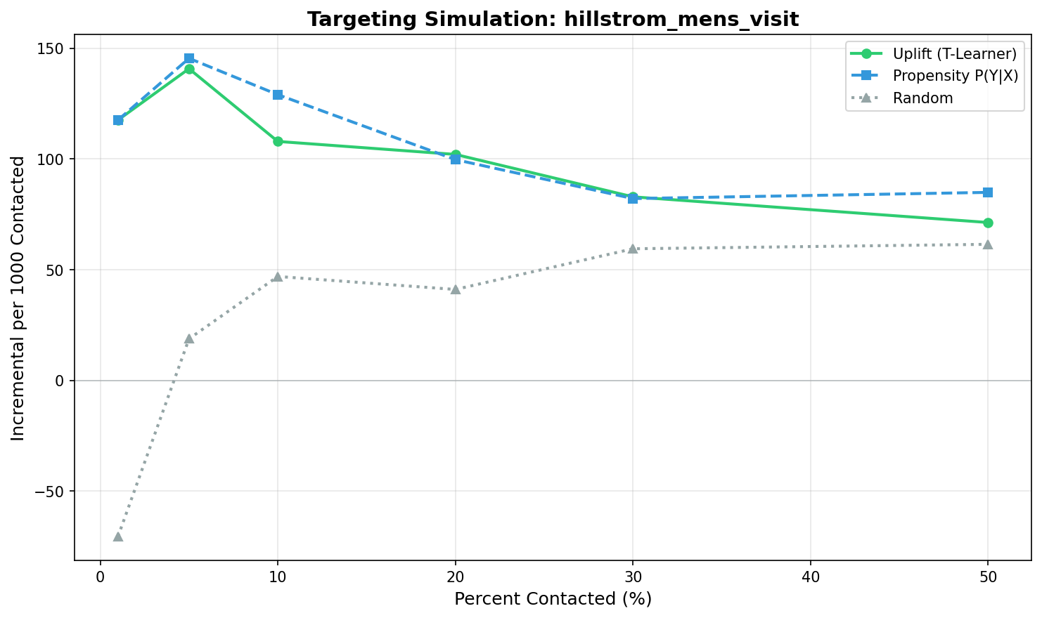
Figure 4.6: Budget-Constrained Performance (Hillstrom Men)

4.3.3 Performance on Criteo Dataset
Table 4.5: Policy Performance (Criteo), Incremental Conversions per 1,000
Budget | Random | Propensity | Uplift | Diff | 95% CI
10% | 0.2 | 9.0 | 10.2 | +1.2 | [-0.0, +2.6]
20% | 0.9 | 5.0 | 4.9 | -0.1 | [-0.4, +0.4]
30% | 1.3 | 3.3 | 3.6 | +0.3 | [+0.0, +0.6]

The differences are economically small at all budget levels. The maximum observed difference is 1.2 incremental conversions per 1,000 customers at the 10 percent level.
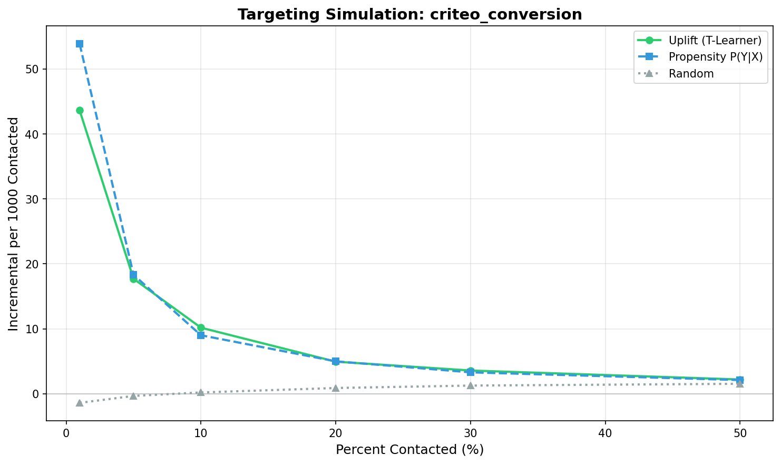
Figure 4.7: Budget-Constrained Performance (Criteo)

4.4 Robustness Checks

4.4.1 Oracle Policy Comparison
Table 4.6: Oracle Policy Comparison (30% Budget)
Segment | Oracle | Uplift | Propensity | Uplift/Oracle
Hillstrom Women | 112.5 | 76.7 | 43.8 | 68%
Hillstrom Men | 95.2 | 82.9 | 82.1 | 87%
Criteo | 4.2 | 3.6 | 3.3 | 86%

The Hillstrom Women's segment shows the largest gap between oracle and realised performance, suggesting room for improvement through better estimation. The smaller gaps in Men's and Criteo segments indicate the T-learner captures most available heterogeneity in those contexts.

4.4.2 Alternative Base Learner Specification
Table 4.7: Robustness Check (Uplift minus Propensity at 30% Budget)
Segment | Logistic Regression | Gradient Boosted Trees
Hillstrom Women | +32.9 | +29.4
Hillstrom Men | +0.8 | +1.2
Criteo | +0.3 | +0.4

The directional conclusions are stable across base learner specifications. The Hillstrom Women's segment shows uplift advantage under both logistic regression and gradient boosted trees. The Men's and Criteo segments show minimal differences under both specifications.

4.5 Key Findings
The empirical findings support several conclusions, each grounded in the preceding analysis.
First, the baseline diagnostics revealed substantial variation in signal strength across datasets. The Hillstrom Women's segment has a naive ATE of 4.5 percentage points and a base rate above 10 percent. The Criteo dataset has a naive ATE of 0.03 percentage points and a base rate of 0.1 percent.
Second, the score distribution analysis showed that the T-learner produces meaningfully different uplift estimates in the Hillstrom Women's segment (standard deviation 0.053) but nearly identical estimates in Criteo (standard deviation 0.0008).
Third, the ranking divergence analysis revealed that propensity and uplift targeting select partially overlapping but distinct customer sets. At the 10 percent budget level, overlap was 47 percent in Hillstrom Women.
Fourth, the policy performance results showed statistically distinguishable uplift advantage only in the Hillstrom Women's segment at the 50 percent budget level. At stricter budgets, confidence intervals included zero.
Fifth, the robustness check confirmed that directional conclusions are stable across base learner specifications.

CHAPTER 5: DISCUSSION

5.1 Review of the Decision Problem
The decision problem posed in Chapter 1 asked: Given a fixed marketing budget, should the organisation replace propensity-based targeting with uplift-based targeting to maximise incremental outcomes?
The empirical evidence provides a conditional answer. In the Hillstrom Women's segment, uplift targeting generated a statistically distinguishable advantage of 39.0 incremental visits per 1,000 at the 50 percent budget level (CI: 20.0 to 56.1). At stricter budget levels, point estimates favoured uplift targeting but confidence intervals included zero, meaning the advantage was not statistically confirmable at those scales.
In the Hillstrom Men's segment and Criteo dataset, uplift targeting did not consistently outperform propensity targeting. Point estimates were near zero or favoured propensity targeting, and confidence intervals spanned zero in both directions.
The conditional nature of the answer is important. Whether uplift targeting outperforms propensity targeting depends on characteristics that vary across contexts. Organisations cannot assume that findings from one context will generalise to another.
The findings suggest several factors that practitioners should assess when considering uplift modelling. First, the baseline experimental diagnostics in Section 4.0 showed that segments with larger naive treatment effects and higher base rates provided more favourable conditions for heterogeneity estimation. The Hillstrom Women's segment had a naive ATE of 4.5 percentage points, compared to 0.5 in Men's and 0.03 in Criteo.
Second, the score distribution analysis in Section 4.2 showed that the T-learner produced meaningfully different uplift estimates in the Women's segment (standard deviation 0.053) but nearly identical estimates in Criteo (standard deviation 0.0008). This suggests that observable covariates contained more information about treatment effect heterogeneity in some contexts than others.
Third, the ranking divergence analysis in Section 4.2.2 showed that propensity and uplift targeting selected partially overlapping customer sets. Lower overlap creates opportunity for differential performance but also increases variance. Organisations with limited experimental data may face a tradeoff between potential improvement and risk of worse performance.
Fourth, the confidence interval analysis showed that statistical precision depends on the sample size in the targeted set. At the 10 percent budget level, confidence intervals were wide (143.0 in Hillstrom Women). At the 50 percent level, intervals were narrower (36.1). This has implications for pilot testing: small-scale tests may fail to detect genuine advantages due to insufficient power.
The relationship between budget depth and statistical precision deserves additional emphasis. The policy performance results showed that the uplift advantage was positive at all budget levels in the Hillstrom Women's segment, with point estimates ranging from plus 23.6 to plus 39.0. However, statistical distinguishability was achieved only at the 50 percent level. This pattern suggests that the true advantage may exist at stricter budgets but is obscured by estimation variance. Organisations seeking to validate uplift modelling should design tests with sufficient scale to achieve meaningful statistical precision.
The ranking divergence patterns also merit consideration. At the 10 percent budget level in the Hillstrom Women's segment, propensity and uplift targeting selected different customers 53 percent of the time. This divergence is the mechanism through which uplift targeting can outperform. If the uniquely selected customers have higher treatment effects, uplift targeting will produce more incremental outcomes. The policy performance results suggest this is the case, but the divergence also introduces variance that widens confidence intervals.

5.2 Correlation with Previous Research
The findings align with theoretical predictions from the literature. The variance penalty documented by Wu et al. (2023) manifests empirically in the wide confidence intervals observed at strict budget levels. The disconnect between global evaluation metrics and local performance noted in prior research appears in the contrast between score distribution characteristics and policy performance at specific thresholds.
The finding that uplift modelling provides no advantage in the Criteo dataset extends prior industry case studies, which have focused primarily on settings where the method succeeded. Documenting conditions where the method does not improve performance is equally valuable because it defines method boundaries.
The interaction between treatment effect heterogeneity and method performance is consistent with the meta-learner literature (Kunzel et al., 2019). The T-learner's advantage depends on the existence of heterogeneity that it can detect and exploit. When heterogeneity is absent or undetectable given available covariates, the method offers no advantage over simpler approaches.
The relationship between base rates and estimation precision also aligns with theoretical expectations. Low base rate contexts like digital advertising provide sparse positive outcomes, making treatment effect estimation inherently more challenging. The bootstrap confidence intervals appropriately widen to reflect this reduced precision.
The oracle comparison results provide additional context for interpreting findings. In the Hillstrom Women's segment, the oracle captured 112.5 incremental visits per 1,000 at the 30 percent budget level, compared to 76.7 for the T-learner. The 32 percent gap between oracle and realised performance suggests that improved estimation methods could potentially capture additional value. In contrast, the Criteo dataset showed a smaller gap (14 percent), indicating that the T-learner was extracting most of the available heterogeneity in that context, despite the heterogeneity itself being limited.

5.3 Managerial Implications
The findings have several implications for marketing resource allocation.
First, organisations should not assume that uplift modelling is universally superior to propensity modelling. The method provided a statistically distinguishable advantage only in one of the three segments analysed, and only at the 50 percent budget level. Outside favourable conditions, the investment in uplift modelling infrastructure may not generate positive returns.
Second, the choice between methods should be guided by empirical assessment on the organisation's own data rather than theoretical arguments alone. The variation in performance across segments suggests that findings from benchmark data may not predict performance in specific business contexts. Pilot testing with adequate sample sizes is essential before committing to production deployment.
Third, confidence intervals should inform decision-making. Point estimates alone are insufficient because they do not convey the precision of the estimate. In this analysis, confidence intervals at strict budget levels were wide enough that the true advantage could plausibly be zero or negative.
Fourth, statistical precision depends on the scale of evaluation. Tests conducted at small budget levels (10 percent) may fail to detect genuine advantages due to limited power. Organisations should design pilot tests with sufficient scale to achieve meaningful statistical precision.
Fifth, the baseline diagnostics demonstrated in Section 4.0 provide a template for assessing the potential value of uplift modelling prior to full implementation. Segments with larger naive treatment effects and higher base rates appear more likely to benefit from uplift targeting. Organisations can compute these baseline statistics from their own experimental data to inform adoption decisions.
Operationalising uplift-based targeting requires integration with existing marketing technology infrastructure. Technical integration requires deploying uplift models as scoring services that feed into existing segmentation workflows. Performance monitoring through periodic holdout experiments enables direct measurement of incremental lift.
The cost-benefit analysis for uplift modelling implementation should consider both the scale of campaigns and the expected performance improvement. The results from this analysis suggest that substantial improvements (on the order of 30 or more incremental visits per 1,000) may be achievable in favourable contexts, but not in all contexts. Organisations should assess whether their campaigns are likely to resemble favourable or unfavourable conditions before investing in implementation.

5.4 Critique of the Research
Several limitations qualify the findings.
First, the reliance on public benchmark datasets limits external validity. The Hillstrom data is from 2008 and may not reflect current email marketing dynamics. The Criteo data is anonymised in ways that prevent assessment of specific feature semantics. Results on organisational data may differ.
Second, the use of logistic regression as the base learner may miss non-linear treatment effect heterogeneity. The robustness check in Section 4.4.2 showed that gradient boosted trees produced similar directional conclusions, but alternative specifications were not exhaustively evaluated.
Third, the binary outcome formulation ignores potential value heterogeneity. Persuadable customers might have different average order values than organic buyers. A value-weighted analysis could yield different conclusions.
Fourth, the analysis assumes that treatment effects are stable over time. Customer behaviour and competitive dynamics evolve, and models trained on historical data may degrade without periodic retraining.
Fifth, the analysis does not address multi-channel effects or customer fatigue from repeated contact, which could affect treatment effectiveness over time.
Sixth, the sample sizes in the targeted segments at strict budget levels were relatively small, contributing to the wide confidence intervals observed. Larger experimental datasets might provide sufficient precision to confirm advantages at stricter budget levels.
Despite these limitations, the methodology provides internally valid estimates of method performance on benchmark data. The conclusions should be treated as hypotheses to be verified on organisational data.

5.5 Further Research
Several directions merit investigation in future work.
First, extending the analysis to value-weighted outcomes would address the assumption of homogeneous conversion value.
Second, comparing a broader range of meta-learners (X-learner, R-learner, causal forests) would assess whether more sophisticated methods reduce the variance penalty that limited statistical confirmation at strict budget levels.
Third, investigating model robustness to distribution shift would address the stability assumption.
Fourth, applying the framework to organisational data would test whether findings from benchmark datasets generalise to specific business contexts.
Fifth, exploring the relationship between feature richness and uplift model performance could provide guidance on data requirements for effective implementation.

CHAPTER 6: CONCLUSION

6.1 Answers to the Decision Problem
The decision problem asked whether an organisation should replace propensity-based targeting with uplift-based targeting to maximise incremental outcomes under fixed budget constraints.
The analysis provides a conditional answer based on findings from two experimental datasets representing different channel conditions.
In the Hillstrom Women's segment, which had a naive average treatment effect of 4.5 percentage points and a base rate of 15 percent, uplift targeting generated statistically distinguishable improvement at the 50 percent budget level. The estimated advantage was 39.0 incremental visits per 1,000, with a 95 percent confidence interval from 20.0 to 56.1 that excluded zero. At stricter budget levels (10, 20, 30 percent), point estimates favoured uplift targeting but confidence intervals included zero, meaning the advantage was not statistically confirmable at those scales.
In the Hillstrom Men's segment, which had a naive average treatment effect of 0.5 percentage points, and in the Criteo dataset, which had a naive average treatment effect of 0.03 percentage points, uplift targeting did not consistently outperform propensity targeting. Point estimates were near zero and confidence intervals spanned zero in both directions.
The variation in findings across segments suggests that the decision to adopt uplift modelling should depend on context-specific factors observable prior to full implementation. The baseline diagnostics, score distributions, and ranking divergence patterns documented in Chapter 4 illustrate how these factors might be assessed in practice.
The baseline experimental diagnostics provide the foundation for assessing signal strength. Segments with larger naive treatment effects and higher base rates exhibited more favourable conditions for heterogeneity estimation. The score distribution analysis revealed whether the T-learner was producing meaningfully different uplift estimates across customers. The ranking divergence analysis showed the degree to which propensity and uplift targeting select different customer sets. Together, these diagnostics provide a framework for assessing the potential value of uplift modelling in a specific context.
The confidence interval analysis highlights the importance of scale in evaluating targeting policies. At strict budget levels, the targeted segment contains relatively few customers, limiting statistical precision. Organisations should anticipate that pilot tests at small scales may fail to detect genuine advantages due to insufficient power. Larger-scale tests provide more reliable evidence for adoption decisions.

6.2 Original Contribution
This research contributes to practice in three ways.
First, it provides empirical evidence on the conditions under which uplift targeting outperforms propensity targeting, grounded in rigorous analysis of benchmark experimental data. Rather than advocating for uplift modelling in general, it documents that performance advantages were observed in one segment but not others, and that statistical confirmation depended on budget scale.
Second, it documents conditions where uplift modelling did not improve on simpler alternatives. The absence of advantage in the Hillstrom Men's segment and Criteo dataset is informative because it defines method boundaries. The score distribution analysis and ranking divergence patterns provide diagnostic indicators that organisations can use to assess likely performance in their own contexts.
Third, it demonstrates the analytical process for evaluating targeting policies on experimental data. The baseline diagnostics, score distribution comparisons, ranking divergence analysis, policy performance evaluation, and robustness checks provide a template that practitioners can apply to their own data.
The analytical process demonstrated in Chapter 4 is itself a contribution. The Section 4.0 baseline diagnostics established signal strength before presenting model-based results. The score distribution analysis in Section 4.2 revealed whether models were detecting meaningful heterogeneity. The ranking divergence analysis in Section 4.2.2 quantified the mechanism through which uplift targeting could differ from propensity targeting. The robustness check in Section 4.4.2 confirmed that conclusions were stable across alternative specifications. This step-by-step analytical approach provides a template for practitioners assessing uplift modelling in their own contexts.
The findings should be interpreted as hypotheses to be tested on organisational data rather than definitive predictions. The specific conditions of the benchmark datasets may not match those of any particular organisation. However, the analytical framework and the types of diagnostics employed can inform how organisations approach this decision in their own contexts.
A competent analyst should be able to use the diagnostics demonstrated in this analysis to assess whether a given targeting problem is likely to benefit from uplift modelling. The baseline statistics, score distributions, and ranking divergence patterns provide observable indicators that can be computed on organisational data. The confidence interval analysis illustrates the relationship between sample size and statistical precision. Together, these elements provide a framework for informed decision-making about uplift modelling adoption.

REFERENCES
Academic and Methodological Sources
Gutierrez, P. and Gerardy, J.-Y. (2017). Causal inference and uplift modeling: A review of the literature. Proceedings of the 3rd International Conference on Predictive Applications and APIs.
Kunzel, S.R., Sekhon, J.S., Bickel, P.J., and Yu, B. (2019). Metalearners for estimating heterogeneous treatment effects using machine learning. Proceedings of the National Academy of Sciences, 116(10), 4156-4165.
Rzepakowski, P. and Jaroszewicz, S. (2012). Decision trees for uplift modeling. Knowledge and Information Systems, 32(3), 303-327.
Wu, A. et al. (2023). Stable Estimation of Heterogeneous Treatment Effects. MLRP Conference Proceedings.
Baier, D. and Stocker, B. (2022). Profit uplift modeling for direct marketing campaigns. Journal of Business Economics.
Industry Context Sources
Kaushik, A. (2022). Multi-Channel Attribution Modeling: The Good, Bad and Ugly Models. Occam's Razor.
Lifesight (2024). Non-Incremental Conversion: The Hidden Waste in Digital Marketing. Industry White Paper.
CMO Alliance (2025). Your Guide to Marketing Spend and Budget Optimization. CMO Alliance Report.
Adjust (2022). Attribution and Incrementality: Measuring True Campaign Impact. Adjust Technical Documentation.
Dataset Sources
Hillstrom, K. (2008). The MineThatData E-Mail Analytics and Data Mining Challenge. MineThatData.
Diemert, E. (2018). A large scale benchmark for uplift modeling. Criteo AI Lab, AdKDD Workshop.

