1. Login to AWS console using user id and password

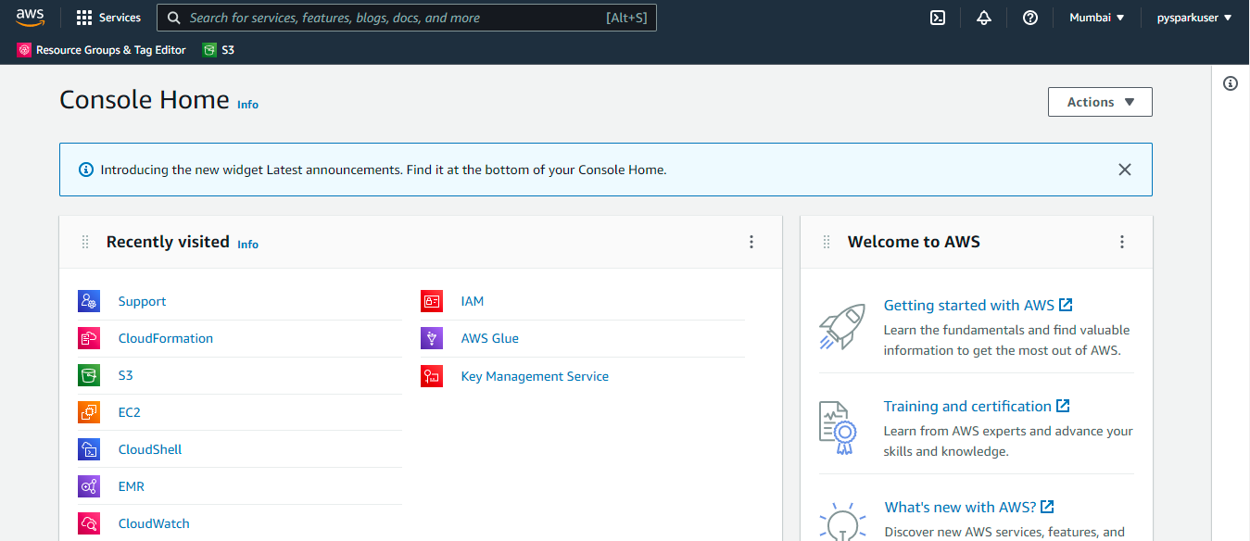

1. Install master instance in EC2

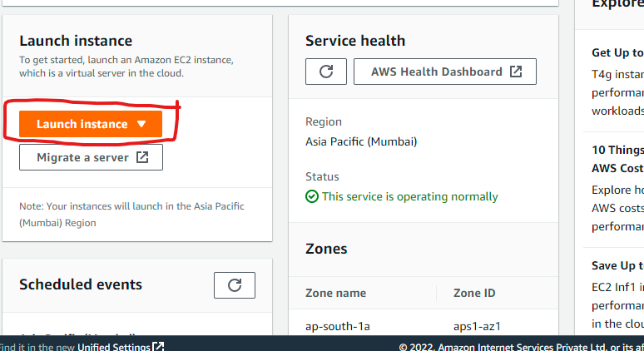

1. Below are screenshot for master EC2 instance provisioning

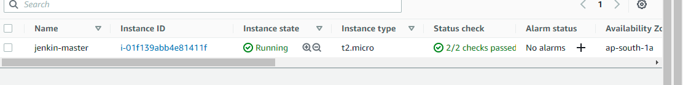

3) Clone your git project in local and EC2 master node

1. Cloning git to local

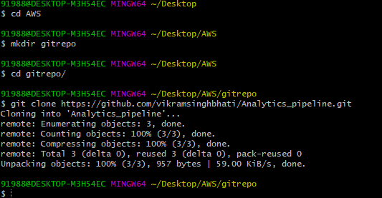

1. Cloning git to jenkin-master EC2 node and install git in /opt path in EC2 directory

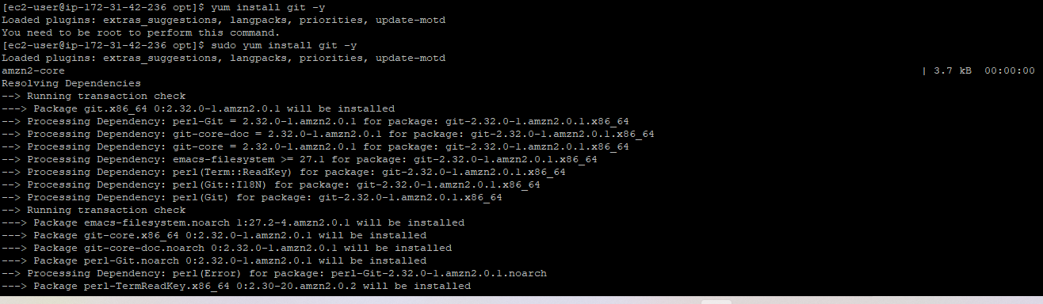

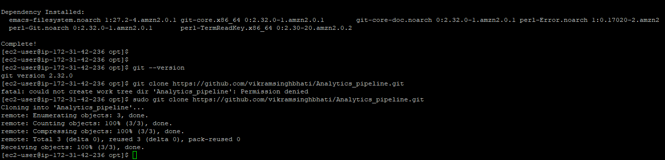

1. Install jenkins and tomcat services in jenkins-master EC2 instance

Run below shell script for tomcat and jenkins install

. ./install_tomcat_jenkins.sh

1. Check jenkins working on not use public ipv4:8080/jenkins in browser

Once Jenkins setup we can see the below landing page

Check jenkin service running or not

sudo systemctl status jenkins

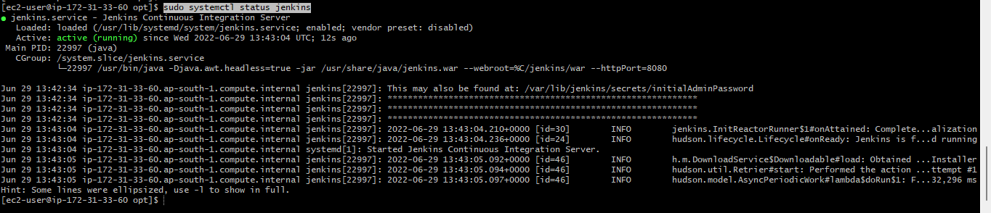

If service not started then plz run below cmd

sudo systemctl start jenkins

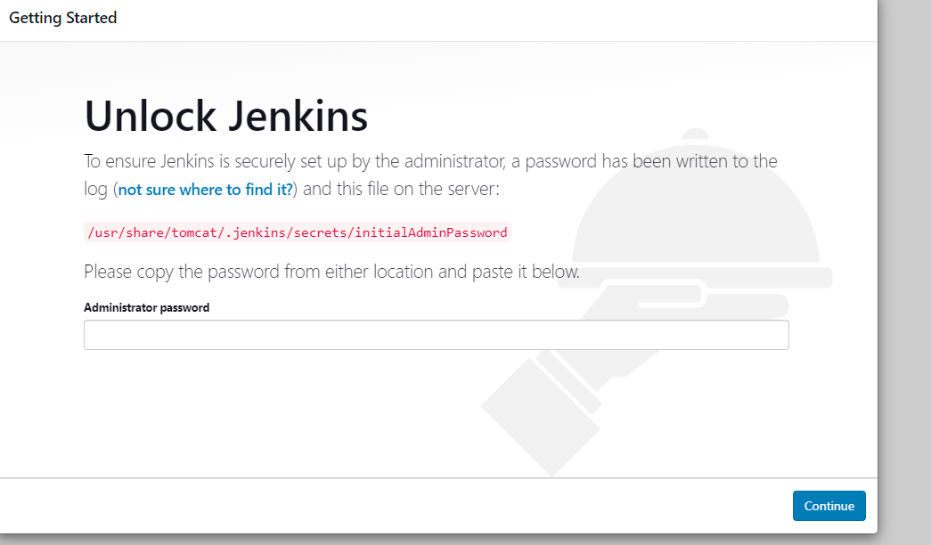

1. Login with default pwd and setup jenkins account .(note default pwd will present in initalAdminPassword file) and install recommended plugin (deafult option)

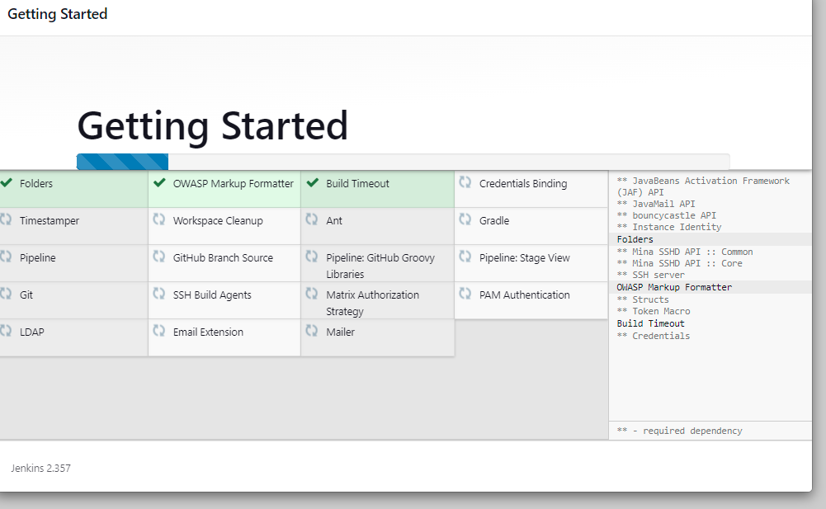

1. Once jenkins is ready below landing page we can see

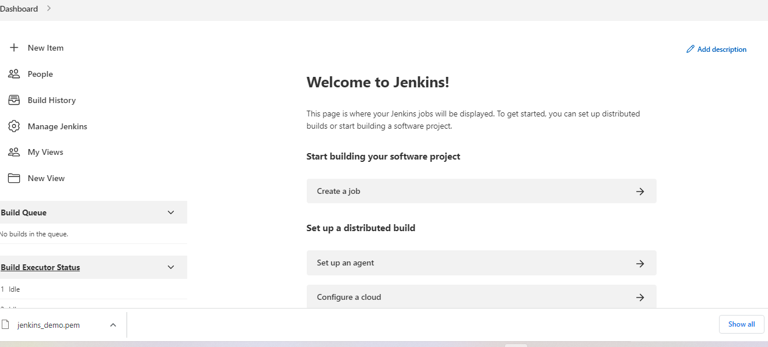

4) add CloudBees AWS Credentials plugin in manage jenkin plugin

5) Add Credentials as per your environment. Example here:  
Jenkins > manage Credentials > System > Global credentials (unrestricted) -> Add  
Kind = AWS Credentials and add your AWS credentials  
Note the ID

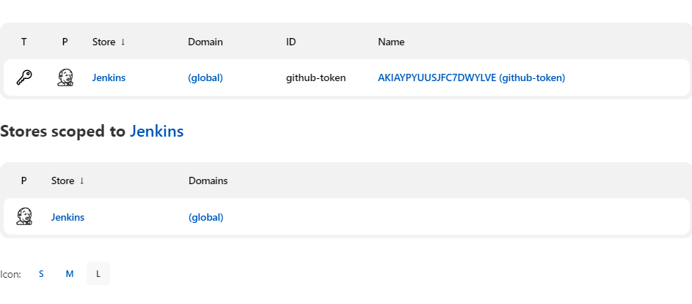

6) create pipeline project with following parameter .( we can use webhook or SCM pooling mechanism as well to look for any changes made in github repository )

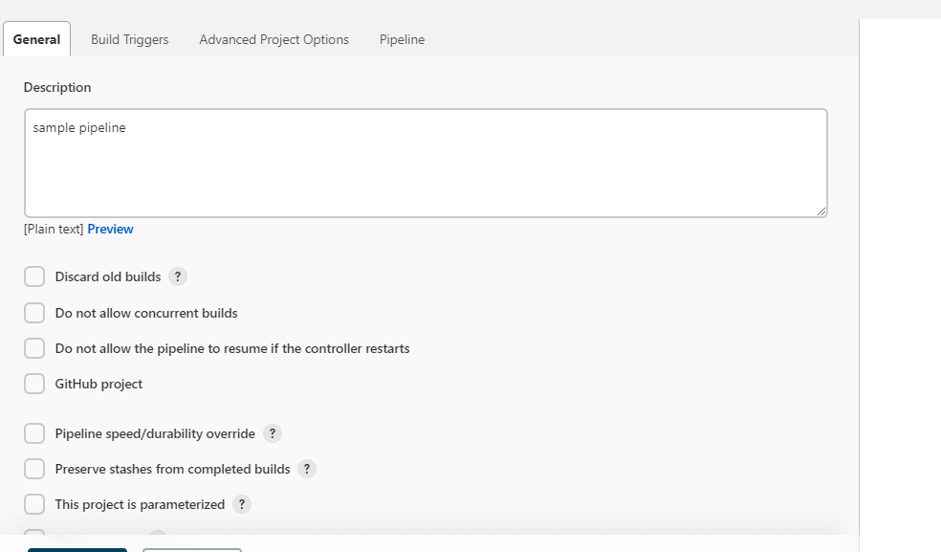

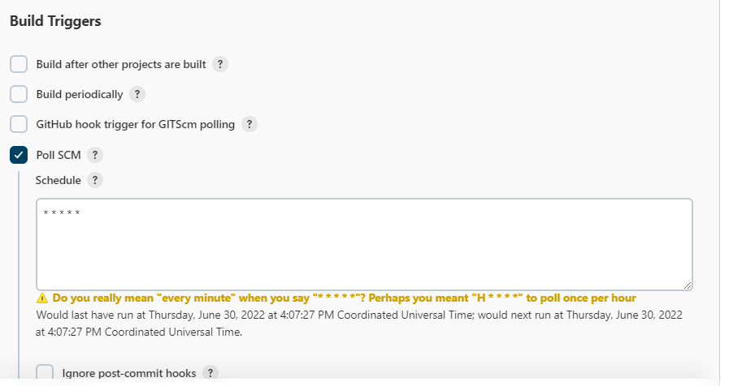

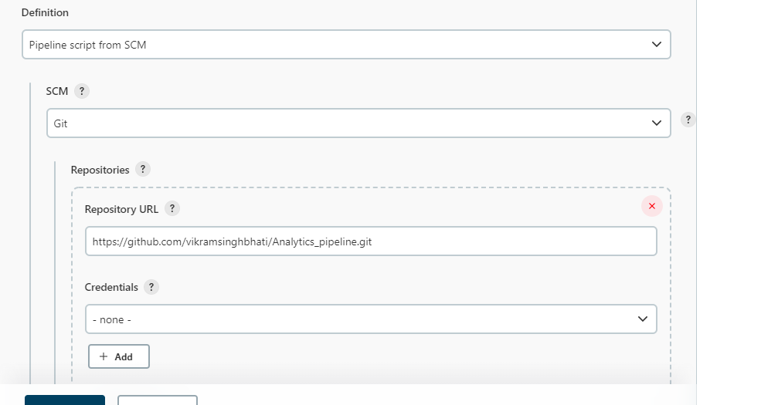

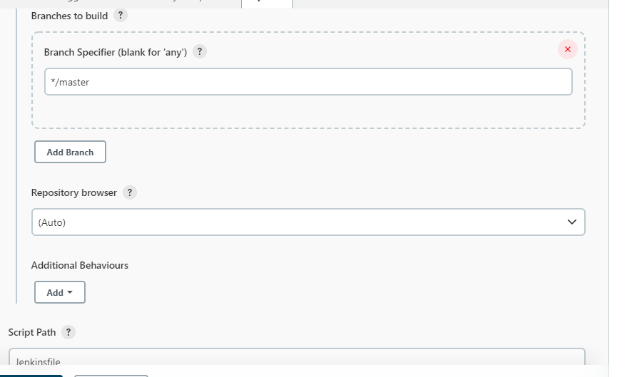

Build log

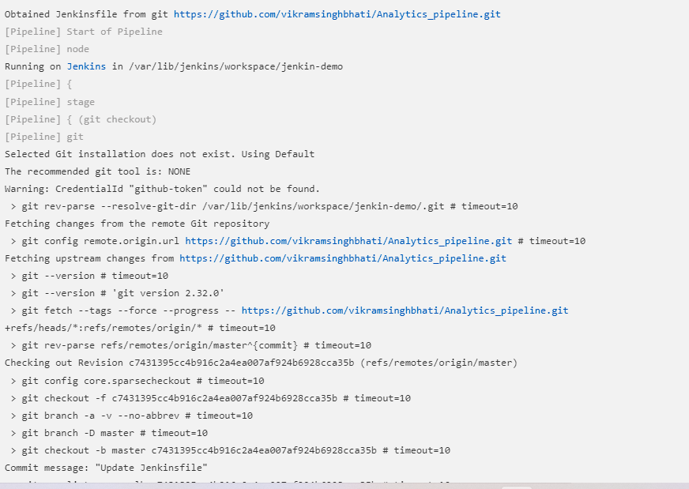

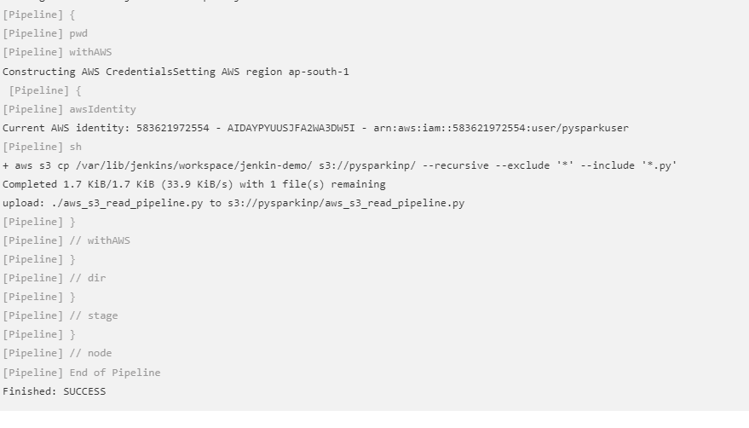

Jenkinfile

node('node'){

stage('git checkout'){

try {

git credentialsId: 'github-token', url: 'https://github.com/vikramsinghbhati/Analytics_pipeline.git'

} catch(err) {

sh "echo error in checkout"

}

}

stage('artifacts to s3') {

try {

dir('/var/lib/jenkins/workspace/jenkin-demo'){

pwd(); //Log current directory

withAWS(region:'ap-south-1',credentials:'github-token') {

def identity=awsIdentity();//Log AWS credentials

// Upload files from working directory 'dist' in your project workspace

// s3Upload(bucket:"pysparkinp", workingDir:'/var/lib/jenkins/workspace/jenkin-demo/', includePathPattern:'**/*');

sh 'aws s3 cp /var/lib/jenkins/workspace/jenkin-demo/ s3://pysparkinp/ --recursive --exclude "*" --include "*.py"'

}

};

} catch(err) {

sh "echo error in sending artifacts to s3"

}

}

}

|  |
| --- |

|  |  |
| --- | --- |
|  |  |
|  |  |
|  |  |
|  |  |
|  |  |
|  |  |
|  |  |
|  |  |
|  |  |
|  |  |
|  |  |
|  |  |
|  |  |
|  |  |
|  |  |
|  |  |