**Set Up your Development Environment**

**GIT Repository:**

<https://github.com/vikramsm/agile>

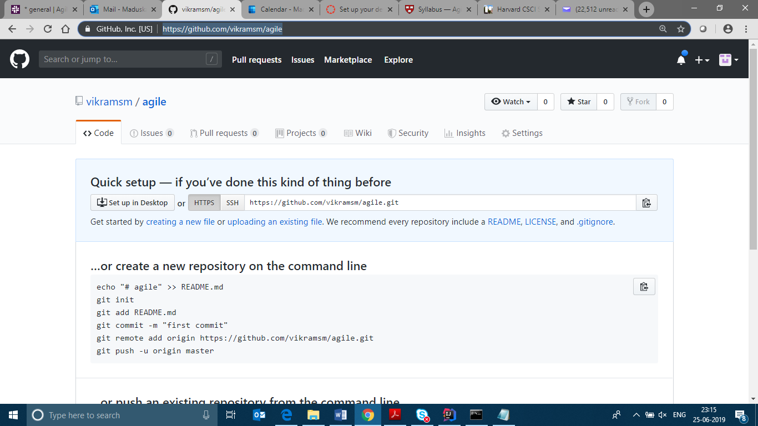

**Hello World Java Code:**

import java.util.Scanner;

public class HelloWorld {

public static void main(String[] args)

{

Scanner input = new Scanner (System.in);

System.out.print("Enter your first name: ");

String fname = input.next();

System.out.print("Enter your last name: ");

String lname = input.next();

System.out.println();

System.out.println("Hello \n"+fname+" "+lname);

}

}

**Run code in CMD:**

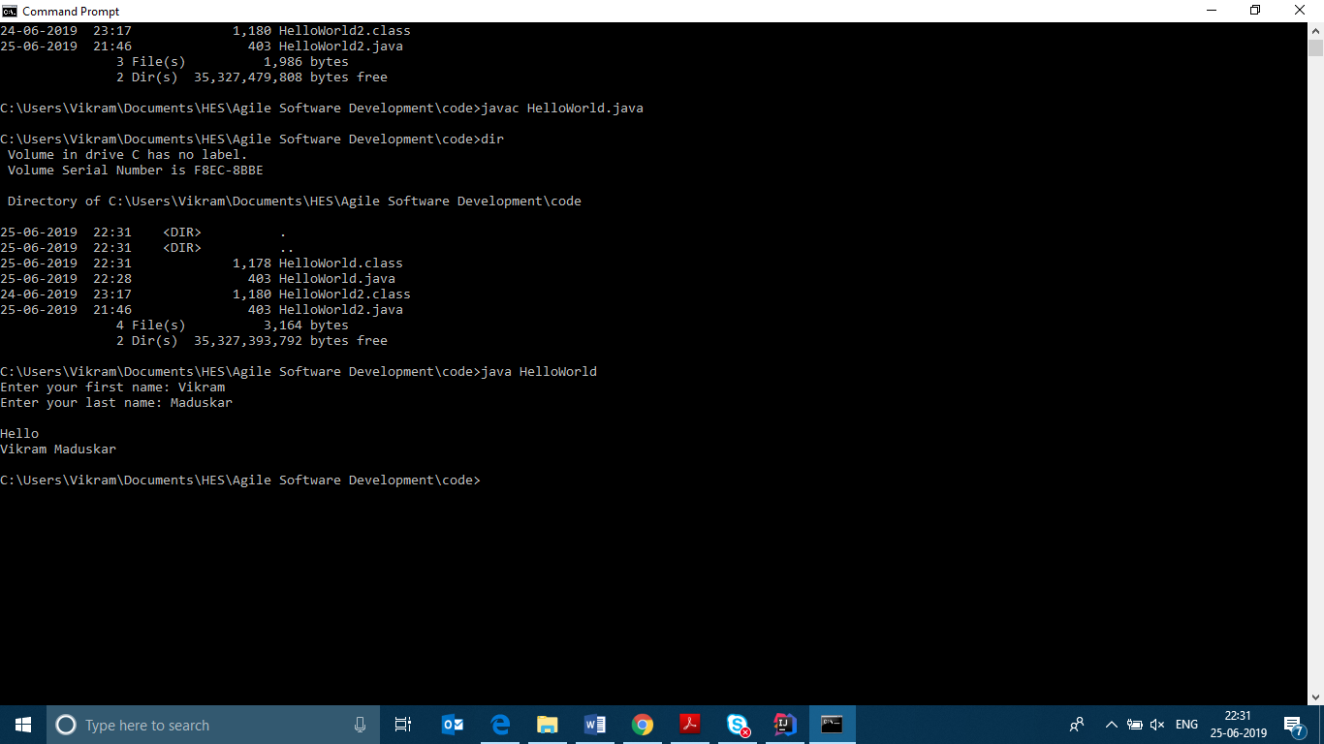

**Run Code in IntelliJ:**

