**REPORT : CLOCK INCONSISTENCY OF SMART PHONE FLASH LIGHT AND A POTENTIAL SOLUTION**

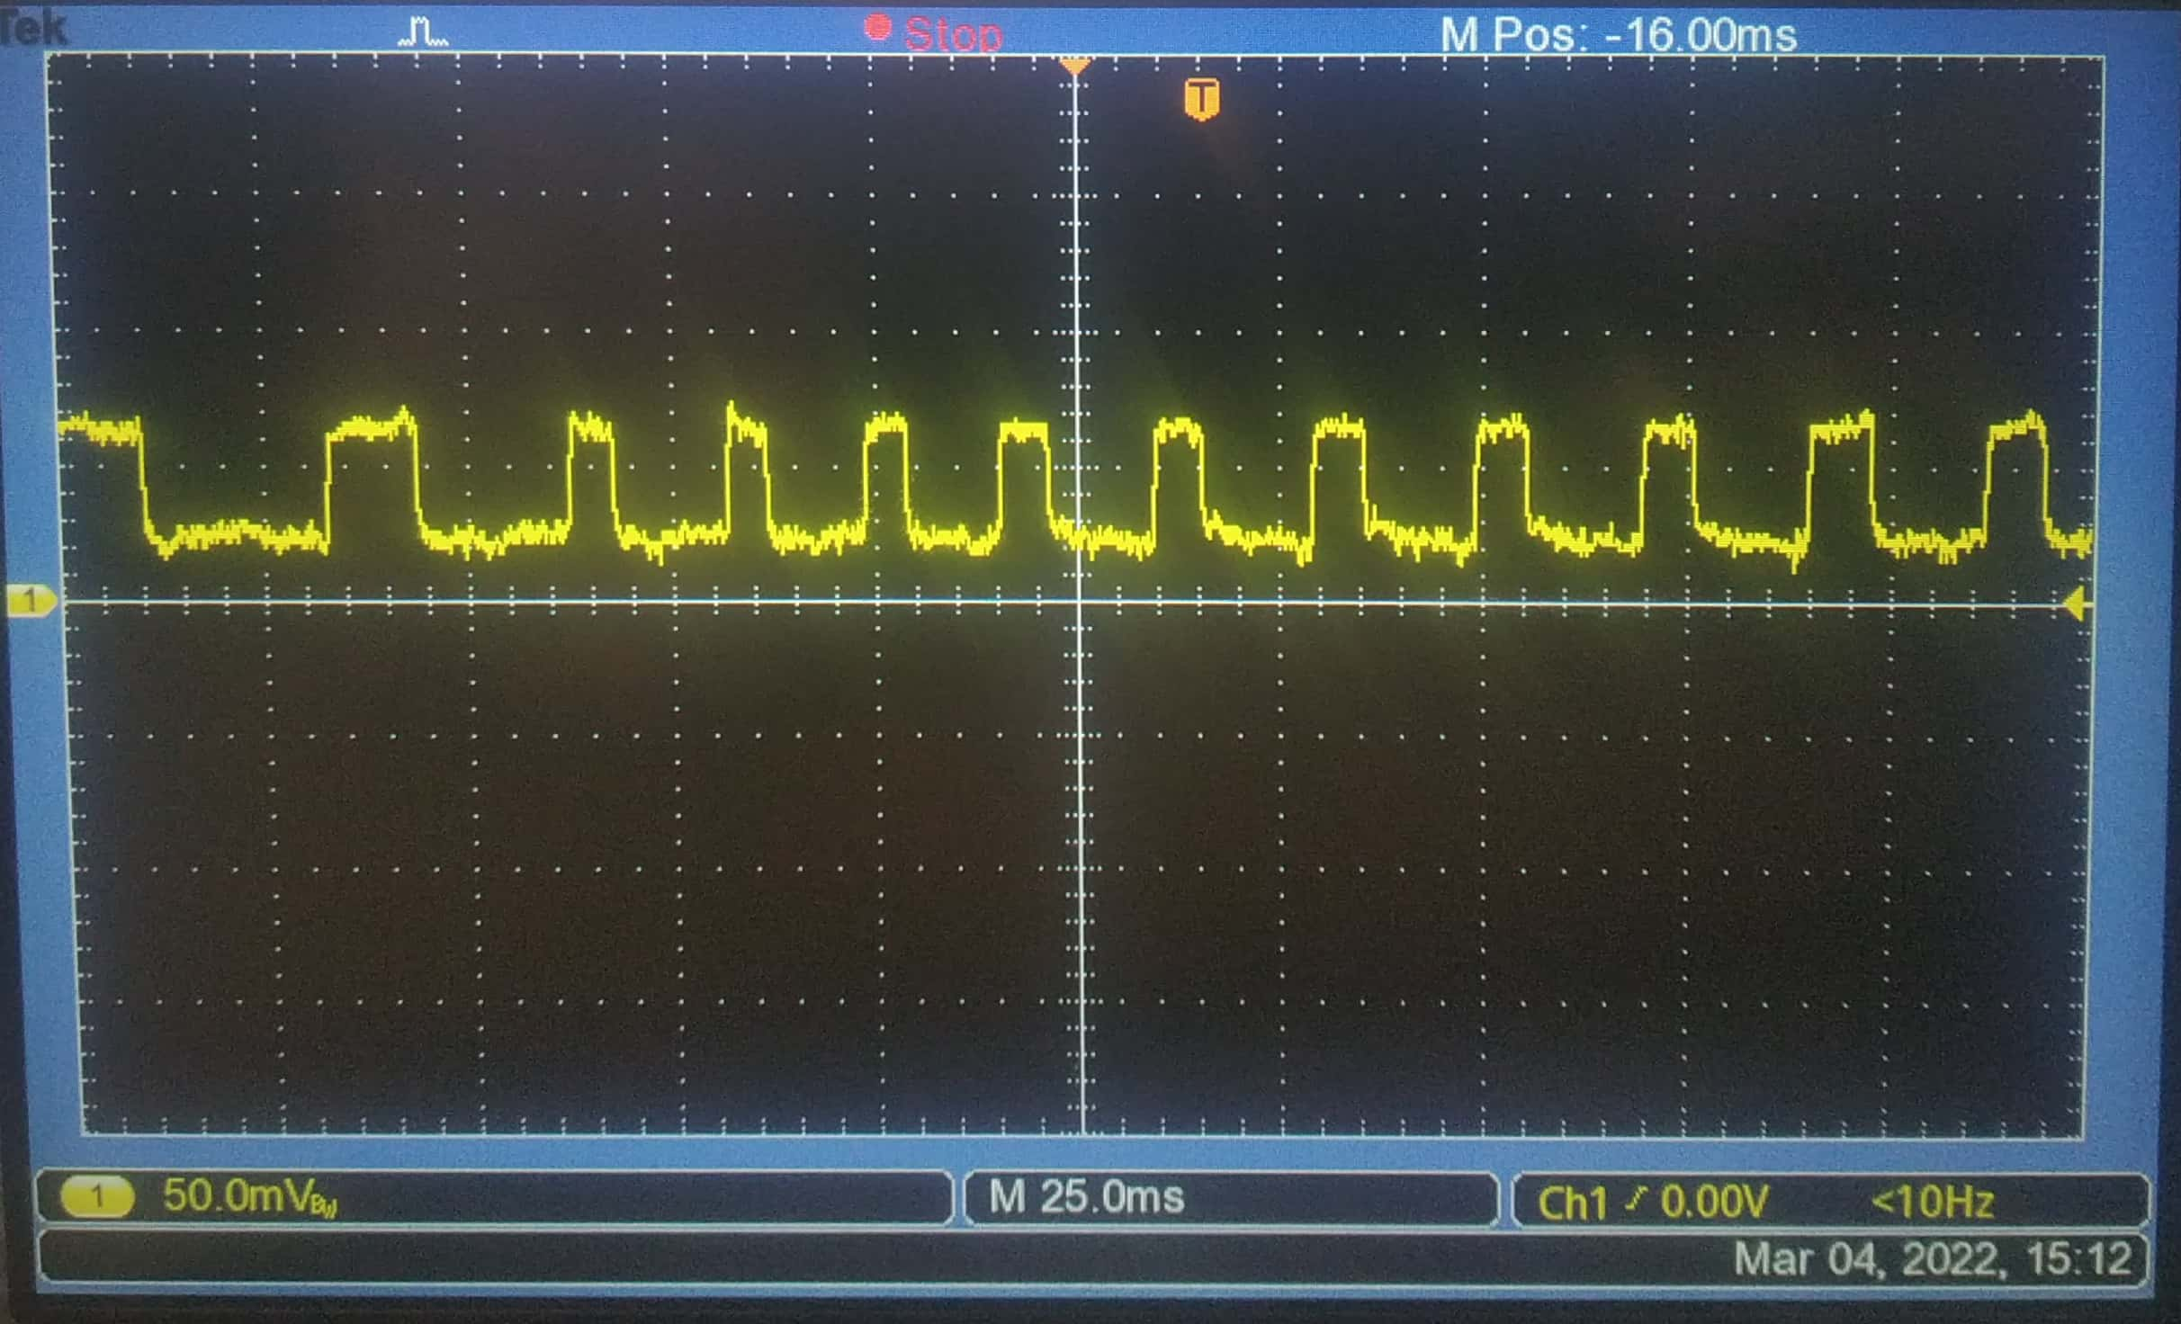

Attached above is the output of a photodiode circuit, when I flash on and off my smartphone flashlight repeatedly at a programmed delay of 1 milli second(ms). And the output clearly indicates that the width of the clock signal is not constant through time and is subject to variation. The minimum width of a single on or off pulse that was observed was 5 ms and the maximum width was 17 ms. So our result is consistent with the results obtained by the references which I have attached below(One of the reference has been suggested by you and the other reference , I had searched out in the internet, carried out by HAL, an agency).

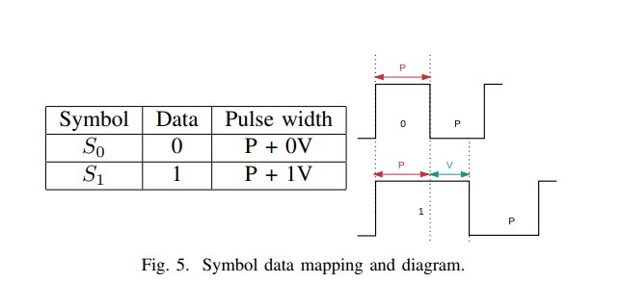

The HAL agency suggests a solution for this clock inconsistency. They use Variable PWM scheme to solve this. Attached above is an illustration of how they encode 1’s and 0’s into specific symbols. The variable ‘P’ is used to denote the maximum pulse width that we had obtained when we had observed the clock signal, and ‘V’ is a variable offset. So a 0 would be mapped to a symbol ‘So’ whose **Total Period= P+P=2P** , whereas a 1 would be mapped to a symbol ‘S1’ whose **Total Period= P+V+P, thus would be equal to 2P+V .**  Attached Picture above shows the mapping clearly. So essentially a 0 symbol and 1 symbol would differ in their ON periods (0 symbol has ON width ‘P’ and 1 symbol has ON width ‘P+V’ , but both have the same OFF period which is ‘P’) . Based on some optimization, they had set V=1.5P .

Obviously as expected , the transmitted signal undergoes pulse width expansion. But In the Receiver side, their method of decoding is simple. **If the incoming pulse has an ON time width greater than or equal to P+V, then the symbol would be treated as a 1, else the symbol would be treated as a 0.**

So, I had implemented their scheme of Variable PWM onto my Mobile device. In our case P = 17 ms as that is the maximum width I have observed in the clock signal, about which I had indicated earlier. Thus with that I had carried out the calculations and subsequently I programmed my mobile to the new modulation and had flashed it in front of the photodiode and had obtained a snapshot of the modulated signal from the oscilloscope. Attached Below is the snapshot.

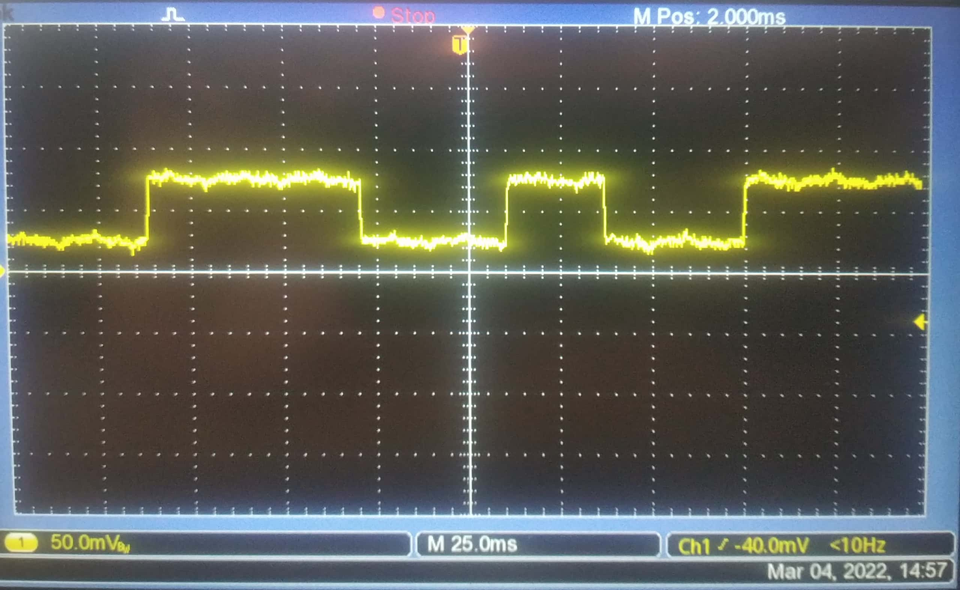

I am in the process of writing a code for the de-modulation process. I will let you know of the output and how efficient this method is sir. I would like to know your feedback on this , thus enabling me to correct myself. The other thing I wanted to ask is I am not able to understand the solution part of the reference that you had suggested sir. I sincerely request you to help me understand their solution so that I can implement their solution also, and finally compare both the solutions and pick the one with the maximum efficiency.

Thank you sir

Attached below is the HAL reference paper that I had used.

https://hal.inria.fr/hal-01683629/document