NW Inventory OS Analysis App V1.1
Workflow, Data Flow, and Field Mapping Documentation
Document Type | Technical workflow, data flow, and field mapping reference
Application Version | V1.1
Primary Use Case | NW CMDB firmware validation and Inventory OS reconciliation
Output Option | Single Excel workbook with multiple analysis sheets
Key Update | Official field mapping matrix embedded in script and documentation
Purpose. This document explains the operational workflow, data flow, and official field mapping used by the NW Inventory OS Analysis App V1.1. It can be used for SOP, transition, governance, and future enhancement documentation.

1. Scope of V1.1
V1.1 focuses on network operating system and firmware reconciliation between NW CMDB, Inventory OS, and Inventory OS Catalog data. The key enhancement in V1.1 is the embedded field mapping matrix, which is also written to the output workbook.
File Slot | Required in V1.1 | Purpose | Processing Usage
Inventory Operating System | Yes | Provides hostname, serial, lifecycle and OS attributes. | Used for presence, serial, lifecycle and future OS validation.
NW CMDB Report | Yes | Provides Configuration Item, Serial number, Firmware Version and Life Cycle Stage. | Primary reconciliation baseline and firmware source.
Inventory OS Catalog Report | Yes | Provides software_product_name and software_version. | Used for firmware catalog validation.
Other report slots | No | Reserved for future versions. | Loadable in GUI but not active in V1.1.
Field Mapping File | Optional | External reference if provided. | Included as Field Mapping Reference sheet if loaded.

2. Official Field Mapping Matrix
The field mapping below is the official logical mapping for V1.1. The same matrix is embedded in the Python script and exported into the output workbook as the Field Mapping Matrix sheet.
Inventory OS report | Inventory OS Catalog | NW CMDB Report | Purpose in Analysis
operating_system_provider | software_provider |  | Provider reference / future provider validation
operating_system_name | software_product_name | Firmware Name | Firmware / OS product matching
operating_system_version | software_version | Firmware Version | Firmware / OS version matching
hostname |  | Configuration Item | CI presence validation
os_lifecycle_status |  | Life Cycle Stage | Lifecycle compliance validation
os_parent_serial_number |  | Serial number | Serial validation and hostname change detection
operating_system_subcategory | subcategory |  | Subcategory reference / future validation
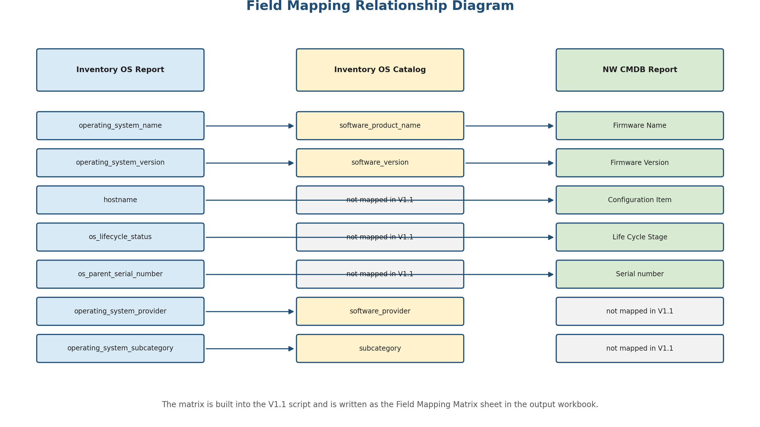
Figure 1. Field Mapping Relationship Diagram

3. Workflow Diagram
The workflow diagram shows the end-to-end sequence from opening the GUI to generating the single Excel output workbook. V1.1 explicitly applies the field mapping matrix before executing the validation and reconciliation logic.
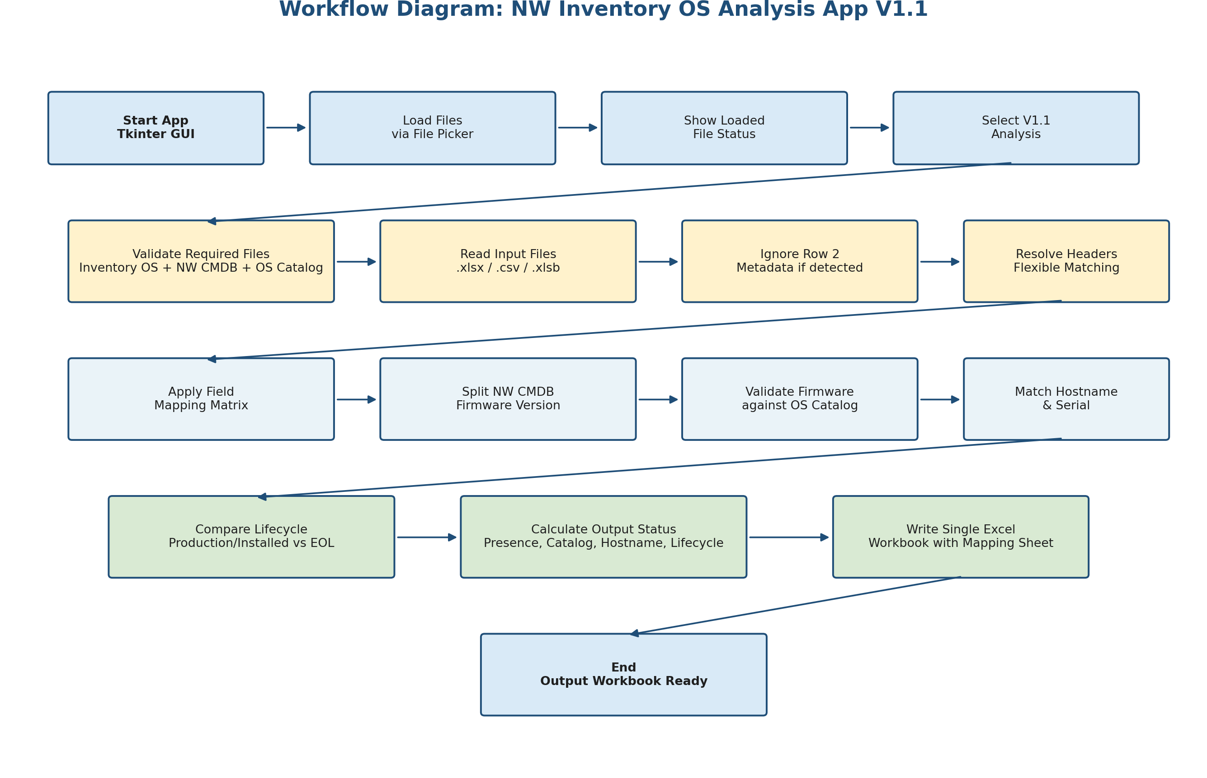
Figure 2. Workflow Diagram for NW Inventory OS Analysis App V1.1

4. Data Flow Diagram
The data flow diagram shows how input reports are read, normalized, mapped, processed, and converted into workbook sheets including the new Field Mapping Matrix sheet.
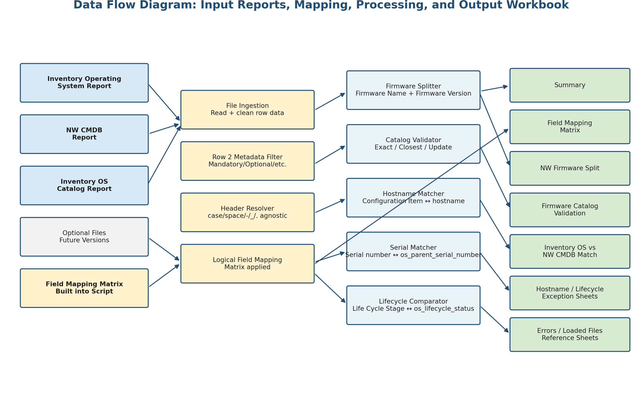
Figure 3. Data Flow Diagram for V1.1

5. Mapping Usage by Analysis Function
Analysis Function | Inventory OS Field | Inventory OS Catalog Field | NW CMDB Field / Output
Firmware product match | operating_system_name | software_product_name | Firmware Name
Firmware version match | operating_system_version | software_version | Firmware Version
CI presence validation | hostname |  | Configuration Item
Hostname change detection | os_parent_serial_number |  | Serial number
Lifecycle validation | os_lifecycle_status |  | Life Cycle Stage
Future provider validation | operating_system_provider | software_provider
Future subcategory validation | operating_system_subcategory | subcategory

6. Core Matching and Validation Rules

6.1 Catalog Matching Rule
- Exact match: Firmware Name equals software_product_name and Firmware Version equals software_version.
- Closest Match Proposed: same product name and same version after removing only a trailing alphabetic suffix from the NW CMDB firmware version.
- catalog update required: no exact match and no accepted closest match found.

6.2 Inventory OS Reconciliation Rule
- Direct presence check compares NW CMDB Configuration Item with Inventory OS hostname.
- Special character check replaces / in the CMDB Configuration Item with _ or - and compares with hostname.
- Serial match compares NW CMDB Serial number with Inventory OS os_parent_serial_number using case-agnostic matching.
- Hostname changed is flagged when serial matches but hostname does not match directly or through slash replacement.

6.3 Lifecycle Rule
- Retire in IS is flagged when Inventory OS os_lifecycle_status is production or Installed and NW CMDB Life Cycle Stage is End of Life.

7. Output Workbook Structure
Sheet Name | Purpose | Notes
Summary | Counts and metrics | Includes totals and outcome counts.
Field Mapping Matrix | Official mapping embedded in V1.1 | New in V1.1.
NW Firmware Split | Firmware Name and Firmware Version output | Preserves Original Firmware Version.
Firmware Catalog Validation | Catalog match outcome | Match, Closest Match Proposed, catalog update required.
Inventory OS vs NW CMDB Match | Main reconciliation output | Includes presence, serial, hostname, lifecycle and catalog statuses.
Hostname Changed | Serial matched but hostname changed | Exception review sheet.
Lifecycle Mismatch | Retire in IS records | Lifecycle action sheet.
IS Load Candidates | Not Present in IS records | Candidates for Inventory Services loading.
Missing Columns and Errors | Validation messages | Blocking and optional missing fields.
Loaded Files | Runtime input file record | Audit/support reference.
Field Mapping Reference | Only when user loads external mapping file | Optional reference sheet.

8. Operational Controls
- Minimum V1.1 processing requires Inventory Operating System, NW CMDB Report, and Inventory OS Catalog Report.
- The mapping matrix is embedded in the script and always included in the output workbook.
- Header matching remains flexible for case, spaces, hyphen, underscore, and dot differences.
- Optional mapping fields are reported if missing but do not block the V1.1 analysis.
- Core fields required for V1.1 analysis remain blocking if missing.
End of Document

